Course Name: | Principles of Data Science | Semester: | IV
Date of Performance: | 29-01-25 | Batch No: | A3
Grade/Marks: | /25 | Roll No: | 16010324044

EXPT 3
TITLE: Exploratory Data Analysis (EDA) to gain insights from data

AIM: To learn how to perform Exploratory Data Analysis to learn distribution of data variables and correlation among them.

OUTCOME: By the end of this experiment, students will:

1. Understand the importance of Exploratory Data Analysis in data science.
2. Perform EDA tasks like:
- Learn distribution of numerical variables and their impact on response variable, if any.
- Use crosstables and Pivot tables for analysis of categorical variables
- Identify outliers in dataset
- Identify correlations among data variables
- Determine the important variables for the problem under study
3. Use Python libraries like pandas, numpy, matplotlib and seaborn to process and visualize the data.

What is EDA?
Exploratory Data Analysis (EDA) is an approach to analyzing datasets to summarize their main characteristics, often using visual methods. It helps data scientists understand what the data can tell us before formal modeling or hypothesis testing.

Task 1: Load and Examine the Dataset
Task Description: Load the dataset and perform initial examination including shape, column names, data types, and viewing first/last rows.
Analysis:
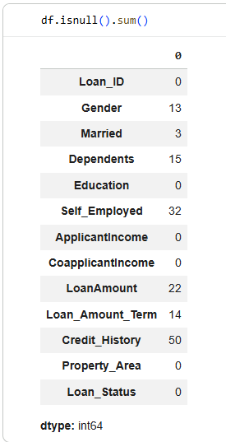
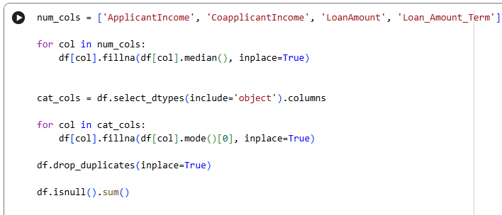
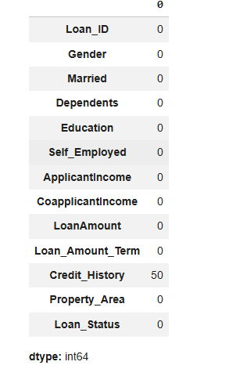
Interpretation:
The dataset was loaded successfully and basic checks such as shape, column names, and data types were performed. This helped in understanding the size, structure, and overall format of the loan dataset before further analysis.

Task 2: Identify and Handle Missing Values

Task Description: Find missing values in the dataset and apply appropriate imputation techniques for numerical and categorical variables.
Analysis:
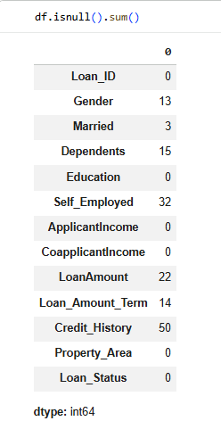
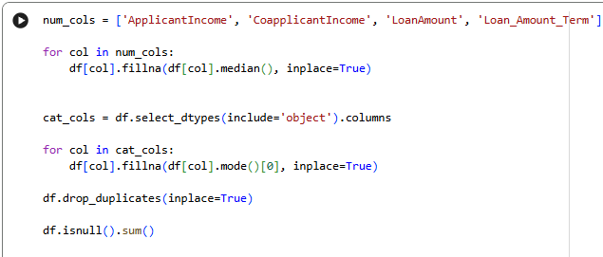
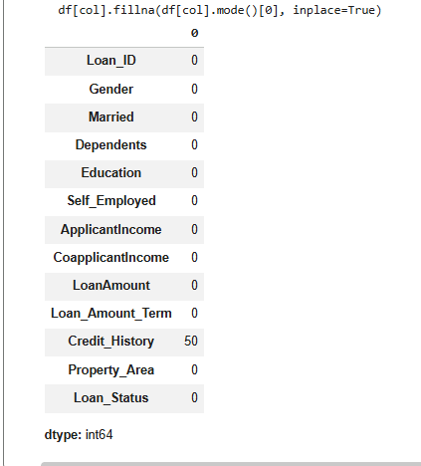

Interpretation:
Missing values were found in both numerical and categorical columns. Numerical values were filled using the median and categorical values using the mode. This helped maintain data consistency without removing any records.

Task 3: Univariate Analysis - Numerical Variables
Task Description: Analyze numerical variables individually using descriptive statistics and visualizations (histograms and boxplots).
Analysis:
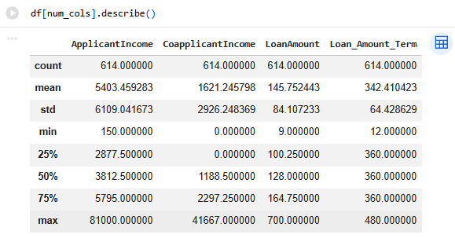

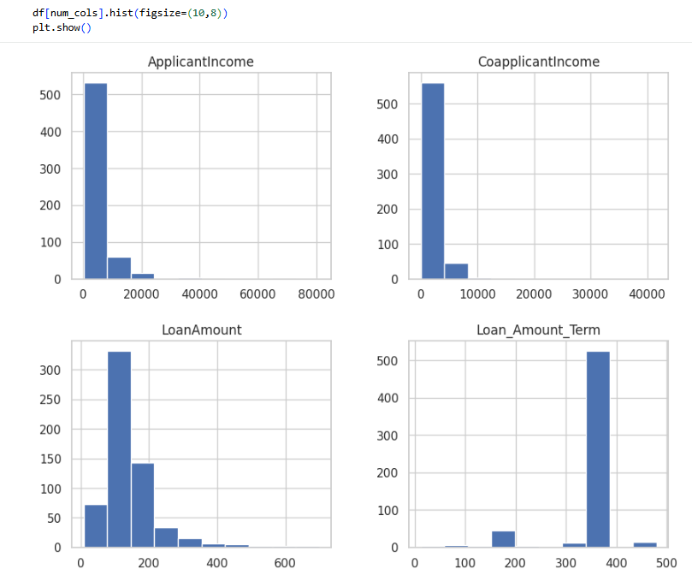
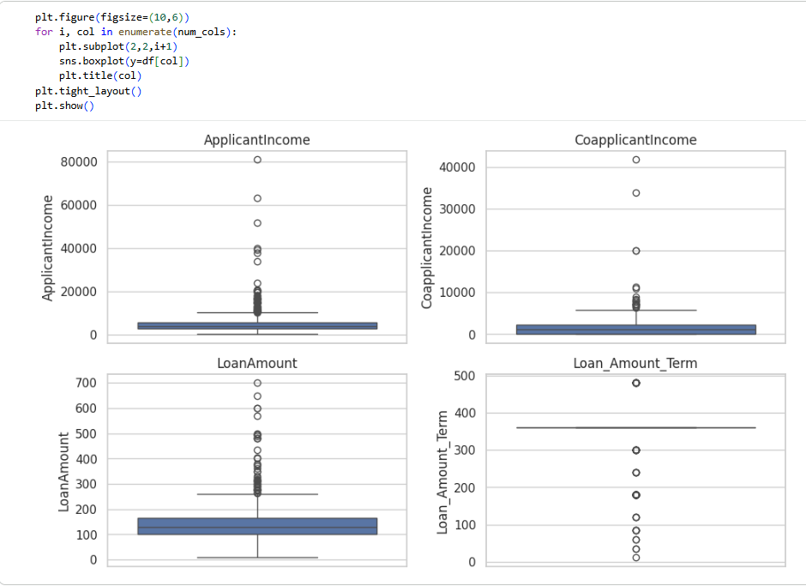
Interpretation:
Descriptive statistics and plots were used to analyze numerical variables. Histograms showed data distribution while boxplots helped identify outliers. Income and loan-related variables showed some skewness and extreme values.

Task 4: Univariate Analysis - Categorical Variables
Task Description: Analyze categorical variables using frequency tables, proportions, and bar plots.
Analysis:

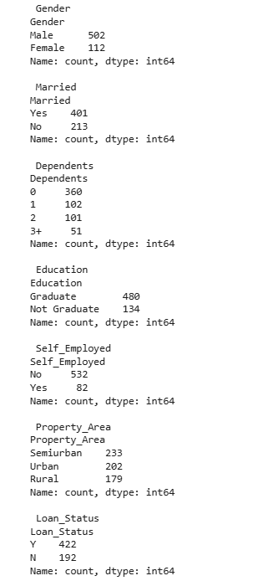
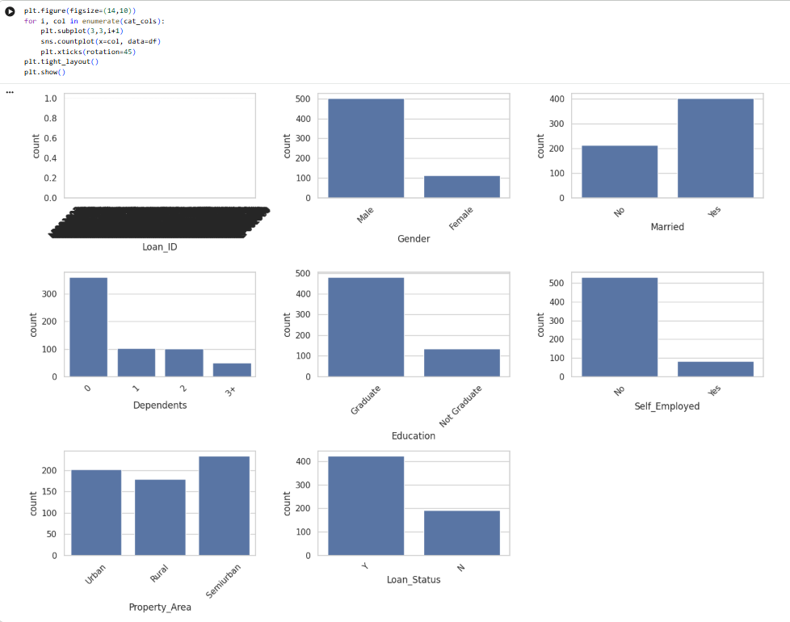
Interpretation:
Frequency tables and bar plots were used to study categorical variables. The analysis showed unequal distribution among categories like education and loan status, indicating class imbalance in the data.

Task 5: Bivariate Analysis - Categorical vs Categorical
Task Description: Analyze relationships between two categorical variables using crosstabs and grouped visualizations.
Analysis:

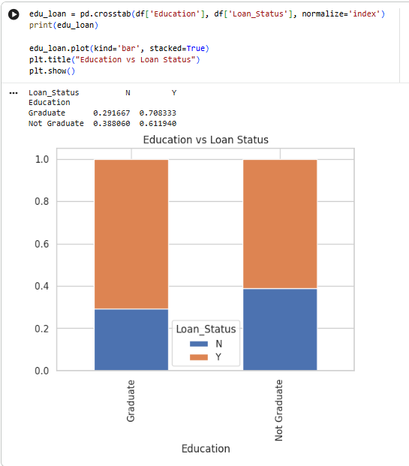

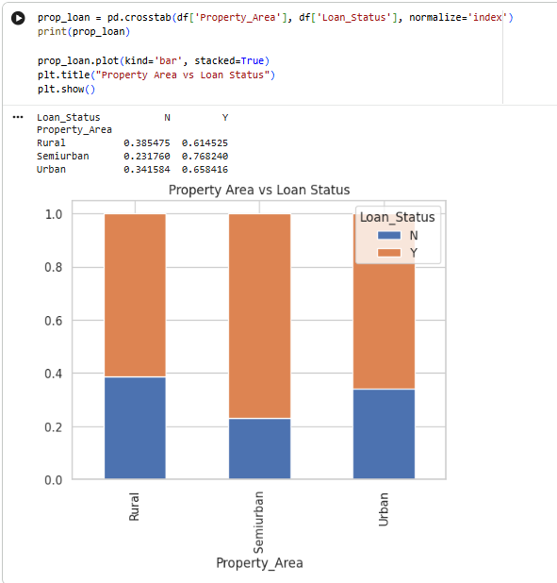
Interpretation:
Crosstabs were used to study relationships between categorical variables. It was observed that factors such as education level and property area influence loan approval status.

Task 6: Bivariate Analysis - Numerical vs Numerical
Task Description: Analyze relationships between two numerical variables using scatter plots and correlation analysis.
Analysis:
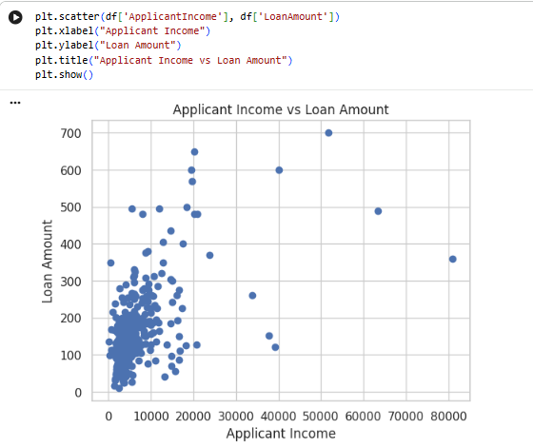

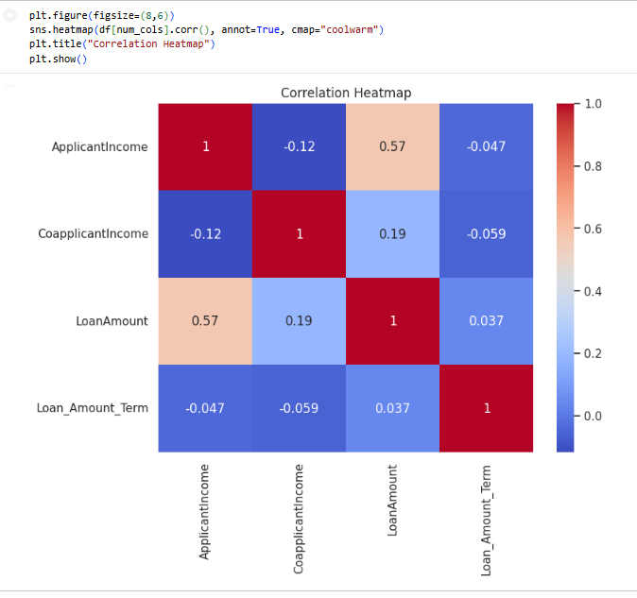
Interpretation:
Scatter plots and correlation analysis showed a positive relationship between applicant income and loan amount. Higher income applicants generally tend to have higher loan amounts.

Task 7: Bivariate Analysis - Categorical vs Numerical
Task Description: Analyze how numerical variables vary across different categorical groups.
Analysis:

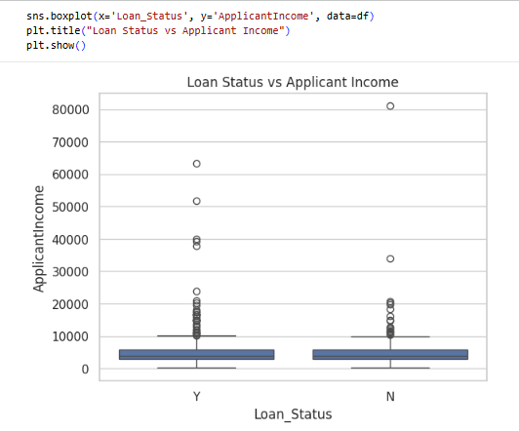

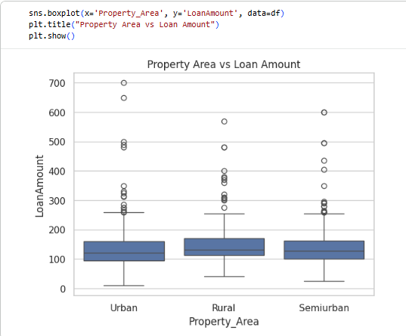
Interpretation:
Boxplots showed variation of numerical variables across categories. Approved loans generally had higher applicant income compared to rejected loans, indicating income plays an important role in approval.

Task 8: Data Manipulation and Insights
Task Description: Perform data manipulation operations and derive key insights from the exploratory analysis.
Analysis:
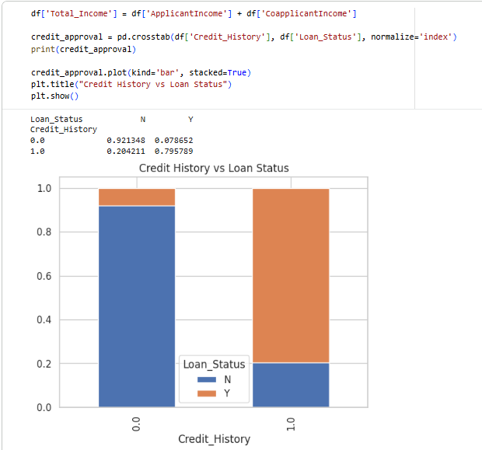

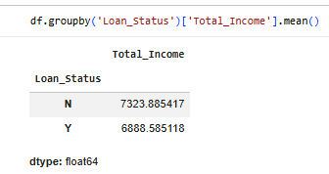
Interpretation:
A new feature, total income, was created for better analysis. The results showed that applicants with a good credit history had a higher loan approval rate, making it a key factor in the dataset.

Conclusion:
In this experiment, I learnt how EDA helped in understanding the dataset by analyzing missing values, data distribution, and relationships between variables. Important factors such as income and credit history affecting loan approval were identified. Overall, EDA proved to be an essential step before further data modeling.

