Course Name: | Principles of Data Science | Semester: | IV
Date of Performance: |  | Batch No: | A3
Grade/Marks: | /25 | Roll No: | 16010324044

Experiment 4
TITLE: Probability Distributions, Central Limit Theorem & Maximum Likelihood Estimation

AIM: To understand and implement standard continuous and discrete probability distributions, demonstrate the CLT, and apply Maximum Likelihood Estimation (MLE).

OUTCOME: By the end of this experiment, students will:
- Understand and visualize standard discrete distributions (Binomial, Poisson)
- Understand and visualize standard continuous distributions (Normal, Exponential)
- Understand and visualize the CLT using sample means.
- Apply MLE to estimate parameters of probability distributions.
- Analyze real-world datasets to determine which probability distribution best models the data.
- Use Python libraries such as `numpy`, `scipy.stats`, and `matplotlib` to perform statistical
analysis.

Task 1: Standard Discrete Distributions

Objective: Understand and visualize discrete probability distributions.

Theory

Binomial Distribution
The Binomial distribution models the number of successes in n independent trials, where each trial has a probability p of success.
Real-world applications:
• Quality control: Number of defective items in a batch
• A/B testing: Number of users who click on a variant
• Clinical trials: Number of patients who respond to treatment
• Coin flips: Number of heads in n tosses

Poisson Distribution
The Poisson distribution models the number of events occurring in a fixed interval of time or space.
Real-world applications:
• Call centers: Number of calls received per hour
• Website traffic: Number of visitors per minute
• Manufacturing: Number of defects per product
• Natural events: Number of earthquakes per year

Solution Approach
1. Import required libraries: numpy, matplotlib, scipy.stats
2. Use scipy.stats.binom.pmf() for Binomial probability mass function
3. Use scipy.stats.poisson.pmf() for Poisson probability mass function
4. Create bar plots to visualize discrete distributions
5. Add labels and titles for clarity
Analysis:
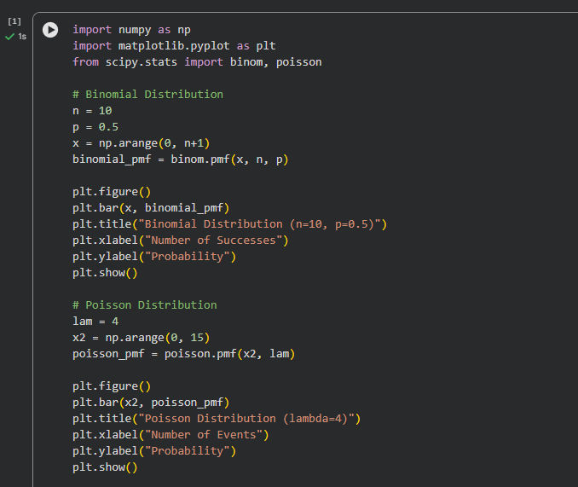
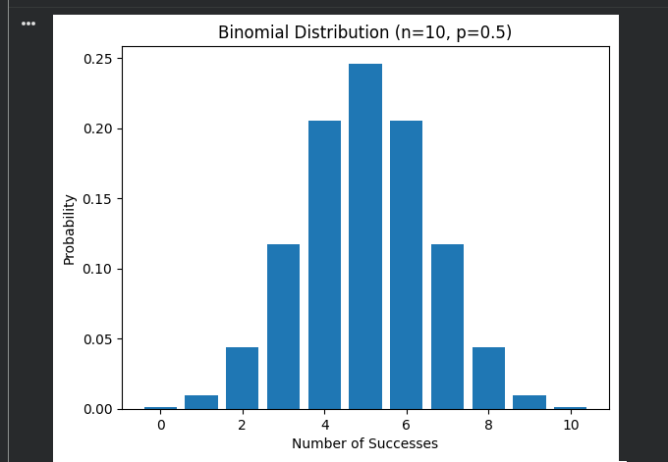
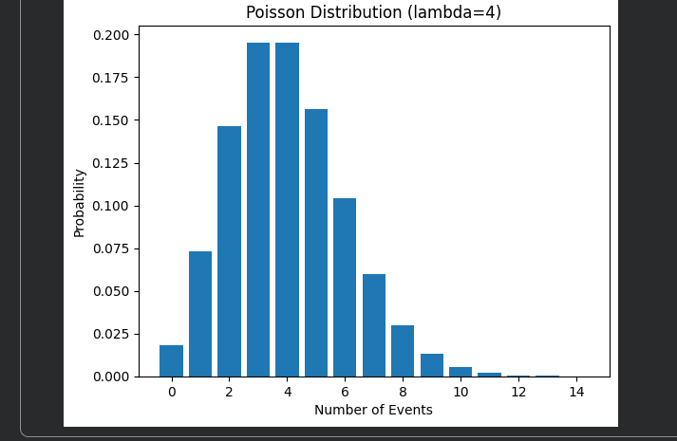
Interpretation:
From the graphs, binomial distribution depends on number of trials and success probability, while Poisson depends on average rate of occurrence. Both are useful for modeling count-based real world problems.

Task 2: Standard Continuous Distributions

Theory

Normal (Gaussian) Distribution
The Normal distribution, also known as the Gaussian distribution, is the most important
probability distribution in statistics. It appears naturally in many phenomena.
Real-world applications:
• Human characteristics: Heights, weights, IQ scores
• Measurement errors in scientific experiments
• Test scores and grades
• Natural phenomena following averages

Exponential Distribution
The Exponential distribution models the time between events in a Poisson process.
Real-world applications:
• Time between customer arrivals
• Time until equipment failure
• Time between phone calls
• Radioactive decay
Analysis:
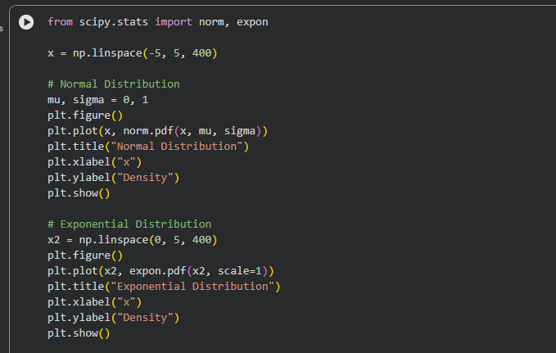
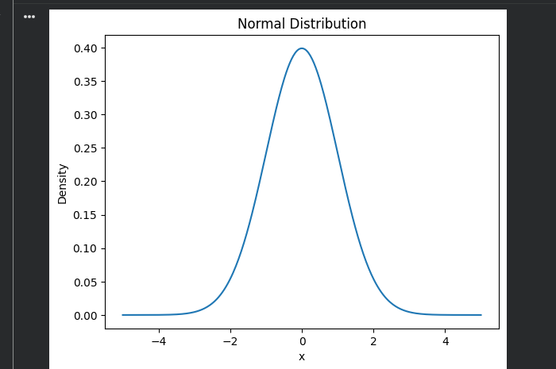
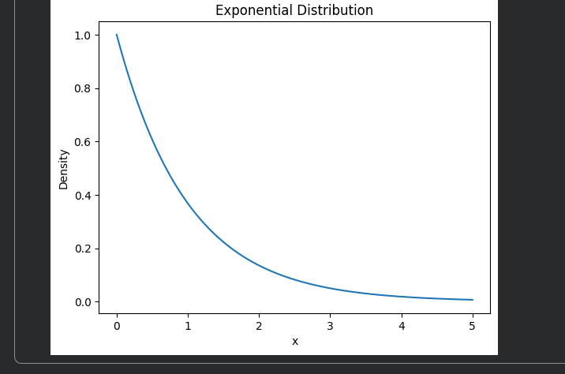
Interpretation:
Normal distribution models natural variations like marks and height, while exponential distribution models waiting time between events like arrivals or failures.

Task 3: Comparing Different Parameters

Objective
Understand how changing parameters affects distribution shapes.

Key Insights
For Normal Distribution (varying σ):
• Smaller σ → Narrower, taller peak (less variability)
• Larger σ → Wider, flatter distribution (more variability)
• Mean (μ) determines center position
For Binomial Distribution (varying p):
• p = 0.5 → Symmetric distribution
• p < 0.5 → Right-skewed distribution
• p > 0.5 → Left-skewed distribution
Analysis:
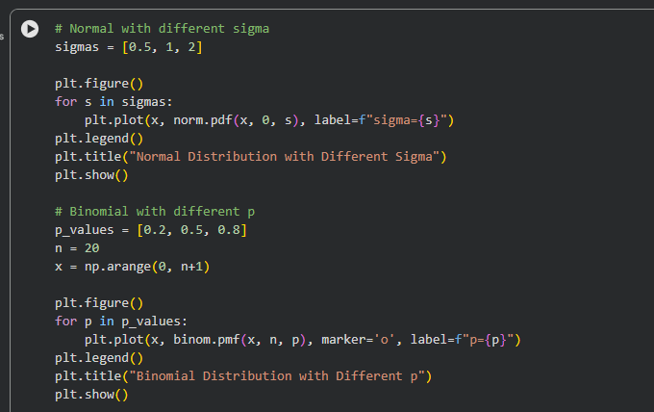
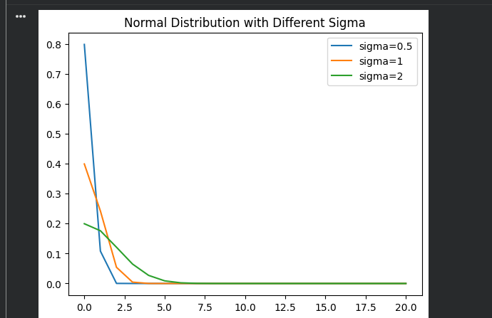
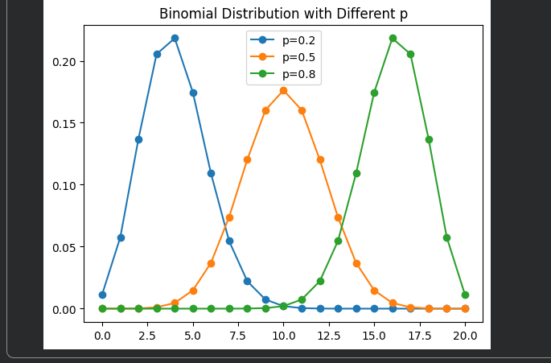
Interpretation:
Lower sigma → narrow peak. Higher sigma → wider curve.
Binomial is symmetric at p = 0.5 and skewed otherwise.

Task 4: Central Limit Theorem

Theory - Central Limit Theorem
The Central Limit Theorem (CLT) is one of the most important theorems in statistics and
probability theory.
Statement: When independent random variables are summed up, their normalized sum tends toward a normal distribution, even if the original variables themselves are not normally distributed.
In simpler terms:
The distribution of sample means approximates a normal distribution as the sample size becomes larger, regardless of the population's distribution shape.
Key Points:
1. Works for ANY population distribution (uniform, exponential, binomial, etc.)
2. Sample size typically needs to be ≥ 30 for good approximation
3. The mean of sample means equals the population mean
4. The standard deviation of sample means = σ / √n (standard error)
Why is CLT Important?
• Foundation of inferential statistics
• Justifies using normal distribution for hypothesis testing
• Enables confidence intervals and p-values
• Explains why normal distribution appears so frequently in nature
• Critical for quality control and process improvement
Mathematical Form:
If X₁, X₂, ..., Xₙ are independent random variables from any distribution with mean μ
and standard deviation σ, then: X̄ = (X₁ + X₂ + ... + Xₙ) / n approaches Normal(μ, σ/√n) as n → ∞
Use `numpy.random` to simulate means of random samples.
Example: Simulating dice rolls and checking the distribution of their means.

Analysis:
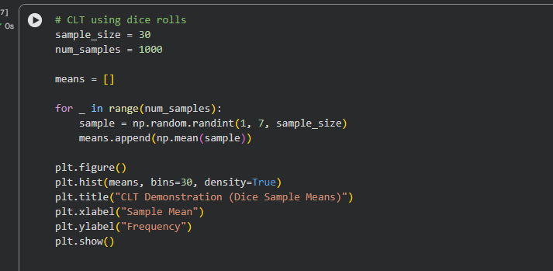
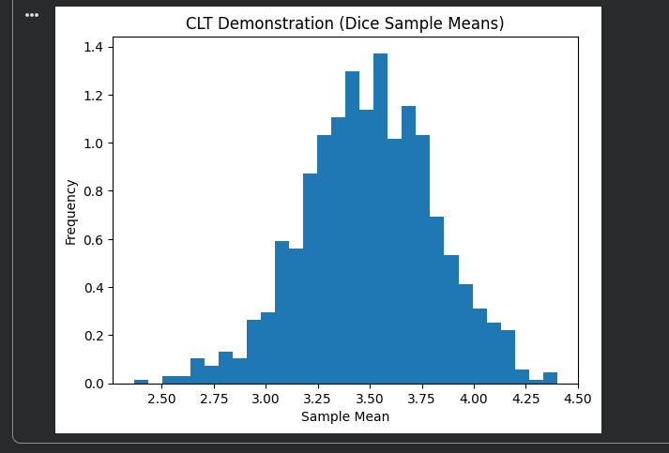
Interpretation:
This verifies the Central Limit Theorem — averages of large samples follow normal distribution regardless of original distribution.

Task 5: Maximum Likelihood Estimation (MLE)

Theory - Maximum Likelihood Estimation
Maximum Likelihood Estimation (MLE) is a method to estimate the parameters of a probability
distribution by maximizing a likelihood function.
Properties of MLE:
• Consistent: Converges to true value as sample size increases
• Asymptotically efficient: Has smallest variance among consistent estimators
• Asymptotically normal: Distribution approaches normal for large samples
Advantages:
• Intuitive: Finds most likely parameters
• General: Applicable to many distributions
• Optimal properties in large samples
• Flexible: Can incorporate constraints
Applications:
• Parameter estimation in statistical models
• Machine learning model training
• Hypothesis testing
• Regression analysis
• Time series analysis
Python Implementation: `scipy.optimize.minimize`
Example: Estimating the parameter of an exponential distribution using MLE.

Analysis:
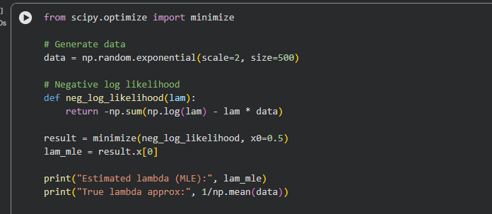
Interpretation:
MLE finds the parameter value that makes observed data most probable. Estimated lambda is close to theoretical value (1/mean), showing MLE works correctly.

Conclusion
In this experiment, I learnt discrete and continuous probability distributions using Python. Visualizing Binomial, Poisson, Normal and Exponential distributions made the effect of parameters easier to observe. The CLT simulation showed that sample means tend toward a normal distribution even if the original data is not normal. Maximum Likelihood Estimation was also applied successfully to estimate model parameters. Overall, the experiment provided practical insight into statistical modeling with Python.

