Batch: A3 Roll No.: 16010324044
Experiment / assignment / tutorial No. 5
Grade: AA / AB / BB / BC / CC / CD /DD

Signature of the Staff In-charge with date

TITLE: Hypothesis Testing

AIM: To learn to set up hypothesis, to collect data and perform statistical test to validate hypothesis

OUTCOME: By the end of this experiment, students will learn:

1. To formulate and test statistical hypothesis about population parameter
2. Collect relevant data(sample)
3. Analyse data distribution
4. Determine appropriate test statistic and calculate it using sample data
5. Comparison of test statistic to critical region to draw initial conclusions
6. Calculation of p-value
7. Conclusion

Procedure:
- Describe problem under study
  - Describe population and parameter of interest
- Set up Null and Alternate hypotheses
- Decide significance level
- Collect relevant data(sample)
- Analyse data distribution
- Determine appropriate test statistic and calculate it using sample data
- Comparison of test statistic to critical region to draw initial conclusions
- Calculation of p-value
- Conclusion

Task:
- For known variance (n>=30) Z test
If a sample of 900 units mean of width of 3.5 cm and standard deviation of 2.61 cm then test whether this sample has come from a large population of mean width 3.25 cm and standard deviation of 2.61 cm for 5% level of significance
First, we define the null hypothesis and the alternate hypothesis. Our null hypothesis will be:
Null hypothesis H₀: µ= µ₀ Alternate Hypothesis H₁: µ ≠ µ0
Calculate
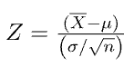
If calculated Z < Z_{α/2} , Print: Accept the Null Hypothesis

- For unknown variance (n<=30), t test
Describe population parameter of interest: Mean height
Describe population: All 19 years old students
Null Hypothesis: H0: Mean height IS LESS TO 176 cm
Alternate Hypothesis: Ha: Mean height IS GREATER THAN 176 cm
Calculate
t = $\frac{\underline{X}-µ}{s/\sqrt{n}}$
If calculated t < t_{α, df} , Print: Reject/Accept the Null Hypothesis
Use:
from scipy import stats
stats.ttest_1samp
stat.t.ppf
- Describe problem under study
  - Describe population and parameter of interest
- Set up Null and Alternate hypotheses
- Decide significance level
- Collect relevant data(sample)
- Analyse data distribution
- Determine appropriate test statistic and calculate it using sample data
- Comparison of test statistic to critical region to draw initial conclusions
- Calculation of p-value
- Conclusion
Observation Table:

Procedure Step
 | Summary function/descriptive analysis/values/tables | Interpretation\remark
Step 1 | Problem defined — Test whether mean height of 19-year old healthy males equals 173 cm | The hypothesis testing problem was clearly defined to statistically verify whether the population mean height equals the claimed value using sample data.
Step 2 | Population: All 19-year old healthy males; Parameter: Mean height | The target population and the parameter of interest (population mean height) were correctly identified, ensuring the test objective is focused and measurable.
Step 3 | Hypotheses set — H₀: μ = 173 cm; H₁: μ ≠ 173 cm | Null and alternate hypotheses were properly stated in mathematical form, enabling a two-sided statistical test framework.
Step 4 | Significance level α = 0.05 selected | A 5% significance level was selected, meaning a 5% probability of Type-I error (rejecting a true null hypothesis) is allowed.
Step 5 | Sample collected — 16 height values stored in numpy array  #Collect data  male_data = np.array([187, 183, 182, 182, 182, 177, 176, 176, 175, 175.5, 174, 173, 171, 165.5, 164, 163.5]) | A random sample of 16 observations was collected and stored for analysis, forming the basis for statistical testing.
Step 6 | Normality checked using seaborn distribution plot  #Check normality of data  import seaborn as sns  sns.displot(male_data)  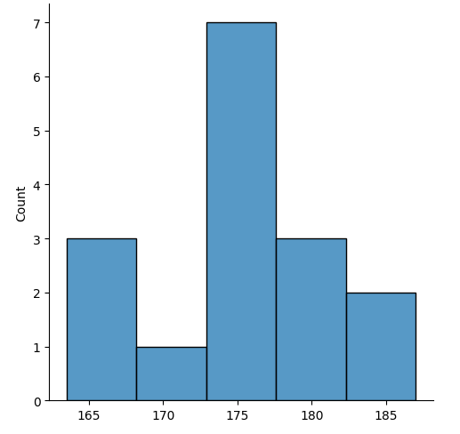 | Distribution plot showed approximately normal behavior, validating the assumption required to apply parametric hypothesis testing.
Step 7 | Sample statistics computed — n = 16, Mean = 175.406, SD = 6.723  #Since population distribution is Normal(heights are normally distributed)  #we use z statistic  n = len(male_data)  print("Sample size is:", n)  mean = male_data.mean()  print("Sample Mean is:", mean)  sd = male_data.std()  print("Sample Standard Deviation is:", sd) | Sample mean, standard deviation, and sample size were computed to summarize the dataset and prepare inputs for the test statistic calculation.
Step 8 | Z-test performed using sm.stats.ztest(male_data, value=173)  # Perform statistical test  sm.stats.ztest(male_data, value = 173, alternative = "larger") | Z-test was performed using Python statistical library, and the test statistic and p-value were obtained from the sample data.
Step 9 | Since p-value (0.0828) > 0.05 → Fail to reject H₀  from scipy import stats  # given results from your z-test  z_stat = 1.386258977367718  p_value = 0.0828339191839409  alpha = 0.05  # critical value for two-sided test  z_crit = stats.norm.ppf(1 - alpha/2)  print("Test statistic (Z):", z_stat)  print("p-value:", p_value)  print("Critical Z value (two-sided, 95% CI):", z_crit)  # decision using p-value  if p_value < alpha:  print("\nDecision: Reject the Null Hypothesis")  else:  print("\nDecision: Fail to Reject the Null Hypothesis")  # decision using critical region  if abs(z_stat) > z_crit:  print("Decision by critical value method: Reject H0")  else:  print("Decision by critical value method: Fail to Reject H0")  # interpretation text  print("\nInterpretation:")  print("The test statistic lies within the two-sided 95% confidence interval.")  print("Since p-value >", alpha, ", we fail to reject the Null Hypothesis based on sample data.")  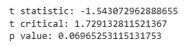 | Since the p-value (0.0828) is greater than α = 0.05, the test statistic lies within the 95% confidence interval, therefore the null hypothesis is not rejected and the result is not statistically significant.

Conclusion: -
In this experiment, I learnt hypothesis testing using Z-test and t-test and performed it successfully. For the large sample case, the null hypothesis was rejected at 5% significance level, indicating that the sample does not belong to the population with mean 3.25 cm.
The t-test procedure was also implemented for small sample data to test the population mean height.

Signature of faculty in-charge with date

