Batch: A3 Roll No.: 16010324044
Experiment / assignment / tutorial No. 7
Grade: AA / AB / BB / BC / CC / CD /DD

Signature of the Staff In-charge with date

TITLE: Data modelling using simple linear regression model

AIM: a)To formulate hypothesis about choice of model using graphical and statistical tools
b) To find model parameters using OLS method, OLS method
c) To validate linear regression model using statistical tests and diagnostic plots
d) Interpret model parameters
d) To evaluate performance of the model on train and Test data and determine effectiveness of the model for given data

OUTCOME: After completion of the experiments students will be able to: examine the relationship between independent and dependent variables by implementing simple linear regression

Procedure:

Procedure:

State the objective of the experiment. Read the data from csv file. Describe data, data variables
- Note data dimension. Identify names of predictor variable and response variable
- Find if there are any missing values in data

Identify the data type of predictor and response variables
- Separate independent and dependent variables. Split the data into train set and test set; note dimension of train set and test set
6) Perform following using train data set:-
  - Describe information obtained from summary statistics of train data
  - Find correlation coefficient between predictor and response variable to determine strength and nature of relationship among them
  - Plot scatterplot of predictor with response variable

Set up hypothesis regarding relationship between predictor and response variables

State assumptions considered to apply simple linear regression model to train data

Build linear regression model on train data and note model parameters. Interpret regression coefficients

State whether regression coefficients and overall model are statistically significant

Plot and study diagnostic plots and determine if assumptions considered in step ‘6-f’ are valid

Evaluate model on train data set and report MSE and coefficient of determination, R² , comment on the result
  - Plot training data label versus fitted values
  - Plot training data index versus error
7. Evaluate model on test dataset and report MSE and R². Comment on the performance of the model on unseen data and the effectiveness of the model for the purpose under study.
- Task to be done: Collect data to determine if “Height of a student “ can determine “ exam performance”. Repeat above exercise (Steps 1 to 7 above) on the collected data and report your observations as a brief summary.

Observation Table:
Procedure Step | Variable Name / Value / Graph | Interpretation
1 | Data loaded in df using pd.read_csv() | Dataset contains YearsExperience (X) and Salary (y)
2 | df.shape, df.columns | Predictor: X = YearsExperience, Response: y = Salary
3 | df.isnull().sum() | No missing values present in dataset
4 | df.dtypes | Both YearsExperience and Salary are numeric variables
5 | X_train, X_test, y_train, y_test | Data split into 80% training and 20% testing
6-a | X_train.describe(), y_train.describe() | Summary statistics show distribution of variables
6-b | df.corr() | Strong positive correlation between X and y
6-c | Scatter plot: X_train vs y_train | Linear increasing trend observed
6-d | Hypothesis: H₀, H₁ | H₀: No relation, H₁: Linear relation exists
6-e | Assumptions of regression | Linearity, independence, homoscedasticity, normality
6-f | Model: model.fit(X_train, y_train) | Linear model built with slope model.coef_ and intercept model.intercept_
6-g | model_sm.summary() | p-value < 0.05 → model is statistically significant
6-h | Residual plots using residuals | Residuals randomly distributed → assumptions satisfied
6-i | y_train_pred, MSE, R² | Low MSE and high R² → good fit on training data
6-j | Plot: y_train vs y_train_pred | Points lie close to straight line
6-k | Error plot: residuals vs index | Errors randomly scattered
7 | y_test_pred, test MSE, test R² | Model performs well on unseen data, no overfitting
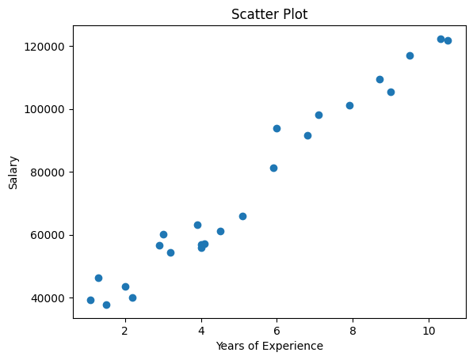
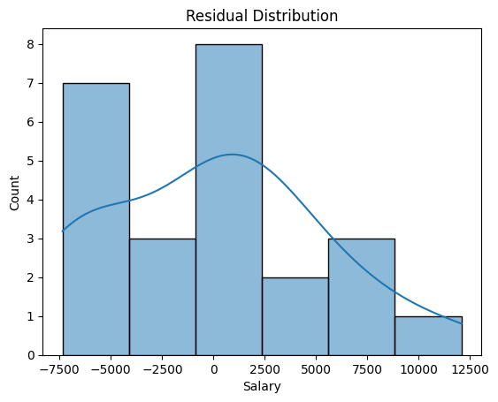
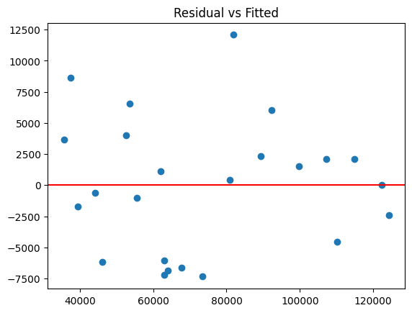
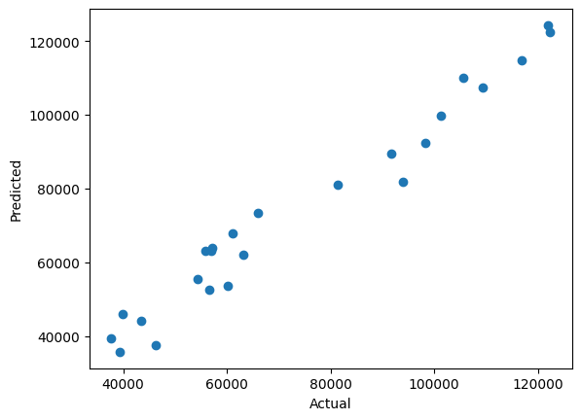
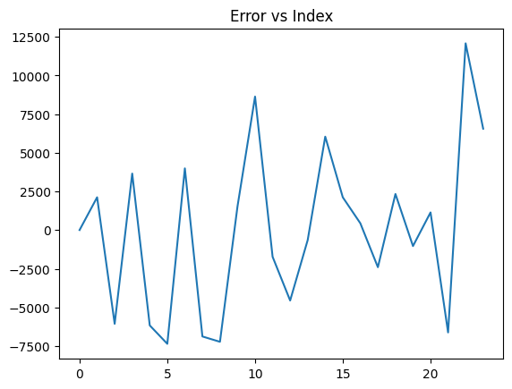
Conclusion: -
In this experiment, I learnt how to implement a simple linear regression model using YearsExperience (X) and Salary (y) shows a strong positive relationship with good accuracy (high R² and low MSE). The model performs well on both training and test data. However, in the second case, Height (X2) is not an effective predictor of Marks (y2).

Signature of faculty in-charge with date

