Batch: A3 Roll No.: 16010324044
Experiment / assignment / tutorial No. 9
Grade: AA / AB / BB / BC / CC / CD /DD

Signature of the Staff In-charge with date

TITLE: Optimization techniques to find optimal parameters for the fiven functionl

AIM: To learn Optimization techniques to obtain optimal solution for unconstrained and constrained problems

OUTCOME: After completion of the experiments students will be able to: identify type of the optimization problem and apply relevant techniques to obtain optimal solution

Procedure:

Procedure:

Read the data from ex1data1.txt file. Describe data, data variables
- Note data dimension.
- Find if there are any missing values in datadentify the data type of predictor and response variables
- Separate independent and dependent variables
- Find correlation coefficient between predictor and response variable to determine strength and nature of relationship among them
- Plot scatterplot of predictor with response variable

Choose regression model based on answers of steps 5 and 6
- Obtain parameters of the model using Ordinary Least Squares(OLS) method. Write salient features of OLS.
- Obtain parameters of the model using Gradient Descent method. Write salient features of GD.

Repeat the above task to obtain parameters of Multiple Linear Regression model. Use Advertizing.csv data.

Perform constrained optimization using Lagrange method.

Observation Table:

Procedure Step
 | Variable name\Value\graph | Interpretation
1 | 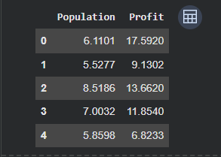 | The dataset contains two numerical variables where Profit depends on Population.
2 | 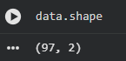 | Dataset has 97 observations and 2 variables, suitable for regression analysis.
3 | 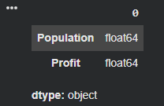 | No missing values are present and all variables are numeric, so data is clean.
4 | 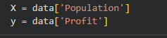 | Population is the independent variable and Profit is the dependent variable.
5 |  | There is a strong positive relationship between Population and Profit.
6 | 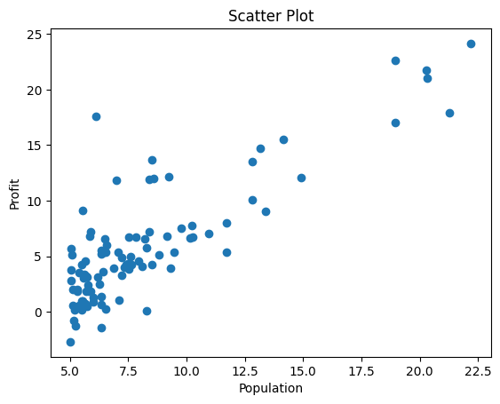 | The scatter plot shows a linear upward trend indicating linear relationship.
7 | Selected Model: Linear Regression | Since correlation is high and scatter plot is linear, linear regression is appropriate.
8 | 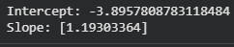 | OLS method provides best-fit line minimizing squared errors.
9 | 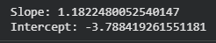 | Gradient Descent gives similar results to OLS, validating the optimization process.
10 | Predictors: TV, Radio, Newspaper; Response: Sales | Multiple variables influence sales, confirming suitability of multiple linear regression.
11 |  | Lagrange method successfully finds optimal solution under given constraint.

Conclusion: -
In this experiment, I learnt optimization techniques such as Ordinary Least Squares and Gradient Descent were successfully applied to obtain optimal parameters for regression models. The results show that both methods provide similar outputs, validating the effectiveness of optimization techniques. Constrained optimization using Lagrange multipliers was also performed successfully.
Signature of faculty in-charge with date

