GMDC Share Value Analysis using Python, Tableau, and Power BI
Dhairya Shah
Department of Electronics and Telecommunication Engineering
K. J. Somaiya School of Engineering, Mumbai, India
Email: [redacted]

Abstract—In recent years, data visualization has emerged as an indispensable component of data analytics, providing an intuitive and efficient means of interpreting large and complex datasets. This project focuses on the share value analysis of Gujarat Mineral Development Corporation (GMDC), a leading state-owned mining company, using Python, Tableau, and Microsoft Power BI. The goal of the study is to visualize, analyze, and interpret GMDC’s stock data to derive insights into market trends, price movements, and trading behavior. Python is used for data collection and preprocessing, while Tableau and Power BI are used for dashboard creation, trend visualization, and key performance indicator (KPI) evaluation. The integration of these tools bridges the gap between data engineering and business intelligence, allowing both descriptive and diagnostic analysis of stock performance. This research highlights how data visualization enhances interpretability, assists investors in identifying trading opportunities, and supports informed decision-making in financial analytics.
Keywords: Data Visualization, Tableau, Power BI, Financial Analytics, Stock Market, Python, GMDC

Introduction
The stock market represents a dynamic environment where share prices fluctuate continuously based on economic, industrial, and psychological factors. Analyzing such complex time-series data requires sophisticated tools capable of transforming large numerical datasets into comprehensible insights. Gujarat Mineral Development Corporation (GMDC), one of India’s largest state-owned mining corporations, provides a representative case for studying share value behavior and market trends.
Traditional statistical methods often fail to communicate hidden patterns, especially in time-dependent financial data. Visualization tools such as Tableau and Microsoft Power BI offer a powerful alternative by enabling dynamic and interactive data representation. By integrating Python for data preprocessing and extraction, this study demonstrates an end-to-end analytical workflow—from raw data collection to visualization and interpretation. The combination of Python’s data handling efficiency and the visualization capabilities of Tableau and Power BI provides a robust framework for financial analytics.
The primary objective of this project is to develop dashboards and visualizations that capture key aspects of GMDC’s share price movements. This includes identifying trend reversals using moving averages, correlating price and trading volume, and comparing long-term versus short-term performance. The study further explores how Tableau and Power BI differ in analytical focus—Tableau emphasizing visual storytelling and trend recognition, while Power BI focuses on KPI-driven and AI-assisted analytics.

Dataset Description
The datasets employed for this study form the foundational basis for the visualization and analytical exploration of stock performance for Gujarat Mineral Development Corporation (GMDC) and its peer companies. Two distinct yet complementary datasets were utilized: (i) gmdc_daily.csv, containing historical daily trading data for GMDC, and (ii) gmdc_and_peers_close.csv, encompassing comparative closing prices of GMDC and similar firms within the same industry domain. The data span from 2015 to 2025, providing a comprehensive temporal range for long-term trend analysis and market behavior assessment.

The gmdc_daily.csv dataset comprises daily observations, each representing a trading day in the specified period. The key attributes include Date, Open, High, Low, Close, and Volume, capturing essential market indicators that reflect intra-day price fluctuations and trading activity. These attributes facilitate the computation of derived indicators such as moving averages, relative price change, and volatility measures. The temporal resolution of the dataset supports the examination of both short-term and long-term stock behavior patterns, enabling multi-scale visualization of market dynamics.

The gmdc_and_peers_close.csv dataset extends the analytical scope by incorporating closing price series of GMDC and its peer companies in the mining and energy sector. This multi-company dataset enables comparative visualizations and correlation analysis across firms, providing insights into co-movement trends and sector-level market dependencies. By aligning time indices across all included entities, the dataset ensures temporal consistency, allowing for accurate comparative analysis through line plots, heatmaps, and correlation matrices.

Both datasets were preprocessed to handle missing values and ensure consistency in date formatting and numerical scaling. Outliers arising from exceptional market events were preserved to retain data authenticity and improve interpretability of real-world fluctuations. The integration of these datasets forms the foundation for subsequent visualization-based analysis, offering an interpretable and data-driven representation of GMDC’s market position relative to its peers. The structure and granularity of the datasets make them well-suited for exploratory financial analytics, trend visualization, and strategic decision-support applications.

Methodology
The methodology adopted in this project follows a structured sequence involving three major stages: data collection and cleaning using Python, visualization and interpretation using Tableau, and advanced analysis and KPI evaluation using Power BI.
In the first stage, Python was employed to acquire GMDC’s share data through the Yahoo Finance API. Using libraries such as pandas, numpy, and yfinance, the data was extracted, cleaned, and formatted. Missing values were handled, and additional calculated columns such as moving averages and daily returns were introduced for trend identification.
In the second stage, Tableau was used to construct interactive dashboards focusing on time-series visualization. Multiple charts were designed, including line charts for closing price trends, dual-axis charts for moving averages, and bar charts for price-volume correlations. These visuals were integrated into dashboards to provide both overview and comparative perspectives.

In the third stage, Power BI was used to perform performance-based analytics through the creation of KPI visuals, combo charts, waterfall analyses, and key influencer evaluations. DAX (Data Analysis Expressions) was used to compute dynamic metrics, while AI-powered visuals identified major factors influencing GMDC’s price fluctuations.
The integration of these three tools—Python, Tableau, and Power BI—created an end-to-end analytical framework enabling comprehensive, reliable, and interpretable share value analysis.

Implementation using Python
Python served as the foundation for data collection and preparation. The yfinance package was used to extract GMDC’s historical share data, which was subsequently processed using pandas for cleaning and transformation. Basic operations included:
Removal of null and duplicate entries to ensure data integrity.
Conversion of date fields to appropriate datetime formats.
Calculation of derived metrics such as daily returns and moving averages.
Exporting the finalized dataset into CSV format for compatibility with Tableau and Power BI.
No predictive or machine learning modeling was performed in this project; Python’s role was limited to data collection, preparation, and feature engineering. The resulting dataset served as the input for visual analytics platforms.

Implementation using Tableau
Tableau was used to create highly interactive and visually intuitive dashboards for time-series and comparative stock analysis.
The first visualization created was a Line Chart representing GMDC’s Closing Price Trend across time, allowing users to identify upward and downward movements clearly. A Dual Axis Chart combining the closing price with the 20-day and 50-day moving averages was designed to highlight crossover points, which typically signal buying or selling opportunities.
A Bar Chart depicting Volume vs Price was created to show the relationship between trading activity and price fluctuations. Periods of high trading volume often corresponded to significant price changes, providing insight into investor sentiment.
Two dashboards were developed:
Stock Overview Dashboard – providing an overall summary of GMDC’s price trends, moving averages, and trading volume.
Comparative Analysis Dashboard – enabling side-by-side comparison of various time periods to analyze long-term versus short-term performance.
These visualizations collectively allowed detailed exploration of GMDC’s market behavior and enhanced understanding of historical performance patterns.
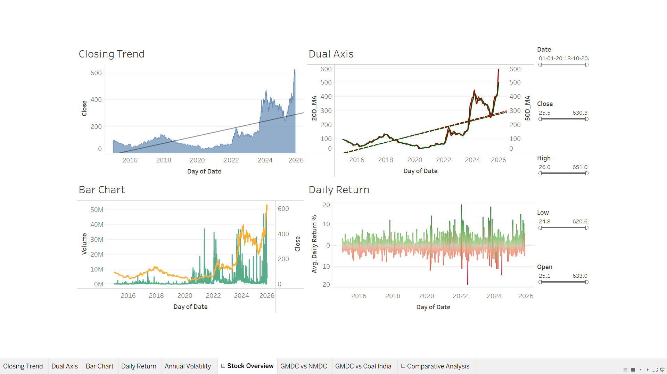
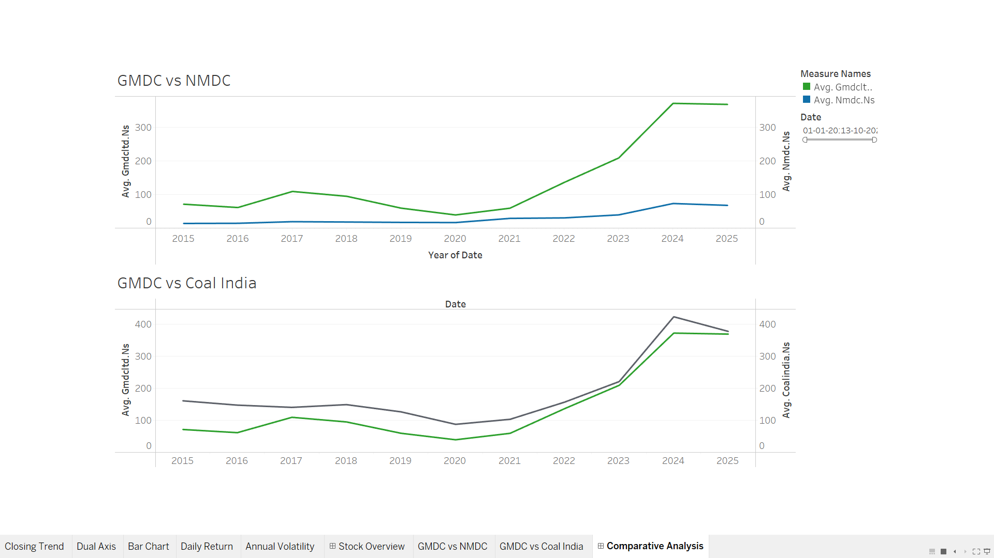

Implementation using PowerBI
Power BI was utilized to design analytical dashboards focusing on performance evaluation through KPIs and diagnostic visuals.
Four key KPI cards were created to represent metrics such as Opening Price, Closing Price, Daily High, and Daily Low. These dynamic KPIs updated based on date filters and slicers.
A Line Chart was implemented to depict price trends, similar to Tableau, but integrated with slicers to enable date-range-based interactivity. A Combo Chart displayed both Price and Volume to correlate trading activity with price variation.
A Waterfall Chart was designed to illustrate day-to-day incremental changes in GMDC’s share price, showing cumulative gains and losses over the analyzed period. A Matrix Visual summarized all numerical stock parameters, while the Key Influencer Visual applied AI-driven analysis to determine factors most strongly impacting GMDC’s closing price — with Volume consistently emerging as the dominant variable.
Together, these visuals provided a comprehensive analytical environment suitable for both investors and analysts to explore GMDC’s financial performance interactively.
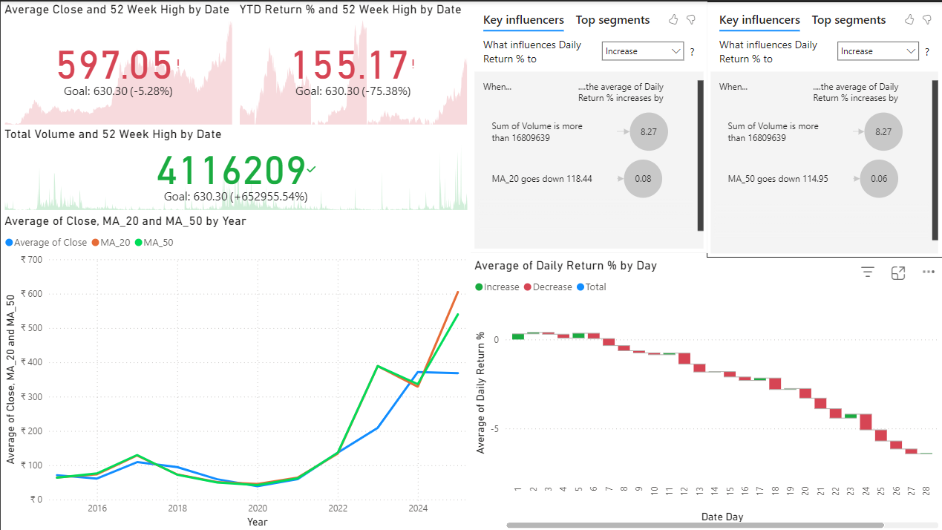

Result and Discussion
The combined implementation of Tableau and Power BI revealed significant insights into GMDC’s market performance. Tableau’s visual analysis demonstrated long-term and short-term trend reversals using moving averages, and volume bars confirmed that heavy trading activity often preceded major price changes. Power BI’s dashboards offered an analytical view, quantifying these trends through KPIs and decomposing daily fluctuations via the waterfall chart.
The comparative analysis revealed that Tableau excels in visual storytelling, interactivity, and pattern discovery, whereas Power BI’s strength lies in performance tracking, AI-driven insights, and business intelligence reporting. Both tools complement each other, collectively offering a hybrid visualization system that enhances the interpretability and analytical depth of financial data.

Conclusions
The project successfully demonstrates the integration of Python, Tableau, and Power BI for comprehensive share value analysis. Python efficiently handled data extraction and preprocessing, Tableau provided deep visual insights into time-series trends, and Power BI offered advanced analytics with KPI tracking and machine learning-based factor analysis.
The study concludes that visual analytics tools significantly enhance the understanding of financial datasets, enabling better decision-making for investors and analysts. The complementary use of Tableau and Power BI bridges the gap between exploratory visualization and business intelligence, creating a scalable and adaptable analytical framework for financial research.

Acknowledgment
The author expresses sincere gratitude to Prof. Rupali Patil for her continuous guidance, motivation, and valuable insights throughout the project. Appreciation is also extended to the Department of Electronics and Telecommunication Engineering, KJ Somaiya School of Engineering, for providing the necessary resources and environment to complete this project successfully..

References
[1] Yahoo Finance – GMDC Stock Data.
[2] Tableau Software, “Tableau Desktop: Technical Documentation,” www.tableau.com
.
[3] Microsoft Power BI Documentation, learn.microsoft.com/power-bi.
[4] Amala Menon et al., “Data Visualization and Predictive Analysis for Smart Healthcare: Tool for a Hospital,” IEEE TENCON, 2021.
[5] Vikas Rahate et al., “Data Analytics for Betelnut’s Selling Dataset Using Tableau,” IEEE ICAECT, 2021.
[6] VanderPlas J., “Altair: Interactive Statistical Visualizations for Python,” J. Open Source Softw., vol. 3, no. 32, 2018.

