MEEM 5990

Getting Data in the Lab

Spring 2016

**Homework 03**

Due 2016-02-18

1. Write a brief description of your interim project (no more than a paragraph) in a text file named “ProjectDescription.txt”
2. Consider the following graph of thermocouple outputs vs. temperature

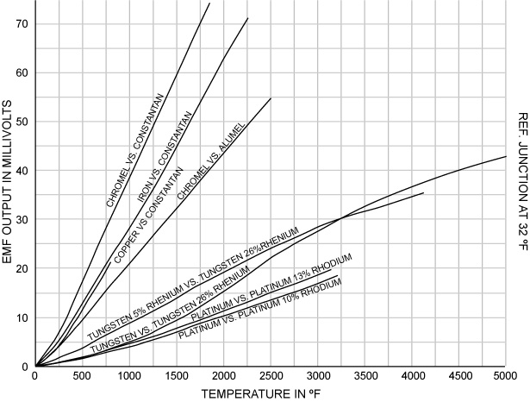

Source: <http://www.convectronics.com/TechInfo5.html>

1. Which thermocouple will provide the greatest sensitivity temperature change at 1000 ºF?
2. What letter type is this thermocouple?

Write your answers in a file named “Problem02.txt”

1. Consider two options three options for measuring angular displacement (e.g. of a shaft):
2. <http://www.alliedelec.com/images/products/datasheets/bm/CLAROSTAT/70152976.pdf>
3. <http://www.mouser.com/ProductDetail/Alpha-Taiwan/RV120F-10-15F-B10K/?qs=sGAEpiMZZMtC25l1F4XBU%2fP0MTCF53RLP9Y2hf6vz4Q%3d>
4. What type of DAQ (analog input, digital output, counter/timer, etc.) would be best for sensor a?
5. What type of DAQ would be best for sensor b?
6. Besides a DAQ system and the system under test, what else would be necessary to use sensor a?
7. Sensor b?
8. If the goal of this measurement was to measure small angle changes from 0-10 degrees, which sensor would be better and why?
9. If the goal of this measurement was to measure total angular displacement over several revolutions, which sensor would be better and why?

Write your answers in a text file named “Problem03.txt”

1. Write a VI which calculates the analog input voltage resolution of an Analog Input system.

Inputs:

* Input voltage range maximum
* Unipolar or bipolar? (e.g., from 0 V to 5 V, or from -5 V to 5 V)?
* ADC resolution in bits (e.g. 12, 16, etc.)

Output:

* Resolution of ADC in volts

Save the VI as “AIResolution.vi”

1. Billy has a system is known to generate a signal that is composed of a 22.5 kHz signal added to a 100 Hz signal.

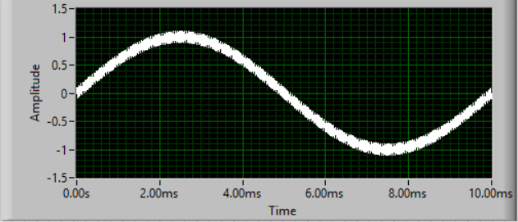

Figure 1: The system output signal

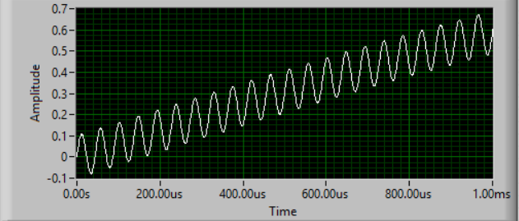

Figure 2: A close-up of the signal. Note the change in the time-axis scale

1. What sampling speed should Billy use, at a minimum, to fully capture the frequency content of this signal?
2. Suppose the Billy considers the 22.5 kHz signal to be noise. What can he do to remove this signal from his data prior to acquiring the signal?
3. If Billy has successfully removed the 22.5 kHz “noise” from his signal, now what sampling rate does he need to run in order to capture the 100 Hz component of interest
4. Suppose that Billy does nothing to remove the 22.5 kHz signal, and samples his data at 1 kHz. At what frequency will the alias of the high-frequency signal appear?

Write your answers in a text file called “Problem05.txt”