MEEM 5990

Getting Data in the Lab

Spring 2016

**Homework 04**

Due 2016-03-24

1. Copy the StateMachineDAQ.vi to a new file in the same folder named “StateMachineDAQ-mod.vi”
2. Study the state diagram for state machine (see “StateMachineDAQ.png”)

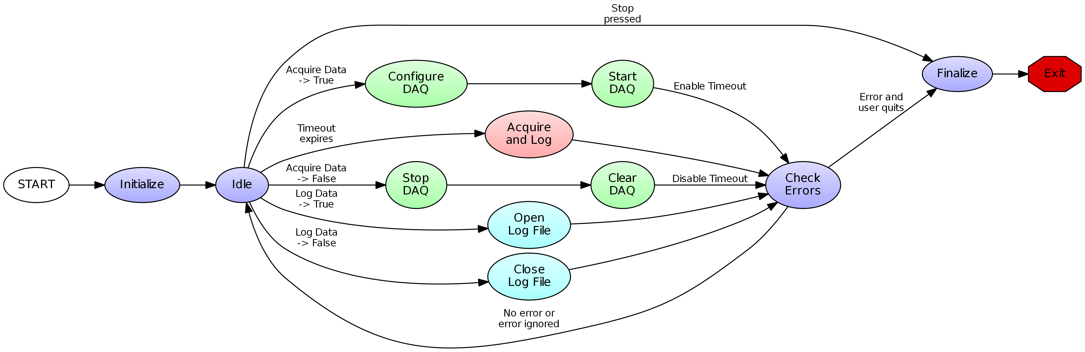

1. Modify StateMachineDAQ-mod.vi in the following way:
   1. Add an OK button (or other boolean control) to the FP labeled “Process 1.” The button should have “Latch on Release” behavior
   2. When the button is pressed, or when the file is closed, execute a new state “Process 1.” If an error occurs in closing the file, do not execute Process 1, and instead move to CheckError.
   3. Process 1 should put up a dialog that says “Blocking Process”
   4. Note that this is, in fact, a blocking process.
   5. The modified VI should have a state diagram as shown in the figure below.

