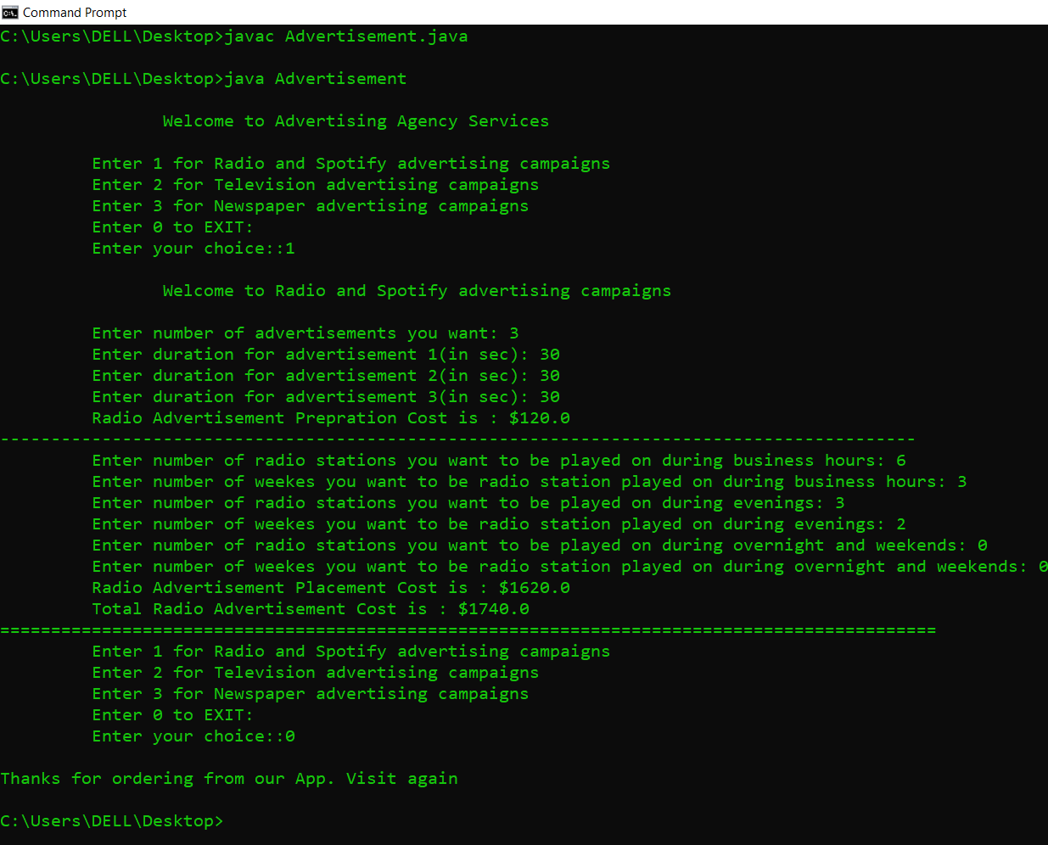

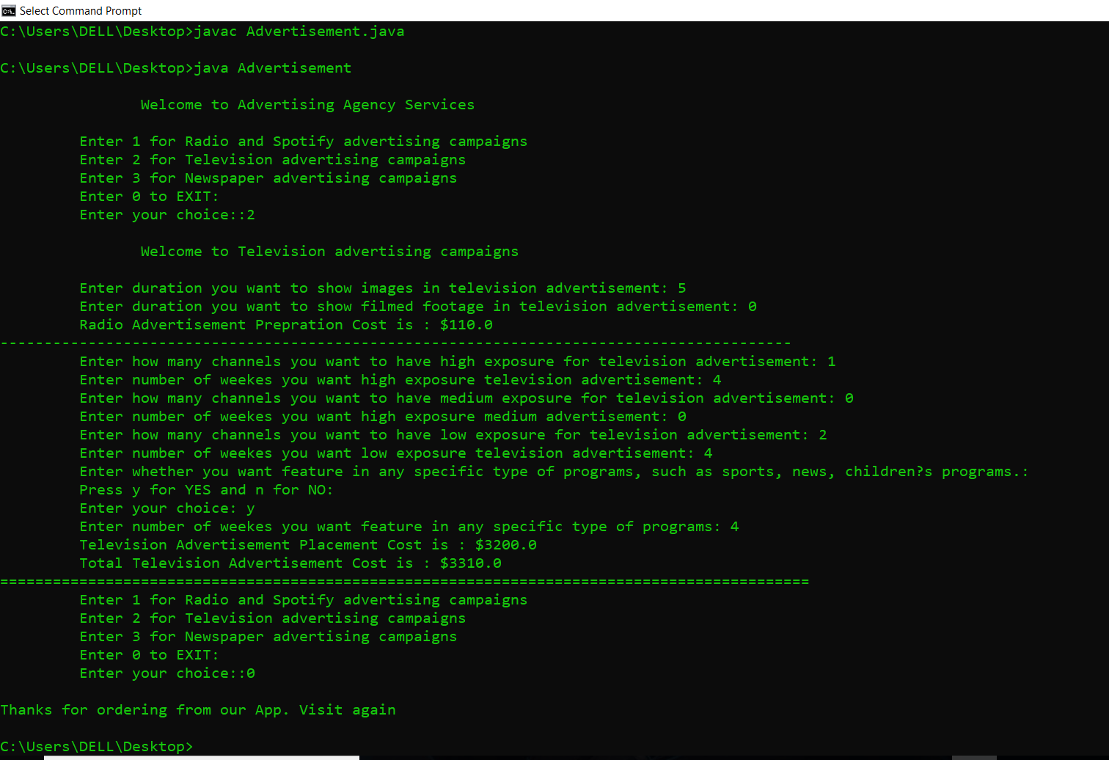

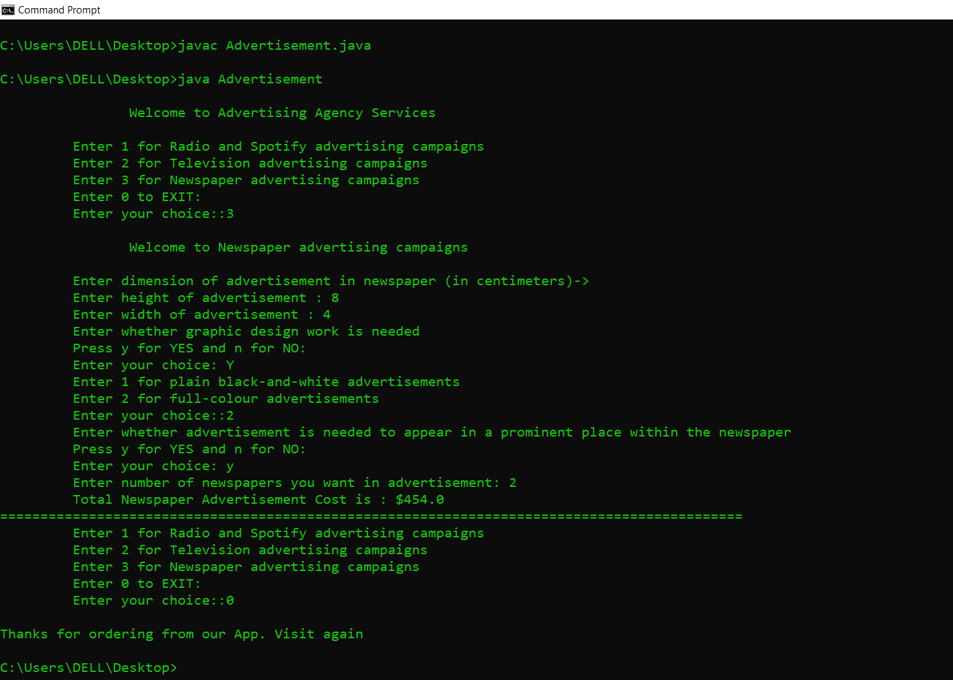

01. Command Prompt C:\Users\DELL\Desktop> javac Advertisement.java C:\Users\DELL\Desktop>java Advertisement Welcome to Advertising Agency Services Enter 1 for Radio and Spotify advertising campaigns Enter 2 for Television advertising campaigns Enter 3 for Newspaper advertising campaigns Enter O to EXIT: Enter your choice: :1 Welcome to Radio and Spotify advertising campaigns Enter number of advertisements you want: 3 Enter duration for advertisement 1(in sec): 30 Enter duration for advertisement 2(in sec): 30 Enter duration for advertisement 3(in sec): 30 Radio Advertisement Preparation Cost is : $120.0 Enter number of radio stations you want to be played on during business hours: 6 Enter number of weeks you want to be radio station played on during business hours: 3 Enter number of radio stations you want to be played on during evenings: 3 Enter number of weeks you want to be radio station played on during evenings: 2 Enter number of radio stations you want to be played on during overnight and weekends: 0 Enter number of weeks you want to be radio station played on during overnight and weekends: 0 Radio Advertisement Placement Cost is : $1620.0 Total Radio Advertisement Cost is : $1740.0 Enter 1 for Radio and Spotify advertising campaigns Enter 2 for Television advertising campaigns Enter 3 for Newspaper advertising campaigns Enter to EXIT: Enter your choice:: 0 Thanks for ordering from our App. Visit again C:\Users\DELL\Desktop>

Cs. Select Command Prompt C:\Users\DELL\Desktop>javac Advertisement.java C:\Users\DELL\Desktop>java Advertisement Welcome to Advertising Agency Services Enter 1 for Radio and Spotify advertising campaigns Enter 2 for Television advertising campaigns Enter 3 for Newspaper advertising campaigns Enter O to EXIT: Enter your choice: :2 Welcome to Television advertising campaigns Enter duration you want to show images in television advertisement: 5 Enter duration you want to show filmed footage in television advertisement: 0 Radio Advertisement Preparation Cost is : $110.0 Enter how many channels you want to have high exposure for television advertisement: 1 Enter number of weeks you want high exposure television advertisement: 4 Enter how many channels you want to have medium exposure for television advertisement: 0 Enter number of weeks you want high exposure medium advertisement: 0 Enter how many channels you want to have low exposure for television advertisement: 2 Enter number of weeks you want low exposure television advertisement: 4 Enter whether you want feature in any specific type of programs, such as sports, news, children's programs. : Press y for YES and n for NO: Enter your choice: y Enter number of weeks you want feature in any specific type of programs: 4 Television Advertisement Placement Cost is : $3200.0 Total Television Advertisement Cost is : $3310.0 Enter 1 for Radio and Spotify advertising campaigns Enter 2 for Television advertising campaigns Enter 3 for Newspaper advertising campaigns Enter O to EXIT: Enter your choice:: 0 Thanks for ordering from our App. Visit again C:\Users\DELL\Desktop>

04. Command Prompt C:\Users\DELL\Desktop> javac Advertisement.java C:\Users\DELL\Desktop> java Advertisement Welcome to Advertising Agency Services Enter 1 for Radio and Spotify advertising campaigns Enter 2 for Television advertising campaigns Enter 3 for Newspaper advertising campaigns Enter O to EXIT: Enter your choice: :3 Welcome to Newspaper advertising campaigns Enter dimension of advertisement in newspaper (in centimeters)-> Enter height of advertisement : : 8 Enter width of advertisement : 4 Enter whether graphic design work is needed Press y for YES and n for NO: Enter your choice: Y Enter 1 for plain black-and-white advertisements Enter 2 for full-colour advertisements Enter your choice::2 Enter whether advertisement is needed to appear in a prominent place within the newspaper Press y for YES and n for NO: Enter your choice: y Enter number of newspapers you want in advertisement: 2 Total Newspaper Advertisement Cost is : $454.0 Enter 1 for Radio and Spotify advertising campaigns Enter 2 for Television advertising campaigns Enter 3 for Newspaper advertising campaigns Enter O to EXIT: Enter your choice:: 0 Thanks for ordering from our App. Visit again C:\Users\DELL\Desktop>