# Export of Packages from Enterprise Architect (EA)

## Enterprise Architect 10 Desktop Version

Menu path for export:  
Project > Model Import/Export > Export Package to XMI (check Export Type 2.1) > Export

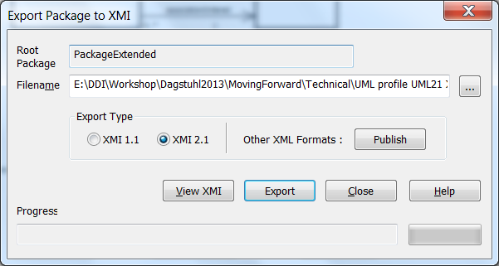

Exported file is XMI 2.1 and UML 2.1 and includes diagrams.

More control is possible by using “Publish Model”. For example, diagrams and EA extensions can be excluded.

Menu path:  
Project > Publish Model > Export

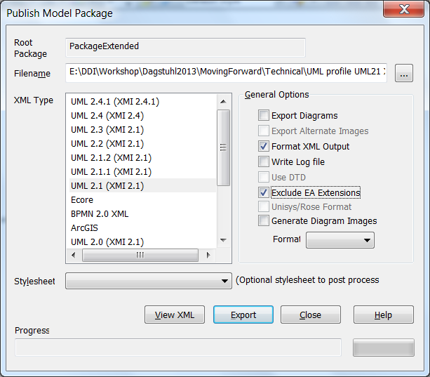

Separate Export of Packages

Packages can be separately exported from EA. The related XMI files can be managed in a repository (XML database). Identifiers are unique across XMI files (packages) of a single model; they are created by EA. Packages can be retrieved from the repository by package name. The repository must maintain an index of packaged elements, and the related type, identifier, version and package name.