**Patterns**

**1. Façade Pattern :**

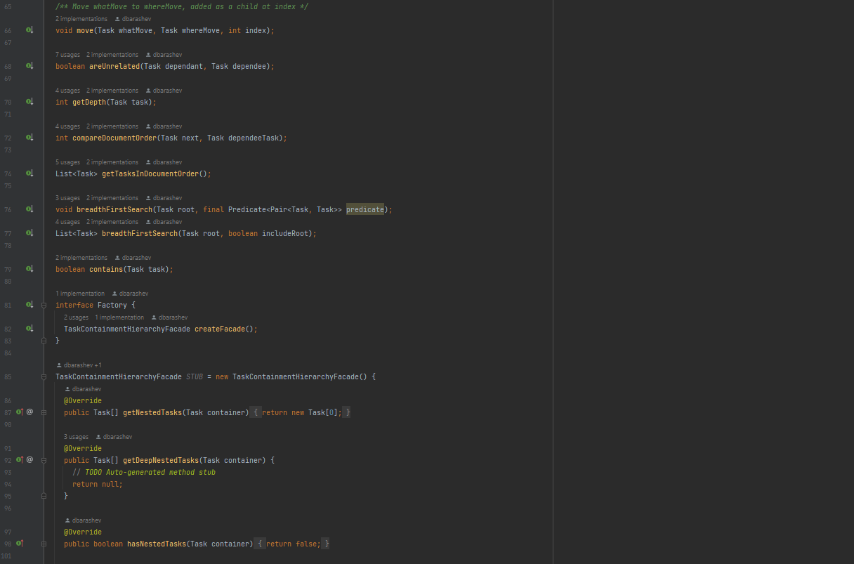

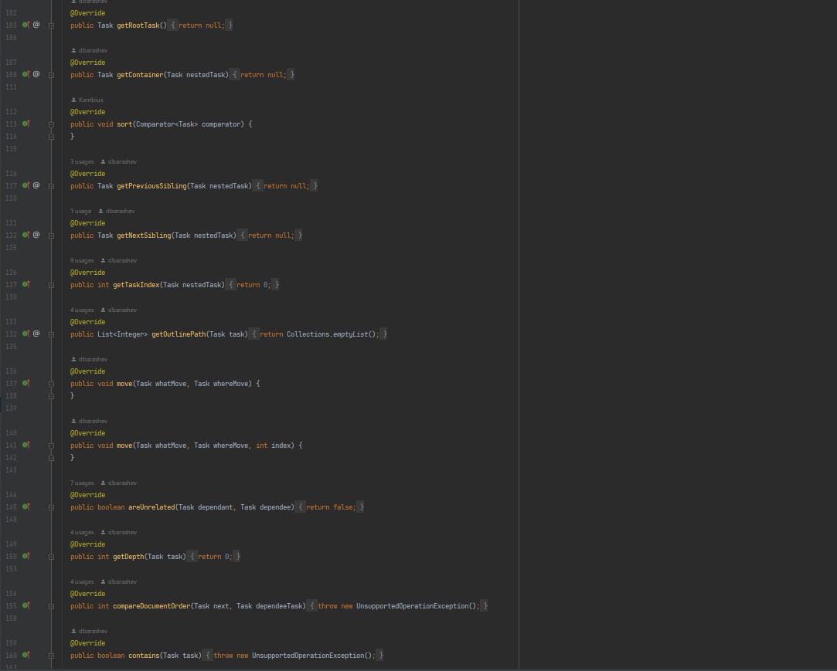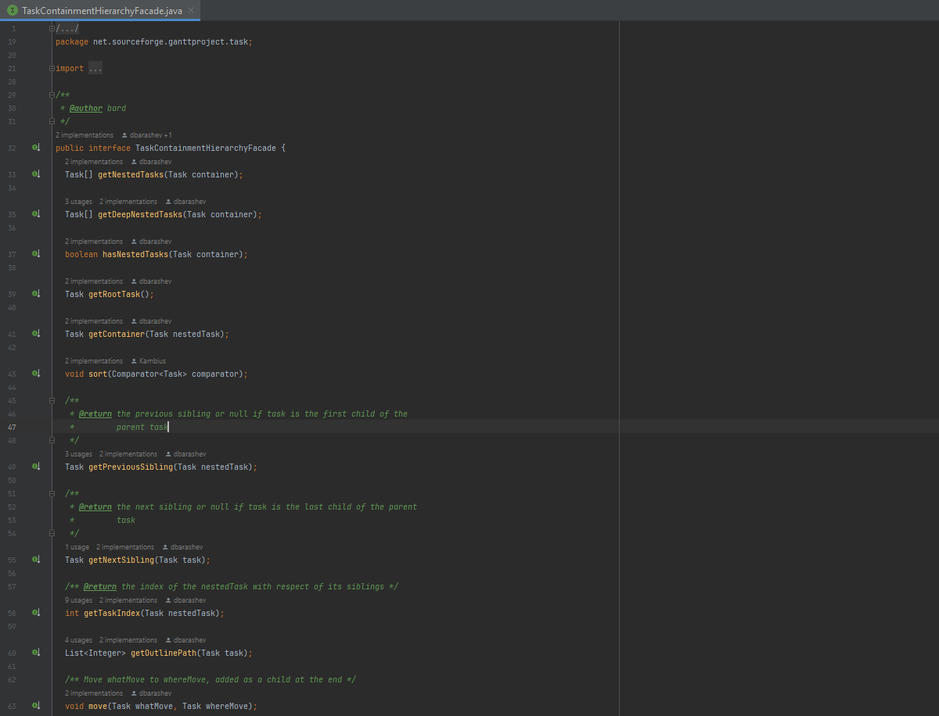

**2. Location :**

java/net/sourceforge/ganttproject/task/TaskContainmentHierarchyFacade.java

**3. Explanation :**

This interface is used for the façade pattern. It’s the first step in the construction of the façade pattern and it’s used to encapsulate many other Task classes and hide its complexity.

1. **Factory Pattern :**

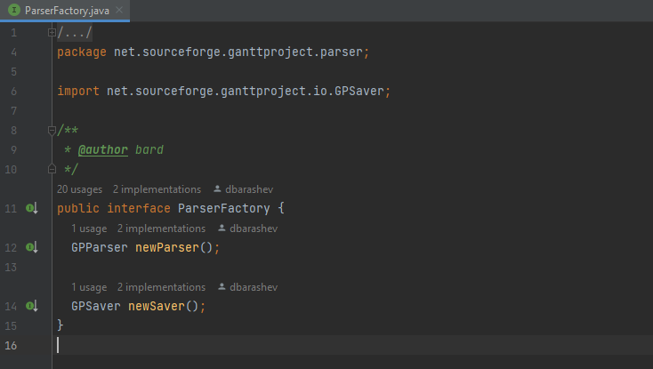

1. **Location :**

java/net/sourceforge/ganttproject/parser/ParserFactory.java

1. **Explanation :**

This interface is used to hide the creation of instances of type Parser behind it making it so we can replace the concrete parser classes with others if we need to and it has no impact on the client code.

1. **Command Pattern :**

1. **Location :**

java/net/sourceforge/ganttproject/action/edit

1. **Explanation :**

These classes were designed with the purpose to encapsulate commands as if they were objects as ways of providing the user more freedom and more functionalities while using the app.