Code Smell

1. Dupicated Code:

* 1. 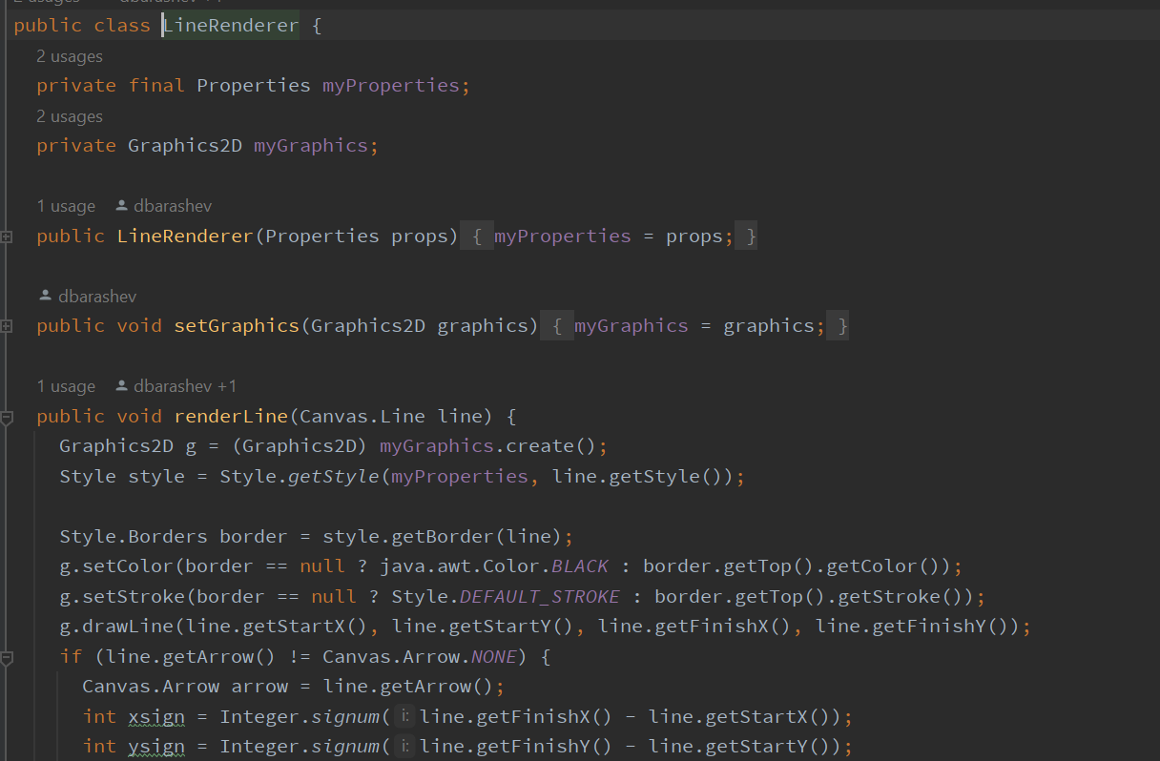
     1. biz.ganttproject.core\src\main\java\biz\ganttproject\core\chart\render\RectangleRenderer.java
     2. biz.ganttproject.core\src\main\java\biz\ganttproject\core\chart\render\PolygonRenderer.java
     3. biz.ganttproject.core\src\main\java\biz\ganttproject\core\chart\render\LineRenderer.java
     4. biz.ganttproject.core\src\main\java\biz\ganttproject\core\chart\render\SummaryTaskRenderer.java
  2. All these classes have the same variables, one method equal and one method that is different in each class but has the same name and same purpose.
  3. It’s possible to eliminate this repetition using an abstract class, AbstractRenderer. This class should have the variables myProperties and myGraphics. In terms of methods, this class implements the method setGraphics and may have an abstract method, render, that allows each class son implements this method.

1. Message chains
   1. Uma imagem com texto

      Descrição gerada automaticamente
   2. ganttproject\src\main\java\net\sourceforge\ganttproject\export\ExporterToCSV.java
   3. This method is calling in chains methods that return other objects. The method getProject returns an IGanttProject. After that is called the method getGanttOptions that is implemented in IGanttProject, this method returns a GanttOptions. Finally, the object GanttOptions calls the method getCSVOptions which returns a CSVOptions object.
   4. Way to resolve this problem the class IGanttProject may have a method that returns a CSVOptions object. After that, the class ExporterToCSV should use the method created in IGanttProject and create a new method that also returns CSVOptions. So we can use the class that we pretend to without knowing the complexity of the system.
2. Speculative generality

* 1. Uma imagem com texto

     Descrição gerada automaticamente
  2. ganttproject\src\main\java\net\sourceforge\ganttproject\PreferenceServiceImpl.java
  3. This class is not implemented.
  4. This class should be eliminated because at this moment is not necessary for this app.