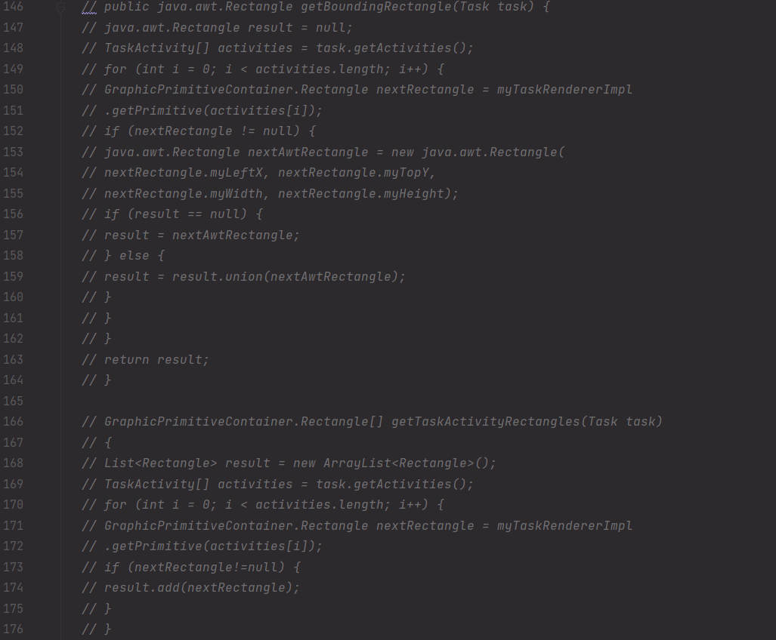Code Smells

1. Dead Code

Location: ganttproject/src/main/java/net/sourceforge/ganttproject/chart/ChartModelImpl.java

Motive: Commented code from previous versions that isn’t being run and still is occupying space.

Solution: Delete the commented code.

1. 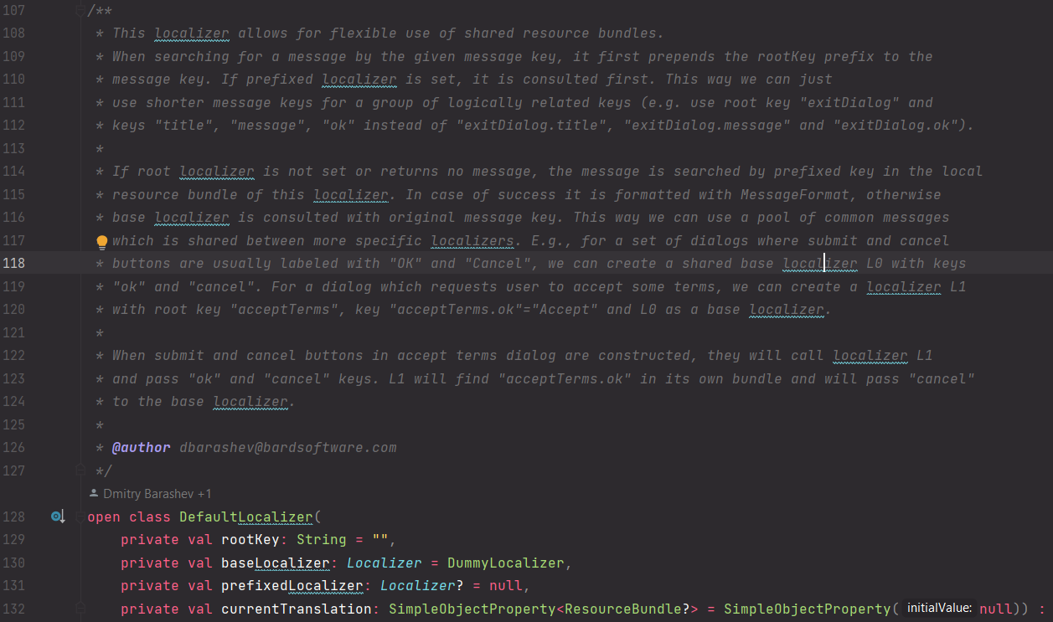Too many comments

Location: /ganttproject/src/main/java/biz.ganttproject/app/Internationalization.kt

Motive: Way too big of a comment for the size of the class.

Solution: Sum up some of the comment into a simpler and easy to read comment.

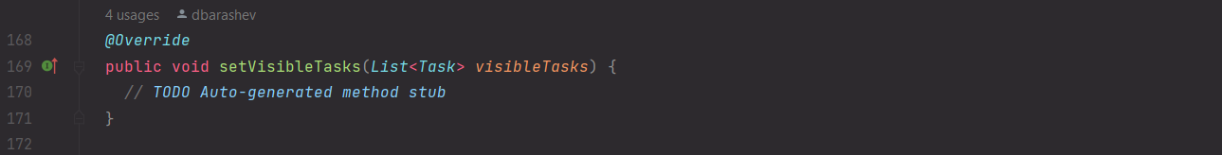

1. Speculative generality

Location: ganttproject/src/main/java/net/sourceforge/ganttproject/chart/ChartModelResource.java

Motive: An auto generated method without implementation inside it. Could lead to errors and, for now, it’s not doing anything.

Solution: Delete the method or fully implement it.