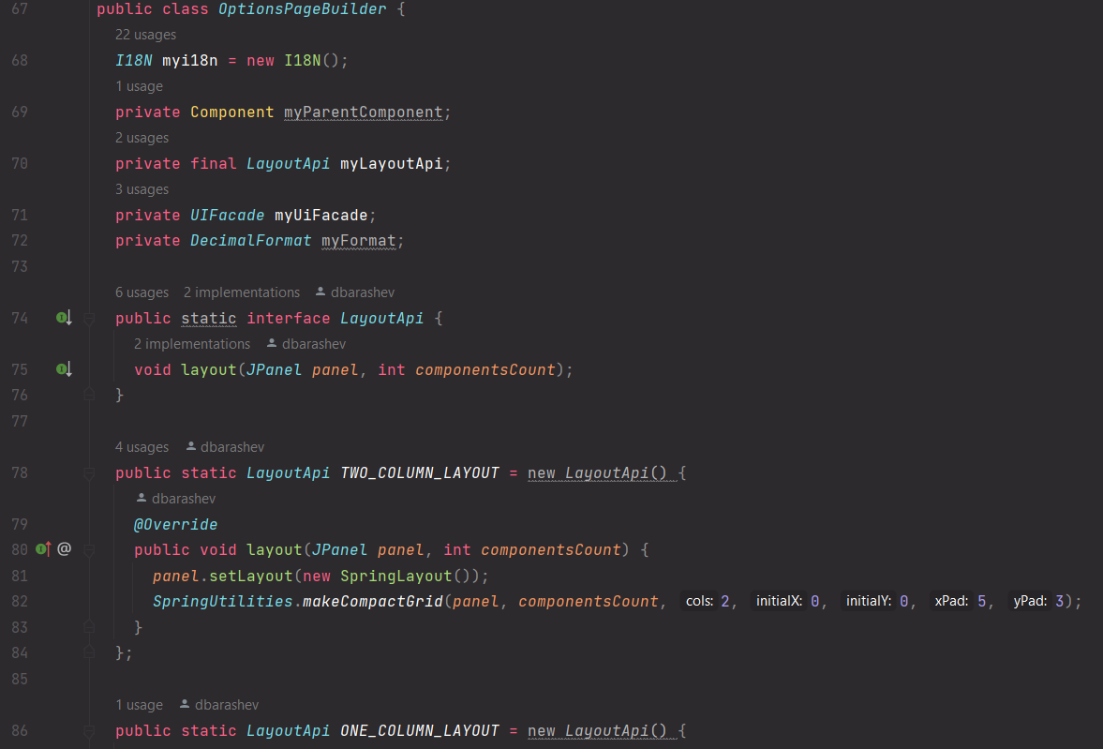Patterns

1. Builder

Location: ganttproject/src/main/java/net/sourceforge/ganttproject/gui/options/OptionsPageBuilder.java

Motive: OptionsPageBuilder is a builder class that allows the construction of complex and different objects step by step using the same construction code.

1. 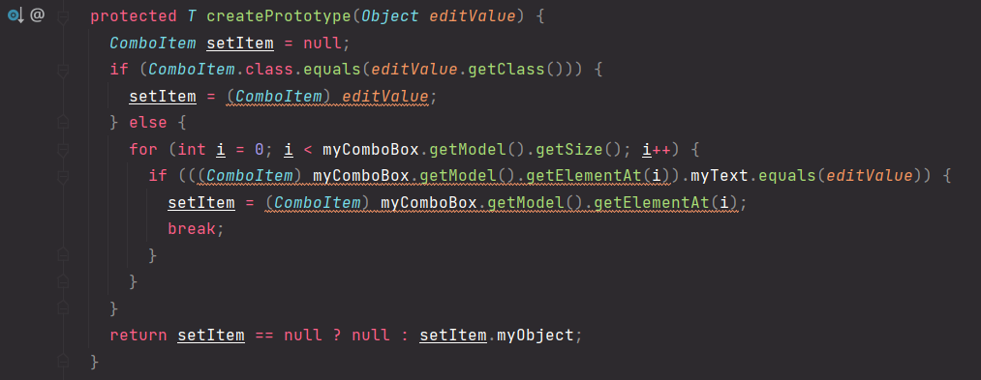Prototype

Location: ganttproject/src/main/java/net/sourceforge/ganttproject/gui/EditableList.java

Motive: This method, located in the EditableList class, allows for the creation copies existing objects without making the code dependent on their original classes.

1. 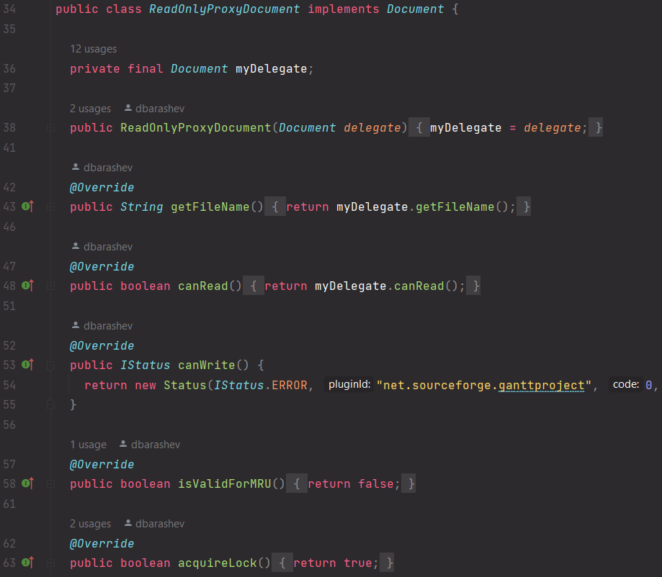Proxy

Location: ganttproject/src/main/java/net/sourceforge/ganttproject/document/ReadOnlyProxyDocument.java

Motive: ReadOnlyProxyDocument is a proxy class permits the usage of itself in order to allow other classes of the Document type to be used in codes that normally wouldn’t be accepted. For example, this proxy is used to surround a Document in the usage of openProject() method inside the recover method in the HelpMenu class.