**Code smells**

1.Dead Code

Location: java/biz/ganttproject/core/chart/grid/OffsetBuilderImpl.java

From line(95 to 97)

Rationale explanation:

The method is commented so it is probably an idea for a code that was not finished or didn’t have purpose to the code

Refactoring proposal:

Since the code is not being used in any part of the project, it should be erased to reduce code size and to make the class simpler.

Codebase snippet:

2.Long Code

Location: biz/ganttproject/core/chart/grid/OffsetBuilder.java

From line(49 to 102)

Rationale explanation:

The constructor is not used to simplify the class giving it methods for every attribute that is saved in the class, it gives the code this unnecessary 53 lines.

Refactoring proposal:

Using the constructor as it should be we can initialize every attribute with only 12 lines saving us a total of 41 lines of code.

Codebase snippet

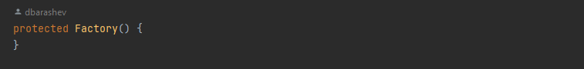

3. Data Clumps

Location: java/biz/ganttproject/core/chart/grid/OffsetBuilderImpl.java

4 methods

Rationale explanation:

There are a lot of parameters that appear numerous times in the methods.

Refactoring proposal:

Some of the parameters should be firstly stored in the class with the right conditions to be used and modified if needed like initialEnd.

Codebase snippet:

