Tasks Use Case

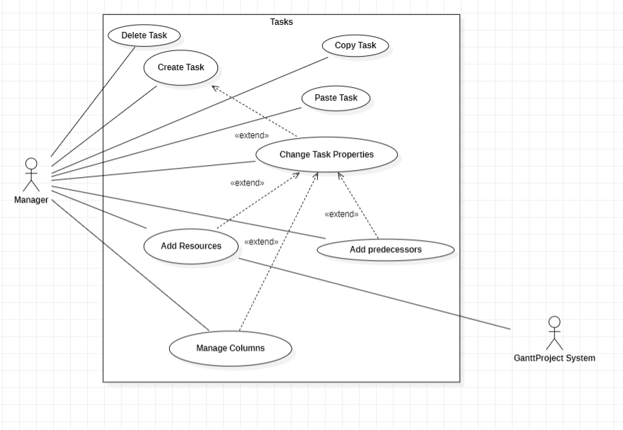

Delete Task

Pre-condition: At least one task exists.

The use case starts when the manager selects the option to delete a task. The system will delete a Task that was created previously.

Pos-condition: None

Primary Actor:

* Manager.

Secondary Actor:

* None.

Copy Task

Pre-condition: At least one task exists.

The use case starts when the manager selects the option to copy a task. The system will copy a Task that was created previously.

Pos-condition:None

Primary Actor:

* Manager.

Secondary Actor:

* None.

Paste Task

Pre-condition: Copy Task was performed.

The use case starts when the manager selects the option to paste a task. The system will paste a Task that was created previously. The system after this operation has two equal tasks.

Pos-condition: None

Primary Actor:

* Manager.

Secondary Actor:

* None.

Create Task

Pre-condition: None

The use case starts when the manager selects the option to create a task. The system will create a default Task. The task is a job that should be done in a period by some workers.

Pos-condition:None

Primary Actor:

* Manager.

Secondary Actor:

* None.

Change Task Properties

Pre-condition: At least one task exists.

The use case starts when the manager selects the option properties task. The system will show some properties that can be changed (name, dates, priority, progress, color, fill and add a website). After the manager set some properties, the system will show a task that is different from other tasks.

Pos-condition: None

Primary Actor:

* Manager.

Secondary Actor:

* None.

Add Resource

Pre-condition: The resource needs exist in the system and at least one task.

The use case starts when the manager selects additional resources for a task. The GanttProject System is responsible for resources. The system will allow the manager to specify who should do the task.

Pos-condition: None

Primary Actor:

* Manager.

Secondary Actor:

* GanttProject System.

Add Predecessors

Pre-condition: Exist at least two tasks.

The use case starts when the manager selects Predecessors in task properties. The system will allow the manager to select another task. The task selected initially, that will change his properties can only begin when the other task chosen finishes.

Pos-condition: None

Primary Actor:

* Manager.

Secondary Actor:

* None.

Manage Columns

Pre-condition: At least one task exists

The use case starts when the manager selects Manage Columns in task properties The system allows the manager and some properties specific to the task.

Pos-condition: None

Primary Actor:

* Manager.

Secondary Actor:

* None.