Use Case Diagram

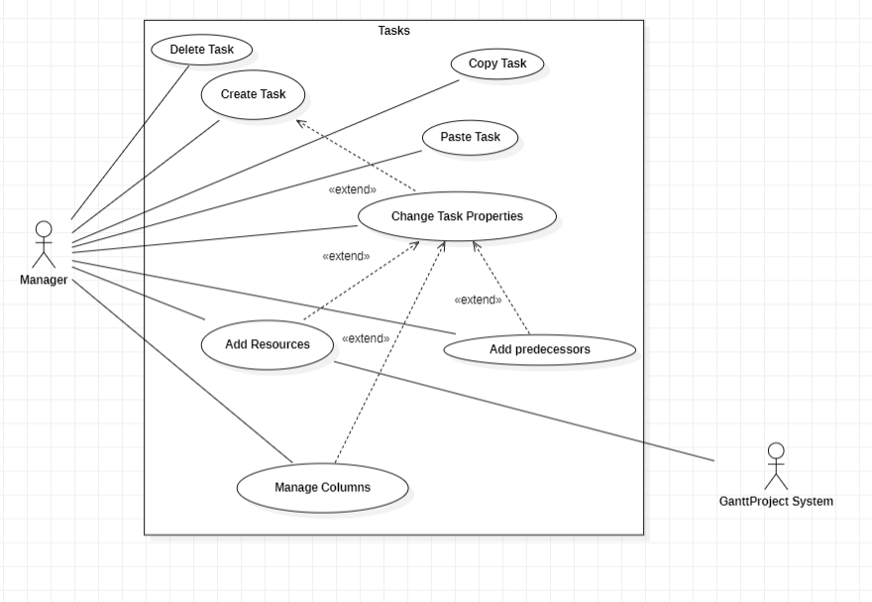

Delete Task

Pre-condition: Exist a task.

The use case start when the manager the option delete task.This functionality allows the Manager delete a Task that was created previously.

Primay Actor:

-Manager;

Secondary Actor:

-Not exists.

Copy Task

Pre-condition: Exist a task.

This functionality allows the Manager to copy a Task with all his properties.

Primay Actor:

-Manager;

Secondary Actor:

-Not exists.

Paste Task

Pre-condition: Copy Task.

This functionality allows the manager to paste a task that was copied before. Then the manager will have two equal tasks.

Primay Actor:

-Manager;

Secondary Actor:

-Not exists.

Create Task

The manager can create Tasks. The task is a job that should be done in a period by some workers.

Primay Actor:

-Manager;

Secondary Actor:

-Not exists.

Change Task Properties

Pre-condition: Exist a task.

When a manager changes the task properties, he can change name, dates, priority, progress, color, fill and add a website. These changes allow the manager to create different kinds of tasks.

Primay Actor:

-Manager;

Secondary Actor:

-Not exists.

Add Resource

Pre-condition: The resource needs exist in the system.

Add resource allow the manager specify who should do the task.

Primay Actor:

-Manager;

Secondary Actor:

-GanttProject System.

Add Predecessors

Pre-condition: Exist at least two tasks.

When the manager adds a Predecessor to a task. The task selected just can start after the task selected as the Predecessor finish.

Primay Actor:

-Manager;

Secondary Actor:

-Not exists.

Manage Columns

The manager can add new property specifics to the tasks.

Primay Actor:

-Manager;

Secondary Actor:

-Not exists.