TEAM 1 ,6
Station 1: Who We Are (The Mirror & The Map)IDENTITIES
- Activity: "Identity Collage & Character Analysis."
- Task:
- Look at a series of diverse portraits .
- Read the short 1st-person "micro-stories.
- Identify what makes each person unique (beliefs, values, culture).
- Then answer the question.
Inquiry Question: What makes a "self"? Is it what we look like, or what we believe?
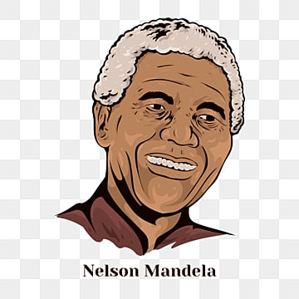


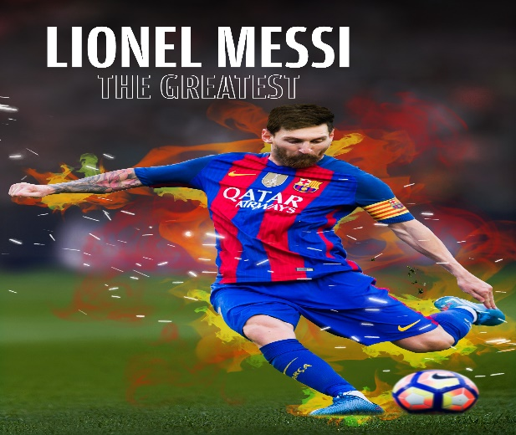
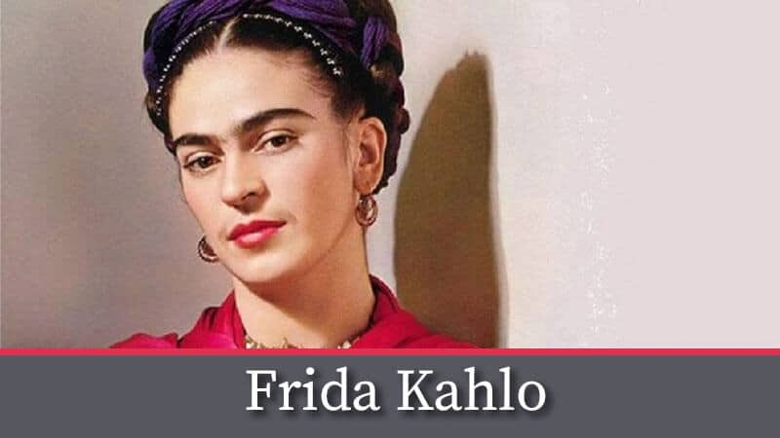

Malala Yousafzai: Identity through Belief
Malala’s identity is rooted in her courage and her belief that everyone has a right to learn.

The Girl with the Magic Pen
Malala grew up in the beautiful Swat Valley in Pakistan. Her father was a teacher who believed girls should have the same dreams as boys.
- The Struggle: When she was only 10, a group called the Taliban took control of her home and said girls could no longer go to school.
- The Secret Identity: At age 11, she started writing a secret blog for the BBC under the name "Gul Makai." She wrote about her fears and her love for books.
- A Global Hero: After surviving an attack for speaking out, she moved to the UK. At age 17, she became the youngest person ever to win the Nobel Peace Prize.
- Identity Lesson: She calls herself a "daughter, a sister, and a student." She shows that your identity can be a shield to protect others' rights.
- She is an activist from Pakistan.
- Malala refused to let others define what a girl should or shouldn't do. Even when it was dangerous, she spoke up for education.

Nelson Mandela: Identity through Resilience
Nelson Mandela’s identity changed from a prisoner to a president, but his heart stayed the same.
- Nelson Mandela: The "Madiba" Spirit
Mandela was born in a small village in South Africa. His nickname was "Madiba," a title of respect from his tribe.
- The Fight for Fairness: He spent his life fighting Apartheid, a system that kept people apart based on the color of their skin.
- The Long Wait: He was put in prison for 27 years because he wanted equality. Even in a small cell, he never let his spirit break. He spent his time studying and even gardening to keep his mind strong.
- The Rainbow Nation: When he was finally freed and became President, he didn't seek revenge. He invited everyone—no matter their skin color—to help build a "Rainbow Nation."
- Identity Lesson: He shows us that forgiveness can be a part of who you are, even when things are unfair.

- A leader who fought against unfair treatment (Apartheid) in South Africa.
- Mandela showed that your identity isn't fixed by how people treat you. He chose to be a person of forgiveness rather than anger.

Frida Kahlo: Identity through Heritage & Art
Frida used her physical pain and her Mexican culture to paint a picture of her true self.

Frida Kahlo: Painting the "Two Fridas"
Frida’s life was full of "colors and crashes." She lived in a bright blue house called La Casa Azul.
- Overcoming Pain: As a child, she had polio, and later, a bus accident left her in a lot of physical pain. Because she had to stay in bed for a long time, her parents put a mirror on her ceiling.
- The Mirror Art: She began painting self-portraits (portraits of herself) because she said, "I am the person I know best."
- Identity through Clothes: Frida was very proud of her Mexican heritage. She wore long, colorful Tehuana dresses and braided flowers into her hair to show her culture to the world.
- Identity Lesson: She shows us that our "scars" and our "roots" (where we come from) are beautiful parts of our identity.
- A world-famous artist known for her self-portraits.
- Frida often painted herself wearing traditional Mexican clothes and surrounded by nature. She didn't hide her "imperfections" or her sadness.

. Lionel Messi: Identity through Passion & Talent
Messi’s identity is tied to his incredible skill, but also his quiet, hardworking nature.

Lionel Messi: The Small Giant
Messi was born in Rosario, Argentina. He started playing football at age 5, coached by his father.
- The Big Hurdle: When he was 11, doctors found he had a growth hormone deficiency, which meant he wouldn't grow as tall as other kids. His family couldn't afford the medicine he needed.
- The Big Move: A team in Spain, FC Barcelona, saw how talented he was and offered to pay for his medicine if he moved there. At just 13, he left his home to follow his dream.
- Staying Connected: Even though he lived in Europe for many years, he never lost his Argentine accent and always went back home to help his community. He is a UNICEF Ambassador, helping kids get an education.
- Identity Lesson: He shows that perseverance (not giving up) helps you grow into the person you want to be, no matter how "small" you start.
- One of the greatest football players in history, from Argentina.
- As a child, Messi was told he was too small to play professionally. He had to overcome health challenges to succeed.

