Station 3: How We Express Ourselves (The Gallery)EXPERIENCES
- Activity: "Medium Match-Up."
- Task:
- Read a poem, look at the painting, listen to the protest song (lyrics), and check comic strip.
- Match "Feelings Cards" to each piece discuss why the author chose that specific way to tell their story.
- Answer the question.
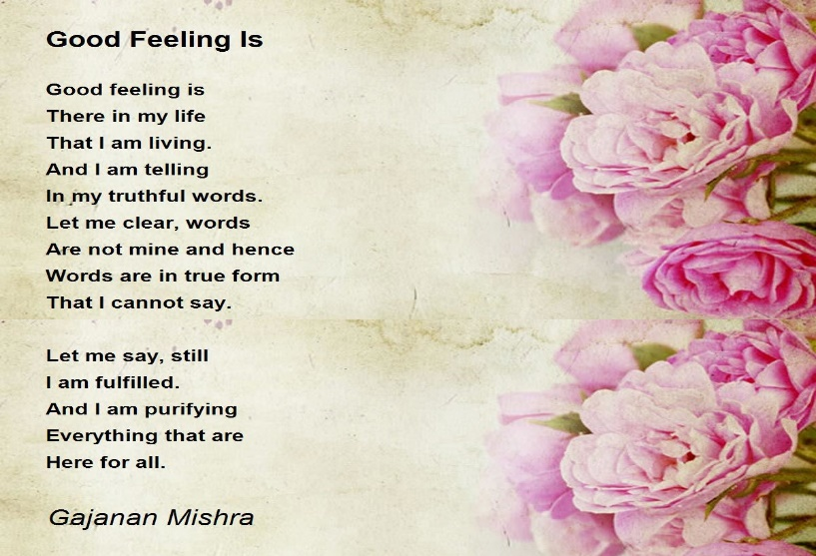
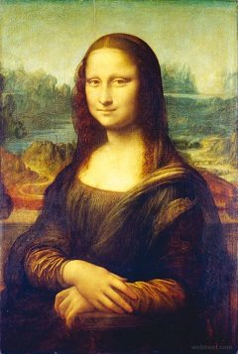
- Inquiry Question: When words aren't enough, how else can we "speak" to the world?

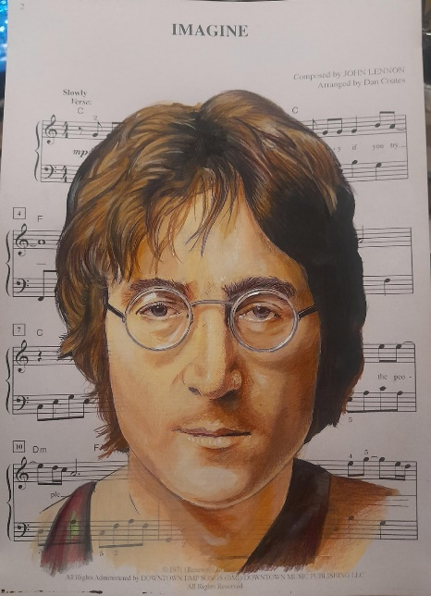
Song: Imagine
https://youtube.com/shorts/9ajSFF0X6QQ?si=YZxSl92kjRvbKIjb
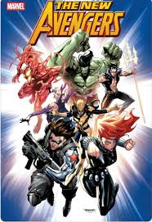

Vulnerable | Curious | Challenged | Peaceful
Defiant | Empowered | Relaxed | Positive
Hopeful | Resilient | Delighted | Examined
Proud | Determined | Overwhelmed | Anxious

