Station 4: How the World Works (The Blueprints) SHARING THE PLANET
- Activity: "Cause and Effect Lab."
- Task:
- Look at the picture 1 and / or picture 3 natural phenomena (like a storm).
- Talk about how what is expressed as well in picture 1 as in picture 2 change i affect human life.
- Answer the question.
- Inquiry Question: What are the invisible "rules" or patterns that govern our world?
Picture 1
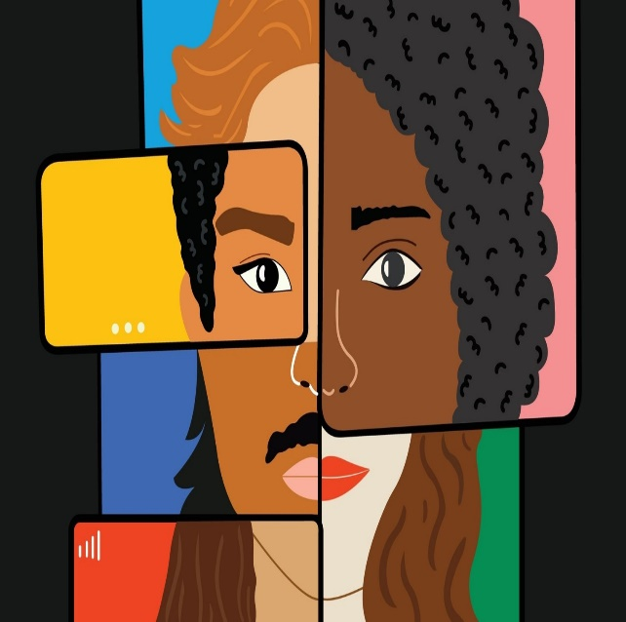

Picture 2
