Station 5: How We Organize Ourselves (The Mini-City)SOCIAL ORGANIZATION
- Activity: "The Community Grid."
- Task:
- You were given a list of roles (Doctor, Baker, Mayor, Garbage Collector) and a "Crisis Card" (e.g., "The bridge is broken!").
- Arrange the roles in a web to show how they collaborate to solve the problem.
- Then answer the question.
- Inquiry Question: Why do humans build systems, and what happens when those systems fail?
- Activity: "The Community Grid."
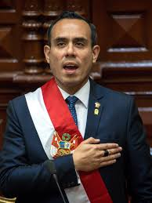
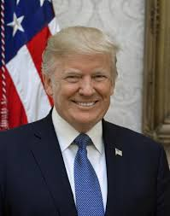



🌀 Crisis Card 1: Severe Storm Hits the City
(Informational basis inspired by environmental reports from National Geographic)
A powerful storm floods streets, damages homes, and contaminates water supplies. Electricity is limited.

Guiding Questions:
- Who acts first?
- Who supports whom?
- What happens if one role does not do their job?

🦠 Crisis Card 2: Sudden Disease Outbreak
(Concept aligned with global health discussions led by World Health Organization)
A fast-spreading illness affects many families. Schools close temporarily. Hospitals are overwhelmed.

Guiding Questions:
- How does each role prevent further spread?
- Who communicates with the population?
- How does food supply continue?

♻️ Crisis Card 3: Garbage Collection Strike
Trash is not collected for two weeks. Streets become polluted. Rats and insects increase.

Guiding Questions:
- How does this affect public health?
- Who negotiates solutions?
- What are the environmental consequences?
_________________________________________

🔥 Crisis Card 4: Extreme Heat Wave
High temperatures cause dehydration, food spoilage, and energy shortages.
(Scientific information can connect to climate research from NASA.)

Guiding Questions:
- Who protects vulnerable citizens?
- How does food supply change?
- What long-term solutions are needed?

🌾 Crisis Card 5: Food Shortage
Due to drought, local crops fail. Bread production decreases. Prices rise.

Guiding Questions:
- How does this affect each profession?
- Who creates national policies?
- How do local and national leaders cooperate?

