 PF/JC/HG/AR/SV – II T - 2025
ENGLISH B - HL

Student’s name: ……………………………..……. Date: …….. Grade: 4TH Section: ……….

Learning Competence :
- Read various types of texts in English as a foreign language.
Receptive skills—reading/listening

THE BLOG
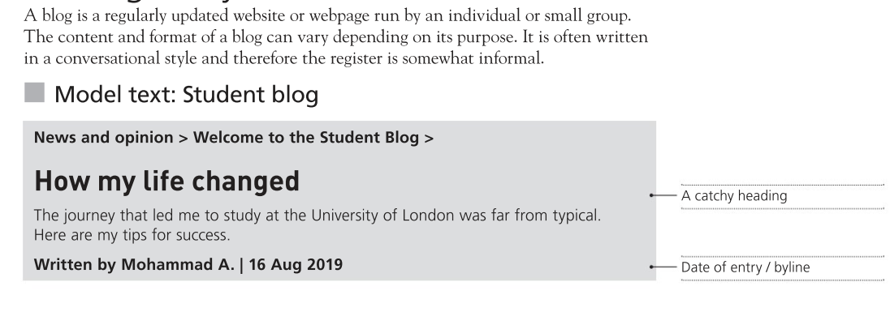
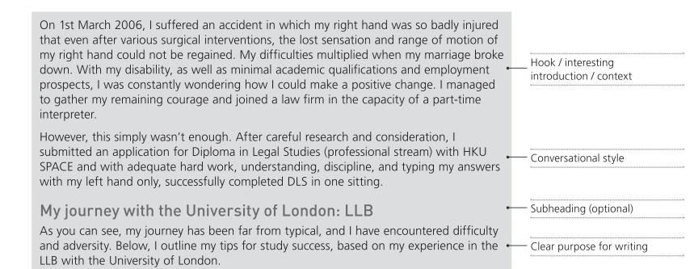

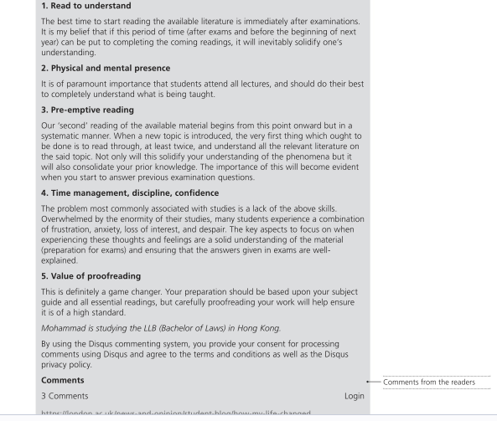
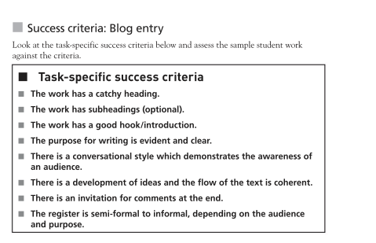

Retrieved on 15/05/2025 from English B Grammar and skill workbook Hium Yung Owen

