

(HG/PF/JC/SV) – II T - 2024
ENGLISH B - HL

Student’s name: ……………………………..……. Date: …….. Grade: 4th Section: _____

Competence : : 3. Identify, organize and present ideas on a range of topics.
Objective : 2.Understand and use language appropriate to a range of interpersonal and /or intercultural contexts and audiences. /4. Understand, analyse and reflect m upon a range of written, audio, visual and audio-visual texts.

AN INTERVIEW
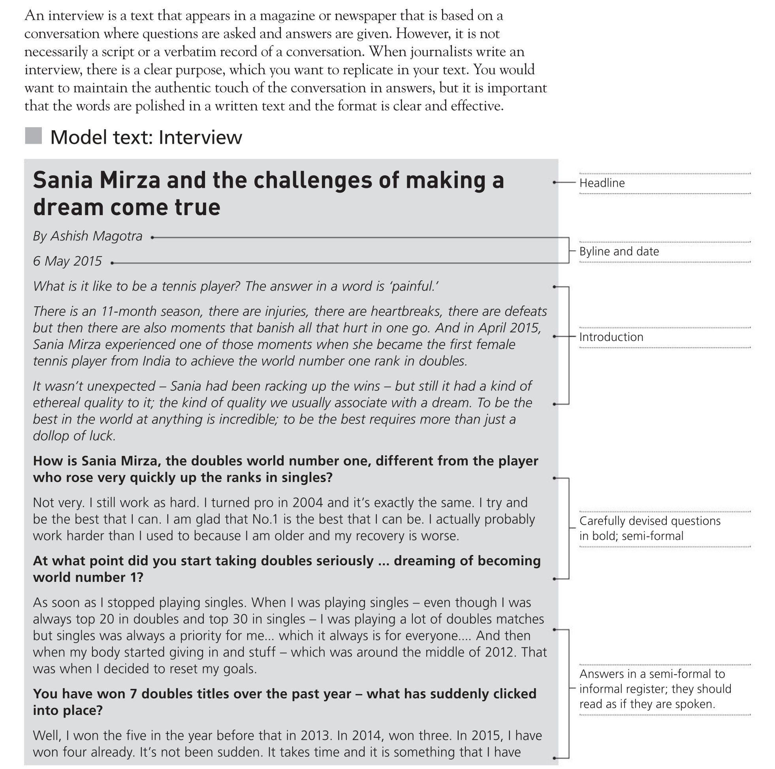

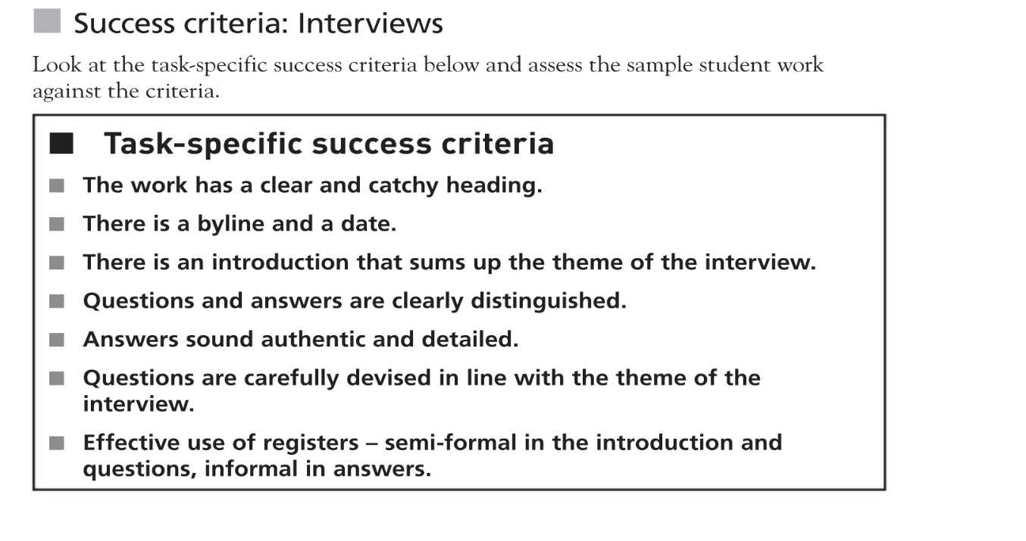
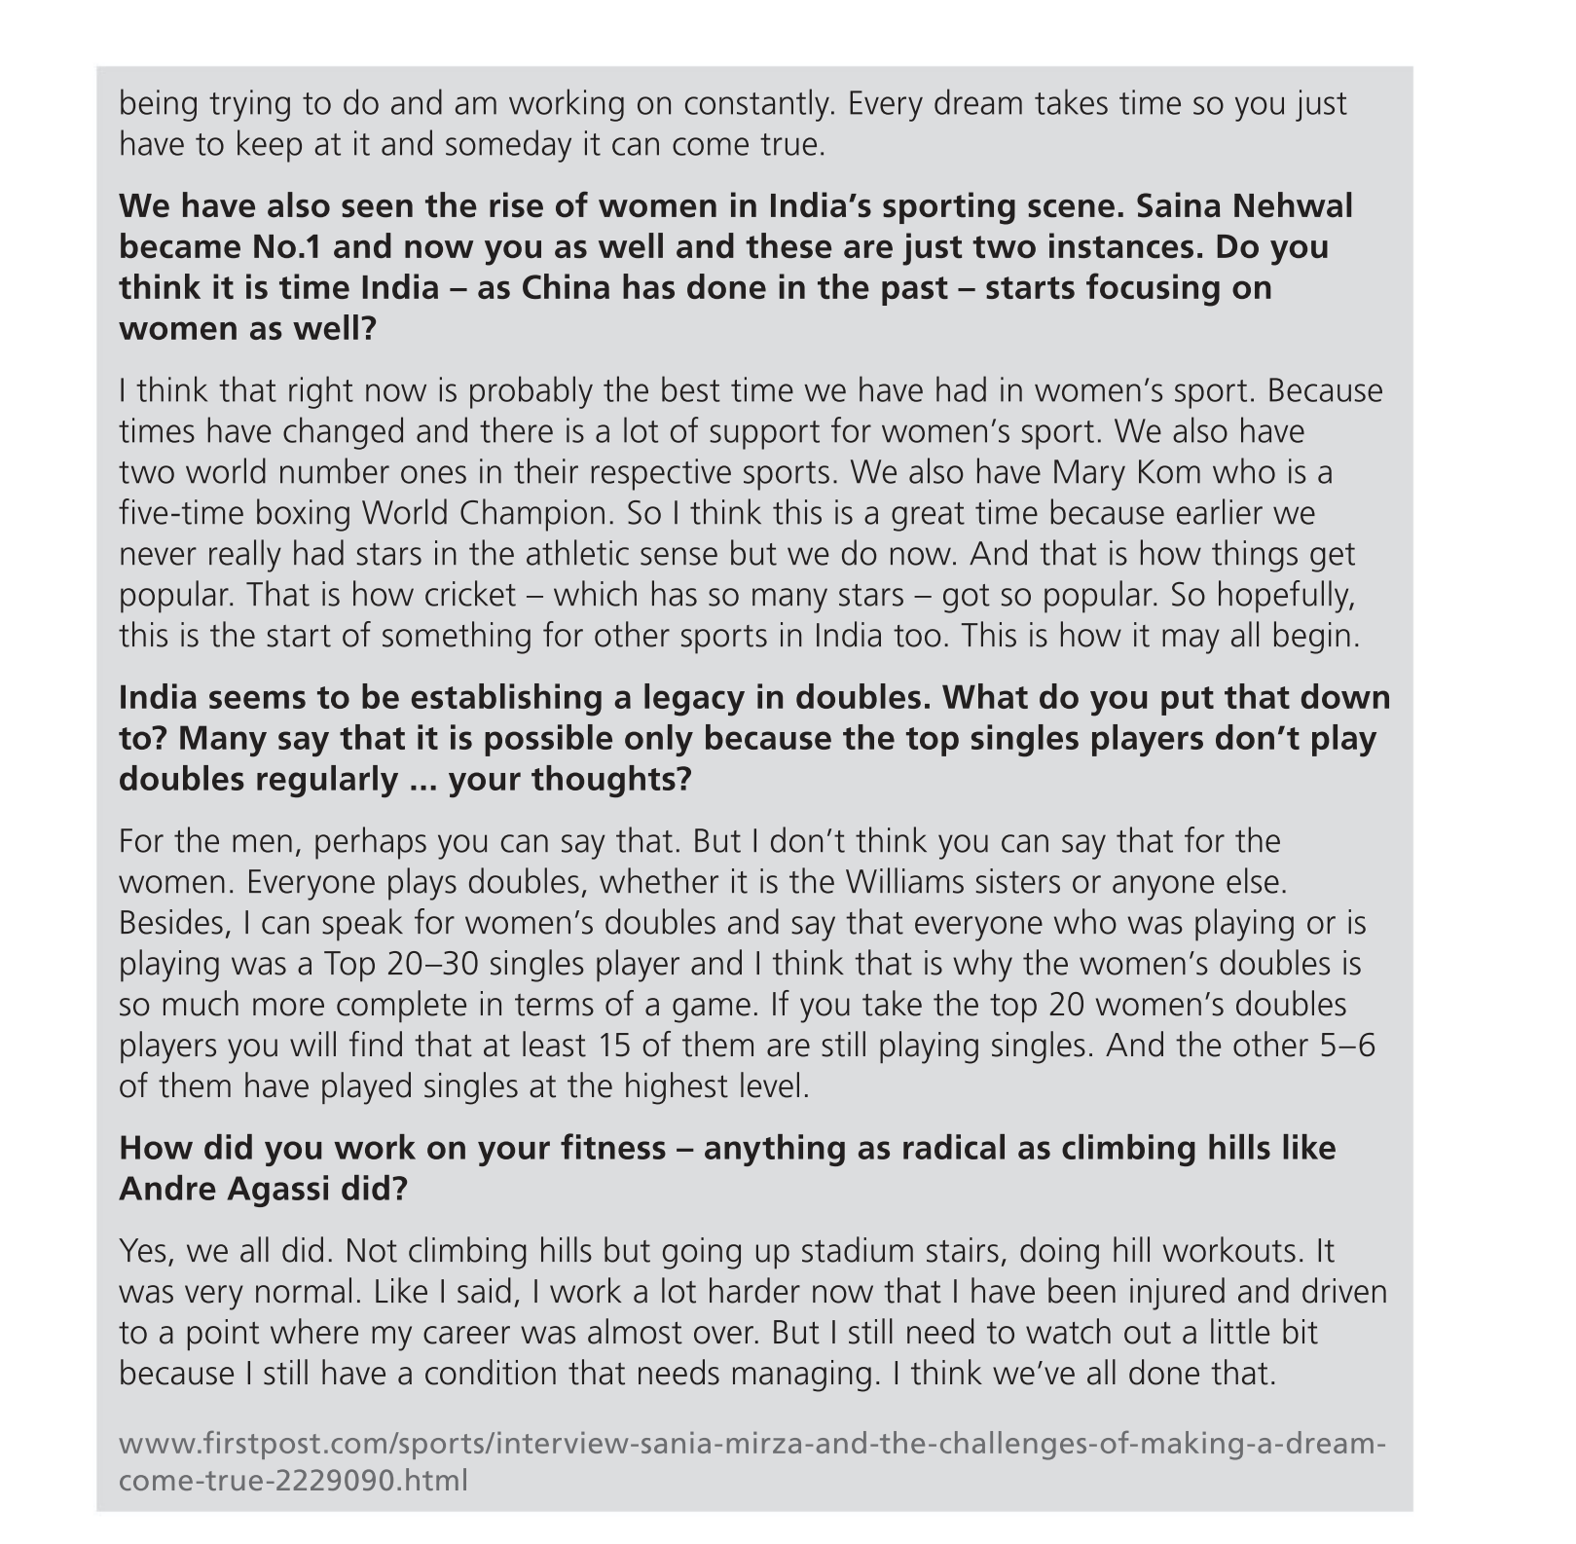

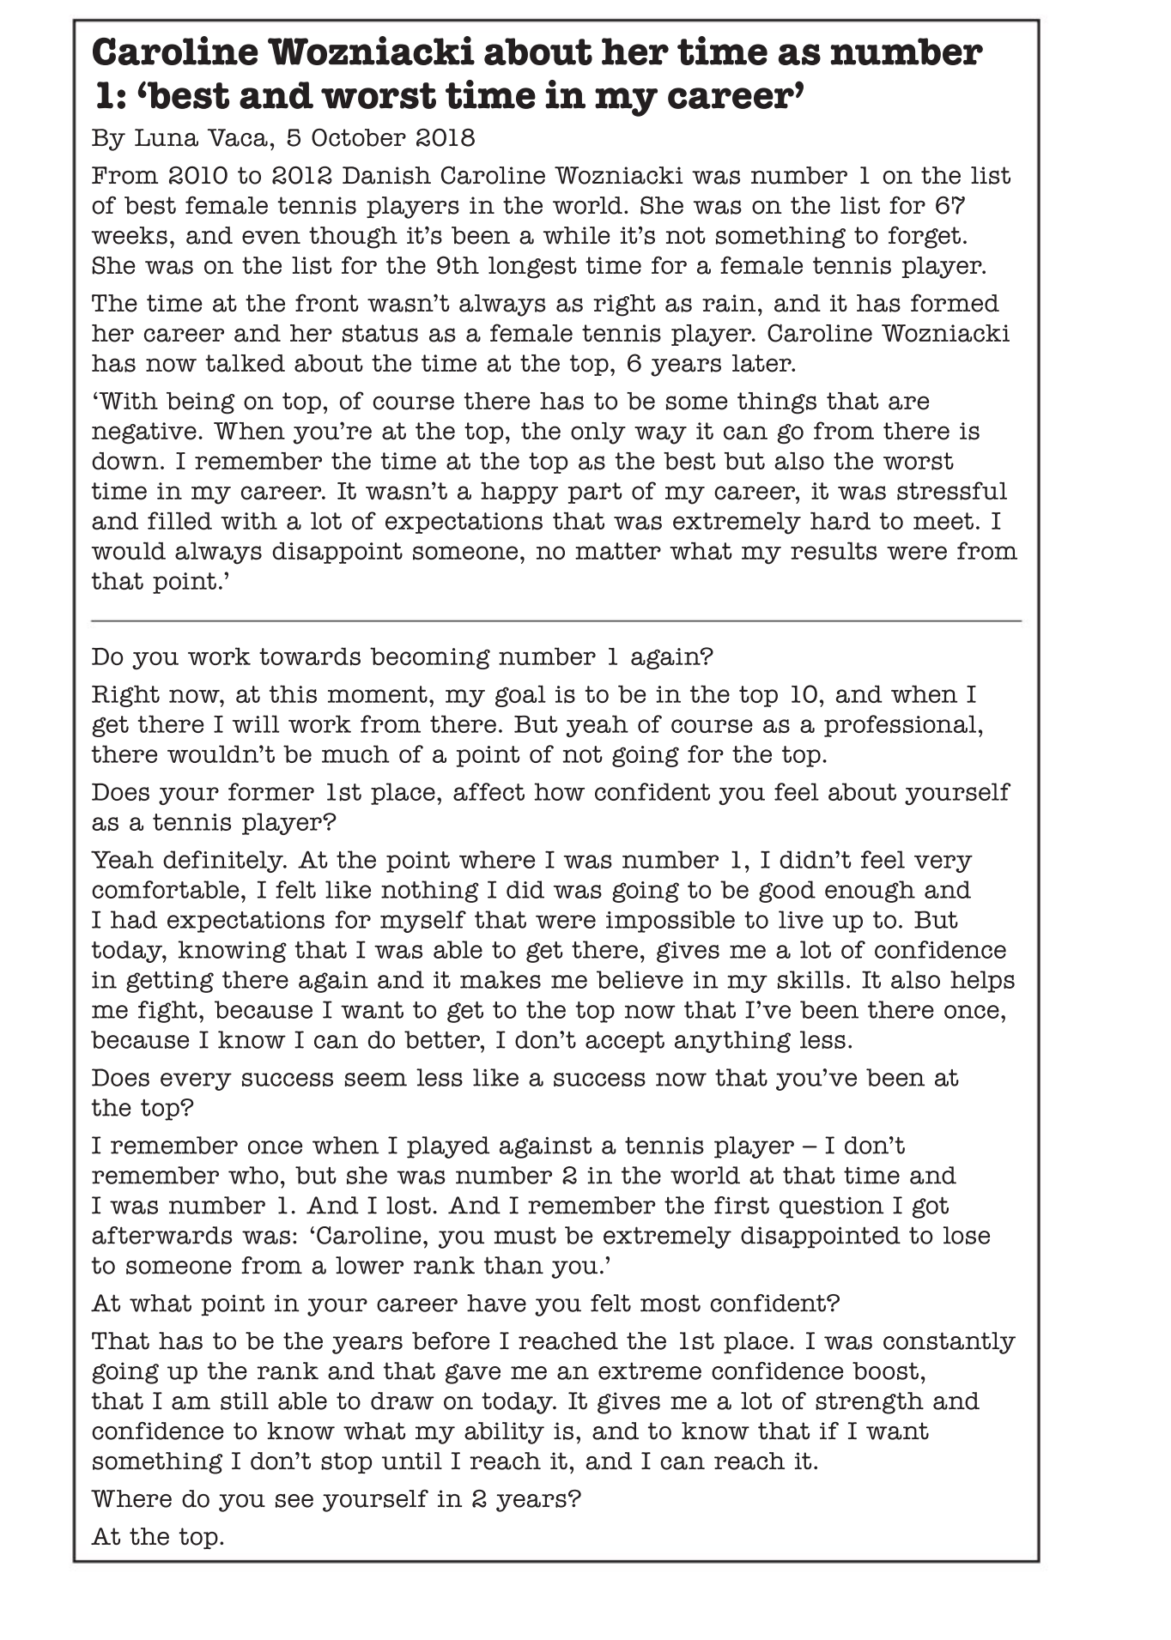
Using all the information given , get in pairs and write an interview. Follow the instructions presented in the b. pages 120,121.

