Sales Analytics Research and Design
Development of a Sales Analytics System Based on Data and Speech-to-Text Technology
Checkpoint 24 October 2026 | Revised 23 October 2026

1 Project proposal

Team member | Group | Proposed responsibility
Rashiduly Bekzat | SE-2418 | Backend and data integration
Taubasar Dameli Almabekkyzy | SE-2402 | Frontend and API integration
Amangeldiev Diasbek Yernarovich | SE-2402 | Speech processing and evaluation
Supervisor Orynbek Alibek Sarsenbekuly. English name spellings are working transliterations from the topic application; responsibilities are proposed for team agreement.
Sales records show what happened to a deal, but the reasons behind a decision often remain in a call recording. We propose a system that links recordings to sales records, creates timestamped transcripts and helps users review objections and next actions alongside sales metrics.
Aim Develop and evaluate a prototype for Russian, Kazakh and mixed sales calls in which every extracted observation can be checked against its source.
Salespeople will review their own calls; managers will review their assigned team. Analysts will use authorized reports. Administrators will manage access and retention without automatically receiving access to call content.

Objectives and scope
We will confirm user needs and data access, define imports and sales metrics, build an asynchronous speech pipeline, add evidence and correction tools, and evaluate the result against simple baselines.
The MVP covers CSV sales imports, explicit call-to-deal links, authorized prerecorded audio, transcript review, objections and next actions, filtered dashboards and export. Speaker diarization is optional and its role labels require confirmation. Live assistance, autonomous CRM changes and employee ranking are outside the initial scope.
The expected outcome is a working research prototype with documented interfaces and reproducible evaluation. The checkpoint materials include research, public-data profiling, a synthetic UX prototype and Bekzat’s backend design amendment. Local user evidence, recording access and supervisor feedback remain pending. A complete application is not required on 24 October.

2 Evidence of relevance
The literature and the four compared products establish that speech can be combined with sales workflows. They do not yet show which features are useful for our intended users. We still need local evidence before treating the initial requirements as confirmed.

What the public data shows
We profiled the UCI Bank Marketing file bank-additional-full.csv. It contains 41,188 records, 20 input variables and 4,640 positive term-deposit subscription outcomes: 11.27% positive. Always predicting the negative class would give 88.73% accuracy. This simple calculation explains why a future outcome model should not be judged on accuracy alone (Moro et al., 2014).
The data also contains explicit unknown categories, including 8,597 values for default and 1,731 for education. These need deliberate treatment during import and modelling. Call duration is known after a call, so it must be excluded from a pre-call predictor.
This older Portuguese banking dataset has no audio, transcripts or usable transcript join key. It supports the data-design discussion but cannot test Russian/Kazakh transcription or the added value of call content. Appendix C gives the profile, hashes and reproduction instructions.

Evidence still to collect

Question | Evidence needed | Requirement affected
Which review task is slow or unreliable? | 3–5 discussions with a manager salesperson analyst and data owner; observed task or attributed estimate | Review workflow and usability baseline
Can calls be linked to deals? | Permitted CSV/manifest inspection and explicit stable identifiers | FR02–FR04
Which languages and conditions matter? | Representative authorized examples including code switching noise and product names | FR06 and NFR09
Which measure supports a real decision? | An agreed numerator denominator period and authoritative outcome field | FR10 and FR14
Public-data analysis is complete; local discussions and a client agreement are not recorded. We will confirm with the supervisor whether this evidence route is sufficient, record any remaining gap, and map confirmed findings to requirements. Appendix F contains the collection forms.

Questions the evaluation will answer
How accurately does the system transcribe each language? Can it identify useful objections and next actions with correct evidence? Does the review workflow help users complete a defined task? An outcome-prediction extension will be considered only if sufficient linked sales data becomes available.

3 Literature review
The review covers 15 scientific publications, including 13 from 2022–2026 and two 2021 foundations. Good et al. (2026) and Vieira et al. (2024) were reviewed through abstracts/previews only. The table summarizes the design implications; Appendix A retains full analysis and claim locations. L01–L15 are analysis IDs, not citation numbers.
ID | Study | Finding and design implication
L01 | Radford et al. (2023)  Whisper: weakly supervised speech recognition | Broad multilingual transfer; local accuracy is unverified. Measure each language and business entity.
L02 | Bain et al. (2023)  WhisperX: accurate transcription timing | Timing/alignment depends on language models. Validate source timestamps on local calls.
L03 | Bredin (2023)  pyannote.audio 2.1: speaker diarization | Diarization varies with acoustic domain. Confirm salesperson/customer roles separately.
L04 | Mussakhojayeva et al. (2022)  KSC2: Kazakh speech corpus | Spontaneous-subset WER is 27.0–36.8%. Use a separate local sales-speech evaluation.
L05 | Asi et al. (2022)  Sales-call dialogue summarization system | Pseudo-only ROUGE gains conflict with automatic FactCC. Check source support and permit human correction.
L06 | Zhong et al. (2021)  QMSum: query-based meeting summaries | Retrieval helps query-based meeting summaries. Retrieve evidence before producing a highlight.
L07 | Tang et al. (2022)  CONFIT: faithful dialogue summarization | Faithfulness gains have small, uneven human evaluation. Audit entities, negation, reference and modality.
L08 | Koenecke et al. (2024)  Careless Whisper: hallucination harms | Historical ASR hallucinations show unsupported-text risk. Check original audio and silence controls.
L09 | Mäntyvaara et al. (2026)  B2B sales-coaching analytics framework | Engineered rejection target raises circularity concerns. Define independent outcomes and leakage controls.
L10 | Stock et al. (2024)  Customer-oriented behaviour in sales dialogues | German call annotations associate with customer ratings. Keep auditable dialogue-act labels and timestamps.
L11 | Fu et al. (2022)  Entity sentiment in telephone conversations | Entity sentiment differs from intent or sales success. Show opinion spans; validate local transfer.
L12 | Good et al. (2026)  Qualifying B2C leads from chats | Written B2C lead signals link chats with outcomes. Test lead features; speech transfer is unverified.
L13 | Vieira et al. (2024)  B2B chat content and sales performance | B2B chat associations are observational. Separate revenue, frequency and conversion.
L14 | Humă and Stokoe (2023)  Resistance in B2B cold calls | Resistance distinguishes ending from delaying a sale. Retain context and distinguish rejection/postponement.
L15 | Song et al. (2021)  SmartSales: FinTech telemarketing coaching | FinTech integration demo does not prove sales uplift. Use as architecture precedent, not performance proof.

4 Existing system comparison
Four systems were compared against the same eight criteria: capture, transcript review, CRM linkage, derived insights, coaching, aggregate analysis, languages and access. These are documented capabilities, not independent benchmarks. Appendix G contains the complete matrix, citations and feature caveats.
System | Documented capability summary | Limit relevant to this project
Gong | Call capture, transcript search, CRM links, topics and coaching. | Russian/Kazakh are listed; local accuracy and commercial access need checking.
Salesloft Conversation Intelligence | Call review, summaries/actions, coaching, topic filtering and announced cross-call trends. | Dual Salesloft/Clari Copilot subscriptions, CI entitlement and Team Access; legacy/new language parity remains unverified.
HubSpot Conversation Intelligence | Associated CRM records, transcripts, comments and reporting. | Russian/Kazakh are listed; transcription and reporting depend on seats/tier.
Dynamics 365 Sales CI | Teams conversations, CRM summaries and manager dashboards. | Insights vary by language; Russian/Kazakh are absent from the reviewed CI matrix.
Sources: (Gong, n.d., 2026a, 2026b, 2026c, 2026d, 2026e; HubSpot, 2026a, 2026b; Microsoft, 2025, 2026a, 2026b, 2026c, 2026d; Salesloft, n.d.-a, n.d.-b, 2026a, 2026b, 2026c, 2026d, 2026e).

5 Technology comparison
Decision | Three alternatives | Proposed choice and reason
Backend | FastAPI; Django; NestJS | FastAPI keeps API and speech/evaluation tooling in Python.
Database | PostgreSQL; SQLite; MongoDB | PostgreSQL supports explicit shared deal/call relationships and JSON metadata.
Speech recognition | Local Whisper; Azure Speech; Google Cloud STT | Local Whisper baseline; compare quality and compute before choosing model size.
Job processing | Synchronous requests; FastAPI BackgroundTasks; Celery | Celery/Redis with PostgreSQL job and outbox recovery keeps processing separate from the API.
Technical sources: (Celery, n.d.; Django Software Foundation, n.d.; FastAPI, n.d.-a, n.d.-b; Google Cloud, 2026a, 2026b; Microsoft, 2026e; MongoDB, n.d.; NestJS, n.d.; OpenAI, n.d.; PostgreSQL Global Development Group, n.d.-a, n.d.-b; SQLite, n.d.). Appendix G preserves the full alternatives and evidence. Private local/S3-compatible audio storage, explicit permissions and reproducible benchmarks remain design requirements; no accuracy or cost winner is assumed.

6 Requirements specification
All 26 requirements, priorities and test mappings are retained in Appendix B and docs/requirements.csv. Bekzat’s review clarified team ownership, atomic imports, durable jobs, version conflicts, access, reporting and deletion. Must items define the MVP; Should items are provisional and Could items are optional. These are specifications for implementation, not passed backend tests.
Requirement IDs | Scope and priority | Acceptance evidence
FR01 | Must: authentication and scoped access | 401 without login; 404 for invisible objects; 403 for forbidden actions; grants remain team scoped.
FR02–FR03 | Must: CSV import and explicit call/deal joins | Apply valid batches atomically with team/source keys; reject invalid links and stale updates without partial writes.
FR04–FR05 | Must: permitted audio and recoverable jobs | Validate media; recover committed jobs; one initial attempt plus at most two automatic retries, including crashes.
FR06–FR07 | Must: versioned timestamps; Should: diarization | Immutable transcript versions and provenance; valid times; confirm speaker roles separately.
FR08–FR09 | Must: supported extraction and human review | Same-call/version evidence; separate item states; reject stale writes and invalidate changed evidence approvals.
FR10 | Must: trustworthy dashboard | Distinct deals, no-call deals, language cohorts, separate date bases/currencies and missing-amount counts.
FR11–FR12 | Must: scoped search and CSV export | Scoped matches; export the same authorized snapshot; recheck download grants and neutralize formulas.
FR13–FR14 | Must: deletion and authoritative outcomes | Deny reads immediately; fence late writes; clean active content within 24h and expire backups within 30 days; retain CRM authority.
FR15–FR16 | Should: evaluator; Could: future CRM adapter | Reproducible language/split/model results; optional scoped idempotent CRM sync.

Quality and data rules
Requirement IDs | Quality and planned verification
NFR01–NFR03 | Must: authorized/minimized data, private objects and secrets, version/hash/revision provenance.
NFR04–NFR05 | Should: API p95 ≤2s under the declared fixture/load; ASR median real-time factor ≤1 and p95 ≤2 on the recorded host.
NFR06–NFR08 | Must: durable recovery, protected reviewed versions, keyboard workflow and reproducible setup. Future usability target: 4/5 users complete three fixed tasks in 10 minutes without help.
NFR09–NFR10 | Should: provisional Russian WER ≤25% and Kazakh ≤30%. Must: raw source-grounded evidence precision ≥95%; zero fabricated numeric commitments after human review.
Time targets exclude upload or ASR waiting where specified. The server derives team ownership and assigns immutable internal IDs. Import keys include team and source; each call links to one authorized deal. Invalid rows block the whole import, and stale updates require revalidation. Times use UTC storage and a selected IANA timezone; money remains separate by currency, with missing-amount coverage reported.
Win rate = won / (won + lost), using distinct CRM deals closed in the reporting period; an empty denominator is Not available. All-language totals include deals without calls. Language filters select linked deals without multiplying them. Call volume uses recorded_at; open pipeline is a current snapshot. Salespeople, managers and analysts receive only their granted record scopes; administrators have no inherent content access.

7 Architecture and diagrams

System context
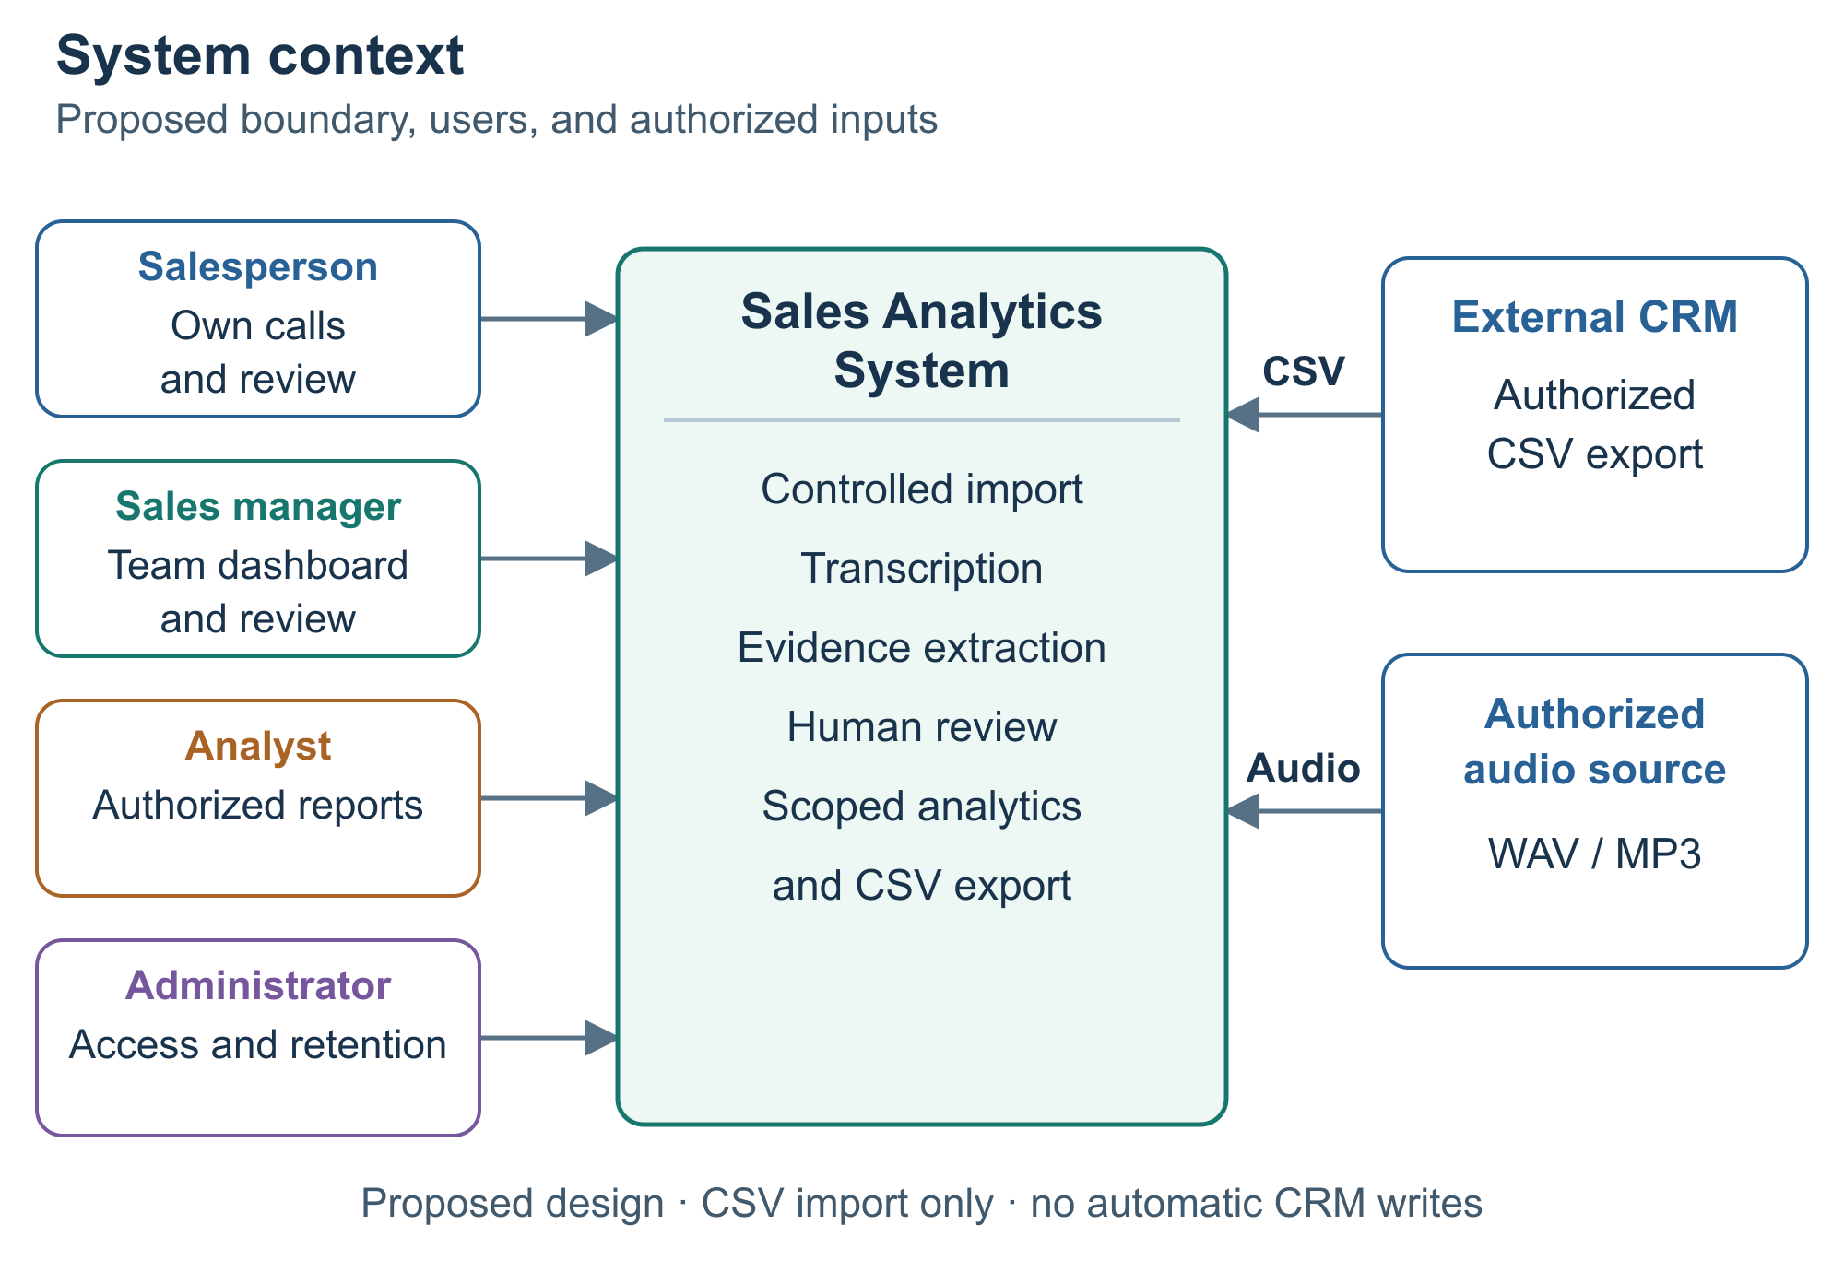
Figure 1 Users and external inputs to the proposed system
The initial boundary accepts authorized audio and CSV/manifest exports. Calls and sales records meet through explicit identifiers. A future live CRM adapter is optional; automatic CRM writeback is outside the MVP.

Use case diagram
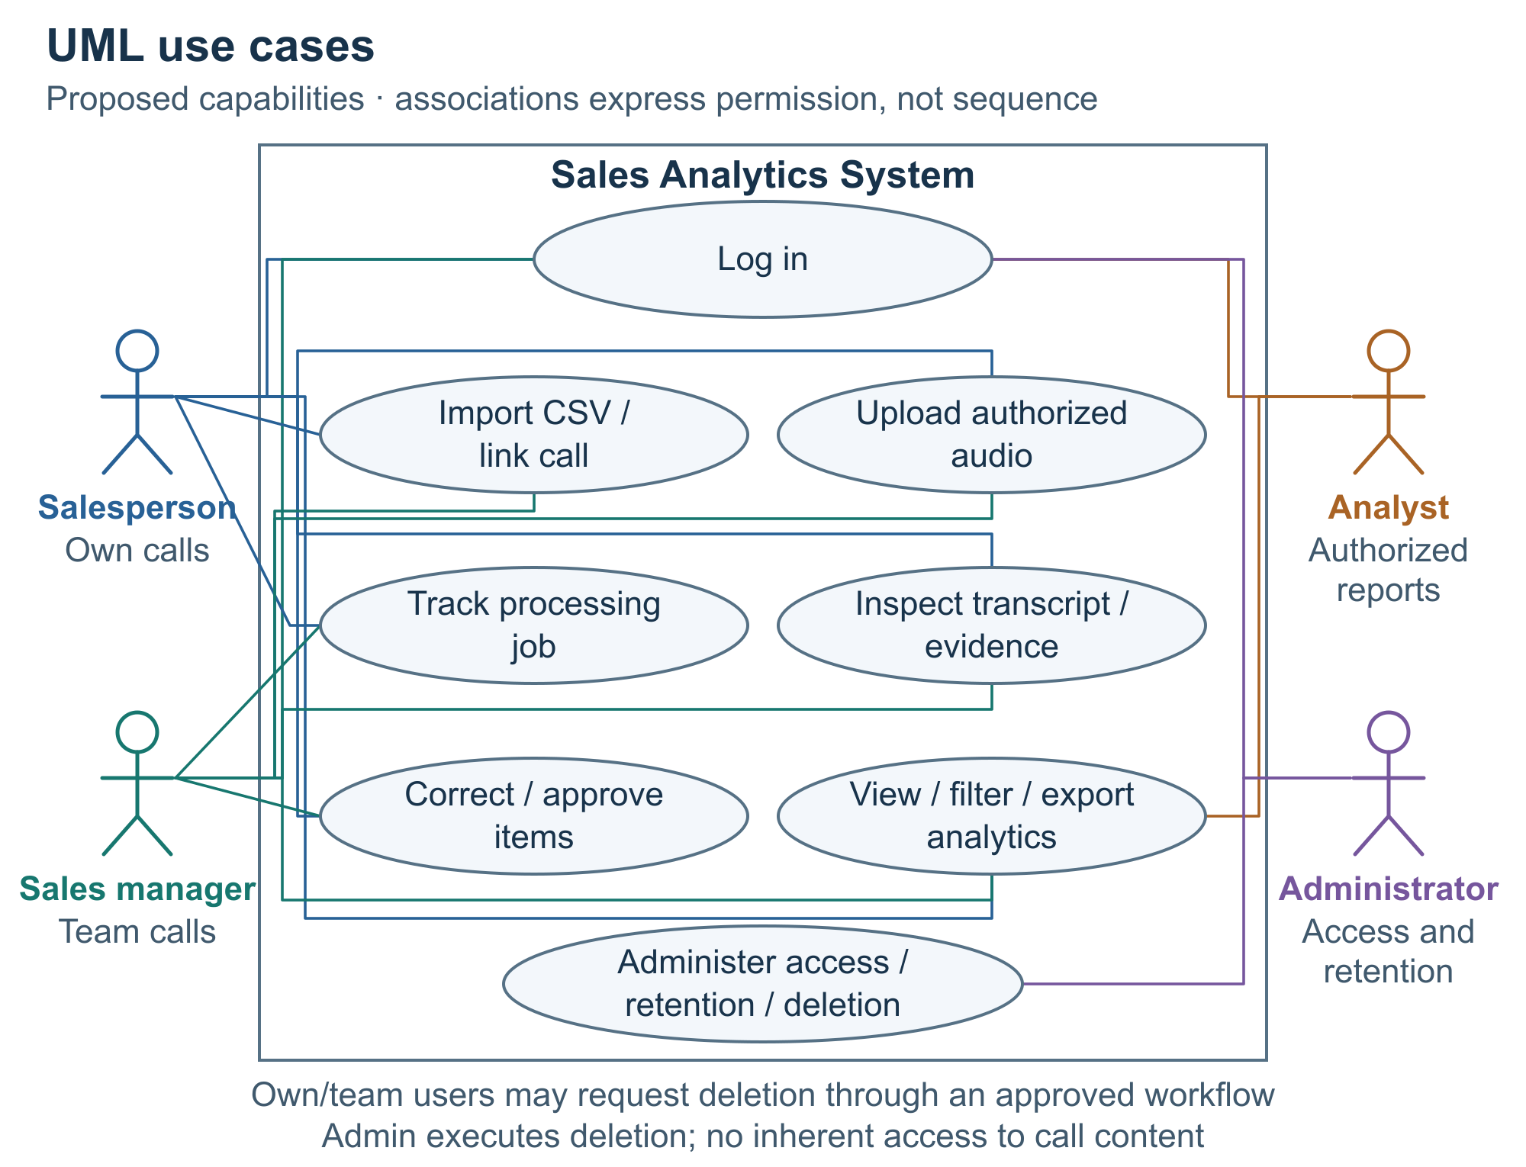
Figure 2 User goals with own-record and team-record permissions
The associations show who can perform each activity. Login does not remove scope restrictions: every API request and file access must also check the user’s permitted records.
The main review scenario is: open a completed call, inspect timestamped evidence, correct an objection interpretation and confirm that item. The next action stays a draft until separately reviewed. Failed processing exposes a recovery action and never changes the CRM outcome.

Component diagram
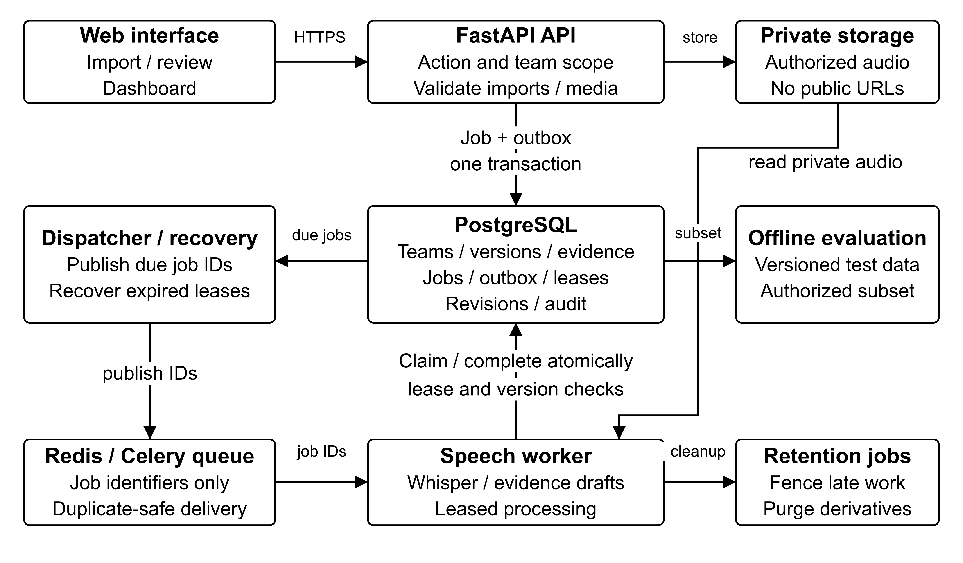
Figure 3 Proposed components and durable job recovery
FastAPI validates access and imports, then commits a processing job and outbox record together in PostgreSQL. A dispatcher publishes job IDs to Redis; recovery scans handle missed messages and expired worker leases. Celery workers process private audio and commit complete versioned results. A late result cannot replace a human correction or restore deleting content. Audio uses an authenticated API proxy. Database, worker and cleanup responsibilities are proposed in Figure 3; the backend is not yet implemented.

8 UX and prototype
Open prototype/index.html for the local clickable mockup with synthetic records and manually written transcripts. It illustrates interaction; no speech service runs. Editable diagrams and SVG exports are in diagrams/. Appendix C retains role/data rules and Appendix F the larger UX preview.
Flow: map and validate IDs → open a call → follow evidence → correct an objection → filter the dashboard. Eight calls link to seven CRM deals; repeated calls never multiply a deal. Retry and review are in-memory illustrations.

9 Verification and evaluation plan
The evaluation separates transcription, extraction and workflow errors. Public-data profiling and synthetic interface checks are complete. Appendix D also specifies backend conflict, recovery, authorization and deletion scenarios; these have not run against an implemented backend. No model benchmark or representative-user study has been completed.

Question | Baseline or comparison | Measure and proposed target
Can we transcribe the target calls? | Selected local Whisper versus a smaller/faster local configuration; cloud only if permitted | Per-language WER, business-entity exact match and valid timing. Provisional WER ≤25% Russian, ≤30% Kazakh; mixed speech reported separately.
Are extracted items useful and supported? | Keyword/rule extraction versus a schema-constrained model; test both gold and ASR transcripts | Objection macro F1 ≥0.75 and action-event F1 ≥0.75, separately; raw evidence precision ≥0.95 against source truth. Zero fabricated numbers after human review.
Does the workflow help users? | Matched tasks in the current manual process and the prototype | Task completion, time, errors and assistance; 4 of 5 users complete the fixed three-task sequence without help in 10 minutes.
Is the implementation practical? | Same fixed fixtures, declared hardware and controlled concurrency | API p95 ≤2 seconds; median ASR real-time factor ≤1 and p95 ≤2; report queue wait, end-to-end time and memory.

Data split and annotation
The feasibility target is 60 authorized calls: 20 mainly Russian, 20 mainly Kazakh and 20 mixed, about 2–15 minutes each. The 30/10/20 split is approximate: assign connected customer/speaker groups intact, then report achieved counts and missing strata. Four representatives may not permit the desired split. Obtain more independent groups or narrow the claim; never describe repeated-speaker partitions as speaker-independent. Freeze the manifest before tuning.
Two annotators label held-out material independently before adjudication. Report six binary objection-label agreement scores, event/field agreement and rare-class support. Score objections and next-action events separately; fix label and empty-output rules. Check factual support against audio or adjudicated gold, including ASR hallucinations. Appendix D defines matching, failed calls and grouped uncertainty.

Measurement conditions
Record model/runtime versions, decoding, hardware and audio conditions. Report real-time factor with warm-up and queue time separately. The future integrated usability study uses two equivalent fixtures with counterbalanced manual/application order; compare common outputs. The present sample-only HTML import cannot pass the full CSV, queueing or authentication requirements.
If enough legitimate linked outcomes become available, compare a constant baseline, structured-only logistic regression and structured-plus-conversation features on the same time/customer-separated split. Use PR AUC and calibration; exclude features unavailable at prediction time. This extension cannot yet support a claim of improved sales or causal revenue uplift.

10 Project management and risks
The allocations below are proposed. Each member will review another member’s work and keep evidence of substantive changes. The full assigned backlog W01–W15 and risk register R01–R09 are in Appendix E and the planning files.

Owner | Work before the checkpoint | Review focus
Rashiduly Bekzat | Confirm schema/data access; review architecture; coordinate supervisor feedback | Interfaces permissions and metric correctness
Taubasar Dameli Almabekkyzy | Refine prototype; agree API states; review sources and user needs | Frontend integration and usability
Amangeldiev Diasbek Yernarovich | Confirm speech/annotation protocol; reproduce data profile; rehearse evaluation | Reproducibility language quality and integration

Date | Proposed milestone | Evidence
22 October | Review scope sources schema and task allocation | Corrected drafts and confirmed responsibilities
23 October | 3–5 discussions data-access check UX walkthrough and supervisor review | Deidentified findings real comments and revision actions
24 October | Resolve comments verify materials and rehearse | Updated report limitations and genuine tracking links when available
The main risks are unavailable recordings or join keys, weak language accuracy, unsupported extracted facts, outcome leakage and delayed stakeholder/supervisor access. Responses are a documented data agreement, stratified pilot, human evidence review, time/customer split and a narrower scope where necessary. Compute limits may require a smaller model or a permitted managed adapter.
Status on 23 October 2026 PRs 2–6 are merged into main at https://github.com/ddigreen/sales-analytics-stt. Demo: https://ddigreen.github.io/vocasales-demo/. Bekzat’s PR 5 adds eight design findings and updated contracts; Diasbek reviewed it. Dameli’s substantive review remains pending for SASTT-4 acceptance. YouTrack has 12 assigned Open issues. Research, public-data and prototype checks are recorded; remaining work includes team acceptance, stakeholder evidence, supervisor feedback, reviewer access and a fixed submission tag.

11 Supervisor feedback and next steps
Review with Orynbek Alibek Sarsenbekuly is pending. The discussion should confirm the pilot scope and data access, assess the research gap, review the architecture and evaluation targets, and agree the next implementation milestone.
After the meeting, record the actual date, artifact version, comment, decision, owner and resulting revision. Appendix F contains the feedback form. Confirm the relevance-evidence route and recording permissions before collecting real audio. Supervisor feedback, team acceptance, reviewer access and the fixed submission tag remain pending. Application implementation continues after this checkpoint.
Appendix guide: A detailed source analysis; B full requirements/tests; C data/access rules; D evaluation; E tasks/risks; F forms/UX; G full comparison matrices and evidence. Both documents use the same APA 7 author–date references.

References
Asi, A., Wang, S., Eisenstadt, R., Geckt, D., Kuper, Y., Mao, Y., & Ronen, R. (2022). An end-to-end dialogue summarization system for sales calls. In A. Loukina, R. Gangadharaiah, & B. Min (Eds.), Proceedings of the 2022 Conference of the North American Chapter of the Association for Computational Linguistics: Human Language Technologies: Industry Track (pp. 45–53). Association for Computational Linguistics. https://doi.org/10.18653/v1/2022.naacl-industry.6
Bain, M., Huh, J., Han, T., & Zisserman, A. (2023). WhisperX: Time-accurate speech transcription of long-form audio. In Interspeech 2023 (pp. 4489–4493). International Speech Communication Association. https://doi.org/10.21437/Interspeech.2023-78
Bredin, H. (2023). pyannote.audio 2.1 speaker diarization pipeline: Principle, benchmark, and recipe. In Interspeech 2023 (pp. 1983–1987). International Speech Communication Association. https://doi.org/10.21437/Interspeech.2023-105
Celery. (n.d.). Introduction to Celery. Retrieved October 23, 2026, from https://docs.celeryq.dev/en/stable/getting-started/introduction.html
Django Software Foundation. (n.d.). Django at a glance. Retrieved October 23, 2026, from https://docs.djangoproject.com/en/6.1/intro/overview/
FastAPI. (n.d.-a). Background tasks. Retrieved October 23, 2026, from https://fastapi.tiangolo.com/tutorial/background-tasks/
FastAPI. (n.d.-b). Features. Retrieved October 23, 2026, from https://fastapi.tiangolo.com/features/
Fu, X.-Y., Chen, C., Laskar, M. T. R., Gardiner, S., Hiranandani, P., & TN, S. B. (2022). Entity-level sentiment analysis in contact center telephone conversations. In Y. Li & A. Lazaridou (Eds.), Proceedings of the 2022 Conference on Empirical Methods in Natural Language Processing: Industry Track (pp. 484–491). Association for Computational Linguistics. https://doi.org/10.18653/v1/2022.emnlp-industry.49
Gong. (n.d.). Conversation intelligence software that turns every call into revenue. Retrieved October 23, 2026, from https://www.gong.io/conversation-intelligence
Gong. (2026a, July 13). About language support in Gong. Retrieved October 23, 2026, from https://help.gong.io/docs/what-languages-are-supported-in-gong
Gong. (2026b, June 30). Analyze team performance. Retrieved October 23, 2026, from https://help.gong.io/docs/analyze-team-performance
Gong. (2026c, January 8). CRM integrations. Retrieved October 23, 2026, from https://help.gong.io/docs/crm-integrations
Gong. (2026d, September 10). Explore call content. Retrieved October 23, 2026, from https://help.gong.io/docs/explore-call-content
Gong. (2026e, January 8). Plans and seats. Retrieved October 23, 2026, from https://help.gong.io/docs/plans-and-seats
Good, V., Bhattacharya, A., Hochstein, B. W., & Voorhees, C. M. (2026). Determining the quality of B2C sales leads from online chats. International Journal of Research in Marketing, 43(2), 383–403. https://doi.org/10.1016/j.ijresmar.2025.07.001
Google Cloud. (2026a, October 22). Cloud Speech-to-Text V2 supported languages. Retrieved October 23, 2026, from https://docs.cloud.google.com/speech-to-text/docs/speech-to-text-supported-languages
Google Cloud. (2026b, October 22). Transcribe long audio files into text. Retrieved October 23, 2026, from https://docs.cloud.google.com/speech-to-text/docs/batch-recognize
HubSpot. (2026a, September 4). HubSpot language offerings. Retrieved October 23, 2026, from https://knowledge.hubspot.com/help-and-resources/hubspot-language-offerings
HubSpot. (2026b, October 9). Review call recordings and transcripts. Retrieved October 23, 2026, from https://knowledge.hubspot.com/calling/review-call-recordings-and-transcripts
Humă, B., & Stokoe, E. (2023). Resistance in business-to-business “cold” sales calls. Journal of Language and Social Psychology, 42(5–6), 630–652. https://doi.org/10.1177/0261927X231185520
Koenecke, A., Choi, A. S. G., Mei, K. X., Schellmann, H., & Sloane, M. (2024). Careless Whisper: Speech-to-text hallucination harms. In Proceedings of the 2024 ACM Conference on Fairness, Accountability, and Transparency (pp. 1672–1681). Association for Computing Machinery. https://doi.org/10.1145/3630106.3658996
Mäntyvaara, J., Nevalainen, P., Glavatskiy, K., & Heikkonen, J. (2026). AI-assisted sales coaching framework: Empirically-derived models for B2B communication analysis. Array, 30, Article 100755. https://doi.org/10.1016/j.array.2026.100755
Microsoft. (2025, January 29). View and understand the call summary page. Microsoft Learn. Retrieved October 23, 2026, from https://learn.microsoft.com/en-us/dynamics365/sales/view-and-understand-call-summary-sales-app
Microsoft. (2026a, July 7). Conversation intelligence FAQs. Microsoft Learn. Retrieved October 23, 2026, from https://learn.microsoft.com/en-us/dynamics365/sales/faq-conversation-intelligence
Microsoft. (2026b, February 27). Enable and configure Sales Insights features. Microsoft Learn. Retrieved October 23, 2026, from https://learn.microsoft.com/en-us/dynamics365/sales/intro-admin-guide-sales-insights
Microsoft. (2026c, May 29). Languages supported for conversation intelligence. Microsoft Learn. Retrieved October 23, 2026, from https://learn.microsoft.com/en-us/dynamics365/sales/language-support-conversation-intelligence
Microsoft. (2026d, May 29). View and understand the home page. Microsoft Learn. Retrieved October 23, 2026, from https://learn.microsoft.com/en-us/dynamics365/sales/dynamics365-sales-insights-app-home-page
Microsoft. (2026e, October 19). What is speech to text? Microsoft Learn. Retrieved October 23, 2026, from https://learn.microsoft.com/en-us/azure/ai-services/speech-service/speech-to-text
MongoDB. (n.d.). Data modeling in MongoDB. Retrieved October 23, 2026, from https://www.mongodb.com/docs/manual/data-modeling/
Moro, S., Rita, P., & Cortez, P. (2014). Bank marketing [Data set]. UCI Machine Learning Repository. https://doi.org/10.24432/C5K306
Mussakhojayeva, S., Khassanov, Y., & Atakan Varol, H. (2022). KSC2: An industrial-scale open-source Kazakh speech corpus. In Interspeech 2022 (pp. 1367–1371). International Speech Communication Association. https://doi.org/10.21437/Interspeech.2022-421
NestJS. (n.d.). First steps. Retrieved October 23, 2026, from https://docs.nestjs.com/first-steps
OpenAI. (n.d.). Whisper [Computer software]. GitHub. Retrieved October 23, 2026, from https://github.com/openai/whisper
PostgreSQL Global Development Group. (n.d.-a). 5.5. Constraints. Retrieved October 23, 2026, from https://www.postgresql.org/docs/current/ddl-constraints.html
PostgreSQL Global Development Group. (n.d.-b). 8.14. JSON types. Retrieved October 23, 2026, from https://www.postgresql.org/docs/current/datatype-json.html
Radford, A., Kim, J. W., Xu, T., Brockman, G., McLeavey, C., & Sutskever, I. (2023). Robust speech recognition via large-scale weak supervision. In A. Krause, E. Brunskill, K. Cho, B. Engelhardt, S. Sabato, & J. Scarlett (Eds.), Proceedings of the 40th International Conference on Machine Learning (Vol. 202, pp. 28492–28518). PMLR. https://proceedings.mlr.press/v202/radford23a.html
Salesloft. (n.d.-a). AI-powered conversational intelligence. Retrieved October 23, 2026, from https://www.salesloft.com/lp/conversational-intelligence
Salesloft. (n.d.-b). Conversation intelligence in Salesloft. Retrieved October 23, 2026, from https://help.salesloft.com/s/article/Conversation-Intelligence-in-Salesloft?language=en_US
Salesloft. (2026a, July 14). Clari + Salesloft defines the next era of AI conversation intelligence, turning buyer signals into revenue actions [Press release]. https://www.salesloft.com/company/newsroom/salesloft-conversation-intelligence
Salesloft. (2026b, September 29). Conversation Intelligence: Call review page UI reference. Retrieved October 23, 2026, from https://help.salesloft.com/s/article/Conversation-Intelligence-Call-Review-Page-UI-Reference?language=en_US
Salesloft. (2026c, April 14). Conversations transcripts. Retrieved October 23, 2026, from https://help.salesloft.com/s/article/Conversations-Transcripts?language=en_US
Salesloft. (2026d, September 30). Integrate Salesforce with Conversation Intelligence. Retrieved October 23, 2026, from https://help.salesloft.com/s/article/Integrate-Salesforce-with-Conversation-Intelligence?language=en_US
Salesloft. (2026e, October 1). Set up topics and filters in Conversation Intelligence. Retrieved October 23, 2026, from https://help.salesloft.com/s/article/Set-Up-Topics-and-Filters-in-Conversation-Intelligence?language=en_US
Song, Y., Zhao, X., Jiang, D., Huang, X., Zhao, W., Xu, Q., Wong, R. C.-W., & Yang, Q. (2021). SmartSales: An AI-powered telemarketing coaching system in FinTech. In Proceedings of the 29th ACM International Conference on Multimedia (pp. 2774–2776). Association for Computing Machinery. https://doi.org/10.1145/3474085.3478555
SQLite. (n.d.). Appropriate uses for SQLite. Retrieved October 23, 2026, from https://www.sqlite.org/whentouse.html
Stock, J., Klakow, D., & Petukhova, V. (2024). Annotating customer-oriented behaviour in call centre sales dialogues. In N. Calzolari, M.-Y. Kan, V. Hoste, A. Lenci, S. Sakti, & N. Xue (Eds.), Proceedings of the 2024 Joint International Conference on Computational Linguistics, Language Resources and Evaluation (LREC-COLING 2024) (pp. 1197–1208). ELRA and ICCL. https://aclanthology.org/2024.lrec-main.107/
Tang, X., Nair, A., Wang, B., Wang, B., Desai, J., Wade, A., Li, H., Celikyilmaz, A., Mehdad, Y., & Radev, D. (2022). CONFIT: Toward faithful dialogue summarization with linguistically-informed contrastive fine-tuning. In M. Carpuat, M.-C. de Marneffe, & I. V. Meza Ruiz (Eds.), Proceedings of the 2022 Conference of the North American Chapter of the Association for Computational Linguistics: Human Language Technologies (pp. 5657–5668). Association for Computational Linguistics. https://doi.org/10.18653/v1/2022.naacl-main.415
Vieira, V. A., Silva, J. D. da, Faia, V. da S., & Gabler, C. (2024). Drivers of industrial sales performance in the agent-buyer chat channel: The role of social and functional content, message valence, and synchronicity. Journal of Retailing and Consumer Services, 78, Article 103774. https://doi.org/10.1016/j.jretconser.2024.103774
Zhong, M., Yin, D., Yu, T., Zaidi, A., Mutuma, M., Jha, R., Awadallah, A. H., Celikyilmaz, A., Liu, Y., Qiu, X., & Radev, D. (2021). QMSum: A new benchmark for query-based multi-domain meeting summarization. In K. Toutanova, A. Rumshisky, L. Zettlemoyer, D. Hakkani-Tur, I. Beltagy, S. Bethard, R. Cotterell, T. Chakraborty, & Y. Zhou (Eds.), Proceedings of the 2021 Conference of the North American Chapter of the Association for Computational Linguistics: Human Language Technologies (pp. 5905–5921). Association for Computational Linguistics. https://doi.org/10.18653/v1/2021.naacl-main.472

