Final Report: Fynd AI Intern Home Assessment 2.0
User Dashboard: https://fynd-ai-intern-home-assessment-2-0.vercel.app/
Admin Dashboard: https://fynd-ai-intern-home-assessment-2-0.vercel.app/admin

A. Overall Approach
The assessment covers two AI/LLM-focused tasks: rating prediction via prompting (Task 1) and an AI-powered feedback system (Task 2).
Task 1 Approach: Rating Prediction via Prompting
Phase | Action | Outcome
Exploration | Implemented 3 distinct prompting strategies (zero-shot, few-shot, chain-of-thought) | Comparative baseline established
Standardization | Enforced strict JSON output schema | 100% parse success rate
Optimization | Designed rating rubric + tie-break rules | Reduced ambiguity in middle ratings
Evaluation | Measured accuracy, validity, consistency | Data-driven strategy selection
Key Insight: All three strategies (zero-shot, few-shot, chain-of-thought) achieved similar accuracy (~64%), suggesting the 8B model's capability - not prompt design - is the primary bottleneck.
Task 2 Approach: Two-Dashboard AI Feedback System (Web-Based)
Phase | Action | Outcome
Architecture | Separated frontend/backend with clear API contracts | Secure LLM calls, scalable design
Reliability | Implemented fallbacks for all failure modes | Graceful degradation under errors
Persistence | Added Supabase for durable storage | Data survives restarts, enables admin analytics
Deployment | Deployed to Vercel + Render | Publicly accessible, auto-scaling

B. Design and Architecture Decisions
Task 1: Rating Prediction
- Three-Strategy Comparison: Implemented zero-shot, few-shot, and chain-of-thought approaches to evaluate accuracy/complexity trade-offs and provide quantitative data.
- Strict JSON Schema: Enforced a structured output format (e.g., {"predicted_stars": <int>, "explanation": "<string>"}) for 100% validity and automated evaluation.
- Smart Few-Shot Selection: Used an algorithm to select clear examples based on sentiment keywords and length, avoiding ambiguity.
Task 2: Feedback System
- Separated Frontend + Backend Architecture: Utilizes Next.js 14 (Vercel) for the frontend, FastAPI (Render) for the backend, Cerebras for LLM, and Supabase (PostgreSQL) for storage. This ensures API keys remain secure and supports scalability.
- Why This Architecture?
Decision | Rationale
Separate backend | Server-side LLM calls (API keys never exposed)
FastAPI | Async support for LLM calls, automatic OpenAPI docs
Supabase | Free PostgreSQL with real-time capabilities
Next.js 14 | App Router, React 18, edge-ready

C. Prompt Iterations and Improvements
Task 1: Evolution of Prompts
- Added a detailed rating rubric (e.g., 1: very negative, 5: very positive), reducing ambiguity in middle ratings.
- Introduced strict output rules (e.g., JSON only, integer stars), improving JSON validity to 100%.
- Added chain-of-thought tie-breakers (e.g., prefer 3 for mixed unless positives outweigh), enhancing handling of ambiguous reviews.
Task 2: LLM Prompt Design
- Structure: System prompt defines the assistant role and strict JSON output (e.g., {"user_response", "summary", "recommended_actions"}). User prompt includes rating, truncated review, and tasks for response, summary, and 3-6 actions.
- Key Improvements: Text truncation at 2500 characters to avoid overflow, defaults for empty reviews, and temperature 0.2 for natural variation.

D. Evaluation Methodology and Results (Task 1)
Methodology
- Dataset: 200 stratified samples from Yelp reviews.
- Metrics:
Metric | Description
Exact Accuracy | Predicted == Actual rating
Within ±1 | Predicted within 1 star of actual
JSON Validity | % of valid, parseable responses
Consistency | Same output across multiple runs (temp=0)

Results
Strategy | Exact Accuracy | Within ±1 | JSON Valid | Consistent
Zero-Shot | 64.50% | 98.00% | 100% | 100%
Few-Shot | 63.50% | 97.50% | 100% | 100%
Chain-of-Thought | 64.50% | 98.00% | 100% | 100%

Key Findings
- Strategies perform similarly, with the model as the bottleneck.
- 100% JSON validity via strict enforcement.
- Zero-shot is most cost-effective due to fewer tokens.
- Errors mostly ±1, concentrated in adjacent ratings.

E. System Behaviour, Trade-offs, and Limitations (Task 2)
How the System Actually Works?
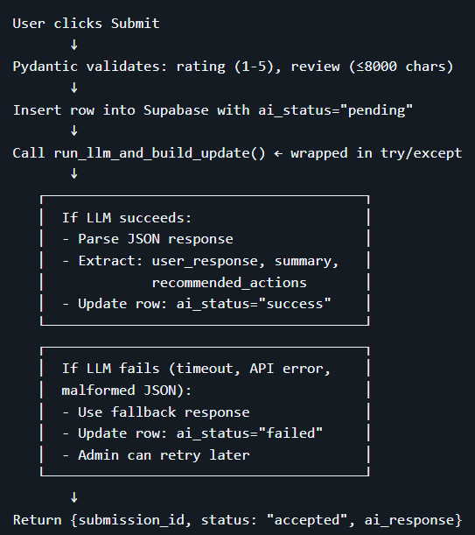

Edge Case Handling
Edge Case | Handling | Code Location
Empty review | Pre-defined response + generic summary/actions | llm/client.py lines 28-33
Long review (>2500 chars) | Truncate with [TRUNCATED] marker | llm/client.py lines 19-22
Non-JSON LLM output | Raise error, use fallback | llm/client.py lines 79-80
Missing fields | Explicit check, raise error | llm/client.py lines 86-87
API timeout | Timeout exception, fallback | llm/client.py line 56
Supabase insert fail | Return 502 error | routes/feedback.py lines 31-34
Supabase update fail | Use fallback, return success | routes/feedback.py lines 48-50
Trade-offs
Decision | Approach | Rationale | Sacrifice
Blocking LLM call | User waits for response | Simpler UX, no polling | Slower response (~2-4s)
Insert-then-update | Pending insert, then update | Data saved on failure, retry possible | Extra DB call
Hard truncation | Cut at 2500 chars | Prevent overflow, consistent latency | Potential context loss
No retry queue | Manual admin retry | Simple implementation | Failures wait for admin
Temperature 0.2 | Slight randomness | Natural responses | Minor tone inconsistency

Limitations
- Render Cold Starts: Free-tier backend sleeps after 15 minutes; first request post-sleep takes 10-30 seconds (workaround: cron ping).
- No Authentication: Open access to admin and submissions (skipped for assessment; add in production).
- Single Point of Failure: Relies on Cerebras; downtime leads to failures (mitigated by fallbacks).
- Actions Not Validated: Trusts LLM output; no quality checks (validation would require extra calls).
- No Rate Limiting: Vulnerable to spam (add in production via tools like slowapi).

Conclusion
Both tasks demonstrate practical LLM integration with emphasis on, wherein Task 1 shows that prompt engineering has diminishing returns, model capability is the primary bottleneck. Task 2 demonstrates a complete system architecture suitable for real-world deployment with appropriate error handling and user experience considerations.

