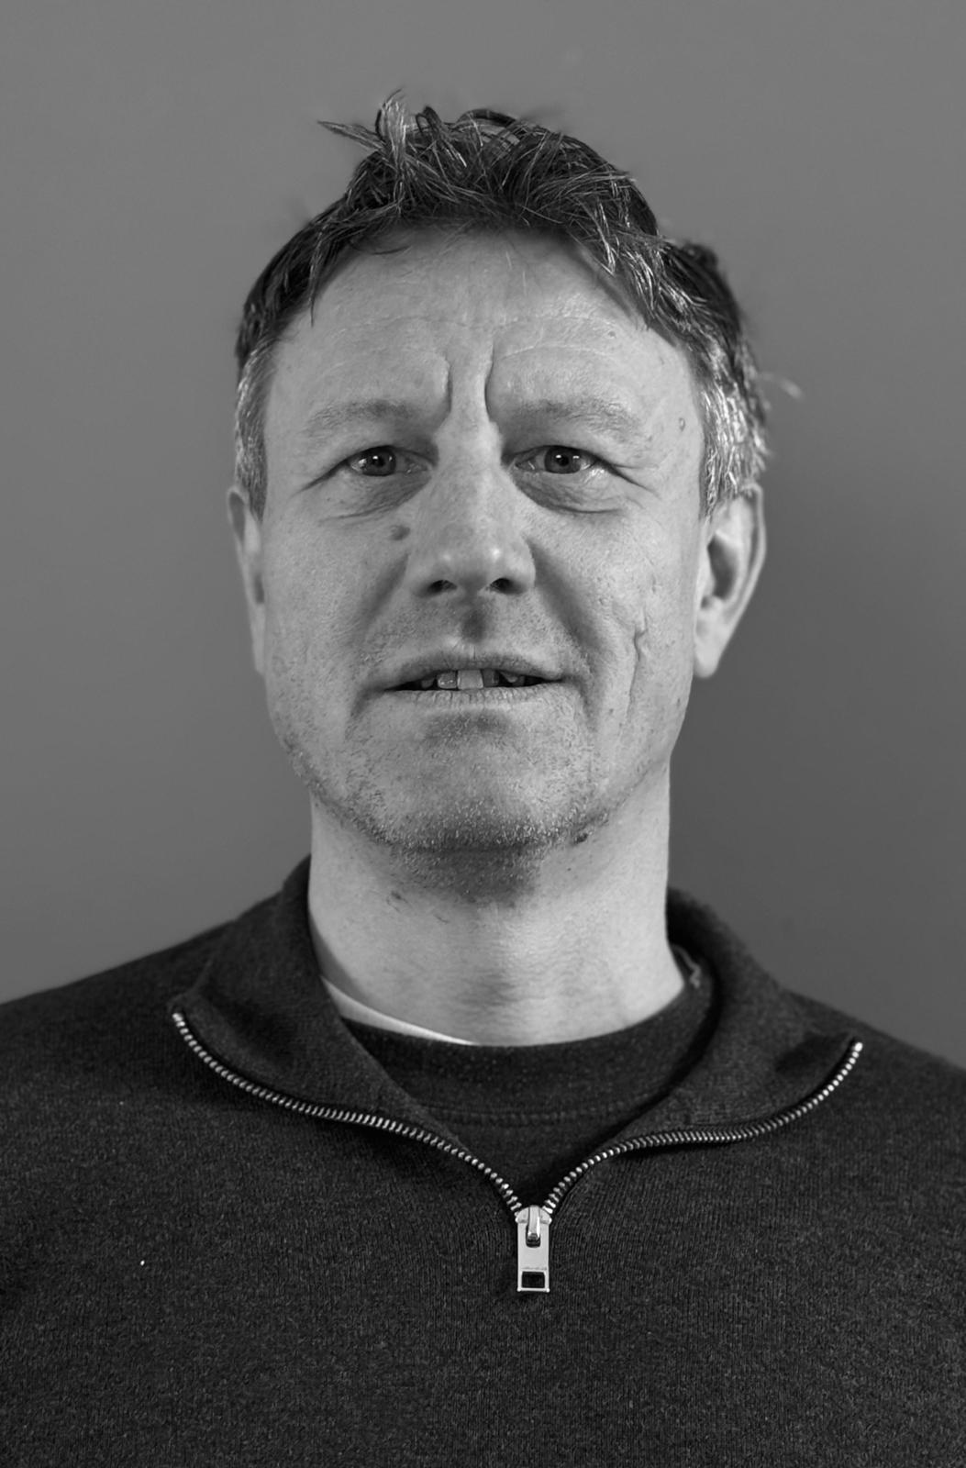

CV of Dick Dijk

Personal information
Name: | ir. Dick Dijk
Position: | Developer/Architect
Telephone: | +31 (0) 6 1645 2852
Email address: | dick@dijkrosoft.nl
City: | Vleuten, The Netherlands
Profile
I am a passionate developer with a preference for Test Driven Development.
I enjoy solving problems and automating as much repetitive work as possible.
I pay great attention to code quality and give presentations at meetups about SonarQube.
Online
https://www.linkedin.com/in/dick-dijk/
https://www.dijkrosoft.nl
https://www.credly.com/users/dick-dijk

Contribution to open source project
https://github.com/stoicflame/enunciate-openapi
Characteristics
Perseverance, flexible, team player but also independent
Education
Regular Education
Aerospace Engineering, TU Delft
IT Education
Python minigames (Manning, certification 2022)
ISTQB® Certified Tester - Foundation Level (certification, 2019)
Oracle Certified Professional, Upgrade OCP Java 6, 7 & 8 to Java SE 11 Developer (certification, 2019)
Professional Scrum Developer (scrum.org, certification, 2017)
Oracle Certified Expert, Java EE 6 JavaServer Faces Developer (certification, 2016)
Oracle Certified Professional, Java SE 8 Programmer (certification, 2015)
Oracle Certified Expert JPA Developer (certification, 2013)
Oracle Certified Master, Java EE 5 Enterprise Architect (certification, 2009)
Groovy (Inter Access, certification, 2012)
JQuery (Envator, certification, 2012)
Masterclass TDD ( Zilverline, Robert C. Martin, 2010)
Sun Certified Developer for Java Webservices (certification, 2010)
Sun Certified Java Programmer, JDK 6 (certification, 2009)
Java Performance Tuning (Xebia, 2006)
EJB 3.0 (InfoSupport, 2006)
KHO Gecertificeerd Softwarearchitect (Open University, certification, 2006)
Sun Certified Business Component Developer (certification, 2005)
Sun Certified Web Component Developer (certification, 2004)
Sun Certified Java Developer (certification, 2004)
Sun Certified Java Programmer, JDK 1.4 (certification, 2003)
Enterprise Java Beans (Sun, 2002)
Visueel Java programmeren (Open Universiteit, 2001)
Objectgeoriënteerd programmeren met Java (Open Universiteit, 2001)
Languages
Dutch, English, French, German
Experience
Languages | Java, Python, JavaScript, Groovy, PL/SQL, Bash, Awk, Sed, Perl, C, C++
Frontend frameworks | React, Angular
Backend frameworks | Java EE, SpringBoot, Quarkus
Databases | Oracle, PostgreSQL, MSSQLServer, MySQL
CI/CD platforms: | GitLab, GitHub, Microsoft Team Foundation (Azure DevOps), SAP NWDI, Hudson/Jenkins, Terraform
Appservers: | OpenEJB, Glassfish, WebLogic, WebSphere, JBoss, Tomcat, SAP WAS, Quarkus
Version Control Systems: | Git, Subversion, CVS, SAP NWDI, ClearCase
Tools: | IntelliJ, Eclipse, NetBeans, JBuilder, NetWeaver Developer Studio, Rational Rose, CA Wily Introscope, NeoLoad, JMeter, Toad, SmartGit
Testing | JUnit, Jest, Mockito, Cucumber, TestNG, Spock
Methods: | Scrum, Agile, Test Driven Development (TDD), Patterns, Object Oriented, UML, RUP
Technologies: | HighCharts, Selenide, Angular, Nexus, SoapUI, Selenium,, CruiseControl, FinalBuilder, SAP Netweaver, MKS, Ant, Maven, SAP CRM, SAP ISA, SAP Webshops, CORBA, XML, XSLT, XML Schema (XSD), JEE, J2EE, JSP, EJB, Servlets, JPA, JSF, Webservices, WSDL, XPath, SOA, LDAP, JAAS, Swing, Struts, Google Analytics, BugZilla, Jira, iDEAL, SEO, JSTD-016, Log4j, Hibernate, CQRS, Spring MVC, SonarQube, Docker, Kubernetes, Redis, Elastic Search, OpenAPI
Operating Systems: | Windows, Linux, Unix, OS X, iOS
Assignments
Period: | August 15, 2023 - February 1st, 2025
Branche: | Legal
Client: | Columbus Letselschade
Role: | Java Developer
Area of work: | Supporting work processes in personal injury claims handling
Technologies: | Java 23, React, SpringBoot, Jest, JUnit, Docker, PostgreSQL, IntelliJ, JPA, Mockito
Contribution: | Further development of Advobot, an application for supporting personal injury cases and advanced task automation
Period: | March 1st, 2022 - June 22, 2023
Branche: | Education
Client: | Ready Education
Role: | Java Developer
Area of work: | App for students to communicate with their educational institution
Technologies: | Java, Python, AWS, Javascript, SpringBoot, Python, Elastic Search, Git, Maven, Kafka
Contribution: | Analysis of production issues in a Python application and implementing improvements in this application. Setting up a new application in Java and SpringBoot to expose existing backend systems for new frontend applications acquired through mergers and acquisitions.
Period: | March 15, 2020 - February 22, 2022
Branche: | Government
Client: | National Police
Role: | Java Developer
Area of work: | Support for street officers with the RAPP app.
Technologies: | Java, Python, Swagger, Angular, Git, Maven, Jenkins, Mockito, REST-Assured
Contribution: | Development of a backend in Java to support the handling of shoplifting cases. Development of Python scripts for automating build and deployment processes.
Period: | November 1st,2019 - June 24, 2023
Branche: | Legal
Client: | Columbus Letselschade
Role: | Java Developer (1 day per week)
Area of work: | Supporting work processes in personal injury claims handling
Technologies: | Java, React, SpringBoot, Jest, JUnit, Docker, PostgreSQL, IntelliJ, JPA, Mockito
Contribution: | Further development of Advobot, an application for supporting personal injury cases and advanced task automation\
Period: | July 8, 2019 - October 31, 2019
Branche: | Finance
Client: | Ortec Finance
Role: | Java Developer
Area of work: | Goal based planning
Technologies: | Java, Swagger, Angular, Enunciate, OpenAPI, WebLogic, Git, Maven, Jenkins, Mockito, REST-Assured
Contribution: | Made an external API available in OpenAPI v3 format, enabling client applications to be largely generated. Additionally contributed to the further development of the financial planning application.
Period: | October 1st, 2018 - June 30, 2019
Branche: | Education
Client: | StuComm
Role: | Java Developer/Architect
Area of work: | Mobile apps for students
Technologies: | Tomcat, Java, SpringBoot, Git, Maven, Jenkins, Docker, SonarQube, Mockito, REST-Assured
Contribution: | Design and build of a Java backend that supports the mobile app. The application has a plugin architecture based on the standard Java services mechanism. The application uses the Java Platform Module System (Java 11) and also utilizes Custom Runtime Images.
Period: | September18, 2016 - September 30, 2018
Branche: | Government
Client: | BKWI
Role: | Java Developer
Area of work: | Work and Income
Technologies: | Tomcat, Java, Git, Maven, Jenkins, GWT, Gerrit, Docker, Kubernetes
Contribution: | Implementing a web application that supports civil servants in performing tasks. Presenting progress.
Period: | April 1st, 2016 - September 13, 2016
Branche: | Finance
Client: | Rabobank
Role: | Java Developer
Area of work: | Rabo Hypotheek Dossier (RHD)
Technologies: | WebSphere, Java, Angular, Git, Maven, Flyway, PowerCenter
Contribution: | Implementeren van functionele aanpassingen aan RHD applicatie en maken van SQL scripts t.b.v. rapportageImplementing functional changes to the RHD application and creating SQL scripts for reporting purposes.
Period: | October 1st, 2015 - March 1st, 2016
Branche: | Finance
Client: | Ortec-Finance
Role: | Java Developer
Area of work: | Financial Planning
Technologies: | WebLogic, Java, JPA, CDI, WebSphere, Git, Maven
Contribution: | Migration of JEE application from WebLogic to WebSphere.

