Skin Detection and Segmentation of Human Face for 3D face reconstruction with Minoru webcam

1. Aims:
   1. Creating a plat form for Human face segmentation for my web-based online Human head reconstruction using Minoru webcam. A part of my PhD thesis. This is divided into 2 parts:
      1. Skin detection
      2. Human face segmentation
2. Previous works:
   1. Skin detection is a very useful technique in Computer Vision to detect and segment human faces, hands and bodies from coloured digital images. There are a large number of researches on the topics such as [1-4].
3. Implementations:
   1. Compensation for Varying Illumination Colours
      1. Due to the interferences of different light sources, some images will present light interferences. If the images have light interference, an extra tool of light compensation should be applied to get the images into normalized states. The determination of whether to apply light compensation or not is stated in research [2]. It started with a histogram of pixel intensity, giving a threshold of 5% of the highest intensity. If there are more than 100 of the pixels higher than this threshold then no needs for compensation otherwise compensation is required.
      2. The image compensation is implemented into 4 steps and described in details in [1]



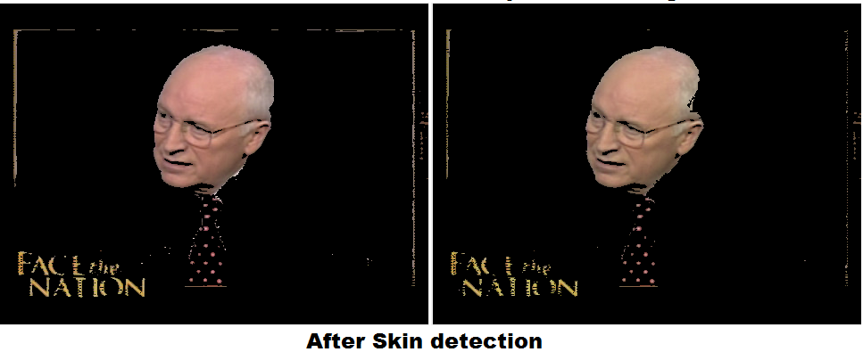

* 1. Skin colour detection:
     1. Almost all skin detection methods are based on the appearance of its colour in various colour spaces such as RGB, YCbCr, HSV, CIE Luv, Farnsworth UCS or normalized RGB [4]. The detection is then based on thresholds from one or multiple bands within a specific colour spaces to determine regions of skin and non-skin. Although, it’s stated that there is no difference in the detection performances between some main colour spaces (RGB, CIE XYZ, HSV, YCbCr and CIE Lab) [4]. Many found it more convenient and suitable to use YCbCr colour spaces for the space of skin detection [1, 3].
     2. The calculation of YCrCb is stated in [3] at page 502 and claimed that the Y component has 220 levels rangeing from 16 to 235 while Cr and Cb both have 225 levels ranging from 16 to 240.
     3. Thresholds are determined by experiences and there are two suggestions within the paper [3]:
        1. One is:
           1. Y > 80
           2. 85 < Cb < 135
           3. 135 < Cr < 180
        2. Two is:
           1. 77 < Cb < 127
           2. 133 < Cr < 173
        3. Let us use the following thresholds:
           1. Y > 80
           2. Cb in (102-25, 102+25)
           3. Cr in (153-20, 153+20)

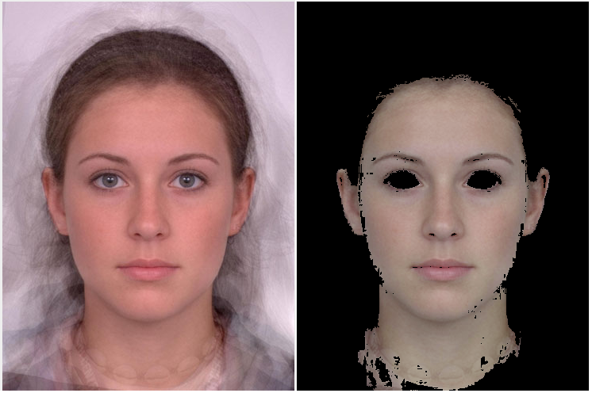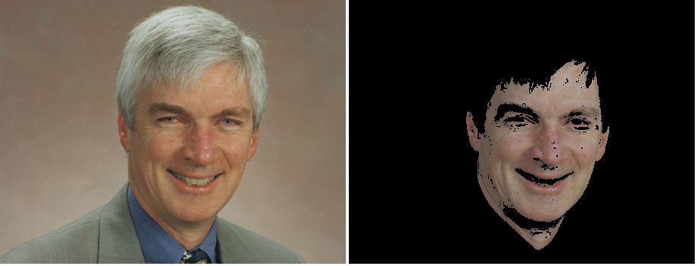

* + - 1. By experience, find out that the threshold is stable for ranging of Cb and Cr, however, the illumination is dependent quite a lot on the level of Y.
      2. Improved by changing Y threshold to server better skin searching

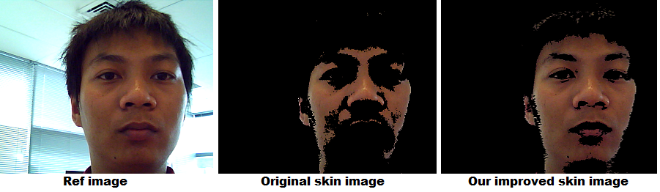

* 1. Face region segmentation:

Face region can be anywhere of the skin region, as some region might contains neck, hands, other faulty region. Therefore, to specify the exact region of face, we need to acquire based on some more feature. From the idea is face is region where containing eyes, noses, mouth… and normally centre of the face is the nose or the centre of the triangle made by eyes and mouth. Eye maps and moth map should required now [5].

* + 1. Segmentation of skin regions:
       1. After the skin colour detection step above, we obtain a binary map of skin and none skin regions which contains disconnections and holes within the image. The first step here is to remove the holes and remove all small skin regions that are disconnected. There are 2 steps:
       2. Hole clearances
          1. We found out that combination of Dilation and Erosion can effectively clear out holes within images:
          2. Apply a dilation on top of skin image to close all the holes
          3. Apply a erosion on top of dilated image to get back the boundary
       3. Skin segmentation

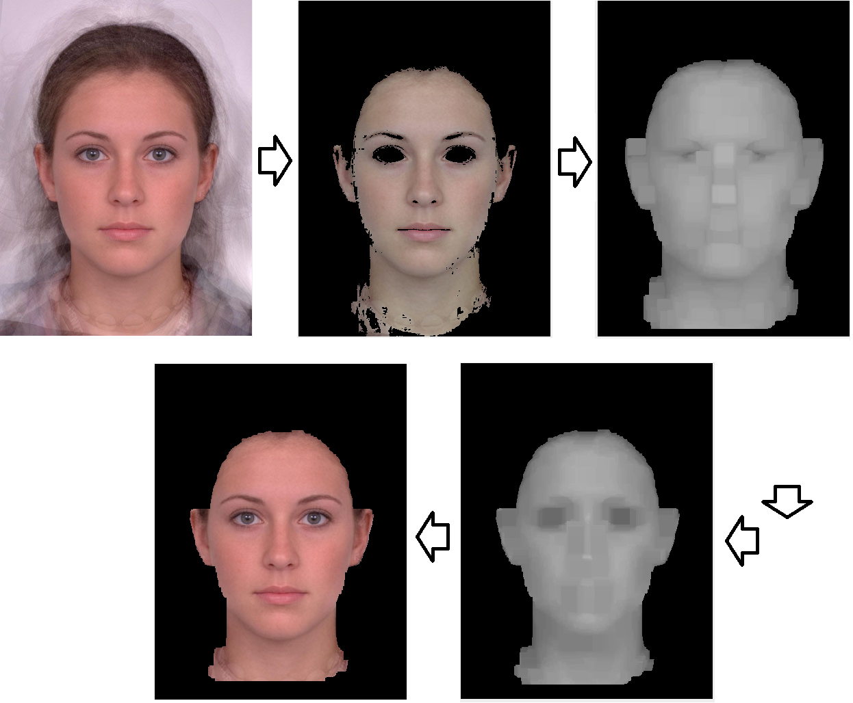

References:

[1] W. Baozhu*, et al.*, "A Robust Method for Skin Detection and Segmentation of Human Face," in *Intelligent Networks and Intelligent Systems, 2009. ICINIS '09. Second International Conference on*, 2009, pp. 290-293.

[2] C.-C. Chiang and C.-J. Huang, "A robust method for detecting arbitrarily tilted human faces in color images," *Pattern Recognition Letters,* vol. 26, pp. 2518-2536, 2005.

[3] T. M. Mahmoud, "A New Fast Skin Color Detection Technique," *World Academy of Science, Engineering and*

*Technology,* vol. 33, pp. 501-505, 2008.

[4] S. L. Phung*, et al.*, "Skin segmentation using color and edge information," in *Signal Processing and Its Applications, 2003. Proceedings. Seventh International Symposium on*, 2003, pp. 525-528 vol.1.

[5] H. Rein-Lien*, et al.*, "Face detection in color images," *Pattern Analysis and Machine Intelligence, IEEE Transactions on,* vol. 24, pp. 696-706, 2002.