Vascular Ultrasound Image Location and Detection Method Based on Mean-shift and Graph Cuts Theory

Ting Yun
School of Computer Science, SouthEast University
School of Information Science,Nanjing Forestry University
Nanjing, China
njyunting@tom.com
Huazhong Shu
School of Computer Science, SouthEast University
Nanjing, China

Abstract—This paper addresses the issue of vascular ultrasound image segmentation and proposes a novel ultrasonic vascular detection method. Firstly mean-shift algorithm is adopted to obtain the initial regional categories and parameters of vascular image; Secondly new data item and smooth item of the energy function is constructed by using the MRF mode, then swap and 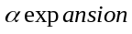 thoughts are employed to optimize segmentation results, consequently the vessel wall and lumen location are accurately located. Finally comparison with experts manually tagging results, and edge correlation coefficients and variance are applied to verify the validity of our algorithm. experimental results show that our algorithm can efficiently combines the advantages of mean-shift and graph-cut algorithm and achieve a better segmentation results.
Keywords: ultrasound image; mean-shift; graph-cut algorithm; Gauss mixture model;

Introduction
Medical ultrasound images is an important type of medical images and is widely used in medical diagnosis, Compared with other medical imaging methods, Ultrasound imaging has the advantages of non-traumatic to human body, real-time display, low cost, ease to use, as an ideal non-invasive method of diagnosis It has a brilliant and broad prospects of development. However, because of the principle of imaging factors lead to insufficient grayscale display range or unreasonable gray distribution, so the auxiliary diagnosis effect of the ultrasound images is constrained, especially in some local details, if the gray scale difference is not obvious, that will bring a lot of difficult to diagnosis. In order to improve ultrasound images quality and enhance the readability of ultrasound medical local details, make images suitable for human eyes observation or machine analysis, therefore in recent years automatic segmentation for pathological area of ultrasound images become the research focus.
Some scholars dealt with the ultrasound image segmentation in the frequency domain, such as literature^{[1]} used wavelet decomposition to achieve wavelet coefficients then combined with neural network method to process segmentation problem. Sheng Y etc^{[2]} constructed an accurate ultrasound image segmentation algorithm in the wavelet domain with the Chan-Vese model, Ali Kermani etc^{[3]} combined the local histogram and wavelet transform to locate the position of breast lesions. J.Xie^{[4]} proposed a new method which combined texture and shape as the prior information, then energy equation was constructed and texture of pathological area was classified by the shape parameter and Gabor filter coefficients. Other researchers processed ultrasound image in the time domain, Literature^{[5]} proposed segmentation algorithm based on gray probability density function and fast matching ideas for vascular image, Literature^{[6]} constructed an image segmentation method based on graph theory, which has the advantages of robust to noise, sensitive to the blurred edge, low residual error rate and fast calculation speed. After remove speckle noise, literature^{[7,8]} adopted active contour model combining with prior information such as shape texture color to complete pathology region division. Christodou^{[9]} used ten different texture feature include first-order statistics, gray level co-occurrence-matrix, gray differential statistics, neighborhood gray difference matrix, statistical feature matrix, texture energy spectrum, characteristic of fractal dimension, power spectrum and shape parameters etc to extract carotid atherosclerotic plaques, then extracting separation results was got by the K-neighboring method.
Vascular ultrasound image segmentation method based on mean-shift and graph cut theory is proposed in this article, Firstly mean-shift method is adopted for initial vascular ultrasound image segmentation, Secondly a new data and smooth item of the energy equation is defined and the graph cut method is used to obtain the global optimal solution, then we realize optimization and modification of the segmentation results and accurately get the vessel wall edge and endovascular location. Lastly comparing with the manual tagging results the validity of our algorithm is proved.

Mean-shift Ultrasound Image Segmentation Method
Mean-shift computational model is an effective tool for analysis in feature space, it was widely used In many computer vision applications. Mean-shift is a probability density gradient function with no parameters estimation algorithm, It along the gradient rising direction to find the peak of the probability distribution. In the kernel density estimation, kernel function generally meets the conditions: 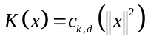,where 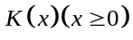 called kernel profile function. The normalization positive constant 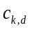is to ensure that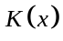 integral is 1. Gaussian kernel function and uniform kernel function is two kind of commonly used kernel function, let 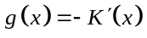, kernel function 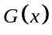 define 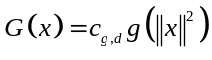. and mean shift vector is defined as follows : 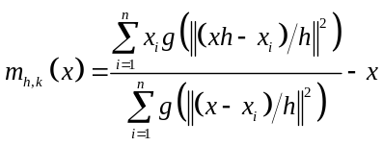 (1)
Mean-shift solving process is divided into two steps:
1) Calculation of mean shift vector 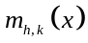;
2) According to the A value to transform nuclear location, this process ensures to converge to the points which neighbourhood are gradient of zero. Let 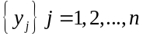 is location sequence during G mean-shift process, by the formula (1) can be got: 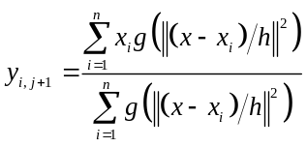, 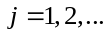 (2) formula (2) is weighted mean value that calculated by nuclear G in 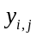 position, where 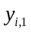 is the core of the initial position.
Ultrasound image segmentation method based on mean-shift algorithm can be described as: Firstly, an ultrasonic image can be represented as two-dimensional grid with dimension vectors, usually 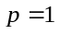 expressed as gray-scale image, and grid space is called spatial domain, gray value space also called co-domain. Through searching for the next shift point in the image space, the search stop condition is simultaneously set, until the displacement is less than a given value, then translation is stopped. Let and (i＝1, 2, …, n) are respectively the input vector and the filter output results.
For the all data points,i＝1, 2, …, n, mean-shift vector of each point are calculated, according to the value that moving window center to the next point. This process is repeated until convergence to the density peak of the data space, when the estimated density gradient is zero, then no need to move, and assign the pixel value 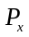 to 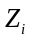, that is 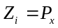. is the filtered pixel. the output image consists of multiple independent regions. Basic steps are as follows:
1) Initialize 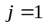 and 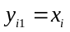
2) According to equation (2),calculate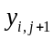 until convergence, and record convergence value is 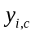.
3) Assign 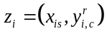.
Through the above three steps we get final results of mean-shift filter, where superscript and respectively represent spatial domain and value range. Using mean-shift filtering method, need to set bandwidth vector 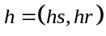 and minimum area .Bandwidth can be regarded as the resolution of segmentation, bandwidth is larger, more details of the image will be ignored, so how to choose the appropriate bandwidth, is the key of successfully using kernel density estimation. In this paper radial gauss kernel function is adopted for ultrasound image segmentation.

Ultrasound Image Segmentation Optimization Based On the Graph Cut Theory
Graph cut algorithm is a global optimization algorithm, by using the class label and construct energy function, it convert image segmentation problem into the problem of minimizing the energy function. Under the guidance of the graph cut theory, network is ingeniously constructed, and energy is linked to the network capacity, lastly network flow principle in graph theory is adopted to find the graph minimum cut, the cut is optimal solution of the energy function minimization problem, besides the image segmentation is completed. Graph cut algorithm are two thoughts, include swap and .

Ultrasound Image Segmentation Model Based On MRF
Image segmentation approach based on the MRF model can be seen as combinatorial optimization problems of the label field which make energy function 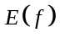 minimization. Energy function can be expressed as follows: (3) Where 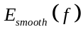 called smooth energy, it is the penalty to the un-smoothness characteristics. 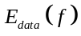 known as the data item energy, it is the punishment to the disagreement between current class label and observation data 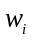 class. For a given image, represent each pixel, is the set of all pixels, all neighboring pixel pair 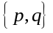 that constitute the set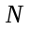. Where 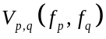 uses four neighborhood Potts model^{[10]}: 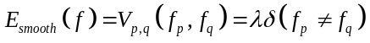, is the factor to balance the data item and smoothing item, each pixel data item energy 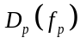 in type (3) can be got by type (4): 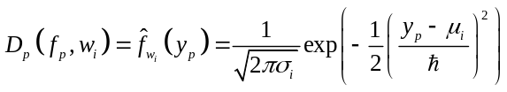(4). Where 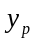 represent attribute value of pixel (such as gray value). 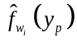 represents the probability of pixel belongs to the category . We use the mean-shift method to obtain the initial ultrasound image segmentation, and get mean values and variances of classes: 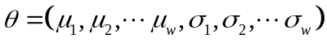,with gauss RBF kernel function type(4) get the pixel corresponding conditional likelihood estimation of classes. Where control the smoothness of conditional likelihood function ,for larger value of , the curve is more smooth, but may lose detail information; The value of is smaller, curve will be more sharper, that will lead over reliance on the observation data, then the promotion performance will degrade. estimation , such as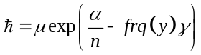,where 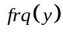 is the occurrence frequency of in the training sample set.

Graph-cut algorithm: swap algorithm ideas
The thought of swap algorithm is continuously select two different categories 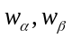, and graph grid is constructed to associate with energy equation(3) in order to obtain the optimal solution of equation. Let be the set of all pixels, while 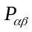 is a pixel points set which class belong to , grid form as shown in figure 1, chart elements are: vertex set 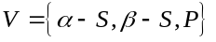,
edge set 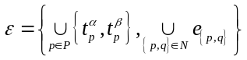, where 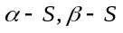 is a graph vertex, 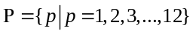,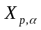 in figure 1 represent pixel label to the class 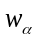 through mean-shift method. Pixel (satisfy 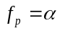 or 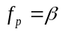) in 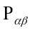 respectively connect with two vertices 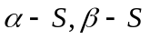 that constitute t-link edges, denoted by 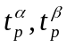.And the internal elements constitute n-link edges, denoted by 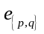, weight assignment approach of t-link and n-link respectively see equation(5) and equation(6).
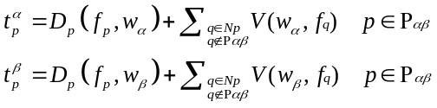 (5)
(6)
Where 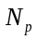 is adjacent area of pixel , literature^{[11]} prove the capacity of cut set is: 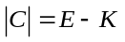 (7). Where is the energy value of equation(3),  is a constant, the optimal solution of energy function(3) is the minimal cut set of graph(1a). swap algorithm randomly select two class from class, and through the energy function to derive the corresponding cut set, then determine the pixel belongs to which class set, thus complete the section optimization, specifically shown in Figure1a.

Graph-cut algorithm: algorithm ideas
The swap algorithm can only specify , 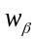class exchange to calculate of the minimum energy. If we limit and make exchange with all other classes, then will get a broader transformation approach, it is algorithm. Literature^{[12]} proved that formations of smooth item to satisfy some constrain, called metrics, and algorithm ideas were that focus on the pixels of class and construct grid to associate with the energy function, then achieve broader transformation approach to optimize the segmentation results. As shown in figure 1b, a set of vertices
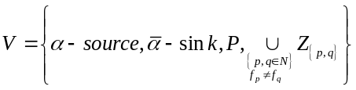is the composition elements of the graph, where ,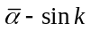 respectively the highest and lowest vertices.  is the any one pixel in , is adjacent pixels of ,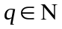. When the two pixel class label 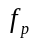and 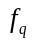 are unequal, then auxiliary nodes 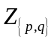 are added, Let 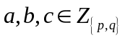are the auxiliary node, adding the auxiliary node 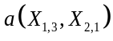 between 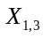 and 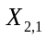, as shown in fig 1b, similarly, there are auxiliary nodes 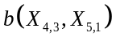 and 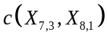. Where edge set is
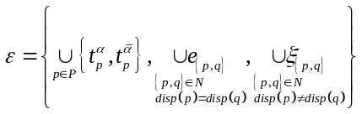, 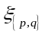are the edges that between auxiliary node with nodes,,. For example figure 1b shows that total three edges of c, the edge 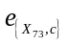 between and 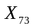, the edge 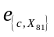 between and 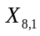; the edge between and , similarly, auxiliary node and construct edges with their adjacent nodes. the pixels of respectively connected with and to construct t-link edges, the internal pixels of connect with each other to constitute n-link edges, edge weights assignment method reference on the formula (8) and (9), if existing auxiliary node , then the edge weight between c and adjacent points can refer to the following formula (10).
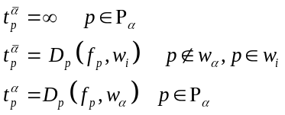 (8) 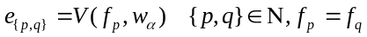 (9)
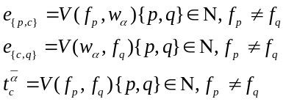 (10)
Where the meaning of data item see formula (4),smooth item as shown in formula (3). Literature^{[12]} proved that the cut-set capacity is 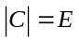 (11), where E is obtained from equation (3), then by the method of to optimally solve the equation (11). The algorithm runs steps is: construct the network shown in Figure 1b, pixel set , Label is the same definition as 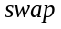algorithm, for the class, if the pixel labels are and , then set t-link and n-link edges to find the minimum graph cut set C, that is to seek the minimum energy 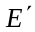 which corresponding to the class label 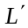, if condition 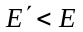be satisfied, then begin to modify the class label by the same mode of swap algorithm, and update the pixels corresponding category set to .

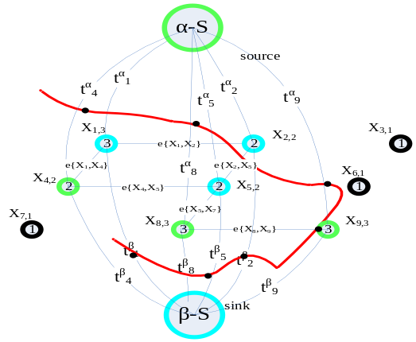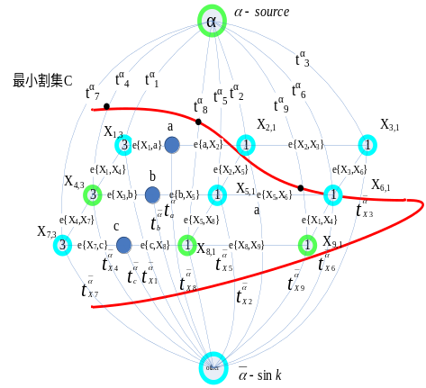
a swap b
Fig 1 Graph cut algorithm principle diagram

Experimental Results
The experiment of three ultrasound images is shown in Fig 2
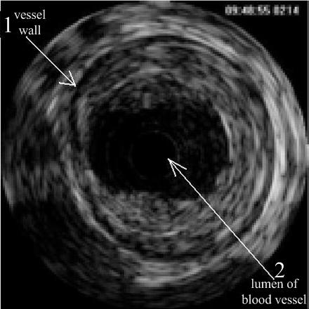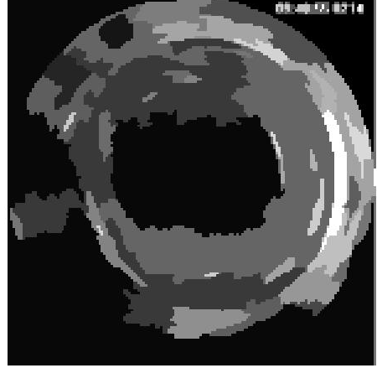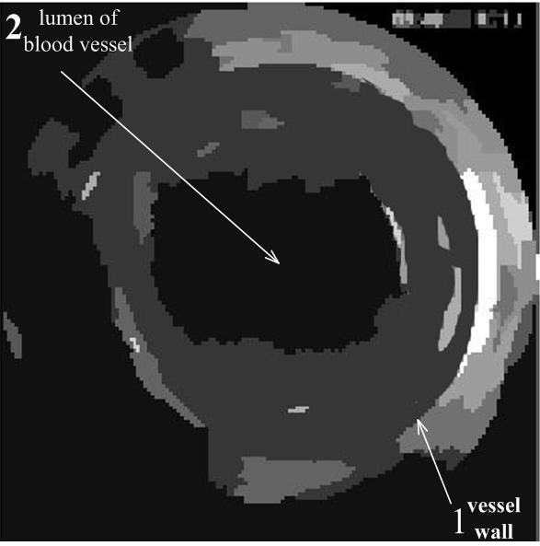
a b c
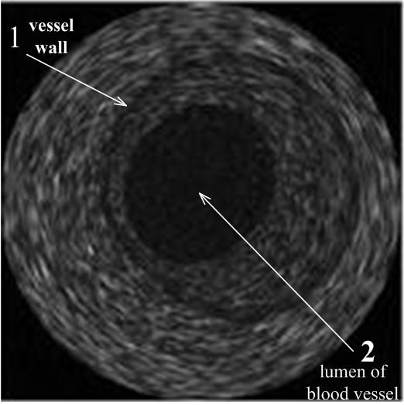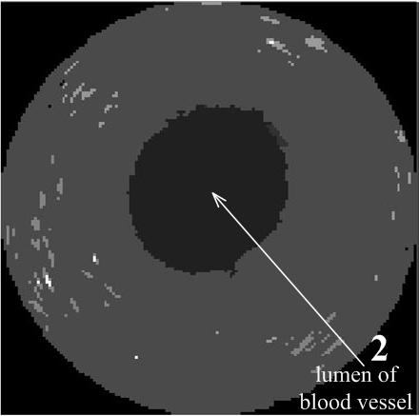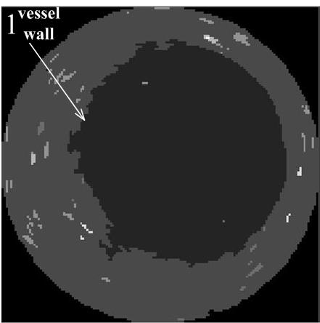
a b c
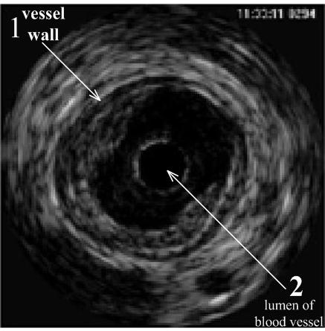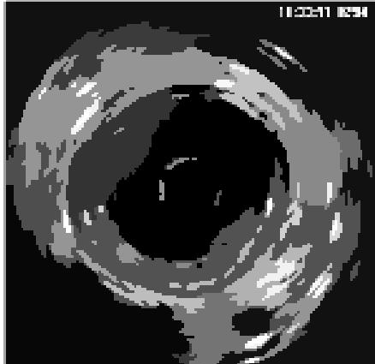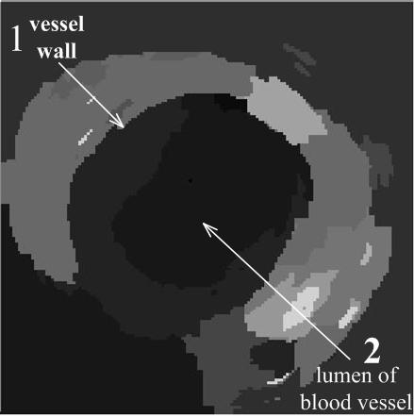
a b c
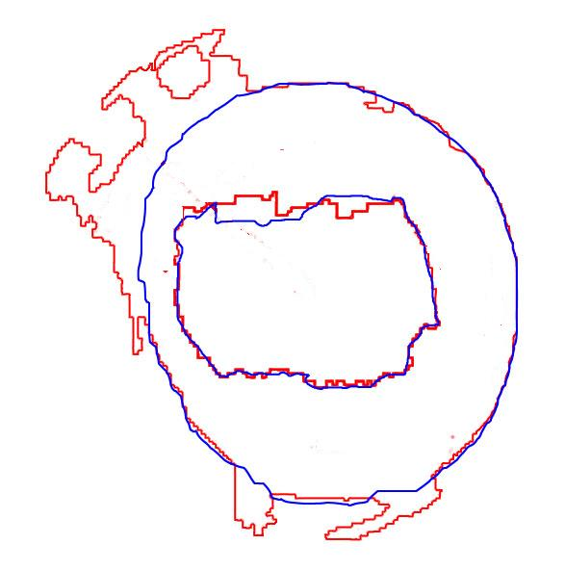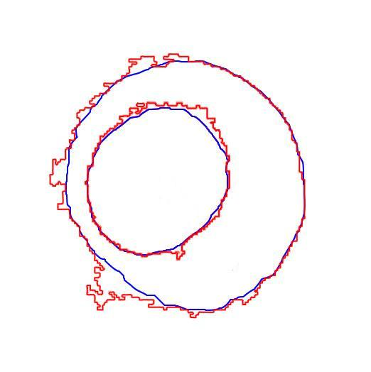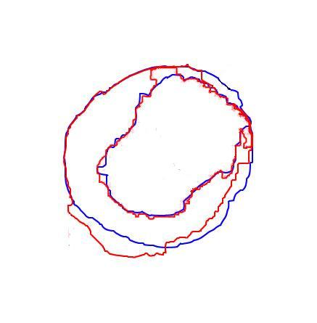
image1 result image2 result image3 result
Fig.2 Segmentation of ultrasound images, First columns: the original ultrasound images; Second columns: three snapshot for mean-shift segmentation results; Third columns: Segmentation of our algorithm, using graph cut re-segmentation after mean-shift segmentation results, where 1 represents the vessel wall and 2 represents lumen of blood vessel. The last row in Fig2 is comparison chart about above three ultrasound image segmentation results, blue lines represents the medical experts hand-labeled results of vessel cell and lumen edge, the red line is the labeling results of our algorithm

Then variance and correlation coefficients are used for comparison of test results, variance represents deviation degree of the two boundary points, while the correlation coefficients indicate similarity of two boundary shape. Firstly starting positions in the two boundaries are chose, then two L sub-sequence (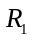and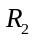) with fixed length in two curves are taken, The similarity of and notes for 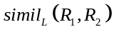, it depicts by 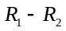 variance ,that is 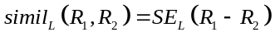, where variance
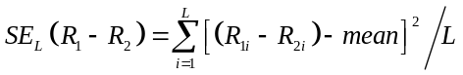
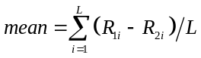,
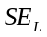 is smaller, the and are more similar, where 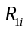 represents the distance between sampling points on a curve to the origin. Correlation coefficients 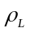 are adopted for edge comparison. 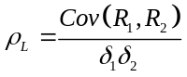, 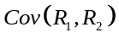 represents covariance between curve and curve , and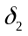respectively denote the standard deviation of and ,
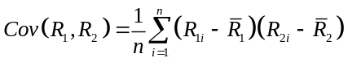 (12)
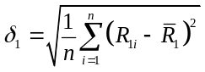 ,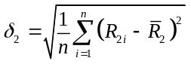 ,
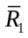 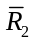 represent the mean distance of all points on curves to the origin.
Table 1 shows the specific experimental parameters and experimental results, including the selection threshold, and the comparison between our algorithm and manual segmentation results, by calculating the correlation coefficients and variance of the curves to compare the similarity between them. From the experimental results can be seen, our designed algorithm can completely extract vascular lumen and accurately locate the position of the vessel wall, it has excellent performance in vascular ultrasound image segmentation.

Table 1. Selected coefficients and Experimental results
 | The h of equal(1) | The of equal(4) | vessel wall segmentation comparison with hand-labeling |  | vessel lumen segmentation comparison with hand-labeling
 | The h of equal(1) |  | variance | correlation coefficient | variance | correlation coefficient
ultrasound image1 | h =17 | 60 | 25.7 | 0.7789 | 13.2 | 0.8524
ultrasound image2 | h =13 | 90 | 12.6 | 0.9121 | 8.4 | 0.9456
ultrasound image3 | h =13 | 90 | 21.2 | 0.7833 | 11.8 | 0.9219

Conclusion and future work
This paper presents a novel vascular ultrasound image segmentation method which combining mean-shift and graph cut algorithm, firstly mean-shift algorithm is adopted for the initial segmentation, then initial classification results which include specific characteristic parameters of each class are obtained according to the histogram classification, subsequently probabilistic model is used to construct data and smooth items of energy function, and then using graph cut method to get the optimal solution of the energy function, thereby locating the position of vessel wall and vessel lumen, comparison with expert manual segmentation results, our algorithm achieve function of blood vessels location. Our future work mainly include two aspects, firstly how to accurately and effectively locate the ultrasound vascular image edge when acquisition effect of ultrasound image are not well, secondly when the amount of medical image data is too large, how to improve maximum flow calculation methods and the graph-cut real-time performance for better adapt to the division of ultrasound images will be the focus of our future work.

References

- Zafer İşcan, Mehmet Nadir Kurnaz. Ultrasound Image Segmentation by Using Wavelet Transform and Self Organizing Neural Network. Neural Information Processing-Letters and Reviews.Vol. 2006, 10(8),.183–190.
- Sheng Yan, Jianping Yuan, Chaohuan Hou. Segmentation of Medical Ultrasound Images Based on Level Set Method with Edge Representing Mask. 2010 3rd International Conference on Advanced Computer Theory and Engineering(ICACTE),Chengdu.
- Ali Kermani, Ahmad Ayatollahi.Medical ultrasound image segmentation by modified local histogram range image method. Biomedical Science and Engineering, 2010,3,1078-1084
- J.Xie Y.Jiang and H.T.Tsui. Segmentation of kidney from ultrasound images based on texture and shape priors. IEEE Transaction on Medical Imaging, 24(1), 539-51,2005.
- Marie-Hélène Roy Cardinal, Jean Meunier, Gilles Soulez, Roch L. Maurice, Éric Therasse, and Guy Cloutier. Intravascular Ultrasound Image Segmentation: A Three-Dimensional Fast-Marching Method Based on Gray Level Distributions. IEEE Trans On Medical Imaging , 2006,25(5),
- Grady L，Funka Lea G.Multi-label image segmentation for medical applications based on graph-theoretic electrical potentials[C].Proceedings of Conference on Computer Vision and Mathematical Methods in Medical and Biomedical Image Analysis，ECCV2004，2004，3117：230-245.
- Cremers, D., Rousson, M., and Deriche, R. A review of statistical approaches to level set segmentation: integrating color, texture, motion and shape. Int. J. Compute Vision, 2007,72(2),195-215.
- Dydenko, I., Jamal, F., Bernard, O., D’Hooge, J. Magnin, I. E., and Friboulet, D. A level set framework with a shape and motion prior for segmentation and region tracking in echocardiography. Medical Image Analysis,2005,10(2),162-177.
- [9] C.I.Christodoulou, C.S.Pattichis. Texture based classification of atherosclerotic carotid plaques. IEEE Transacion on Medical Imaging. 2003,22(7), 902-912,.
- Roger Fjortoft，Yves Delignon，Wojciech Pieczynski，et al. Unsupervised Classification of Radar Images Using Hidden Markov Chains and Hidden Markov Random Fields [J]. IEEE Transaction on Geoscience and Remote Sensing(S0196-2892)，2003，41(3)：675-686.
- Richard Szeliski，Ramin Zabin，Daniel Scharstein，et al. A Comparative Study of Energy Minimization Methods for Markov Random Fields with Smoothness-Based Priors [J]. IEEE Transaction on Pattern Analysis and Machine Intelligence(S0162-8828)，2008，30(6)：1068-1080
- Boykov Y, Versler O , Zabih R. Fast approximate energy minimization via graph cuts [J] .IEEE Transactions on Pattern Analysis and Machine Intelligence , 2001 ,23 (11) :122221239.ternational Journal of Computer Vision, 1999, 33(3): 181-200
.

