Vascular Ultrasound Image Location and Detection Method Based on Mean-shift and Graph Cuts Theory

Ting Yun, Lirong Sheng, Sheng Xu
School of Computer Science, SouthEast University
School of Information Science, Nanjing Forestry University
Nanjing, China
njyunting@tom.com
Huazhong Shu
School of Computer Science, SouthEast University
Nanjing, China

Abstract—This paper addresses the issue of vascular ultrasound image segmentation and proposes a novel ultrasonic vascular location and detection method. Firstly mean-shift algorithm is adopted to obtain the initial regional categories and parameters of vascular image; Secondly new data item and smooth item of the energy function is constructed by using the MRF mode, then swap and 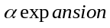 thoughts are employed to optimize segmentation results, consequently the vessel wall and lumen location are accurately located. Finally comparison with experts manually tagging results, and edge correlation coefficients and variance are applied to verify the validity of our algorithm. experimental results show that our algorithm can efficiently combines the advantages of mean-shift and graph-cut algorithm and achieve a better segmentation results.
Keywords: ultrasound image; mean-shift; graph-cut algorithm; Gauss mixture model;

Introduction
Medical ultrasound images is an important type of medical images and is widely used in medical diagnosis, Compared with other medical imaging methods, ultrasound imaging has the advantages of non-traumatic to human body, real-time display, low cost, ease to use. As an ideal non-invasive diagnosis method it has brilliant development and broad prospects. However, because of the imaging mechanism lead to be insufficient grayscale display range or unreasonable gray distribution, so the ultrasound images auxiliary diagnosis effect is constrained, especially in some local details, if the gray scale difference is not obvious, that will bring a lot of difficult to diagnosis. In order to improve ultrasound images quality and enhance the readability of ultrasound images local details, make images suitable for human eyes observation or machine analysis, therefore in recent years automatic segmentation for pathological area in ultrasound images become the research focus.
Some scholars dealt with the ultrasound image segmentation in the frequency domain, such as literature^{[1]} used wavelet decomposition to achieve wavelet coefficients then combined with neural network method to process segmentation problem. Sheng Y etc^{[2]} constructed an accurate ultrasound image segmentation algorithm in the wavelet domain with the Chan-Vese model, Ali Kermani etc^{[3]} combined the local histogram and wavelet transform to locate the position of breast lesions. J.Xie^{[4]} proposed a new method which combined texture and shape as the prior information, then energy function was constructed and texture of pathological area was classified by the shape parameter and gabor filter coefficients. Other researchers processed ultrasound image in the time domain, Literature^{[5]} proposed segmentation algorithm for vascular image based on gray probability density function and fast matching ideas, Literature^{[6]} constructed an image segmentation method based on graph theory, which has the advantages of robust to noise, sensitive to the blurred edge, low residual error rate and fast calculation speed. After remove speckle noise, literature^{[7,8]} adopted active contour model combining with prior information such as shape texture color to complete pathology region division. Christodou^{[9]} used ten different texture feature include first-order statistics, gray level co-occurrence-matrix, gray differential statistics, neighborhood gray difference matrix, statistical feature matrix, texture energy spectrum, characteristic of fractal dimension, power spectrum and shape parameters etc to extract carotid atherosclerotic plaques, then extracting separation results was treated by the K-neighboring method.
Foundation item: The issue is subsidized by the National Key Basic Research Program Project 973 (2011CB707904), National Natural Science Foundation of China(30671639), Natural Science Foundation of Jiangsu Province (BK2009393), High academic qualifications fund of Nanjing Forestry University (163070052,163070036).
Author:Ting Y (born 1980.10), post-doctor, lecturer, main research include Medical Image Processing and Machine Vision; Lirong S, doctor, lecturer; Huazhong S, professor, doctoral supervisor, main research include Medical Image Processing and Pattern Recognition.
Because the imaging mechanism of ultrasound images is complex, characteristics of pathological area are disturbed by noise and un-pathological region, so the visual features of critical regions are not distinct, the swap thought of graph cut algorithm can only get local optimum solution, so for the excessive interference ultrasound image can not achieve satisfactory results, if increase the iteration steps that will spend more time, thus vascular ultrasound image segmentation method based on mean-shift and graph cut theory is proposed in this article, firstly mean-shift method is adopted for initial vascular ultrasound image segmentation, in image small adjacent areas with similar gray attribute are classified into one class, secondly a new data and smooth item of the energy function is defined and the graph cut method is used to obtain the global optimal solution, thereby optimization and correction of segmentation results are realized and the vessel wall edge and endovascular is accurately located. Finally comparing with the manual tagging results the validity of our algorithm is proved.

Mean-shift Ultrasound Image Segmentation Method
Mean-shift computational model is an effective tool for analysis in feature space, it was widely used In many computer vision applications. Mean-shift is a probability density gradient function with no parameters estimation algorithm, It along the gradient rising direction to find the peak of the probability distribution. In the kernel density estimation, kernel function generally meets the conditions: 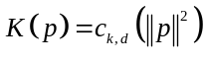,where 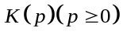 called kernel function and represents a single pixel in the image domain The normalization positive constant 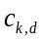is to ensure that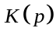 integral is 1. In mean-shift method gaussian kernel function and uniform kernel function is two kind of commonly used kernel function, let 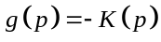, kernel function 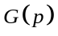 define 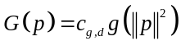. and mean shift vector is defined as follows: 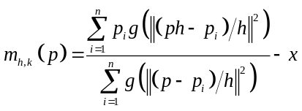 (1) 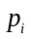 is the sample point of the current Parzen window.
Mean-shift solving steps include two parts:
1) Calculation of mean shift vector 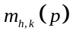;
2) According to the value to transform nuclear location, this process ensures to converge to the points that neighborhoods gradient are zero. Let 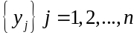 is location sequence during mean-shift process, by the formula (1) can be got: 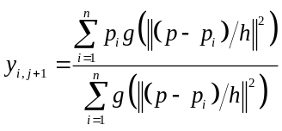, 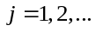(2) formula (2) calculate weight mean value with kernel function G in 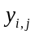 position, where 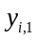 is the initial position of kernel.
Ultrasound image segmentation method based on mean-shift algorithm can be described as: Firstly, the ultrasonic image can be represented as a two-dimensional grid in three-dimensional space, grid space is called spatial domain, gray value space also called range domain. Through searching for the next shift point in the image space, and set the stop conditions, until the displacement is less than a given value, then translation is stopped. Let and (i＝1, 2, …, n) are respectively the input vector and the filter output results.
For the all data pointsi＝1, 2, …, n, mean-shift vector 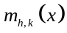 of each point are calculated, according to the value that moving window center to the next point. This process is repeated until convergence to the density peak of the data space, when the estimated density gradient is zero, then no need to move, and assign the pixel value 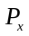 to 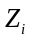, that is 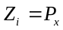. is the filtered pixel. the output image consists of multiple independent regions. Basic steps are as follows:
1) Initialize 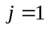 and 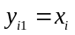
2) According to equation (2), calculate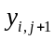 until convergence, and record convergence value is 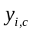.
3) Assign 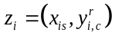.
Through the above three steps we get final results of mean-shift filter, where superscript and subscript respectively represent spatial domain and value range. Using mean-shift filtering method, need to set bandwidth vector 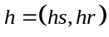.Bandwidth can be regarded as the resolution of segmentation, bandwidth is larger, more details of the image will be ignored, how to choose the appropriate bandwidth, is the key of successfully using kernel density function. In this paper radial gauss kernel function is adopted for ultrasound image segmentation.

Ultrasound Image Segmentation Optimization Based On the Graph Cut Theory
Graph cut algorithm is a global optimization algorithm, by using the class label and construct energy function, it convert image segmentation problem into the problem of minimizing the energy function. Under the guidance of the graph cut theory, network is ingeniously constructed, and energy is linked to the network capacity, lastly network flow principle about graph theory is adopted to find the graph minimum cut, the cut is optimal solution of the energy function minimization problem, besides the image segmentation is completed. Graph cut algorithm are two thoughts, include swap and .

Ultrasound Image Segmentation Model Based On MRF
Image segmentation approach based on the MRF model can be seen as optimization problems of acquisition the label field which make energy function 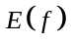 minimization. Energy function expressed as follows:
(3) Where 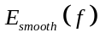 called smooth energy, it is the punishment to the un-smoothness characteristics; 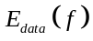 known as the data item energy, it is the punishment to the disagreement between current class label and observation data 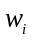 class. For a given image, represent each pixel, is the set of all pixels, all neighboring pixel pair 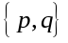 that constitute the set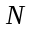. Where 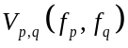 uses four neighborhood Potts model^{[10]}: 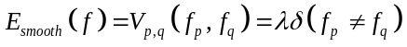, is the factor to balance the data item and smoothing item, each pixel data item energy 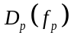 in type (3) can be got by type (4): 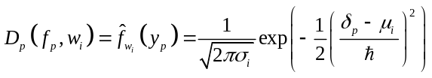(4). Where 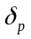 represent attribute value of pixel (such as gray value). 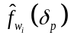 represent the probability of pixel belongs to the category . We use the mean-shift method to obtain the initial ultrasound image segmentation, and get mean values and variances of classes:
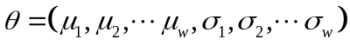,with gauss RBF kernel function (4) get likelihood estimation of the pixel to the corresponding classes. Where control the smoothness range of function(4), when the value of is large, function curve is more smooth, but may lose more detail information; The value of is smaller, function curve will be more sharper, that will over-reliance on the observation data, then the algorithm performance will degrade. In literature^{[5]} the method to estimation is given, such as 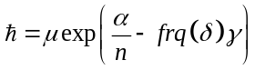,where 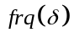 is the occurrence frequency of in the training sample set.

Graph-cut algorithm: swap algorithm ideas
Thought of the swap algorithm is repeatedly calculation two different categories 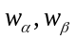, and graph grid is constructed to associate with energy equation(3) in order to obtain the optimal solution of equation. Let be the set of all pixels, while 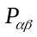 is a pixel points set which class belong to , grid construction as shown in figure 1, figure elements are: vertex set 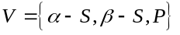, edge set
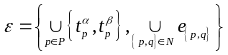, where 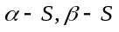 is two graph vertex, 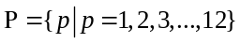,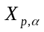 in figure 1 represent pixel label to the class 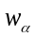 through mean-shift method. Pixel (satisfy 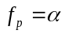 or 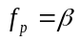) in 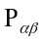 respectively connect with two vertices 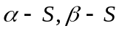 that constitute t-link edges, denoted by 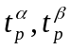, and the elements among constitute n-link edges, denoted by 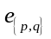, the weight of t-link and n-link assignment approach respectively see equation(5) and equation(6).
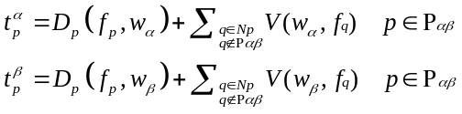 (5)
(6)
Where 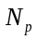 is adjacent area of pixel , literature^{[11]} prove the capacity of cut set is: 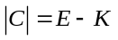 (7). Where is the energy value of equation(3),  is a constant, the optimal solution of energy function(3) is the minimal cut set of graph(1a). swap algorithm randomly select two class from class, and through the energy function to solve the corresponding cut set, then determine the pixel belongs to which class set, thus complete the segmentation optimization, specifically shown in Figure1a.

Graph-cut algorithm: algorithm ideas
The swap algorithm can only exchange 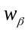 class to calculate of the minimum energy. If we limit and make exchange with all other classes, then will get a broader transformation approach, it is algorithm. Literature^{[12]} proved when formations of smooth item satisfy ‘metrics’ constrain, then algorithm ideas can be adopted to achieve more broader transformation, as shown in figure 1b, a set of vertices V,
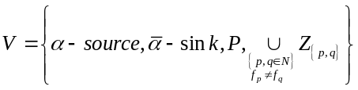 is the composition elements of the graph, where ,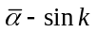 respectively the highest and lowest vertices.  is the any one pixel in , is adjacent pixels of 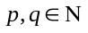. When the two pixel class label 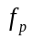and 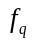 are unequal, then auxiliary nodes 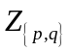 are added, Let 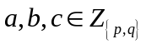are the auxiliary node, adding the auxiliary node 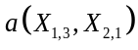 between 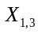 and 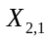, as shown in fig 1b, similarly, there are auxiliary nodes 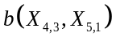 and 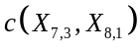. Where edge set is
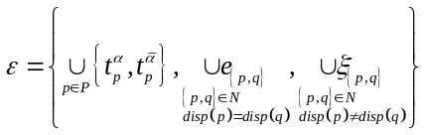, 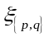are the edges that between auxiliary node with nodes,,. For example figure 1b shows that total three edges of c, the edge 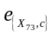 between and 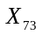, the edge 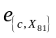 between and 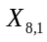; the edge between and , similarly, auxiliary node and construct edges with their adjacent nodes. the pixels of respectively connected with and to construct t-link edges, the pixels among P connect with each other to constitute n-link edges, edge weights assignment method is expressed by formula (8) and (9), if existing auxiliary node c, then the edge weight between c and adjacent points can refer to the following formula (10).
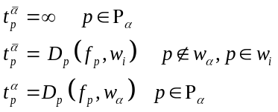 (8) 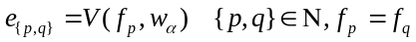 (9)
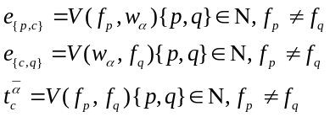 (10)
Where the definition of data item D see formula (4), smooth item as shown in formula (3). Literature^{[12]} proved that the cut-set capacity is 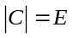 (11), where E is obtained from equation (3), then using the method of to optimally solve the equation (11). The steps of algorithm is: construct the network shown in Figure 1b, pixel set , Label is the same definition as swap algorithm, for the class, if the pixel labels are and , then set t-link and n-link edges to find the minimum graph cut set C, equivalent to seek the minimum energy 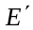 which corresponding to the class label 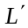, if condition 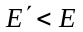is satisfied, then modify the class label by the same mode of swap algorithm, and update the class set of every pixel to .if 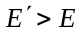,then exchange to other class and calculate the energy.

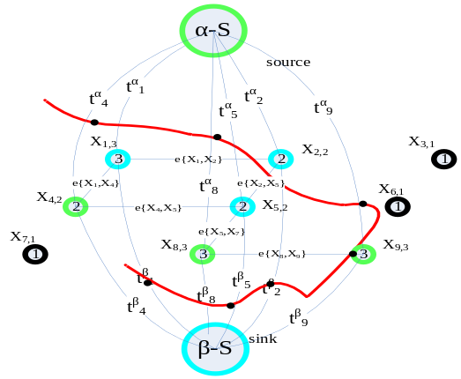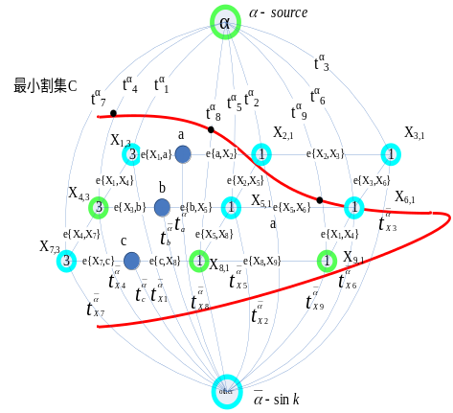
a swap b
Fig 1 Graph cut algorithm principle diagram

Experimental Results
The experiment of three ultrasound images is shown in Fig 2
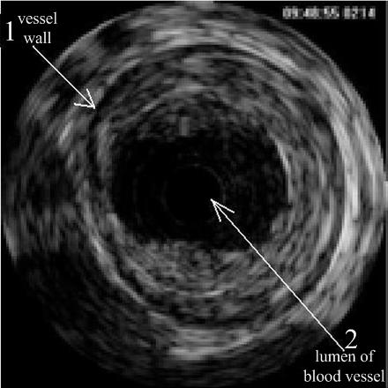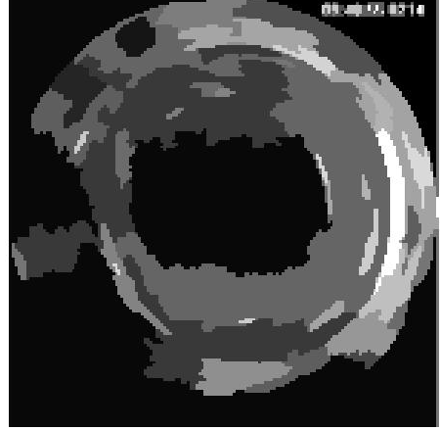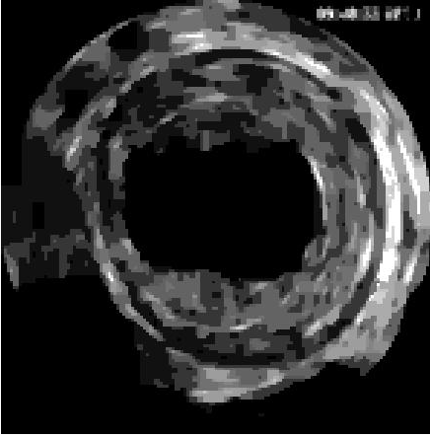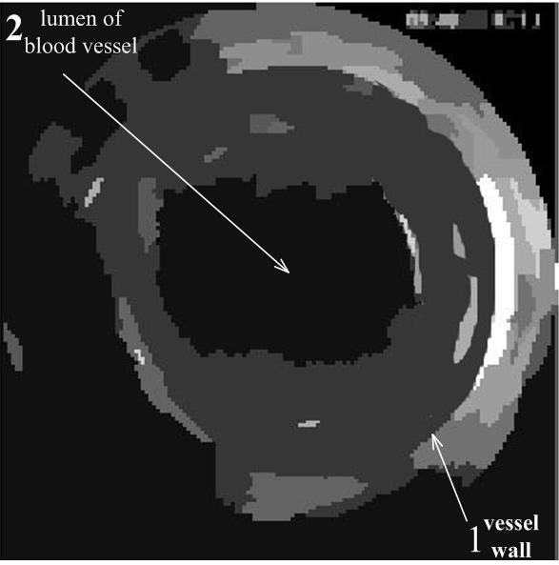
a b c d
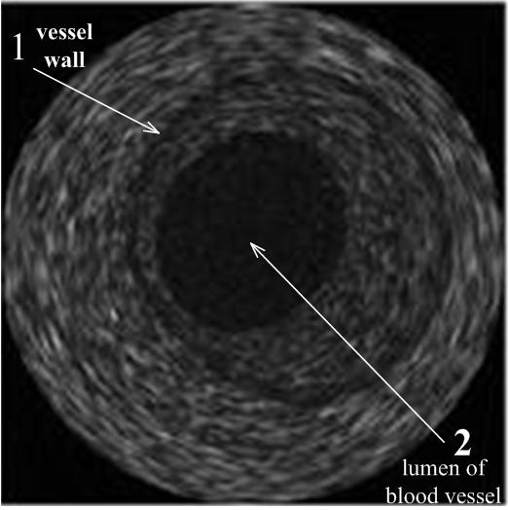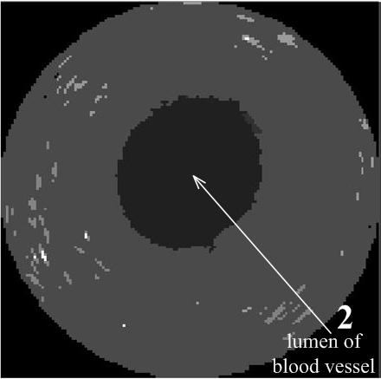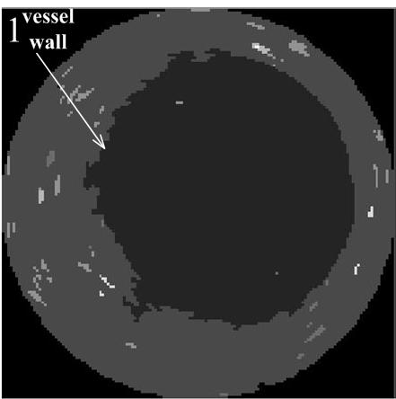
a b c d
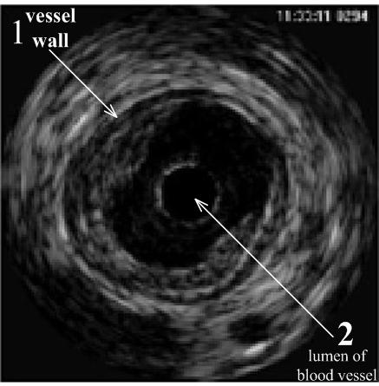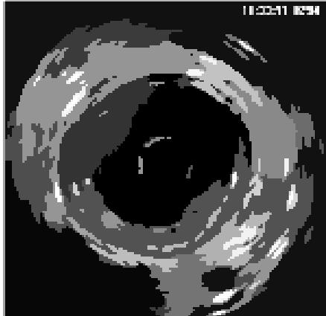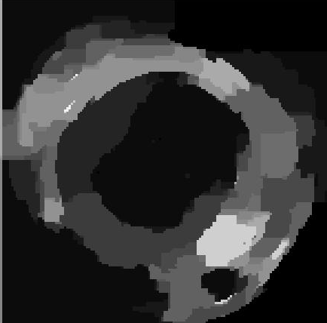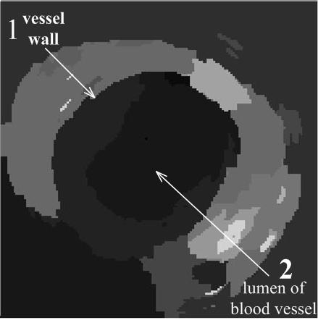
a b c d
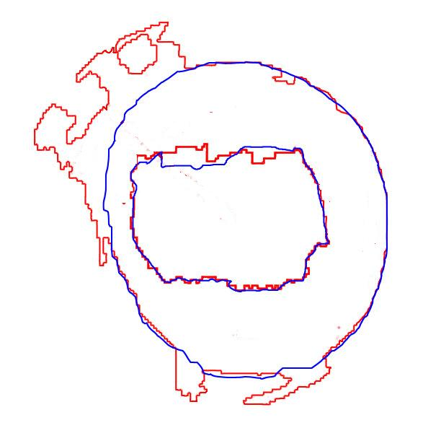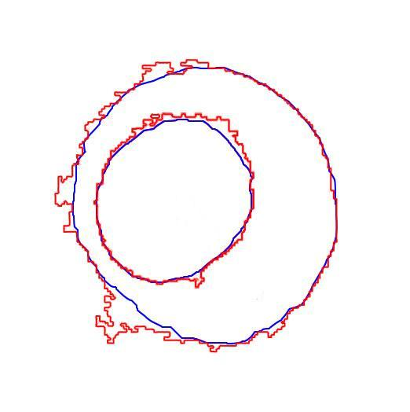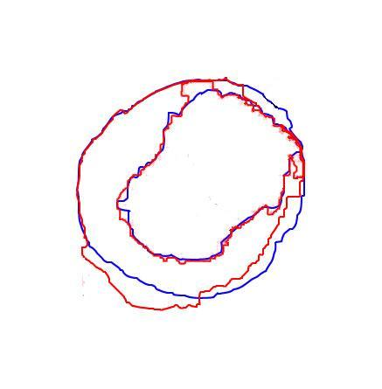
image1 result image2 result image3 result
Fig.2 Segmentation of ultrasound images, First columns (a): the original ultrasound images; Second columns (b): three snapshot for only mean-shift segmentation results; Third columns (c): only the graph cut algorithm used to get the segmentation results. Fourth columns (d): Segmentation of our algorithm, using graph cut re-segmentation after mean-shift segmentation results, where label 1 represents the vessel wall and label 2 represents lumen of blood vessel. The last row in Fig2 is comparison chart about above three ultrasound image segmentation results, blue lines represents the medical experts hand-labeled results of vessel cell and lumen edge, the red line is the labeling results of our algorithm

Then variance and correlation coefficients are used for comparison of test results, variance represents deviation degree of the two boundary points, while the correlation coefficients indicate similarity of two boundary shape. Firstly starting positions in the two boundaries are chose, then two L sub-sequence (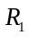and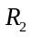) with fixed length in two curves are taken, The similarity of and notes for 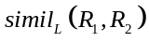, it depicts by 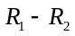 variance , that is 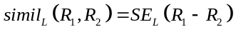, where variance
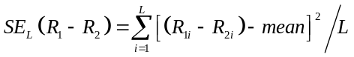
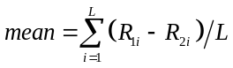,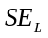 is smaller, the and are more similar, where 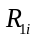 represents the distance between sampling points on a curve to the origin. Correlation coefficients 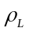 are adopted for edge comparison. 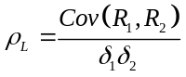, 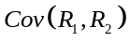 represents covariance between curve and curve , and 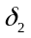 respectively denote the standard deviation of and ,
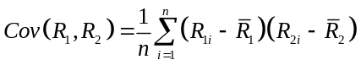 (12)
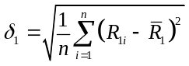 ,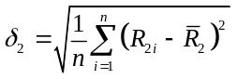 ,
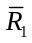 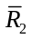 represent the mean distance of all points on curves to the origin.
Next, true positive ratio (True positive ratio, TP), false-positive ratio (False positive ratio, FP) and total similarity degree (Similarity, SI) are adopted, these three indicators evaluate the tumor region differences between the expert manual labeled results and our algorithm calibrate segmentation results^{[13]}:
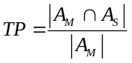，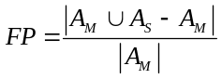，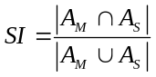(13)
where 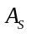 represents tumor region of our algorithm segmentation, 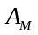 represents the doctors manually label tumor area, is higher, that our segmentation results cover the higher degree of expert manual calibration area; FP index is lower, then the covered wrong area is less; SI index is higher, that our segmentation result is closer to the manual label area. In this paper we define:
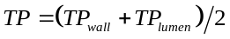,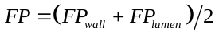,
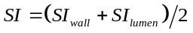
Table 1 shows the specific experimental parameters and experimental results, including the selection threshold, and the comparison between our algorithm and manual segmentation results, by calculating the correlation coefficients and variance of the curves to compare the similarity between them. From the experimental results can be seen, our designed algorithm can completely extract vascular lumen and accurately locate the position of the vessel wall, it has excellent performance in vascular ultrasound image segmentation.

Table 1. Selected coefficients and Experimental results
 | The h of equal(1) | The of equal(4) | vessel wall segmentation comparison with hand-labeling |  | vessel lumen segmentation comparison with hand-labeling |  | TP (%) | FP (%) | SI (%)
 | The h of equal(1) |  | variance | correlation coefficient | variance | correlation coefficient | wall+ lumen | wall+ lumen | wall+ lumen
ultrasound image1 | h =17 | 60 | 25.7 | 0.7789 | 13.2 | 0.8524 | 92.1 | 22.07 | 77.92
ultrasound image2 | h =13 | 90 | 12.6 | 0.9121 | 8.4 | 0.9456 | 95.3 | 8.90 | 86.80
ultrasound image3 | h =13 | 90 | 21.2 | 0.7833 | 11.8 | 0.9219 | 89.6 | 17.21 | 80.31

Conclusion and future work
This paper presents a novel vascular ultrasound image segmentation method which combining mean-shift and graph cut algorithm, firstly mean-shift algorithm is adopted for the initial segmentation, then initial classification results which include specific characteristic parameters of each class are obtained according to the histogram classification, subsequently probabilistic model is used to construct data and smooth items of energy function, and then using graph cut method to get the optimal solution of the energy function, thereby locating the position of vessel wall and vessel lumen, comparison with expert manual segmentation results, our algorithm achieves vascular location function. Our future work mainly include two aspects, firstly how to accurately and effectively locate the ultrasound vascular image edge when acquisition effect of ultrasound image are not well, secondly when the amount of medical image data is too large, how to improve calculation speed of maximum flow methods and enhance the graph-cut real-time performance for better adapt for the division of ultrasound images, these will be the focus of our future work.

References

- Zafer İşcan, Mehmet Nadir Kurnaz. Ultrasound Image Segmentation by Using Wavelet Transform and Self Organizing Neural Network. Neural Information Processing-Letters and Reviews.Vol. 2006, 10(8),.183–190.
- Sheng Yan, Jianping Yuan, Chaohuan Hou. Segmentation of Medical Ultrasound Images Based on Level Set Method with Edge Representing Mask. 2010 3rd International Conference on Advanced Computer Theory and Engineering(ICACTE),Chengdu.
- Ali Kermani, Ahmad Ayatollahi.Medical ultrasound image segmentation by modified local histogram range image method. Biomedical Science and Engineering, 2010,3,1078-1084
- J.Xie Y.Jiang and H.T.Tsui. Segmentation of kidney from ultrasound images based on texture and shape priors. IEEE Transaction on Medical Imaging, 24(1), 539-51,2005.
- Marie-Hélène Roy Cardinal, Jean Meunier, Gilles Soulez, Roch L. Maurice, Éric Therasse, and Guy Cloutier. Intravascular Ultrasound Image Segmentation: A Three-Dimensional Fast-Marching Method Based on Gray Level Distributions. IEEE Trans On Medical Imaging , 2006,25(5),
- Grady L，Funka Lea G.Multi-label image segmentation for medical applications based on graph-theoretic electrical potentials[C].Proceedings of Conference on Computer Vision and Mathematical Methods in Medical and Biomedical Image Analysis，ECCV2004，2004，3117：230-245.
- Cremers, D., Rousson, M., and Deriche, R. A review of statistical approaches to level set segmentation: integrating color, texture, motion and shape. Int. J. Compute Vision, 2007,72(2),195-215.
- Dydenko, I., Jamal, F., Bernard, O., D’Hooge, J. Magnin, I. E., and Friboulet, D. A level set framework with a shape and motion prior for segmentation and region tracking in echocardiography. Medical Image Analysis,2005,10(2),162-177.
- [9] C.I.Christodoulou, C.S.Pattichis. Texture based classification of atherosclerotic carotid plaques. IEEE Transacion on Medical Imaging. 2003,22(7), 902-912,.
- Roger Fjortoft，Yves Delignon，Wojciech Pieczynski，et al. Unsupervised Classification of Radar Images Using Hidden Markov Chains and Hidden Markov Random Fields [J]. IEEE Transaction on Geoscience and Remote Sensing(S0196-2892)，2003，41(3)：675-686.
- Richard Szeliski，Ramin Zabin，Daniel Scharstein，et al. A Comparative Study of Energy Minimization Methods for Markov Random Fields with Smoothness-Based Priors [J]. IEEE Transaction on Pattern Analysis and Machine Intelligence(S0162-8828)，2008，30(6)：1068-1080
- Boykov Y, Versler O , Zabih R. Fast approximate energy minimization via graph cuts [J] .IEEE Transactions on Pattern Analysis and Machine Intelligence , 2001 ,23 (11) :122221239.ternational Journal of Computer Vision, 1999, 33(3): 181-200
- Madabhushi A, Metaxas D N. Combining low-, high-level and empirical domain knowledge for automated segmentation of ultrasonic breast lesions. IEEE Transactions on Medical Imaging, 2003, 22(2): 155-169
.

