Live Mitochondria Transportation Tracking Based on Disturbance Elimination in GFP Images

Yang Li, Junmei Xu, Sidan Du, Kanglian Zhao
School of Electronic Science and Engineering
Nanjing University
Nanjing, China

Abstract- The signal-to-noise ratio (SNR) of the live mitochondria time sequence images captured by fluorescent microscopy is generally low and the frames of these images is limited. That makes the detection and tracking of mitochondria particles difficult. Especially, it is extremely difficult to get the movement trajectory for the disturbance of the mitochondria movement involves its self-moving and the motion caused by the live host and its neuron. A tracking algorithm for live mitochondria based on disturbance elimination is proposed in this paper. The time sequence image is frame-to-frame registered firstly, in which the edge corners pixels are chosen to be the feature points. Then those mitochondria particles are tracked by frame-to-frame displacement vector. The algorithm proposed has been applied to the dynamic image sequence including neuron and mitochondria, saving much time without manually picking up the feature points. It provides a new method and reference for medical image processing and biotechnological research.
Keywords- Fluorescent microscopy; Live mitochondria; Particle tracking; Image registration

Introduction
Fluorescent protein technology and high-resolution fluorescence microscopy has brought new development to the molecular biology and cell biology ^{[1-2]} and The observation and study of mitochondrial movement in which many researchers believe that important information of life are included. The mitochondria movement can be analyzed qualitatively and precisely though the time sequence images captured by fluorescent microscopy. In the present study, most feature extraction and data analysis and were manual ^{[3]}, which is time-consuming and may be influenced by individual differences between analyzer. Limited by fluorescence microscopy, the signal-to-noise ratio of the live mitochondria time sequence images captured by fluorescent microscopy is generally low and the frames of these images are limited.
In this paper, an effective live mitochondria tracking algorithm in neuron axon was proposed and the vector of live mitochondrial movement was calculated at the same time. Those clear and recognizable mitochondria pixels in images are chosen as the feature of mitochondrial particles to register image frames. Then the axon can be aligned by the image sequence registering to eliminate the disturbance interference to mitochondrial particles. Finally, based on the accurate alignment of axon image, the motion displacement vector can be extracted from inter-frame difference.

problem for tracking mitochondria particles
Live mitochondria tracking can be difficult, because the disturbance of the mitochondria movement which involves its self-moving and the motion caused by the live host and its neuron will interference the processing of detecting and tracking .
Fig.1 (a) (b) (c) are three sub images to show the disturbance. Two frames image (frame No. 1 & frame No. 40) from a time sequence of the live mitochondria in neuron axon of drosophila larva are added into one overlaying image. These sub image are three areas from the overlaying image. Because the neuron axon and its live host keeps moving along the axial direction and keeps deformable random swaying in radial direction, dislocated axons showed in Fig.1 (b) and (c). This dislocation and disturbance which cannot be aligned and eliminated by simple translation, rotation and other affine transforms make detecting and tracking difficult. Fig.1 (a) shows the mitochondria particles which stay stationary along the time mitochondria particles sequence are matched into pairs. It is showed that matched mitochondria particles have almost the same shifting vector, and the mitochondria particles pointed by the homodromous arrows have the same relative position. Therefore the movement and dislocation of all these particles pointed by the arrows mainly comes from interference of neuron axon self-movement and its host exists in these two frames of images.
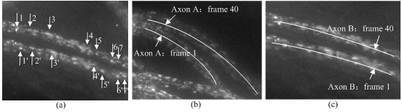
Figure 1. Frame-to-frame overlaying for mitochondria (frame 1 & 40): (a) Almost stationary mitochondria; (b) Difference of axon A from two frames; (c) Difference of axon B from two frames
And according to some research^{[3]} of the different influence on mitochondrial transport from Kinesin-1 and Dynein in the drosophila motor neuron axon. Mitochondrial transport is showed in Table 1, 57% of mitochondria particles are stationary, 29% of them are anterograde by the velocity of 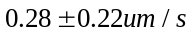 , and the other 14% are retrograde by the velocity of 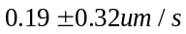 according to the result of tracking some neuron axon. Most mitochondria particles move slowly during a short interval(1 second to10 seconds). Therefore, they can be used as background with neuron axon and their overall movement in the image is caused by the interference of neuron axon.
- Proportion of Three Classes of the Mitochondrial Movement
 | Stationary | Anterograde movement | Retrograde movement
Percentage (%) | 57 | 29 | 14
Net velocity  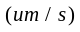 | 0.0
Net velocity 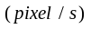  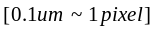 | 0.0

In the whole mitochondria time sequence images, many mitochondria particles are stationary and only interfered by the an overall disturbance. Therefore, in this paper Those stationary particles and the axons are taken as the datum points and background, then the interference of neuron axon disturbance will be eliminated by aligning the background will ^{[4]}. Finally, active mitochondria particles will be detected and tracking easily.

Disturance eliminate and track
In this paper, the image sequence was aligned by feature points matching to eliminate the interference to mitochondrial particles from neuron axon. As was mentioned in the reference ^{[7]}, the only information of particles was their location in the process of particle tracking. Thus the locations of corner points were taken as feature points for mitochondrial particles to align the frames. The main ideas for the method were: if the set of feature points was 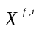 in the reference image and was 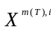 in the floating images and the number of feature points was , the match of feature points should make formula below be minimum.
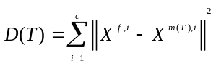

Feature Points Matching based on NCC and RANSAC
Due to better performance on gray image corner detection brought by Harris operator ^{[5]}, Harris operator is used to obtain the edge feature points of mitochondria particles. Traditionally the NCC method (Normalized Cross Correlation) is used to establish their correspondence of feature points between two images. It suppresses noise effectively but the error rate of matching is not low. And this paper combines the NCC method and RANSAC (RANdom Sample Consensus) algorithm ^{[6]} to establish the above relationship between two images, and finally ensures the matching accuracy of identical mitochondria particles between two frames. The NCC method establishes a criterion with cross correlation using gray information near each corner , then divides the matching pair into parts according to the result of the criterion and finally obtains a whole matching pair collection. The RANSAC algorithm is used to eliminate the wrong pair then. The whole flow chart is showed as Fig.2.
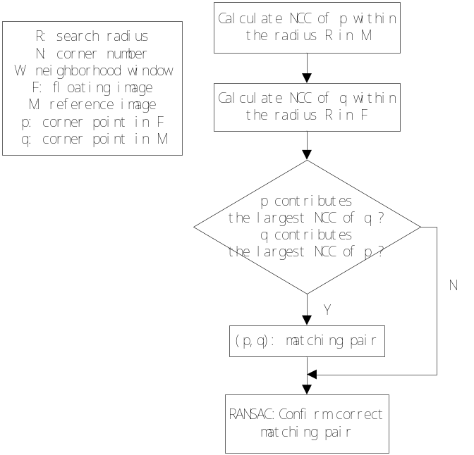
Figure 2. Algorithm Flow Chart
As showed in Fig.2, the set of the matching pair is first obtained by the NCC method. Then find all matching pairs and randomly pick up four matching pairs with optional three non-coplanar pairs among them to confirm the parameters of affine transform. Calculate the accumulated sum of geometric error through forward transform and backward transform of the remaining pairs: 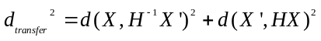. (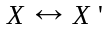 is the matching point pair). If the sum is less than the given threshold, this matching pair is called the inner point pair (correct matching). Repeat the calculation process until the num of the inner point pair is larger than the given threshold. And the algorithm will stop when the above repeating count is less than the present value.
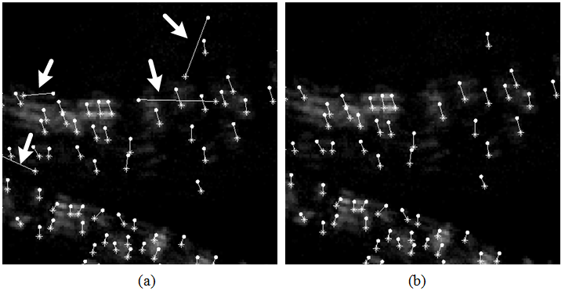
Fig 3 Feature points matching:
(a) NCC method ; (b) NCC method + RANSAC algorithm

The above experiment detects numerous corner points of mitochondria particles among which most particles are only interfered by the neuron axon and others’ movement combines self-movement and the interference caused by neuron axon. In the process of NCC matching, the neighborhood region of the corners is cross correlated and the matched corners mostly come from the mitochondria particles that are only interfered by the axon. Then RANSAC algorithm is used to eliminate wrong matches. Experiments show that the combination effectively eliminates the wrong matches and ensure the whole matching to converge.

Deformation Domain Estimation by Surface Fitting
Due to relatively accurate and widely distributed matching point pair obtained in the step of feature points matching, and continuous shift on each pixel of the floating image relative to the reference image, this paper estimates global shift surface by establishing cubic fitting surface of all shift vectors of matched points in the floating image. And this global shift surface is just the deformation domain of the floating image relative to the reference image, obtained by cubic interpolation along vertical and horizontal direction separately. Then the registering image is the sum of the global shift surface and the pixel coordinates of the reference image. Coordinates calculated is not integral and need to be bilinear interpolated.

Particles Tracking based on Sets of Displacement Vector
The problem of particle tracking could be described as below. Set image sequence 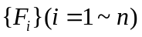 with frames, 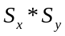 is the image size, 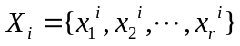 is the set of points detected in 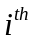frame. Define the tracking path with the length of is 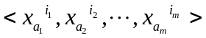 (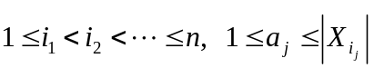). And finally the set of path in the image is 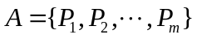(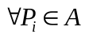, 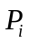 represents the particle).
The paper describes this problem as below. Set the frame 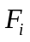, the previous frame 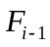, and 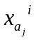and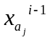 represent the position for the detected mitochondrial particle in these two frames separately. Reference on the previous frame, the position for the particle in frame after registered is 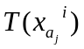, and then 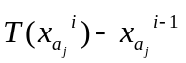denotes the displacement vector . The movement trajectory for the mitochondrial particle from the starting position 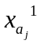 is
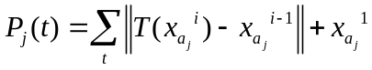
The algorithm of displacement vector is showed in Fig 4. ,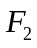and 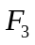 are three continuous frames of image. We want to find the corresponding point of 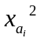 from image 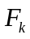(k=2 here) in 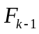 and 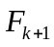. The circles pointed by 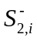 and 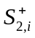 denote the finding area, 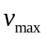, the max moving range of the particle , serves the radius of the circle, and 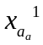and 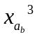 are set as the corresponding points of separately. We will find and 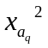additionally when we forward search the corresponding point of from the next frame . Then we find that the point is operated and currently denotes the competitive point forming the potential path 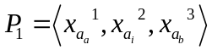. When we forward search on the basis of again , maybe we will obtain the second potential path 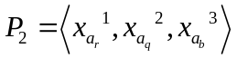. If it occurs, we will choose the proper path through setting the cost function 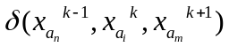[. Finally the points of the continuous frame subtracts to obtain the displacement vectors after the appropriate path is found.
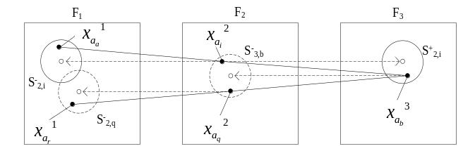 Figure 4. Particle tracking by searching corresponding points
The paper processes those registered images, and they are registered between the neighboring frames, so the above algorithm need to be improved. Whether we search the corresponding point forward or backward, we should transform to the position in the registered image, and additionally we make use of the improved algorithm just in the neighboring two images.

experiment and result
Frames of the time sequence images showed in Fig.1 which totally have 60 frames captured by Olympus fluorescence microscopy and a high sensitive Nikon CCD detector. are used to verify the presented algorithm. The frame interval is 5 seconds. The arrow indicates the mitochondrial particles which are interfered by the disturbance in different frames in Fig.1. With the inter-frame displacement vector sequence method, the particles movement are analyzed in registration image in this paper. After the inter-frame registration, the registration image and reference image are used to calculate inter-frame difference. They are registered and tracked. The normalized mutual information value between reference image and floating image was 1.18. After registration, the value is 1.32. When two images were the same, the maximum value is 2.0. That shows the algorithm could make the registration images closer to the reference images. More important, the method of the mitochondrial detecting and tracking is achieved. It is proved that disturbance of the mitochondria movement which involves its self-moving and the motion caused by the live host and its neuron has been eliminated effectively.
The tracking result shows in Fig.5 (b) could be got after enhancement and remove large fuzzy connected domain. The white curve was the mitochondrial transportation tracks that the mitochondrial particles were not affected by axon and the oval-shaped particles marked the combined movement. The first difference was the mitochondrial particles velocity after fitting the curve and could be used to analyze the fluorescent protein influence on mitochondria transportation.
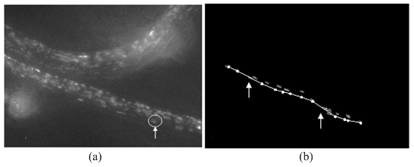
Figure 5. Tracking of the mitochondria particle: (a) local marking of the moving particle; (b) the movement curve of the particle
An active particles tracking method which is used in noisy image sequence was presented in this paper. The main feature was described as below: in the image sequence, the active particles moving boundary were registered and most edge corner points which did not have automatic movement were used as feature points. The mitochondrial transportation tracks of active particles was tracked by inter-frame displacement vector. The method had been successfully used in dynamic image sequence in which the neuron and mitochondria had simultaneous movement. The method did not need to manually extract the feature points of particles to save time and offered a new reference for medical image processing and biotechnology research.

References
- P. V. Roessel and A. H. Brand, “Imaging into the future: visualizing gene expression and protein interactions with fluorescent proteins,” Nat. Cell Biol., vol. 4, E15-E20, 2002.
- S. G. Megason and S. E. Fraser, “Digitizing life at the level of the cell: high-performance laser-scanning microscopy and image analysis for into imaging of development,” Mech. Develop., vol. 120, pp. 1407-1420, November 2003.
- A. D. Pilling, D. Horiuchi, C.M. Lively et al, “Kinesin-1 and Dynein Are the Primary Motors for Fast Transport of Mitochondria in Drosophila Motor Axons,” Mol. Biol. Cell, vol. 17, pp. 2057-2068, April 2006.
- M. K. Cheezum, W. F. Walker and W. H. Guilford, “Quantitative Comparison of Algorithms for Tracking Single Fluorescent Particles,” Biophys. J., vol. 81, pp. 2378-2388, April 2001.
- B. Zitova and J. Flusser, “Image registration methods: a survey,” Image Vision Comput., vol. 21, pp. 977-1000, November 2003.
- C. Schimid and R. Mohr, “Local Gray value Invariants for Image Retrieval,” IEEE T. Pattern Anal., vol. 19, pp. 530-535, May 1997.
- K. Shafique and M. Shah, “A Non-Iterative Greedy Algorithm for Multi-frame Point Correspondence,” IEEE T. Pattern Anal., vol. 27, pp. 51-65, January 2005.
- D. Chetverikov and J. Verestoy, “Tracking Feature Points: A New Algorithm,” 14th International Conference on Pattern Recognition (ICPR’98), vol. 2, pp. 1436-1438, 1998.
- I. K. Sethi and R. Jain, “Finding trajectories of feature points in a monocular image sequence,” IEEE T. Pattern Anal., vol. 9, pp. 56-73, 1987.

