Two-Stage 3D Reconstruction From Uncalibrated Multiple Views Using Particle Swarm Optimization

Ya-Ping Wong and Boon-Yian Ng
Faculty of Information Technology
Multimedia University
Cyberjaya, Malaysia
ypwong@mmu.edu.my, nbyian@mmu.edu.my

Abstract— Given a set of 2D images of a set of 3D points, with known correspondence among them, we would like to reconstruct the coordinates of the 3D points and discover the projection matrices associated with the cameras used to capture these 2D images. Once this information is obtained, we would be able to compute any novel view of these 3D points from a virtual camera placed at any position and orientation. We solve this problem as a two-stage optimization problem using Particle Swarm Optimization (PSO) algorithm. In the first stage, we directly estimate the camera intrinsic and extrinsic parameters using a subset of the 2D points. The 3D points are estimated in the second stage.
Keywords- 3D Reconstruction, Particle Swarm Optimization

The 3D Reconstruction Problem

The Problem Statement
Given m cameras and n 3D world points, the 3D world points are projected to the cameras to form n image points on each of the camera. We wish to reconstruct the n 3D world points and discover the m projection matrices associated with each of the m cameras.
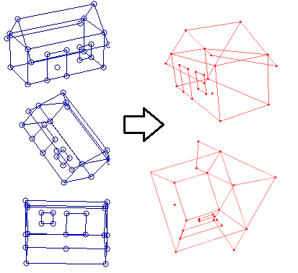
- On the left are 3 different images of a set of 3D world points used for the 3D reconstruction; the two images on the right are generated artificially after the 3D reconstruction is solved.
To illustrate this, Fig. 1 shows 3 sets of image points extracted from 3 different images captured using 3 different static virtual cameras. After the problem of 3D reconstruction has been solved, we can easily generate any novel views such as the two views on the right in Fig. 1. Only the points shown in the figure are used in the computations and the lines are only for visualization purpose only.
The problem of 3D reconstruction from multiple views can be written as follows.
Given image points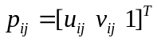
for i = 1,...,m and j = 1,...,n,
find scale factors 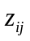,
projection matrices 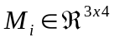 and
3D world points 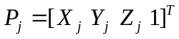
for i = 1,...,m and j = 1,...,n,
such that the estimated image points
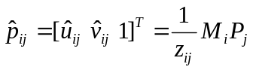
for i = 1,...,m and j = 1,...,n (1)
minimize the re-projection error (cost function)
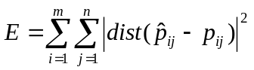, (2)
where 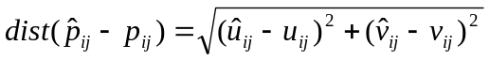. (3)
Here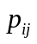is the homogeneous coordinate vector of the image point in the i-th camera of the j-th 3D world point and 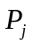 is the homogeneous coordinate vector of the j-th 3D world point. We do not need to explicitly compute because is simply the last value in the vector produced by 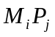.
The input to this optimization problem above therefore has 2mn values while the output has 12m+3n values.
Detailed description of this problem and the geometrical solutions can be found in [1], [2], [3] and [4]. Most of the geometrical solutions are very complex and often yield poor results due to various problems outlined in the references above. A detailed discussion on this is beyond the scope of this paper.
In this paper, we outline an approach to solve this 3D Reconstruction problem using Particle Swarm Optimization (PSO) algorithm.

Related Work
There have been many attempts to solve the 3D Reconstruction problem using Evolutionary Computation methods such as those listed in our previous paper [5]. Most of these works assume that the cameras have been calibrated and the motion of the cameras is constrained and known in advance. Most of these algorithms make use of evolutionary computation method which involves evolutionary operators such as crossover and mutation. It is our goal to find a simpler solution which does not involve such operators.
The works that are closest to our work were given by L. de la Fraga and I. Vite Silva in [6] and [7]. However, the main differences between their works and ours are:
- Their works are based on Differential Evolution and ours are based on the much simpler formulation of PSO algorithm.
- Their works required that the images are captured with the same camera at different positions and orientations. For our algorithm, the images can be captured using different cameras with very different camera intrinsic parameters such as focal length.
This paper is an extension of our work published in [5]. More details about the related work can be found in that paper.

Particle Swarm Optimization

The Background
Particle Swarm Optimization (PSO) is a population-based stochastic algorithm within the class of Swarm Intelligence [8] optimization techniques first introduced by Kennedy and Eberhart in [9] for solving continuous and discrete optimization problems. The search space of a problem can be visualized as a multi-dimensional terrain for software agents called particles to navigate to find a solution. A candidate solution is represented as the position of a particle on this terrain and the objective is to find the minimal or maximal point of the terrain. A swarm of particles is mobilized and each particle is given a position and velocity which would be modified by the algorithm in searching for better positions at each iteration.

The PSO Problem Statement
Given a d-dimensional search space  of a problem, and 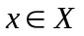, the problem of PSO is to find 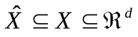such that,
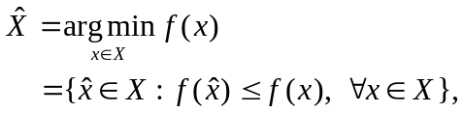 (4)
where 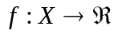is the fitness function (also called objective function or cost function).

The PSO Algorithm
In general, most PSO algorithms are carried out in the following steps:
- Create a swarm of particles uniformly distributed over with random positions and velocities.
- Evaluate each particle’s position using fitness function.
- If a particle’s current position is better than its previous best position discovered so far, update the information about the best position.
- Determine the best position among the best positions of all the particles within a predefined neighborhood.
- Update the velocities of all particles and move particles to their new positions according to the update equations to be discussed later.
- Repeat Step 2 until stopping criteria are satisfied.

Update Equations of Original PSO
The original positions and velocities update equations introduced by Kennedy & Eberhart in [9] are:
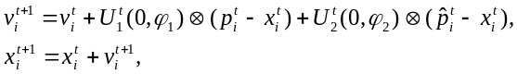 (5)
where,
t = time step,
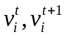, = velocity of particle-i at t and t+1 respectively,
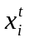,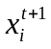 = position of particle-i at t and t+1 respectively,
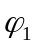 = cognitive acceleration coefficient,
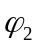 = social acceleration coefficient,
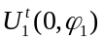= vector at t, entries are random numbers uniformly distributed in the interval [0, ),
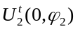= vector at t, entries are random numbers uniformly distributed in the interval [0, 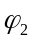),
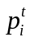 = best position found so far by particle-i,
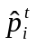 = best position found so far by the neighborhood of particle-i.
is component-wise vector multiplication.

The velocities and positions need to be constrained in this model.

Update Equations of PSO With Inertia
In [10], Shi and Eberhart introduced inertia into the update rule as follows:
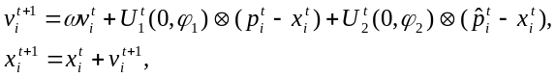 (6)
where,
= inertia weights.
Variants of this rule have also been proposed by Shi and Eberhart in [11] to [13].

Update Equations of PSO With Constriction
The convergence effect of the various PSO parameters was studied in details by Clerc and Kennedy in [14], and constriction coefficient was proposed to overcome explosion and oscillations. The simplest form is:
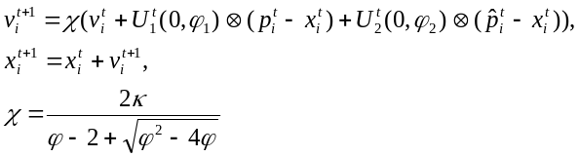 (7)
where 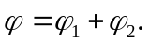Under the condition 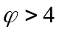and 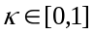, the swarm is guaranteed to converge to a stable point. 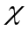is called constriction coefficient and velocity clamping is not required.

Two-Stage 3D Reconstruction Using PSO

Camera Parameters
In (1), the projection matrix 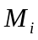 associated with camera-i is a 3 x 4 projection matrix which can be decomposed as:
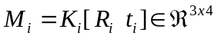 (8)
with,
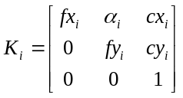, 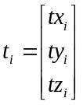and 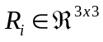. (9)
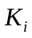is called the calibration matrix which represents the camera intrinsic parameters where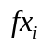and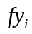are camera focal lengths measured in width and height of the pixels respectively, 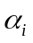is the factor accounting for the skew due to non-rectangular pixels and 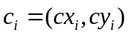 are the image coordinates of the principal point of the camera.
The rotational matrix 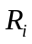and translational vector are the camera extrinsic parameters which relate the camera orientation and position respectively to a world coordinate system. We parameterized using a quaternion.
A rotation of radian about a vector 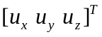can be represented by a quaternion 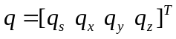where and the rotational matrix becomes:
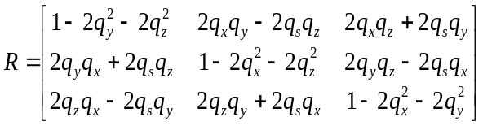.
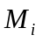associated with camera-i can now be completely parameterized by a vector 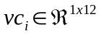for camera-i and given m cameras, we can form a single vector as follows:
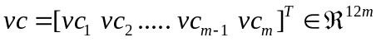 (10)

3D World Points
Given n 3D world points, we have 3n parameters which can be put together to form a vector (vector for world) as below:
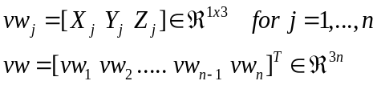 (11)

Points in Particle Swarm Parameter Space
Thus, putting (10) and (11) together, a point in the parameter space for the particle swarm is therefore formed by:
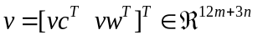 (12)

The 3D Reconstruction Algorithm
The dimension of the PSO algorithm parameter space is equal to the number of parameters we wish to estimate in our problem. Thus, given m cameras and n 3D world points, the dimension of our parameter space is equal to 12m + 3n. It would be computationally expensive to solve this directly when the number of 3D points is huge.
Fortunately, just as in most calibration algorithms, the camera parameters can be discovered if we know in advance just a small subset of the actual 3D points corresponding to the 2D points on the images. However, in our problem, we do not have such known 3D points. On the other hand, since it is impossible to solve for the 3D points without the camera parameters, it is tempting for us to try to solve for all the 3D points and the camera parameters simultaneously. This proves to be computational intensive since our search space has 12m + 3n dimensions given m cameras and n 3D world points. However, if n is small, this indeed is possible. With this in mind, when n is big (>30 points), we formulate our 3D reconstruction problem as a two-stage problem, where we solve for the camera parameters before we solve for 3D points. Our 3D reconstruction algorithm is therefore as below.
STAGE 1: Solve for Camera Parameters
a. Select 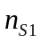3D world points to form the parameter space together with the camera parameters for the m cameras. The dimension of the PSO parameter space will be 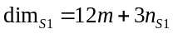.
b. Solve for the camera parameters for the m cameras and the 3D world points together using the PSO algorithm stated above.
From our experiments, we found that 15 to 25 points that spread out sufficiently on the images are enough for us to achieve this purpose.
STAGE 2: Solve for 3D World Points
For every 3D world point, which may or may not be one of the earlier number of 3D world points, solve for the 3D world point coordinates using PSO. In this situation the dimension of the parameter space is 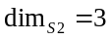.
With this Two-Stage 3D Reconstruction method, the complexity of the algorithm grows only linearly with the number of 3D world points.

Experiments and Results

Parameter Setting and Update Equations
In our previous paper [5], we ran our experiments using the PSO with Inertia stated in (6) above. However, we found that the choice of, 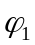and are very problem-dependent and the wrong values often cause the algorithm not being able to converge to a good solution. We have experimented with other PSO models and we found that PSO with Constriction in (7) is one of the most stable ones, as claimed by Clerc and Kennedy [14]. Clerc and Kennedy [14] and Poli et al. [15] recommended the optimal for be set to 4.1 and it is common to set 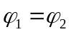= 2.05, so that =+=4.1. Thus 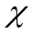= 0:729843788 if is set to 1. For our case, we use = 1.9 and = 2.1 in all our examples in this paper to allow the system to converge a little faster but the result may not be the most optimal one. Other parameters are similar to those shown in our earlier paper [5].
We will show 3 examples of the results of our experiments. The first example has already been shown in Fig. 1. The inputs to the system (the three images on the left of Fig. 1) are captured from a 3D model using virtual cameras as shown in Fig. 2. Only the points are used and the lines are for visualization purpose only.
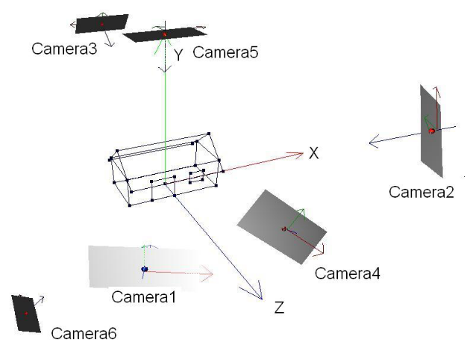
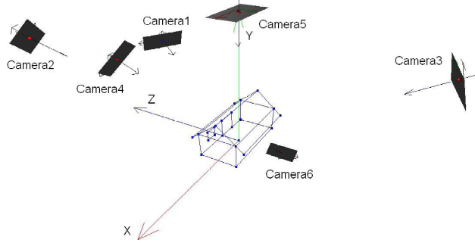
- Virtual cameras used to generate input to the system
In this example, all the 23 3D points are computed in Stage 1 and thus Stage 2 is not necessary.
In the second example, the Stanford Bunny model from Stanford Computer Graphics Laboratory is used to generate the input images. The results are shown in Fig. 4. 25 particles were used in Stage 1 and 15 particles were used in Stage 2. There are 453 points in this model.
We can see that once the camera parameters have been estimated accurately enough, it takes very few iterations in a short time for all the points to be estimated in Stage 2. Once these 3D points have been estimated, we may generate any novel views of the model. Fig. 3 shows the 3D model from a viewpoint different from the input images. Due to space constraints, we shall not discuss error analysis here.
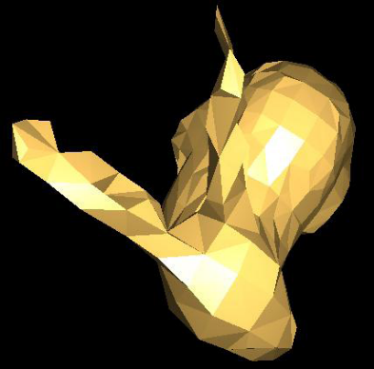
- A novel view of the reconstructed Stanford Bunny.

Itr_{S1,}  Itr_{S2} | Time_{S1,}  Time_{S2} | 6 Different Views
Input Images => |  | 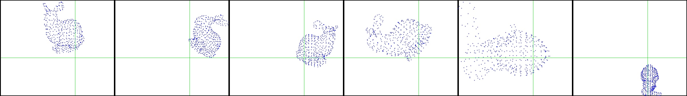
1,  0 | 0.001,  0.00 | 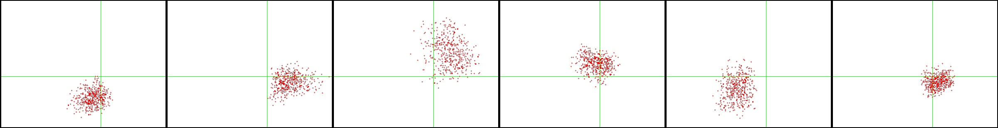
10,  32 | 0.01,  0.54 | 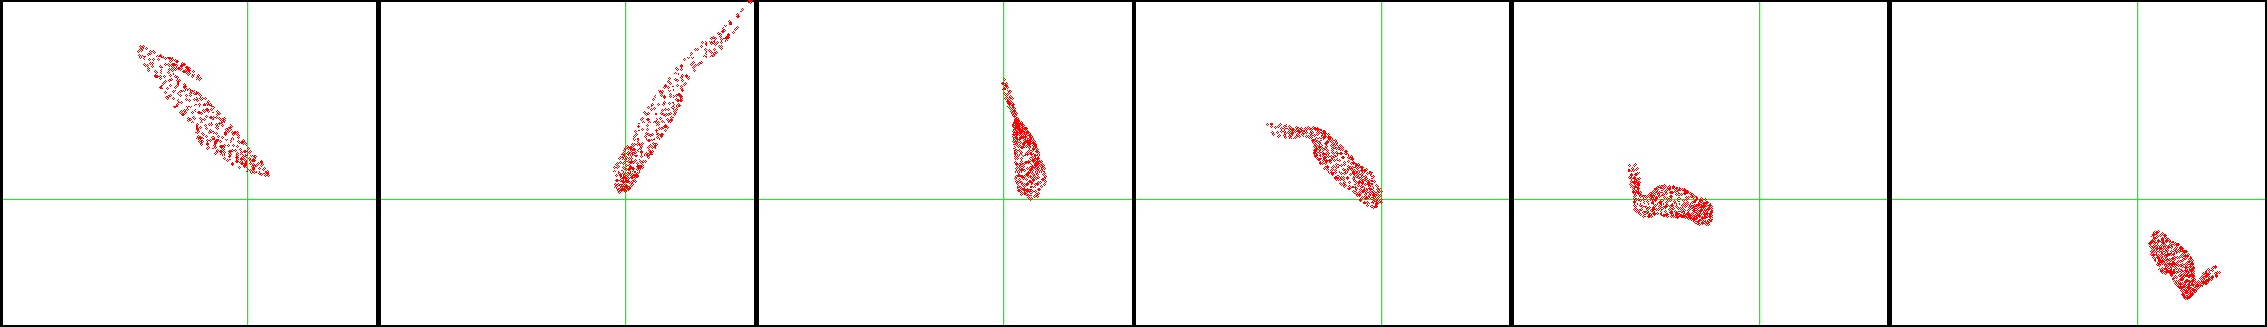
100,  32 | 0.08,  0.59 | 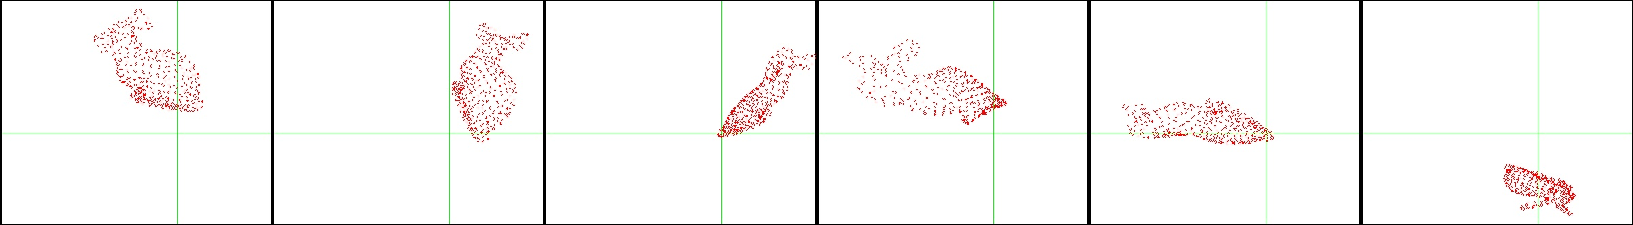
1000,  32 | 0.44,  0.56 | 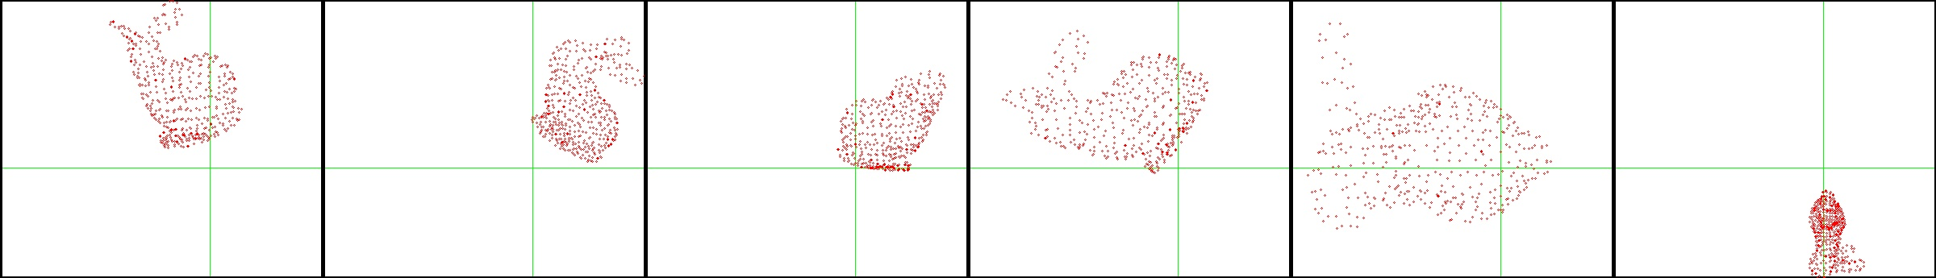
10000,  0 | 4.14,  0.00 | 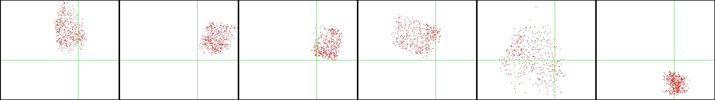
10000,  2 | 4.23,  0.04 | 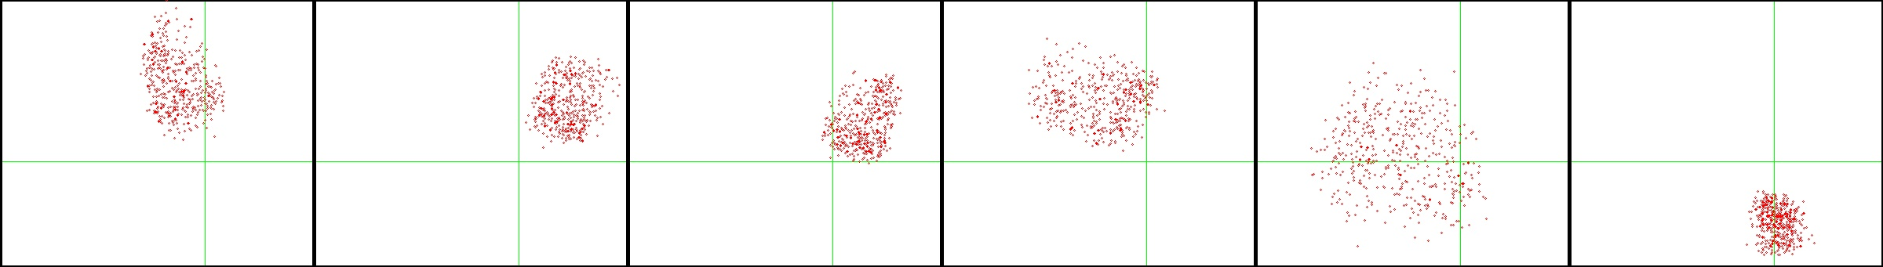
10000,  4 | 4.32,  0.09 | 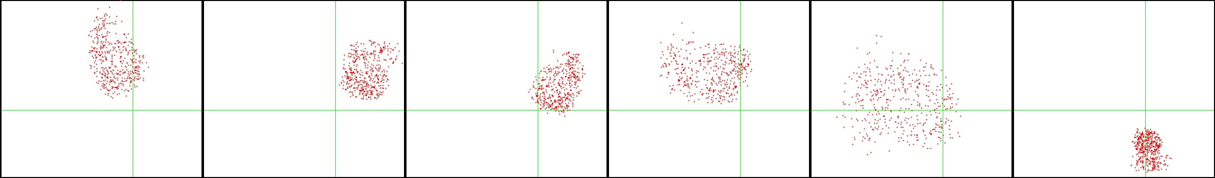
10000,  8 | 4.14,  0.14 | 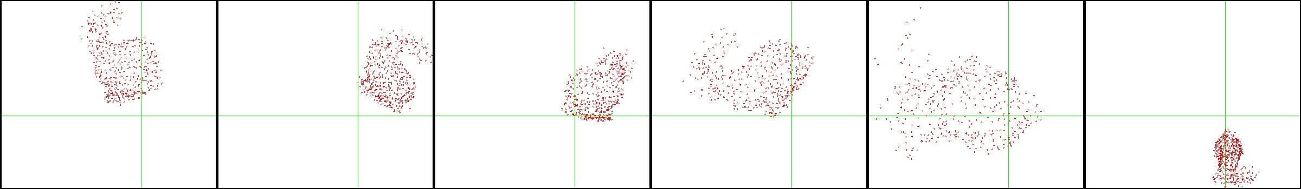
10000,  16 | 4.12  0.28 | 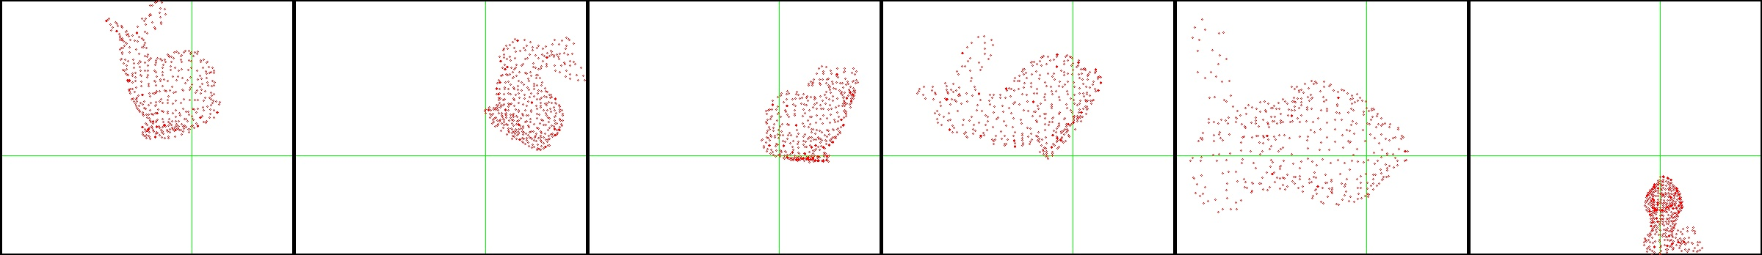
10000,  32 | 4.29,  0.58 | 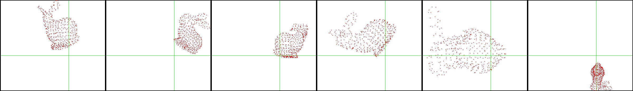

- 3D Reconstruction of the Stanford Bunny. Number of iterations and time taken for Stage 1 (S1) and Stage 2 (S2) are shown in the first two columns.

We carried out our experiments on a ASUS Notebook G60 Series with Intel(R) Core(TM) i7 CPU Q720@1.60GHz running 64bits Windows 7. In the last six cases in Column 2 of Fig. 4, the times taken to carry out 10000 iterations of Stage 1 may not be exactly the same because they came from separate runs. We are aware that it is better to take the average time from multiple runs. However, what we are interested to show here is to give the reader a sense of the speed of the algorithm.
Our third example is shown in Fig. 5, where the input of our system is now image points from sketched figures, instead of input images captured from existing 3D models using virtual cameras. The lines are for visualization purpose only and not used by the system.
- 3D Reconstruction from sketch figures.
input | 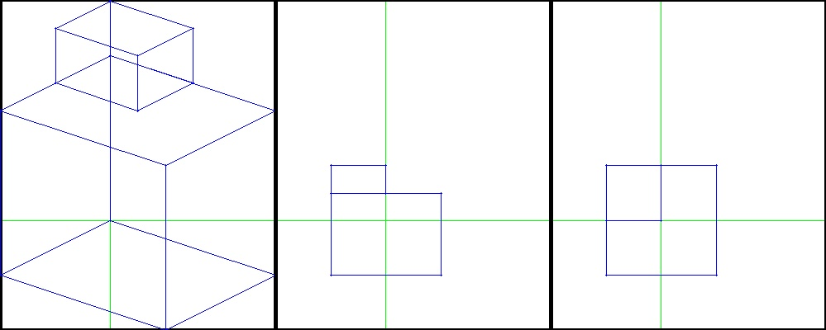
output | 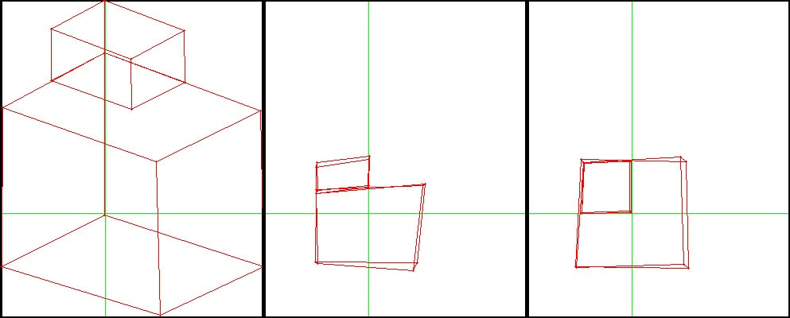
novel views | 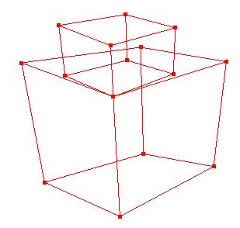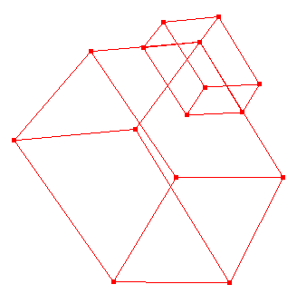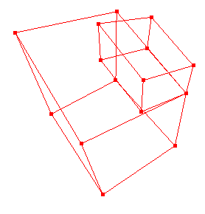

Future Work and Conclusion

We have demonstrated that PSO can be a very simple and yet efficient tool for solving the 3D reconstruction problem. In the future, we intend to apply the algorithm to images captured from real cameras. Further studies are needed to find the best PSO models to use and to find the optimal PSO parameters to be used. At the moment, we assume that each image contains the same number of points representing the same set of 3D points in the world. This restriction can be removed with extra processing.

References

- D.A. Forsyth and J. Ponce, Computer Vision: A Modern Approach. Prentice Hall Professional Technical Reference, 2002.
- R. Hartley and A. Zisserman, Multiple View Geometry in Computer Vision, Cambridge University Press, New York, USA, 2003.
- O. Faugeras, Q.T. Luong and T. Papadopoulou, The Geometry of Multiple Images: The Laws That Govern The Formation of Images of A Scene and Some of Their Applications, MIT Press, Cambridge, MA, USA, 2001.
- Y. Ma, S. Soatto, J. Kosecka and S.S. Sastry, An Invitation to 3-D Vision: From Images to Geometric Models, Springer-Verlag, 2003.
- Y.P. Wong and B.Y. Ng, "3D Reconstruction from Multiple Views Using Particle Swarm Optimization", in Evolutionary Computation, 2010. CEC 2010. (IEEE World Congress on Computational Intelligence). IEEE Congress on, pages 9-16, Barcelona, Spain, 2010.
- L. de la Fraga and I. Vite Silva, “Direct 3D metric reconstruction from multiple views using differential evolution,” in EvoWorkshops, vol. 4974 of Lecture Notes in Computer Science, 341-346, Springer, 2008.
- L. de la Fraga and I. Vite Silva, “Direct 3d metric reconstruction from two views using differential evolution,” in Evolutionary Computation, 2008. CEC 2008, (IEEE World Congress on Computational Intelligence), 3266-3273, 2008.
- A. P. Engelbrecht, Fundamentals of Computational Swarm Intelligence, John Wiley & Sons, Chichester, UK, 2005.
- J. Kennedy and R. Eberhart, “Particle swarm optimization,” in Neural Networks, 1995. Proceedings, IEEE International Conference on, vol. 4, 1942-1948, 1995.
- Y. Shi and R. Eberhart, “A modified particle swarm optimizer,” in Evolutionary Computation Proceedings, 1998. IEEE World Congress on Computational Intelligence., The 1998 IEEE International Conference on, 69-73, 1998.
- Y. Shi and R.C. Eberhart, “Parameter selection in particle swarm optimization,” in EP '98: Proceedings of the 7th International Conference on Evolutionary Programming VII, 591-600, Springer-Verlag, London, UK, 1998.
- Y. Shi and R.C. Eberhart, “Empirical study of particle swarm optimization,” Evolutionary Computation, 1999. CEC 99. Proceedings of the 1999 Congress on, 1999.
- R.C. Eberhart and Y. Shi, “Tracking and optimizing dynamic systems with particle swarms,” Evolutionary Computation, 2001. Proceedings of the 2001 Congress on, 94-100 vol. 1, 2001.
- M. Clerc and J. Kennedy, “The particle swarm - explosion, stability, and convergence in a multidimensional complex space,” Evolutionary Computation, IEEE Transactions on, 6, 58-73, 2002.
- R. Poli, J. Kennedy and T. Blackwell,. "Particle swarm optimization", Swarm Intelligence, 1:33, 2007.

