Video Signal Acquisition Using Compressive Sampling with Motion Compensation
I. Wahidah^{1,2}, A.B. Suksmono¹, T.L.R. Mengko¹, and Hendrawan¹
¹ Institut Teknologi Bandung, School of Electrical Engineering & Informatics, Indonesia.
² Institut Teknologi Telkom, Faculty of Electrical & Communications Engineering, Indonesia.
wahidah@ittelkom.ac.id
Abstract
We present a new compressive sensing’s variant scheme to encode and recover video signal. The first stage of video processing will transform the signal into a sparse domain, in which only a few coefficients are considered significant. The acquisition/projection stage will select coefficients based on certain random distribution, for instance, Gaussian i.i.d. process. At the decoder, the reconstruction stage will extract the original signal from the corrupted one. Basis Pursuit is employed to recover video accurately. This task is challenging because the nature of video that is composed by huge data in the form of frames, blocks, as well as pixels. In the experiments, we perform block-based coding and compressive sensing to the Y-component of a low frame rate and low resolution video. The results show that the use of higher measurement rate in reference frames and motion compensation in non-reference frames yields PSNR greater than 30 dB.
Keywords: compressive sensing, video coding, compressed sampling, motion compensation

Introduction
Compressive sensing is a data acquisition technique that aims to sample signals sparsely in transform domains [1]. The process of compressive video sensing utilizes a more random measurement scheme with a convex optimization procedure to acquire a subset of signals at a rate that is significantly below Nyquist rate [2]. However, it will work only if the signal is sparse in the transform domain. Conventionally, discrete cosine transform (DCT) provides a good basis for signal transform. In a video coding process a frame is divided into blocks and DCT is performed on these blocks. After DCT and quantization, many transform coefficients become very small; these coefficients are discarded. Albeit the video is acquired fully, much of the information is discarded after DCT. The system proposed could change video processing scheme by integrating the coding and acquisition.
There were various algorithms proposed to reconstruct highly incomplete signal. Those algorithms can be categorized into three major classes, i.e. convex optimization, greedy methods, and iterative thresholding. In this study, we use the convex optimization represented by basis pursuit (BP) [1]. Theoretically, basis pursuit should outperform matching pursuit (MP) in terms of accuracy. In order to support the algorithm, we employ inverse discrete cosine transform for sparsity basis and Gaussian distribution for projection basis.
In general, basis pursuit will find the optimum reconstructed signal by means of linear programming. The received signal will be predicted from over complete dictionary elements. This reconstruction method is pretty reliable in finding the best combination of elements. However, basis pursuit is more associated to optimization problem rather than algorithm [3]. Among the common algorithms utilized to solve BP problem recently are Dantzig simplex and interior point method.

Compressive Sensing
In the conventional sensing and sampling method, the acquired data are vast. This is due to the Nyquist-based analog sampling, as well as massive acquisition during digital sampling. With compressive sensing, it is proven that we could apply sampling frequency below Nyquist limit to signals characterized as sparse [3]. Yet, the reconstructed image/video quality remains satisfactory in terms of PSNR.

Definition
Generally, compressive sensing is based on exploiting sparsity of the signal in a particular domain [2, 4]. It consists of several main stages, i.e. sparsification by transformation, projection (measurement), and reconstruction. Let x = {x[1], . . . ,x[N]} be a set of N samples of a real valued random process X. Let s be the representation of x in the Ψ domain, that is:
(1)
where s = [s₁, . . . , s_{N}] is an N-vector of weighted coefficients s_{i} = <x,Ψ_{i}>, and Ψ = [ψ₁|ψ₂|…|ψ_{N}] is an N ×N basic matrix with ψ_{i} being the i-th basic column vector. The number of non-zero coefficients K after transformation is usually much less than N.
The next stage is signal projection or measurement. This is where the main difference between compressive sensing and other coding mechanism is. For image or video frame, the projection stage determines which pixels will be taken for the next processing block. The transformation is conducted by means of a measurement matrix, based on basic distribution function.
The main idea is to remove this “sampling redundancy” by needing only M samples of the signal, where K < M « N. Let y be an M-length measurement vector given by: y = Φx, where Φ is an M×N measurement matrix. The above expression can be written in terms of s as:
y = Φx = ΦΨs (2)
At the decoder, each key frame x = Ψs with size N is excellently approximated via basis pursuit, which solves the convex optimization problem as:
ΦΨs’ = As’ = y (3)

where y is an M×1 vector, y = Фx, A = ФΨ is a M×N matrix, ||s’||₁ is the l₁ norm of s’, i.e., the sum of the absolute value of each component in s’. Basis Pursuit (BP) is a principle for decomposing a signal into an optimal superposition of dictionary elements, where optimal means having the smallest L₁ norm of coefficients.

Sparsity Basis
We use inverse DCT for Ψ in equation (2). The inverse discrete cosine transform for two dimensional signals can be expressed as follow:
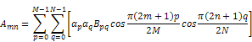
(4)
where 0 ≤ m ≤ M-1, 0 ≤ n ≤ N-1
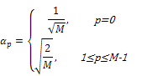
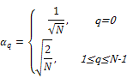
There are various transformation methods that can be utilized to sparsify signals, embracing DHWT, DCT/IDCT, curvelet, etc. We choose IDCT for its simplicity yet reliable results. After applying IDCT to the original signal, we have a sparser signal in Ψ domain. More than 60% of the coefficients values are considered very low compared with the coefficients at lower frequency.

Projection Basis
Furthermore, we use an i.i.d. Gaussian measurement matrix for Φ. This choice of Φ ensures that the restricted isometry property is fulfilled [4]. The projection stage determines the selected coefficients to be transmitted or stored. The greater number of coefficients selected the better signal quality at the receiver. On the other hand, more coefficients mean more bit or bandwidth required to transmit the signal. The generation of measurement matrix is done through randn function in Matlab. Because we do not want to take all N coefficients, this matrix converts an N-length vector to an M-length vector [6].
y = Φx (5)
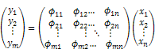
The measurement matrix is then altered to orthonormal basis. It is presumed that the receiver has knowledge regarding the matrix; hence we will multiply the received signal y by the transpose of the matrix.

Proposed System
In this section, we describe our system for compressive video sensing. Fig. 1 shows the block diagram of the system.

Compressive Sensing System
Firstly, an individual frame is divided into B blocks of size n×n. The frame is then tested, whether it is a reference or a non-reference one. The first frame is always a reference. We set higher measurement rate and intra-frame coding for the reference frame. As for the non reference frames, we use lower MR and motion compensation is employed to reduce the temporal redundancy of these frames. For example, if the total MR is 20%, then we assign 30% and 15% for each frame type. If the total MR is 30%, then the reference and non reference frames will have MR of 50% and 20% respectively. All frames then undergo the compressive sampling stage.
The inter-frame prediction block removes the temporal redundancy by applying simple block matching algorithm to the non reference frame. In the experiment, we use three-step-searh mechanism to perform motion compensation. Hence, this type of frame will reveal sparser input to the compressive sensing stage. This results in higher compression factor than that of reference frame.

Reconstruction Stage
The reconstruction algorithm will estimate the original signal by means of L1 minimization. In the experiment, the basis pursuit method is used to find signal representations in overcomplete dictionaries by convex optimization. There are a few implementations of basis pursuit environment; such as L1-Magic by Candes, et al that is carried out in Matlab. It obtains the decomposition that minimizes the L1 norm of the coefficients. Because of the non-differentiability of the L1 norm, this optimization principle leads to sparser decompositions [3]. Because it is based on global optimization, it can stably resolve in some ways better than other methods from the class of greedy algorithms. BP can be used with noisy data by solving an optimization problem with an L1 norm of coefficients. BP is closely connected with linear programming.
Basis Pursuit develops a connection with linear programming (LP). The linear program in so-called standard form is a constrained optimization problem defined in terms of a variable x ∈ Rm by
min c^{T}x subject to Ax = b, x ≥ 0 (6)
where c^{T}x is the objective function, Ax = b is a collection of equality constraints, and x ≥ 0 is a set of bounds. The Basis Pursuit problem can be reformulated as a linear program in the standard form (6) by making the following translations [1]:
(7)
The translation of A is related to the projection matrix. Most linear programming solution focused on variants of Dantzig's simplex algorithm. Currently, some spectacular breakthroughs have been made by the use of “interior-point methods", which use an entirely different principle.
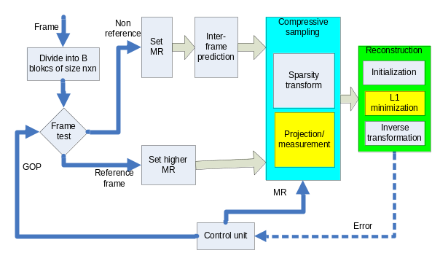
Figure 1: Compressive video sensing system.

Experimental Results
In this section, we report our experimental results, namely the effect of compressive sensing with different combination of measurement parameter MR, on reconstructed video’s PSNR. The system is applied to grayscale video sequence, i.e. the Traffic and Rhinos sequences of 80×60 pixels. Sequence “Traffic” is characterized by steady camera with fast motion, while sequence “Rhinos” is captured by shaky camera with slow object motion. In our simulations, a block size of N = n×n pixels is used. These block sizes provide good trade-off between efficiency and reconstruction complexity [7].
- Original 91st frame of Traffic 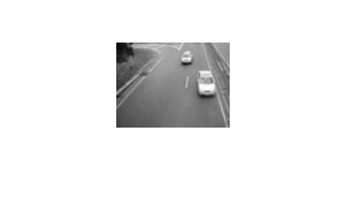
- Reconstructed 91st frames from 20% pixels
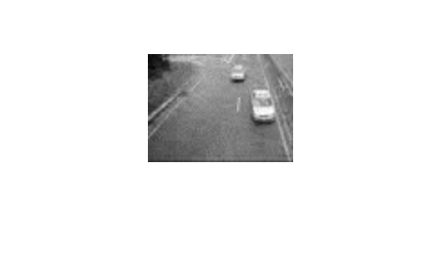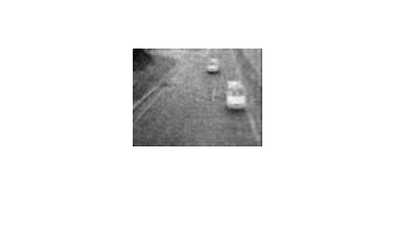
- Reconstructed 91st frames from 40% pixels
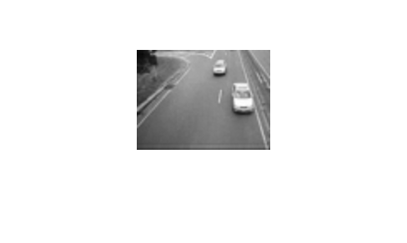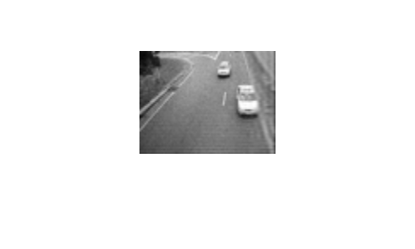
Figure 2: 91st frame of “Traffic” reconstructed from 20-40% pixels, block size of 8×8 (left) and 32×32 (right).
- Original 91st frame of Rhinos 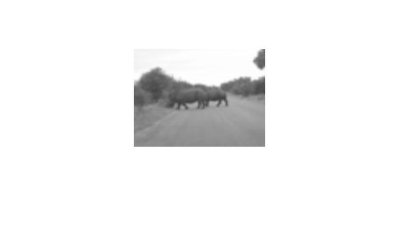
- Reconstructed 91st frames from 20% pixels
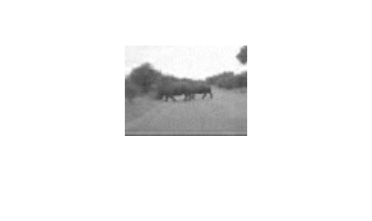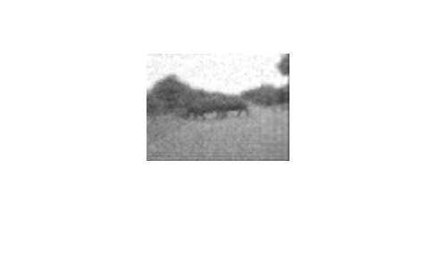
- Reconstructed 91st frames from 40% pixels

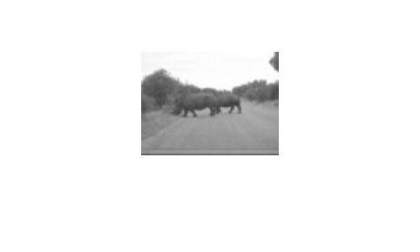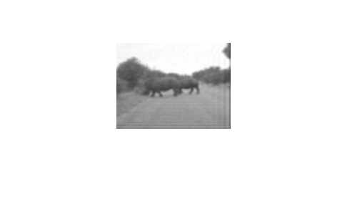
Figure 3: 91st frame of “Rhinos” reconstructed from 20-40% pixels, block size of 8×8 (left) and 32×32 (right).
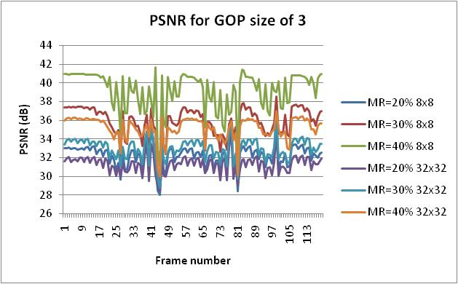
Figure 4: PSNR fluctuation per frame for sequence “Traffic” with various measurement rates and three frames per GOP.
Fig. 2 and Fig. 3 show the original and reconstructed 91st video frames for various measurement rates. It can be seen that larger size of measurement matrix results in better quality. In addition, the frame using 8×8-blocks is visually more prominent than that of 32×32. Measurement rate of 30% gives satisfactory appearance with PSNR > 33 dB for 8×8 block. Meanwhile, 32×32 block needs at least 40% pixels to achieve similar quality.
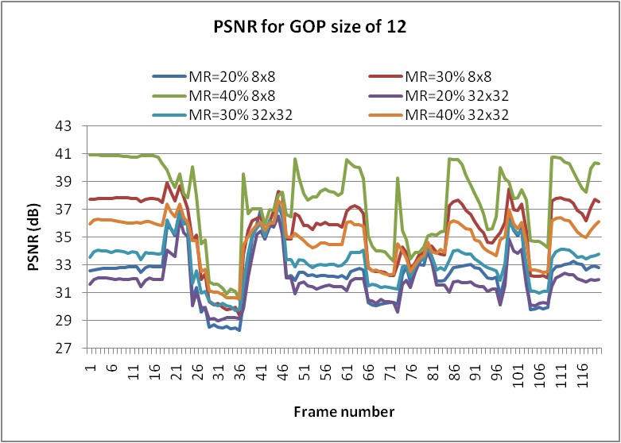
Figure 5: PSNR fluctuation per frame for sequence “Traffic” with various measurement rates and 12 frames/GOP.
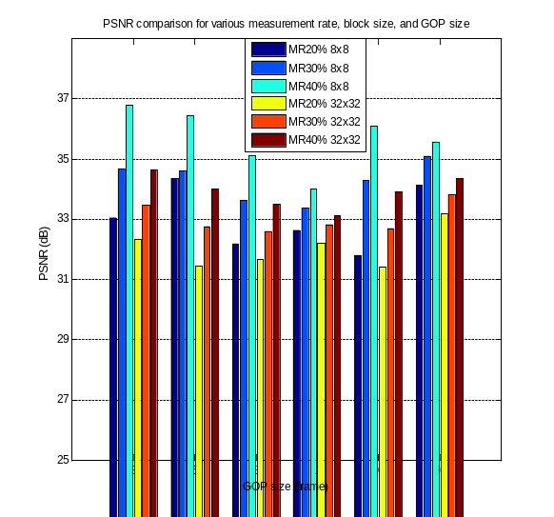
Figure 6: PSNR for video sequence “Traffic” with MR 20% to 40% and GOP size of 3 to 30 frames
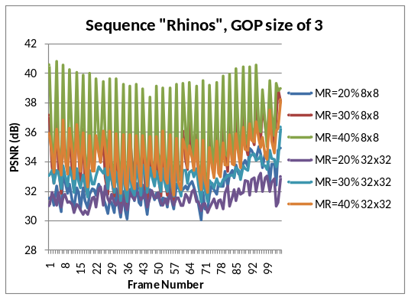
Figure 7: PSNR fluctuation per frame for sequence “Rhinos” with various measurement rates and 3 frames/GOP
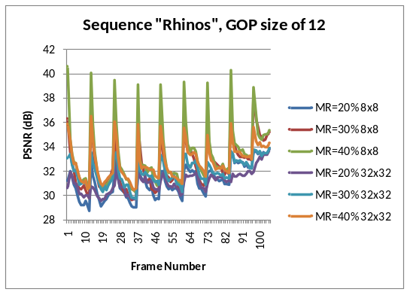
Figure 8: PSNR fluctuation per frame for sequence “Rhinos” with various measurement rates and 12 frames/GOP
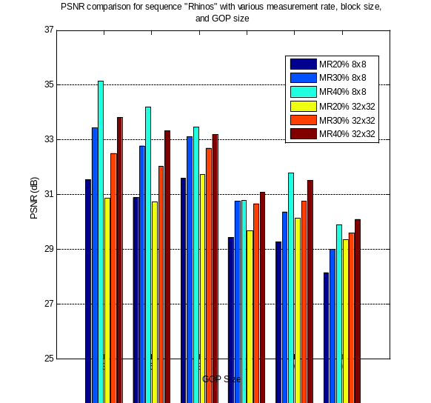
Figure 9: PSNR for video sequence “Rhinos” with MR 20% to 40% and GOP size of 3 to 30 frames
Fig. 4, Fig. 5, Fig. 7, and Fig. 8 present the results for numerous experiments on measurement rate and GOP size. It can be seen that the GOP size of 3 slightly outperform the other GOP size. Fig. 6 and Fig. 9 summarize the entire scenario implemented in our experiment. It is obvious from above that GOP size 3 and 5 can be recommended for better quality for video captured by still camera. For video with moved camera, represented by sequence “Rhinos”, the PSNR is 2-3 dB lower than that of sequence “Traffic”. The sequence “Rhinos” is more affected by the selection of GOP size because the temporal redundancy is less in this kind of video. Moreover, the measurement rate of 20% is sufficient to achieve good PSNR.

Conclusions
In this paper, we propose a system based on the novel concept of compressive sensing to achieve low complexity acquisition of video. Each frame of the video is split into a number of smaller non-overlapping blocks of equal size to reduce the complexity of CS algorithms and exploit the varying sparsity across blocks within a frame. Compressive sensing is performed on all frames that satisfy simple test. The system was studied on a widely used video sequences: Traffic. The measurement rate of 30% is shown to have a good accuracy, i.e. PSNR > 32 dB. Reference frames are used to predict sparsity of the blocks within successive frames. Overall, the system shows the potential of compressive sampling to efficiently acquire video signal before further processing.

References
- R.G. Baraniuk, “Compressive sensing [Lecture Notes],” IEEE Signal Processing Magazine, no. 24, pp. 118-121, 2007.
- D. Donoho, “Compressed sensing,” IEEE Transactions on Information Theory, vol. 52, pp. 1289-1306, April 2006.
- S. Chen, D. Donoho, and M. Saunders, “Atomic decomposition by basis pursuit,” SIAM J. on Scientific Computing, no. 20, pp. 33–61, 1998.
- E. J. Candes, J. Romberg, and T. Tao, “Robust uncertainty principles: exact signal recovery from highly incomplete frequency information,” IEEE Transactions on Information Theory, vol. 52, pp. 489-509, February 2006.
- S. Kirolos, J. Laska, M. Wakin, M. Duarte, D. Baron, T. Ragheb, Y. Massoud, and R. G. Baraniuk, “Analog-to-information conversion via random demodulation,”: Proceedings of IEEE Dallas Circuits and Systems Workshop, 2006.
- M. B. Wakin, J. N. Laska, M. F. Duarte, D. Baron, S. Sarvotham, D. Takhar, K. F. Kelly, and R. G. Baraniuk, “Compressive imaging for video representation and coding,” Proceedings of Picture Coding Symposium, China, 2006.
- V. Stankovic, L. Stankovic, and S. Cheng, “Compressive sampling of binary images,” Proceedings of Congress on Image and Signal Processing, 2008.
- D. Needell, “Topics in compressed sensing,” PhD Thesis. University of California, 2009.
- E. J. Candes, and T. Tao, “Near-optimal signal recovery from random projections: universal encoding strategies?,” IEEE Transactions on Information Theory, no. 52, pp. 5406-5425, December 2006.

