“FrameShot”- Preview of Static Video Frame on Touch Screen Device

Chetan Gawai, Mahesh Shivankar, Pratik Jain, Suraj Jachak

Department of Computer Engineering, Pune Institute of Computer Technology, Pune, India

Email-id: pratikjain108@gmail.com

ABSTRACT
The field of multimedia communication provides myriads of opportunities to innovate. Consider media player applications like VLC media player, windows media player and so on. They are still untapped in terms of enhancements for previewing the video frames in the form of thumbnails(static images) before it actually reaches that temporal sequence. This paper proposes to enhance the existing open source media player for the frames of H.264 file format to be previewed even before the slider reaches that position. An open source application, VLC media player is chosen for the said purpose. Also, the world of touch screen devices has advanced so much, hence this project shall be deployed on a touch screen device.

Keywords
Video frame, thumbnail, H.264, VLC media player

INTRODUCTION
Generally, media players simply offer to play video without any other sophisticated arrangements which can help the viewer to understand which scene is present at which location with respect to time. In other words, a viewer has to constantly navigate back and forth over the slider bar in the media player to realize the presence of a particular scene at a particular moment. Also, these amenities are not available currently on touch screen devices. Thus, the paper presents implementation of following tasks:
- Avail preview of a thumbnail from video at some future time
- Deploy the application on a touch based device
The idea gets clear with the help of Fig.1 where encircled image is the static video image rendered before the video reaches there.
The application can save a lot of time in case of a crucial video being played. It can help in navigating from one position to another on the slider bar.
VLC media player is a free and open source media player and multimedia framework written by the VideoLAN project. VLC is a portable media player, encoder, and streamer supporting many audio and video codecs and file formats.
The next section describes the work done in this field. Section 3 describes the challenges in this work. Section 4 describes the design model in this project. Section 5 describes the future works that can be done followed by conclusion.
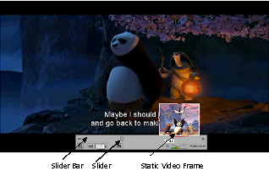
Fig 1. Screenshot of preview of static video frame

RELATED WORK:
A number of applications have been developed to play media files. The present applications, however, are time consuming as they lack facility to preview a video frame at a particular instance of time without disturbing the current sequence being played.
Our aim is to make amendments in the existing open source media player like VLC media player to be able to carry out the said task.

- CHALLENGES:
- VLC itself is vey huge such that finding things is in itself very difficult.
- Deriving static frames in the form of images out of the video.
- Debugging of VLC source code
- VLC is monolithic.
- Deployment on touch screen devices.

- DESIGN MODEL:
Let S be a system such that
S = {A, M, I, D, T, R,O, B, X, Y, X1, Y1 | Φ}
Where,
A = Application on which the video is running
M = Media file, which will be played
I = Set of static fixed frames
D = Set of changes those will be applied
T = Time
R = Set which contains intermediate frames after applying changes
O = Contains result of scaling
B = Set (buffer) which contains all the frames
X, Y = Resolution of the original frames (X = Length, Y = Height)
X1, Y1 = Resolution of the scaled frames (X1 = Length, Y1 = Height)

Input: M ( Media File) and I (Static Frames)

Initial Condition:
I = {I0, I1, I2, ……, In}
D = {D0, D1, D2, …., Dn}
D0 = {d00, d01, …, d0n}
D1 = {d10, d11, ...,d1n}
.
.
Dn = {dn0, dn1,…., dnn}
R = {Φ}
B = { Φ }
O = { Φ }
X, Y, X1, Y1 – Fixed
Set of Rules: Φ
- Addition of changes to the static frames
R =add_change(A, M, Ii, Di, T) ,∀ i 0 ≤ i ≤ n
This function will give a set of frames
( R ) which will contain the static frames ( I ) along with several other frames which will be obtained by applying changes ( D ) to the static frames ( I ) according to the timings of the static frames.
Frame Ii will be operated with Di (di0,di1, … din) to give a number of frames in R (Ri0, Ri1, … Rin). It is as shown in Fig 2.
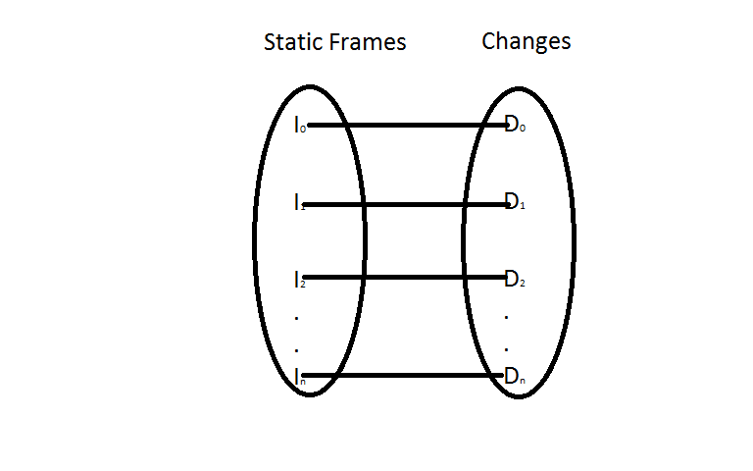

Fig 2. Addition of changes to static frame
- Scaling
O = scaling(R, T)
The above function will scale all the frames of the original resolution (X, Y) to the frames of resolution (X1, Y1). Scaling is required because preview requires video frames to be of smaller size so that they can be displayed as a thumbnail.
A frame in R = { r | r ∈ R && xiyj ∈ r }, 0 ≤ i ≤ X , 0 ≤ j ≤ Y.
A frame in O = { o | o∈ O && xiyj ∈ o },
0 ≤ i ≤ X1 , 0 ≤ j≤ Y1
Above inequalities are as represented in Fig 3.
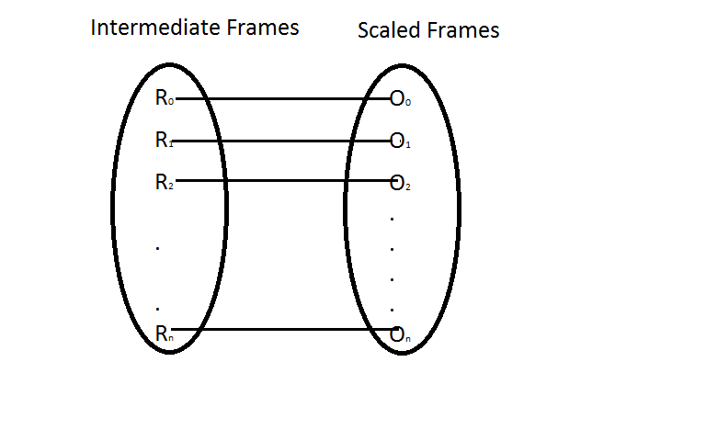

Fig 3. Representation for Scaling

- Store
B = store(O)
This function will store all the scaled frames from O in B for the purpose of linearly displaying according to the time.

- Display
O’ = display(B, T)
This function will display a frame from the buffer according to the correct time by which the media file is being played.
Success:
O’ = f(A, M, T)
O’ ⊆ B
When application A is running a media file M, a frame that is obtained for a particular time T will be displayed if it is identified from the buffer B.

Failure:
- Oi ∉ scaling( R )
If a frame in R doesn’t have a corresponding scaled frame in O.
- Ii ∉ R
If the static frame is not found in R after applying changes.
- C = { t | O’(t) ∉ B}
If there is no frame found at a particular time.

- FUTURE FRAMEWORK:
We plan to device a video cutter which can cut a length of videos with the help of the static images which can act as starting point and terminating point. This video cutter can then be integrated into the media player.
Also, the size of the slider bar when using on a small touch screen device limits the movement of the finger, finger size being too large for the small sized slider bar. Thus, augmentation of the slider bar size remains a task for the future.

- CONCLUSION:
Thus, FrameShot provides a platform to preview the video frame even before the video reaches that temporal sequence keeping the current sequence undisturbed.

- REFERENCES:
[1] Taehyun Kim and Mostafa H. Ammar,
“Optical Quality Adaptation for MPEG-4 Fine-Grained Scalable Video”, appears in INFOCOM 2003, Twenty-second annual joint conference of IEEE computer and communications, IEEE societies.
[2] Weiping Li, Fellow IEEE, “Overview of Fine Granularity scalability in MPEG-4 video standard”, appears in MPEG-4, 2001 Proceedings of workshops and exhibition.
[3] ThomasWiegand, Gary J. Sullivan, Senior Member, IEEE, Gisle Bjøntegaard, and Ajay Luthra, Senior Member, IEEE “Overview of the H.264/AVC Video Coding Standard” appears in Circuits and Systems for
video technology, July 2003.
[4] Gary J. Sullivan, Pankaj Topiwala, and Ajay Luthra, “The H.264/AVC Advanced Video Coding Standard: Overview and Introduction to the Fidelity Range Extensions”.

