The super-resolution techniques based on
the integral imaging

GUO Cai-xia
College of Electronic Information Engineering
Chang Chun University of Science and Technology, Changchun , China，130022
PIAO Yan
College of Electronic Information Engineering
Chang Chun University of Science and Technology, Changchun, China，130022
e-mail：piaoyan66@126.com

Abstract— In the integral imaging system, due to the limitation of the optical equipment, making the quality of the reconstruction images are affected. In order to overcome the lens array’s impact, we use the super resolution method to improve the quality of the image. In this paper, a new POCS algorithm is proposed, the experimental results show that the algorithm is superior to the traditional POCS algorithm and interpolation algorithm, it can improve the quality of the reconstruction image.
Keywords- micro-lens array; integral imaging; POCS algorithm; super-resolution;

Introduction (Heading 1)
In the 3D imaging technology, people pay high attention to integral imaging technology. The technology is divided into collection and shows two processes [1-4]. First of all, recording a 3D object space scene by micro lens array , each micro lens records a different spatial information of the object from a different direction, behind the lens formed small " element image". Then through the same parameters micro lens array or through the computer display the original space scene. Although integral imaging got people's more attention, but low resolution still is an important question. Due to some inherent system parameters restrictions, for example, the size of the lens arrays and gradient between them and the pore diameter of the diameter of the distance, the CCD camera resolution and display devices and so on, affect the resolution of the image [5]. But now, in the image processing technology, the super resolution technology is a more active field, and in this field it has had a lot of research results. At present it has been widely used in astronomy remote sensing, military monitoring and medical diagnosis, etc. So, in order to solve the integral image’s low resolution problem, in this paper, we use super-resolution techniques in it’s shows process and obtain a high resolution integral image.
The super resolution (super reconstruction LR) technology refers to using One or multiple low-resolution images and some corresponding algorithm to get a high resolution image [6].
Super-resolution image reconstruction is proposed by the Harris and Goodman in the 1960s.Initially, it has been presented with the single image restoration concepts and methods. In the early 20th century, Tsai and Huang first proposed that achieve a resolution enhancement static image from the image sequence of translation scene or multi-frame image sequence image [7]. And from the results of current research and application standpoint, super-resolution reconstruction algorithm is divided into three categories: based on the interpolation algorithm, based on the reconstruction algorithm and based on the learning algorithm.
This work is supported by National Natural Science Foundation of China(No.60977011).
This paper adopts POCS method, this method is based on the reconstruction algorithm. It is a typical and simple and effective method, there will be a good prospect. Super-resolution reconstruction is an ill-posed problem [8], but the POCS algorithm is using the set theory approach, meanwhile adding reasonable prior information, and seeking a feasible solution to satisfy all of the information. This algorithm map each estimate to the nearest point in the next set, so the results depend on the initial estimate, and because the traditional POCS algorithm is likely to make the image edge declined. This paper presents a new algorithm, we add the wavelet filter to remove noise in each iteration, so that each iteration produces a new initial values to keep the image edges quality.

Background and Algorithm

The basic principle of the integral imaging
Integral imaging system includes two processes: collection and display, and the display system can be divided into two kinds: One is a full optical integral imaging system(II), as shown in the right side of figure one is the full optical integral imaging system; the other is a computational integral imaging system(CII) [9-12]. CII is using computer to set up the simulation of optical imaging system, from the element images which is getting in the collection system obtaining the pixel information of 3D image, then through the computer getting 3D image. Figure (1) the left side is the basic principle of collection system through the micro-lens array, how many a lens to have how many element image it has, so any parallax information of the space are spread on the whole record film. In this paper, the micro-lens arrays are composed of 53 x 53 square refractive micro lens, and putting them at the front of the object, then forming the element images array. The resolution of the reconstructed image is decided by the number of micro lens, So through the computer reconstruction, the maximum resolution of a checkpoint image is 53×46. Using the traditional method for the reconstruction of the integral image there must be the low resolution problem.
Although according to the known principles, the more the number of micro-lens, the higher the resolution of the reconstructed image, however, in practical applications, the number and size of micro-lens of optical micro-lens array is limit by collection devices (such as CCD) and display devices. Between them has a certain proportional relationship. So under the certain number and size of micro lens, raising the image resolution and quality is the key problem need to be solved in computer integral image reconstruction system. This paper presents using super-resolution method to solve the low-resolution problem of integral images.
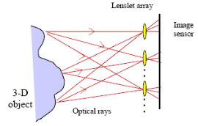
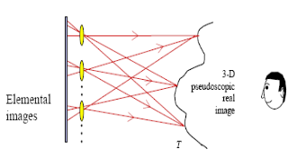

Figure (1)

Integral Image degradation model
In the integral imaging system, through the micro lens arrays get the element images, then using computational integral imaging reconstruction method to reconstruct the integral images. Due to the resolution of the image reconstruction is lower, so we process the LR images by super resolution methods, these low-resolution images can be viewed as high-resolution images through the displacement transform, blur, and noise under the influence of sample obtained [13].
Specific model is as follows:
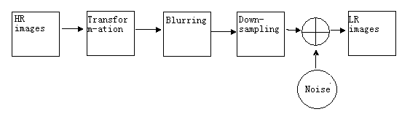
Figure 2 Diagram of degradation model

By the above figure can get formula is as follows:
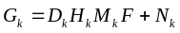 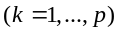 （1）
Suppose, there are pieces of low-resolution image , Image size , each frame low-resolution images are arranged in a vector direction rows of form, denoted by,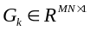, is the original high resolution image, the size of .q is a interpolation factor , and q>1. As above, we Arranged in the same direction at the line in the form of vector, denoted by F，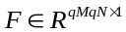. Degraded image model is shown in Figure 1, where F is the original high-resolution image, M is motion blur, H is linear shift invariant fuzzy blurs, D is under Sampling from high-resolution images to low resolution, N is noise that is introduced by the system..
Among them,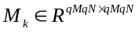is the frame k ' movement matrix of this scene and can be obtained by motion estimation; 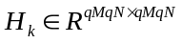is the blurring matrix of imaging system; 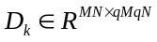 is the sample matrix under ideal sampling; 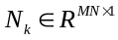 is the system noise.
In this work we assume that our imaging devices and imaging conditions are the same.
So, for 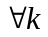，H_{k} =H，D_{k} =D；formula (1) can be expressed as
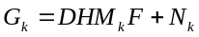；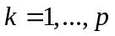 （2）formula (2) is the super-resolution image reconstruction model. Super-resolution reconstruction algorithm is that how to calculate the original high-resolution images X from low-resolution images when we know D, H, F_{k}, N_{k}, Y_{k}.

POCS algorithm
POCS is refers to mapping a given space vector arbitrary point to another point which satisfy all convex set. This method is a kind of iterative process. These sets are for restraining the solution space of the SR (super resolution) reconstruction, In other words, they are to restrain the last solution to satisfy the certain prior information, these prior information are about observations, lower quality model, the statistic characteristics of noise, etc[14-16].
In Super-resolution reconstruction, we define a high-resolution image to low-resolution sequences image model at first. General discrete image model is defined as follows:
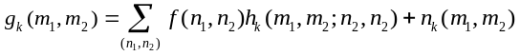
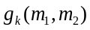is the Low-resolution images, 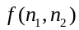is the original high-resolution, 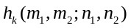 is degraded function, 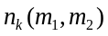 is additive noise.
In the POCS algorithm, each prior condition will bring the solution to a closed convex set of feasible. So, if there are priori information, there will be corresponding closed convex sets, i=1,2...,m.. This algorithm projects each estimate point to the nearest point in the next set. For given set of constraints, its corresponding projection operator is, Iterative process can be expressed as follow:
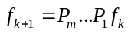
We require a feasible solution which is satisfied all constraints. First, we use the statistical characteristics of noise to define a closed convex set, the collection is a limitation to the remainder term. The limits determined by confidence, the corresponding confidence can be made from the confidence of Gaussian distribution. The convex set defined as follows
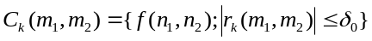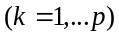
is remainder term:
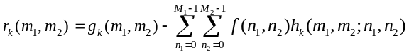
To a certain point residual, modified formula is as follows:
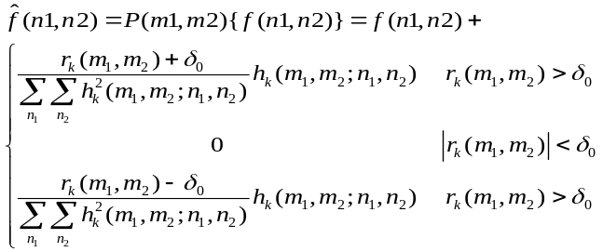
Where is statistical confidence, it is determined by the statistical properties of noise, we can also use the prior knowledge of amplitude to improve the results of reconstruction. To amplitude of the constraint may be defined as:
the projection 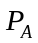 is defined as:
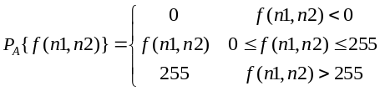

The Improved Algorithm
As POCS algorithm is projecting each estimate to the nearest point in the next set, so the results depend on the initial estimate, and because the traditional POCS algorithm, the quality of the image edge will be decline, this paper presents a new algorithm, we add the wavelet filter to remove noise in each iteration, so that each iteration produces a new initial values to keep the image edge better.
According to the principle of wavelet transform, a image can be broken down high frequency signal and low frequency signal. High-frequency signal contains noise and the image edge information, So threshold processing is applied on the high-frequency signal, and then through the high-pass filter. Last enhance the image quality.
In this paper, we use two complementary filters to perform the transform of discrete wavelet for generating two signals. One is low frequency, the other one is a high-frequency part of the image.
Using wavelet threshold de-noising method reduces some noise interference. Let is the wavelet coefficients. is a given threshold, and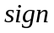is sign function. Processing wavelet coefficients expression is as follows:
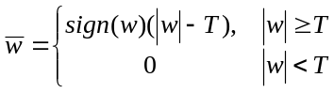
At last, get the de-noising signal. In this paper, use wavelet threshold in each Iterative process. The result shows that this approach has some feasibility.

Experiments and Results
In the 55mm square areas, there are 53×53 square refractive lens in the micro lens array. We get the 2D element images which used to reconstruct 3D scene by the optical collection system, that is the 53×46 element image set. In this paper, the micro-lens size is 1.08mm×1.08mm, the focal length f of each micro-lens is 3mm. Then we get five images in 53×46 low resolution by using the reconstruction technology of CII, as shown in figure 3. Finally, use the bilinear interpolation method, the general POCS method and the proposed super- resolution reconstruction method in this paper. Through the comparison shows that the method of this paper proposed can obtain higher resolution and clear integral image.


Figure 3 low resolution images
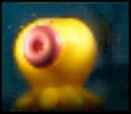

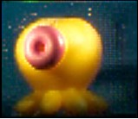

Figure 4(a) Figure 4(b) Figure 4(c)
Figure 4(a) Bilinear interpolation method image;
Figure 4(b) General POCS method images;
Figure 4(a) the proposed method;
We can see from the above graph, although the interpolation algorithm improves the image resolution but the image special fuzzy, the traditional POCS algorithm improved, and the method proposed in this paper not only improves the image resolution but also improves the image definition.

Conclusion
Super resolution technology is applied to integral imaging system in this paper, and comparing the interpolation algorithm, the traditional POCS algorithm with the improved algorithms in the paper, shown as figure 4(a), figure 4(b) and figure 4(c). We can see that the proposed algorithm can increase the image contrast and improve the resolution of the integral images effectively. So it solves the low resolution problem of the image in the integral imaging system.

Acknowledgment
This work is supported by National Natural Science Foundation of China (No.60977011). I appreciated Professor Piao Yan for providing me with material, equipment and advice and also thank the schoolmates of our laboratory for enlightening discussions.

References
- [1] S. A. Benton, Selected Papers on Three-Dimensional Displays,SPIE Optical Engineering Press, Bellingham, WA,(2001).
- [2] G. Lippmann, “La Photographie Integrale,” Comptes-Rendus Academie des Sciences, vol. 146, 1908, pp. 446-451.
- [3] S. Hong, J.-S. Jang, and B. Javidi, “Three-Dimensional Volumetric Object Reconstruction Using Computational Integral Imaging,” Opt. Express, vol. 12, 2004, pp. 483-491.
- [4] D.-H. Shin, M. Cho, K.-C.Park, and E.-S. Kim, “Computational Technique of Volumetric Object Reconstruction in Integral Imaging by Use of Real and Virtual Image Fields,” ETRI J., vol.27, 2005, pp. 708-712.
- [5] H. Arimoto and B. Javidi, “Integral Three-Dimensional Imaging with Digital Reconstruction,” Opt. Lett. vol. 26, 2001, pp. 157-159.
- [6] T. Naemura, T. Yoshida, and H. Harashima, “3-D Computer Graphics Based on Integral Photography,” Opt. Express, vol. 8, 2001, pp. 255-262.
- [7] Dong-Hak Shin, Byoungho Lee, and Eun-Soo KimImproved, “Viewing Quality of 3-D Images in Computational Integral Imaging Reconstruction Based on Lenslet Array Model” ETRI Journal, Volume 28, Number 4, August 2006.
- [8] Adrian Stern and Bahram Javidi, “3-D computational synthetic aperture integral imaging (COMPSAII),” Department of Electrical and Computer Engineering, University of Connecticut, Storrs, Connecticut 06269-1157.
- [9] T. Naemura, T. Yoshida and H. Harashima, “3-D computer graphics based on integral photography,” Dept. of Inform. & Commun. Eng., The Univ. of Tokyo,7-3-1 Hongo, Bunkyo-ku, Tokyo 113-8656, Japan.
- [10] Seung-Hyun Hong, Ju-Seog Jang, and Bahram Javidi, “Spatiotemporally multiplexed integral imaging projector for large-scale high-resolution three-dimensional display,” Optics Express, Vol. 12, Issue 4, pp. 557-563 (2004).
- [11] Gerald C. Holst, [CCD Arrays, Cameras and Display], JCD Publishing, Winter Park, FL,1996.
- [12] Tsai R Y, Huang T S, “Multi-frame image restoration and registration,” Advances in Computer Vision and Image Processing. Papers 1 (2): 317-339(1984).
- [13]Tekalp M, Ozkan M K, Sezan M I. "High-resolution image reconstruction from lower-resolution image sequences and space-varying image restoration," Proceeding of IEEE International Conference On ASSP. San Francisco:IEEE,1992.169-172.
- [14] Mehmer K. Ozkan, A. Murat Tekalp, and M. Ibrahim Sezan,” POCS-Based Restoration Of Space-Varying Blurred Images,” IEEE Transactions on Image Processing, Vol. 3, No. 4, July 1994
- [15] M. Ibrahim Sezan, “An Overview of Convex Projections Theory and its Application to
- Image Recovery Problems,” Ultranmicroscopy , 40(1992) 55-67
- [16] Yang Y，Galatsanos N．Removal of Compression Artifacts Using Projections onto Convex Sets and Line Process Modeling[J]．IEEE Trans. on Image Processing，1997，6（10）：1345-1357

