Study of On-line detected Multi-dimensional Parameter Estimating System Optimization

Wang Chun-yang
School of Electronical and Information Engineering,
Changchun University of Science and Technology
Changchun, China
wangchunyang19@cust.edu.cn

Tai Bing-yong
School of Electronical and Information Engineering,
Changchun University of Science and Technology
Changchun, China
wangchunyang19@cust.edu.cn

Liu Xue-lian
School of Electronical and Information Engineering,
Changchun University of Science and Technology
Changchun, China
wangchunyang19@cust.edu.cn

Abstract—Aiming at the demands of high real time in real-time signal detection system, a system design that combines FPGA and DSP was introduced in this paper, in which FPGA as the main controller, completing all control functions of the system, DSP as the microprocessor, focusing on the algorithm of the large amount of data. The paper mainly analyzed the principle and structure of the system, studied the hardware structure, detailed the function of each part to achieve, and completed hardware emulation by constructing Programmable System on Chip (SOPC) in FPGA. Meanwhile, it introduced the software flow chart, and completed the acquisition, processing, transmission and display of the parallel real-time signals. Experimental results show that the system has a good real-time.
Keywords-Online Inspection；Multi-dimensional Parameter；System Optimizaton；SOPC

ⅠIntroduction
This system is applied to the information processing which detects many types of large volume data, demands good real-time processing, FPGA as the system host processor, completes all the functions includes the system initialization, logic control, memory control, etc., and the image data pre-processing, DSP as the auxiliary processor, only completes data computing and analysis, it’s communication with external devices, and logic control coordination is completed all by FPGA. The design makes full use of FPGA and DSP’s respective advantages, maximizes their capacity for complex logic and outstanding performance of rapid processing for massive data, both strengths and weaknesses complement for each other so as to achieve the purpose of optimizing system performance, and the system’s real-time is well ensured.

System hardware design

System Design
The system uses ALTERA's FPGA EP2S180 which belongs to Stratix Ⅱ type, TI's TMS320DM642 (hereinafter referred to as DM642) DSP as the main chip to implement the system feature, the system block diagram is shown as Figure 1, mainly includes the data acquisition module, A/D converter module, FPGA master controller module, data storage module, DSP auxiliary processor module, MCM program download and data display modules[1], to achieve the rapid extraction, conversion, high-speed image data processing, transmission and real-time display for the multi-dimensional parameters of the measured object.
Activated, FPGA completed the system initialization at first, set the DSP's working status, deployed the sensor mode, started the data sampling and the A/D conversion. Pressure, displacement and etc. which volume of data is small and does not require a large amount of data calculated via the FPGA cache directly transmitted into the DSP for fast processing, while the large data volume of digital video signals were sent by the FPGA into two SDRAMs for DSP to read in the follow-up operation to process. FPGA controlled the two SDRAMs to work in the way of ping-pong, when one SDRAM is full of data, FPGA immediately notifies DSP by interruption to read this piece of data in the corresponding address of this SDRAM, at the same time, FPGA transmitted data into another piece of SDRAM in turn, made the data flow in the system to achieve high-speed transmission. In the initial stage of the process, DSP was in the wait state after completion of its initialization,, and through queries and interrupt real-timely detected the interrupt signal issued its FPGA (read data command), once detected, DSP immediately read the data of SDRAM in the corresponding processing, and the results are stored in the memory, at last according to the user's requirements, the results was sent to the microcontroller through the dual-port RAM, and through the microcontroller interface into the PC to display and storage.
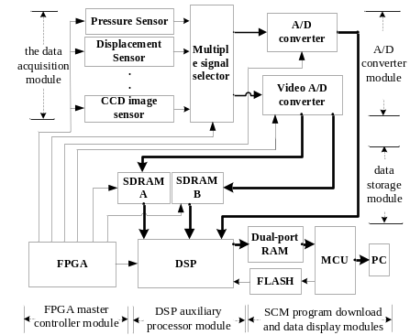
Fig.1 System Block Diagram

System Realization
The system design used PHILIPS's enhanced video input processor chip SAA7111A to digitize the video information collected by CCD image sensor[2], the on-chip generated clock by digital PLL lock sync, the line sync signal enables automatic detection and separation. Figure 2 shows the A/D converter block diagram of logical connections.
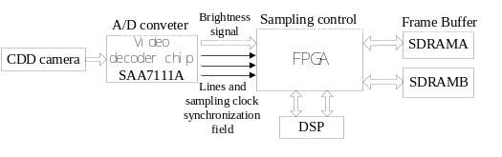
Fig.2 A/D Converter Logic Diagram
Throughput of video interface is decided by the size of data buffer and the move speed of DMA, in order to guarantee the real-time of video data, when video capture, the data move time must be less than the data fill time; and data display, the data move time must be less than the data output time.
Time video data buffer filled by the fill level of the effective sampling time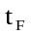and the image blank time , the total time is calculated by 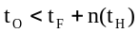, where n is the number of rows of image buffer. To BT.1120 standard (1125 lines / 60 mode), for example, sampling points per line activities 1920Y, 960Cb and Cr, a blank sample of 280 points, the sampling frequency is 74.25MHz. Thus available 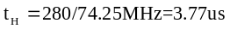. In 20-bit Y/C mode, the total buffer is 5120B, in the cases of brightness and color half of each, 8-bit and 10-bit compactly arranged large package format, the buffer can store one line image; with 10-bit arranged to store 0 line, so the total time of DMA empty the buffer and moving speed are as following:
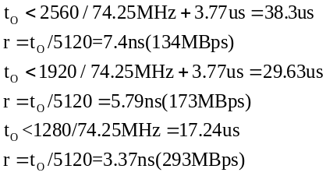
Thus, to ensure the real-time of video data, DMA's moving speed must be greater than 300MBps, in fact, DM642’s EDMA can provide bandwidth up to 2GBps, which can fully meet the design needs.
As for the constant video decoder chip SAA7111A, the system used two HY57V283220 ((L) T (P)-H) type SDRAM [3] to constitute 4M*64bit memory space, and directly connected with DM642 external memory interface (EMIFA) as DSP image processing connection speed buffer circuit, FPGA control two SDRAMs to store data in ping-pong manner to ensure that at any one time DSP can read and process the date in one SDRAM at least to realize the rapid extraction and high-speed processing of the image data. The hardware connection was shown in Figure 3.
After giving the system power, FPGA configures CCD image sensors work in automatic gain, automatic exposure mode. SAA7111A outputs image signals VPO8~VPO15, VREF (field sync reference signal), HREF (line synchronization reference signal), RSTO (parity field signs and signals), VS (vertical synchronization signals), HS (line sync signal), LLC2 (pixel clock signal) and other signals, FPGA provides SAA7111A 13.5 as it’s working clock SCL, and controls CCD signals’s acquisition in accordance with the output of the synchronous^{[6]}. SAA7111A firstly converts the analog video signals that CCD image sensor capture into digital video signals, then transmits it to the FPGA’s cache buffer, and then save the data into SDRAMA’s designated address and then sents an interrupt signal DSP_INT to the DSP, then DSP reads the data in SDRAMA for image processing, while FPGA controls CCD data acquisition and deposited the data in a designated address in SDRAMB.
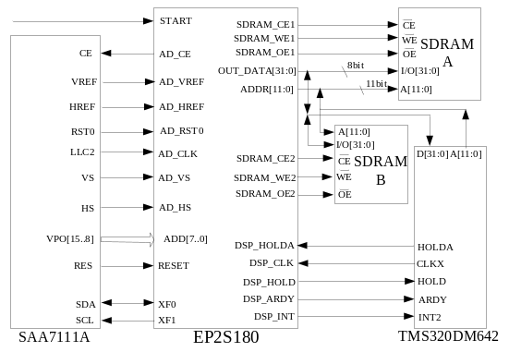
Fig.3 System Hardware Connection Diagram
Digital video signal VPO[15:8] connect FPGA data input ADD[7:0], FPGA data output OUT_DATA[31:0]、address ADDR[11:0] is respectively connected with SDRAM’s data port I/O[31:0], address port A[11:0]. DM642’s data lines D[31:0]、address lines A[11:0] is respectively connected with SDRAM’s data I/O[31:0]、address lines A[11:0] through the data bus and the address bus. FPGA controls SDRAM’s chip select and enable through the SDRAM_CEx、SDRAM_OEx and SDRAM_WEx, DSP_ARDY says that delay count field end.
DM642 Once detected the FPGA’s interrupt signal then sent the signal data to the FPGA through the pin CLKX, FPGA set the DM642’s HOLD pin low, then DM642 will set HOLDA pin low. FPGA set SDRAMA’s select signal pin CE1 low, output enable pin OE1 high, completed digital video data written in SDRAMA, at the same time set SDRAMB’s select signal pin CE2 high, output enable pin OE2 low, make DM642 read the data in SDRAMB’s cache for data processing[7]. When FPGA finished writing one image data and DM642 completed an image processing before, to write data into SDRAMB, DM642 read the data in SDRAMA’s cache. FPGA stored the odd and even field image signals in the odd field SDRAM(ODD) and even field SDRAM (EVEN) based the state signal RSTO. Data read completed, DM642 set HOLD pin high .
The system adopted dual-mode power supply [4] to eliminate the delay time between the core power supply and I/O power supply: CPU Core’s Voltage is +1.4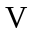, the current is 850; Peripheral I/O voltage is +3.3, the current is 300. This two independent voltage terminal is connected through a Schottky diode, electricity supply must be in strict accordance with the order to ensure core power on first, at latest the same time with I/O power supply, so that avoid chip damage. Two power are all converted from 5 power by MAX1951ESA.

System Software
The system software[5] set the module’s configuration parameters within DM642, including video port parameter configuration, SDRAM and FLASH register configuration, IIC bus parameter configuration, decoding chip register configuration and ect.
System initialized after power, FPGA simulated IIC Bus Timing via internal software to configure SAA7111A internal registers, set it’s working style, then FPGA controlled the pressure sensor, the displacement sensor and the CCD camera to collect and storage data, DM642 read the data by HOLD and HOLDA handshake signals. FPGA opened SAA7111A output to write the data which was collected, after an image video data is written into the SDRAM frame buffer, FPGA closed SAA7111A video output and sent a break signal to DM642, then DM642 read the data and processed it using specific algorithms. The processed video data was cached in the dual-port RAM, and the image analysis results was transferred to PC for display and storage by microcomputer, DM642 restarted reading request after the image processing was completed to read the next frame data. The main program flow chart[7] was shown in Figure 4.
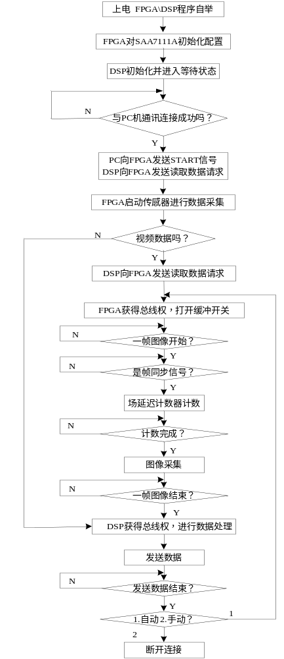
Fig.4 Main program flow char

SOPC System on a chip
FPGA/SOPC (system on programmable chip) with low power consumption, high performance, low cost, high reliability and etc., integrating the memory, I/O interfaces, DSP modules and phase-locked loop into one FPGA chip to optimize the circuit design in scale reliability, functionality, power and other aspects[8], has become the development trend of the embedded systems. This system design focused on FPGA’s controlling of the two SDRAM memory with ping-pong, to ensure that DSP could read data timely and effectively for fast processing, so that maximum DSP’s performance. Adding SDRAM controller core in FPGA chip, connect it with the Nios Core through on-chip bus Avolon to build FPGA-based SOPC system to provide greater storage capacity, faster access speed, and more cost-effective. Structure diagram was shown in Figure 5, including the core controller unit (FPGA host controller), IIC, RS232, EMIF peripheral interfaces and SDRAM、FLASH data storage modules, completed the system performance testing of data storage controlling, simulation results was as Figure 6.
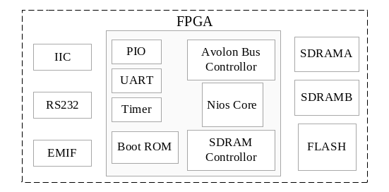
Fig.5 SOPC Chart
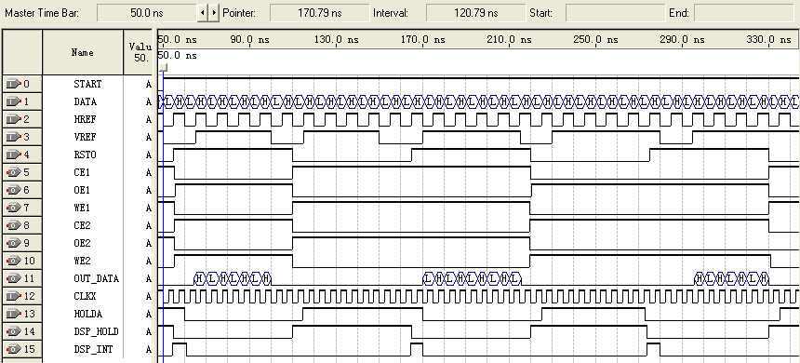
Fig.6 SDRAM memory control simulation map
The rising RTSO identified a new starting point of one image, the high VREF corresponded to the effective pixel line during the period of scanning the image, the high HREF corresponded to the pixel effective sampling time. By the simulation results, it can be seen that OUT_DATA (data output port) could output data sampling effective data in real time for DSP processing under the control of FPGA.

Conclusion
This system design introduced FPGA as the main controller to complete the entire control of the system, DSP only as a secondary processor, which was essentially different from the universal application of the multi-signal processing system in which DSP was generally predominant. Experiments showed that this system in a large extent enhanced the real-time logic control in the system running, at the same time, freed DSP from the complicated system control to focus on analysis and processing the collected information, so that, met the requirement of real-time maximum in signal detection system. In addition, the system had a faster processing speed, and ensured a good real-time for multi-dimensional parameters system.
The writer innovation:
The fundamental difference from the previous FPGA+DSP structure was that FPGA played a leading role and DSP was as co-processor in the system, DSP processed its data fastest under the coordination of FPGA, which maximum the excellent performance of DSP.
References
[1] Li Zheng-dai, LIU Wen-yi. Multi-channel signal acquisition system hardware design.[J]. Micro Computer, 2008,24 (1-2) :2-3.
[2] Ma Yu-feng, Gong Shen-guang. MSP430 Microcontroller based multi-channel signal acquisition system.[J]. Wuhan University of Technology (Transportation Science & Engineering), 2009,33 (2) :3-4.
[3] Cheng Bo, Wu Qin-zhang, Su Hai-bing, Zhou Jin. TMS32OC62O3 real-time using image processing system.[J]. Optical Engineering, 2004,31 (4) :1-2.
[4] Xu Hong, Lv Jun, Chen Xi'ai, Gong Xue-xia, Yang Chen'na. Design of video processing and testing system based on DSP and FPGA. [DB / OL]. Http://spied.org / terms
[5] SHANG Bin-liang, ZHANG Zhen-ren, LI Ai-hua. Research and Design of Intelligent Diagnosis Instrument Based on DSP [DB / OL]. Http://spied.org/terms
[6] Feng Gui, Lin Qi-wei. Application of DSP in the image transmission system [DB/OL].Http://spied.org/terms
[7] Yuan Run-ping. Image processing system based DSP[D]. Beijing: University of Electronic Science and Technology, 2005.44-48
[8] Lang Pei. Real Time Image Processing System based ARM+DSP, Tianjin University of Technology ,2007.42-46

  * This work was supported by the Weapons Prophecy Fund of China(No.62301110716)

