**On-going Assessment Number 3 of 4  
Dynamic Web Pages  
Event: Hands-On Exam**

**Subject Coordinator: Geneveve Cortez-Mabalhin   
Assessment Instructions:**

* This assessment is to be performed **in class.**
* Create a **Membership System** and incorporate it to the **Extreme Explorer** website you created from the first assessment. You may **modify the** **membership.html** page you created in your Assessment 1 to add the new fields required for the updated Membership form. Data inputted on the fields should then be inserted in a database. See the sample updated form layout below.
* Analyze the project requirement for the pages required and apply appropriate PHP Scripts. Create a database and use appropriate Structured Query Language if required to provide solutions to the functionalities required in each web pages.
* Save the document files all together (images, html/php files) with the folder name **CIV03_YourStudentId_Ass3.zip** and send through SIS.

**This following Assessment is designed to assess your competency in the following competency units:**

**ICADBS403A**: Create basic databases

* Analyse requirements for the database
* Use data modelling to design the database to suit requirements
* Create a database on a web or database server
* Test database and debug

**ICAWEB425A**: Apply structured query language to extract and manipulate data

* Identify SQL requirements from the specification documentation
* Create a relational database
* Test SQL results

**ICAWEB415A:** Produce server-side script for dynamic web pages

* Analyse requirements for web documents requiring server-side dynamic interaction
* Design server-side scripts
* Produce web documents
* Test scripts and debug
* Set up security

**Web Pages Required:**

1. **Membership Form** (INSERT Form)

* A webpage, which allows new users to input their details and then store their record in the database.
* Validate the data entry to accept valid data. (ie. Accept ONLY numbers for age, fields should not be left blank)

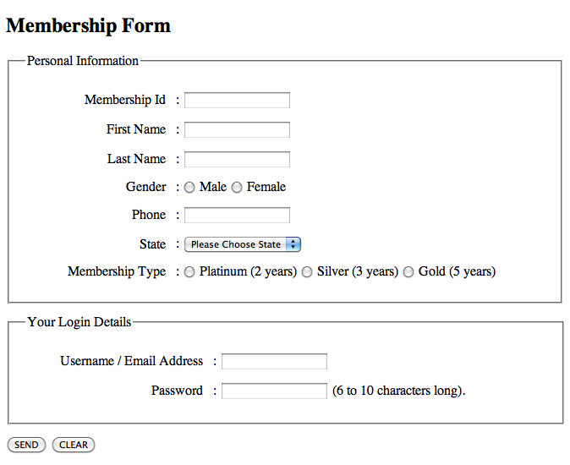

1. **Membership Form** cont. (Once the SEND button is clicked, data inputted on the fields should be inserted into the database (ex. INSERTED.PHP) and display the output below – similar to Assessment 1’s output, no need to display the whole table – if you want to show the whole table you can do this on the search page.)

*Therefore, Inserted.php page could contain the codes to do the query to insert the records to the database **AND** copy paste the previous codes you did to generate the output below.

*You may refer to your Assessment 1.doc from your SIS, if you need a reference.

**OUTPUT:---------------------------------------------------------------------------------------------------**

**Welcome to Extreme Explorer FirstnameLastname! *(declare variables)***

**Extreme Explorer have branches in New South Wales, Northern Territory, Queensland, Southern   
 Australia, Western Australia,*(use array for this)***

**\*The nearest shop in your state is 27 Bathurst St. Sydney, New South Wales.  
*(useswitch / if-else-if statement – refer to Options for State below,* call the state name using array*)***

**\*Congratulations on your Gold Membership. You will have a 30% discount on any purchases you make.*(use switch / if-else-if statement – refer to Options for Membership below)***

**---------------------------------------------------------------------------------------------------**

**\*Options for State:**

a) New South Wales -> 27 Bathurst St., Sydney, New South Wales.  
b) Northern Territory ->16Kincumber St.,Darwin, Northern Territory.

c) Queensland ->7TulipwoodRoad,Brisbane, Queensland.

d) Southern Australia ->18RebeccaRoad,Adelaide, Southern Australia.

e) Western Australia ->2Catherine St.,Perth, Western Australia.

**\*Options for Membership:**

a) Platinum ->You will have a **10% discount** on the total amount of purchase you make.

b) Silver ->You will have a **20% discount**on the total amount of purchase you make.

c) Gold ->You will have a **30% discount** on the total amount of purchase you make.

1. **Admin’s Update Page**

* A webpage, which allows the administrator to UPDATE the member’s data and display the updated record in a tabular data. All fields could be changeable except for the Member’s ID.

1. **Admin’s Delete Page**

* A webpage, which allows the administrator to DELETE member’s records and display the updated record in a tabular data from the database.

1. **Admin’s Search Page**

* A webpage, which allows the administrator to SEARCH for certain records from the database given a specific criteria.

1. **Admin’s Menu Page *(Add a link on the Main menu page of the website that would link to Admin’s Menu Page)***

* A webpage, which serves as a quick link to all the record management web pages. (Delete Record Page, Update Record Page, Insert Record Page and Search Record Page).

1. **Login Page *(Add a LOGIN link on the Main menu page of the website)***

* A webpage, which allows registered users to login.

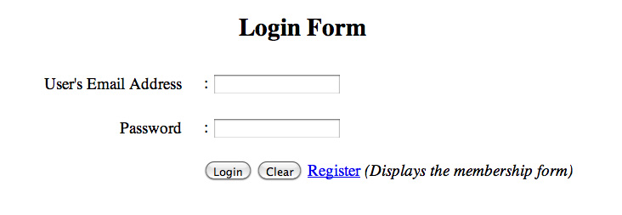

1. **Welcome Page**

* Displays when a registered member successfully logs in with the valid username and password.



1. **Unsuccessful Login Page**

* Displays for unsuccessful login.



1. **Other Pages**

* Other PHP pages to setup connection to server, database and create a table

**Marking Criteria:**The total course grade for this assessment is **300 marks.**

|  |  |
| --- | --- |
| **Marking Criteria** | **Marks** |
| Ability to research client requirements for a database solution | 20 |
| Ability to design a database that meets client requirements | 40 |
| Ability to create a database on a web hosting service to meet client requirements by a due date. | 40 |
|  |  |
| Ability to create databases and tables | 25 |
| Ability to query one or more tables to provide required data | 25 |
| Ability to add, modify and delete records from tables | 30 |
| Ability to drop databases and tables. | 20 |
|  |  |
| Ability to create dynamic web pages from a client requirement using server-side scripting to retrieve information from a web-hosted database | 20 |
| Ability to create scripts for the quick upload of data to web-hosted databases | 10 |
| Ability to create server-side scripts for inserting, updating and deleting data from a web server database | 40 |
| Ability to create server-side scripts to encode passwords | 10 |
| Ability to create server-side scripts to manage sessions and secure login. | 20 |
|  |  |
| Prepare and publish organisational content and information required by industry for website | 25 |
| Ensure disclosure of policies and services | 25 |
| Communicate product or service conditions and notifications | 25 |
| Ensure customer service support | 25 |
| **Total Marks** | **400** |

**Submission Method:  
Submit the assessment in class during the assessment time period.**

* Zip all the web files with the filename: **CIV03_YourStudentId_Ass3.**zip it and send it though the SIS.
* SIS: Login to SIS, go to Academic Summary, Click on CIV03, then use the Assignment 3 Submit Form

# Submission Date:

All assessment tasks are to be submitted by end of Block F, 9th of August 2013.   
Students must submit a medical certificate to avoid a penalty for late submission.

**Late submission will incur the following penalty:**

1 day late, 5% off final grade, 2 days late 10% off final grade, 3 days late 15% off final grade, 4 days late 20% off final grade, 5 days late 25% off final grade. *Assessments will not be accepted if more than 5 days late unless evidence of a medical certificate is submitted*.

**Assessment Appeal Form**

An Assessment Appeal Form may be completed for those students wishing to appeal a result. This is available to download and print via the SIS page, or you may collect this from the Level 5 Administration office. Completed Assessment Appeal Forms are to be provided to the Student Services Office, Level 5.