### GUIDE

### File Format

After extracting the ZIP file, your folder structure should look like this:  
Real Estate Scraper and Appraiser/

│── main.py

│── guide.docx

│── first_run.bat

│── RUN.bat

└── data/

└── wordlist.txt

### First Run

To get started with the app, follow these steps:

1. **Install Python 3** (if you haven’t already) by downloading it from .[python.org](https://www.python.org/downloads/)
2. **Run** first_run.bat – This will automatically install all the necessary Python libraries.
3. Once the setup is complete, you're ready to use the app!

**Operating the App**

For you to run the app you have to click on the RUN.bat file. After that a terminal will appear shortly followed by the gui of the app, it should look like this:

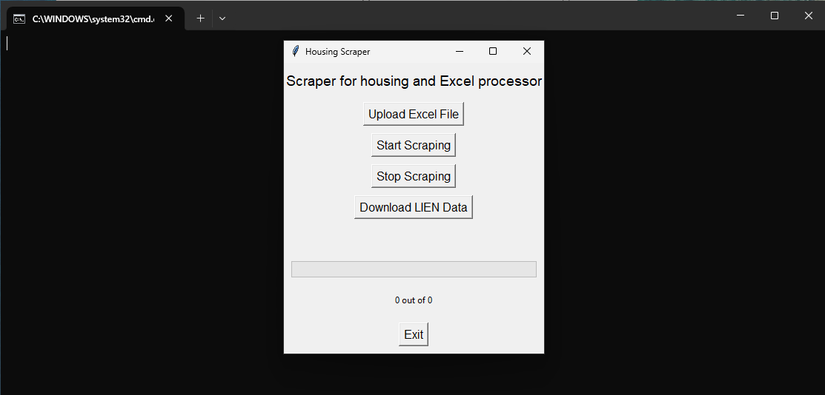

You can resize these windows to fit your preference or even minimize the terminal if needed.

You'll also notice **five buttons**, each with a unique function. Here’s a quick overview of what they do:

**Upload Excel File**

This button allows you to **upload an** .xlsx **file**, which will then be used to **scrape PINs** for the following categories:

* **Nuisance**
* **Nuisance Board-Up**
* **Unsafe Structures**

The results will be in the data folder under the names nuisance.csv, nuisance_board_up.csv and unsafe_structure.csv. **If these files already exist then they will be replaced!!**

**Start Scraping**

Pressing this button will prompt you to **select a** .csv **file** for scraping. The application will then:

1. **Open the file** and search for the header **“DocLegalDescription”** in the first row.
2. **Extract PINs** based on the data in that column.
3. **Start the scraping process.**

During scraping, a progress window will appear to keep you updated in real time:

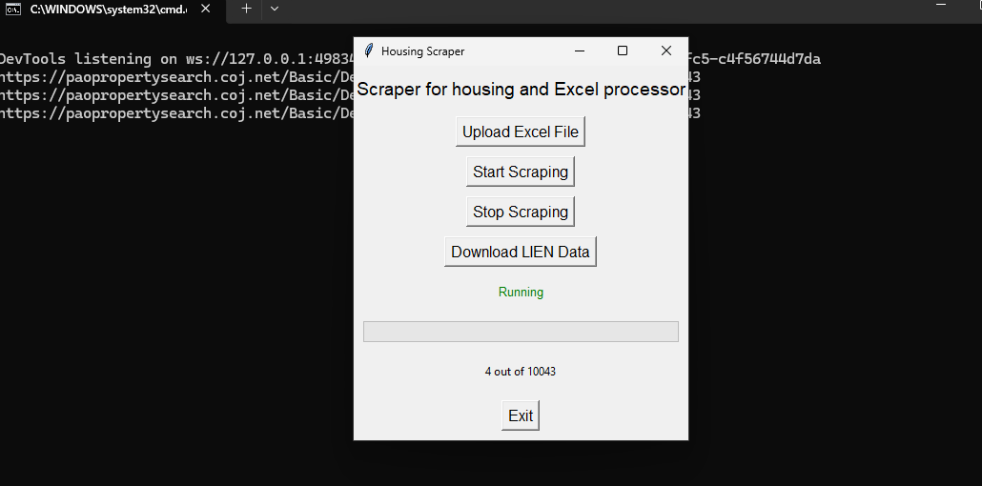

When finished a file will appear on the Real Estate Scraper and Appraiser folder called businees_info.xlsx, **if this files already exists it will be replaced!!**

**Stop Scraping**

Pressing this button **will permanently stop** the scraping process at the current record. The file will be saved with all the data scraped up to that point, but **you will not be able to resume from where you left off**. If you need to continue, you will have to restart the scraping process from the beginning

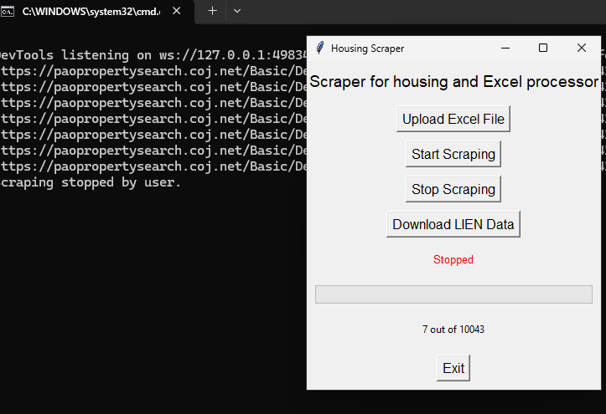

**Download LIEN Data**

This button **starts downloading the LIEN data from the or.duvalclerk website**. Once the download is complete, the file will be saved inside the **data** folder with the name SearchResults.csv. If a file with the same name already exists, it will be saved as SearchResults(1).csv, SearchResults(2).csv, and so on.

**Exit**

Just closes the program

**Changing the Wordlist**

The program uses a **wordlist** to determine whether a name belongs to a **company or a person**.

### How to Edit the Wordlist:

1. **Navigate to** wordlist.txt inside the data folder.
2. **To add a new word**, simply type it on a new line.
3. **To remove a word**, delete the corresponding line.

This allows you to customize the filtering process based on your needs.