### INSTRUCTIONS FOR USING THE GOOGLE MY BUSINESS SCRAPER

#### 1. Download the Captcha Solver Extension

##### Download two specific Chrome extensions:

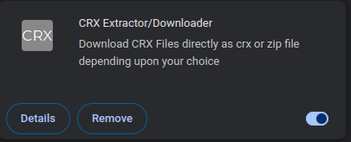

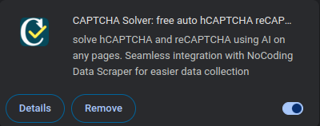

* + Use the first extension to download the second one as a .crx file.
  + Rename the downloaded .crx file to captcha.crx.

#### 2. Install Python 3

1. **Check if Python 3 is Installed**:
   * Open Terminal or Command Prompt and type: python3 --version.
   * If Python 3 is not installed, follow the next steps.
2. **Install Python 3**:
   * Visit the official Python website at <https://www.python.org/downloads/>.
   * Download the latest version of Python 3 for your operating system and follow the installation instructions.
3. **Verify the Installation**:
   * After installation, open Terminal or Command Prompt and type: python3 --version.
   * Confirm that the correct version of Python 3 is displayed.

#### 3. Install pip (Python's Package Manager)

1. **Check if pip is Installed**:
   * In Terminal or Command Prompt, type: pip --version.
   * If pip is not installed or needs to be updated, proceed to the next step.
2. **Install pip**:
   * Download the get-pip.py script from the official website at <https://bootstrap.pypa.io/get-pip.py>.
   * Run the script with Python 3 to install pip.
3. **Verify pip Installation**:
   * Confirm pip is installed by typing: pip --version.

#### 4. Install Required Python Libraries

Install the following libraries using pip:

* pandas
* selenium
* openpyxl
* webdrivermanager
* urllib3

you can install pandas for example by writing in terminal : pip install pandas

#### 5. Prepare the Scraper Folder

1. Create a folder named google my business.
2. Place the following files into this folder:
   * main.py
   * captcha.crx
   * input.xlsx

#### 6. Update the Script Path

1. Open the main.py file in a text editor.
2. Locate the first line: my_dir='/home/mitsos/Documents/code base/google my business/'
3. Replace it with the path to your google my business folder. For example:

my_dir = '/Users/yourname/Desktop/google my business/'

#### 7. Running the Scraper

1. Prepare your input.xlsx file with the data to scrape.
2. Run the main.py script in Python.
3. When the browser opens, **activate the captcha solver**:
   * Click on the Chrome Extensions icon.
   * Select and activate the captcha solver extension.
   * Complete this step within **45 seconds**.
4. After the scraper finishes, the results will be saved as output.csv and output.xlsx in the same folder.

#### 8. Best Practices to Avoid Google Blocking

* Use a VPN and regularly switch servers to mask your IP address.
* Use proxies to manage individual connections like HTTP requests.
* Limit input files to 50-100 entries for better accuracy and to reduce detection risks.