Технически университет – Варна

**Дисциплина:** *Бази от Данни*

ДОКУМЕНТАЦИЯ НА

ЗАДАНИЕ

**Ръководител:**

*гл. ас. др. инж. Диян Динев*

**Информация за Студента:**

**Име:** *Даниел Димитров*

**Фак. Номер:** *19623345*

**ГРУПА: 1**

**Факултет:** *ФИТА*

**Катедра:** *КНТ*

**Специалност:** *КСТ*

1. 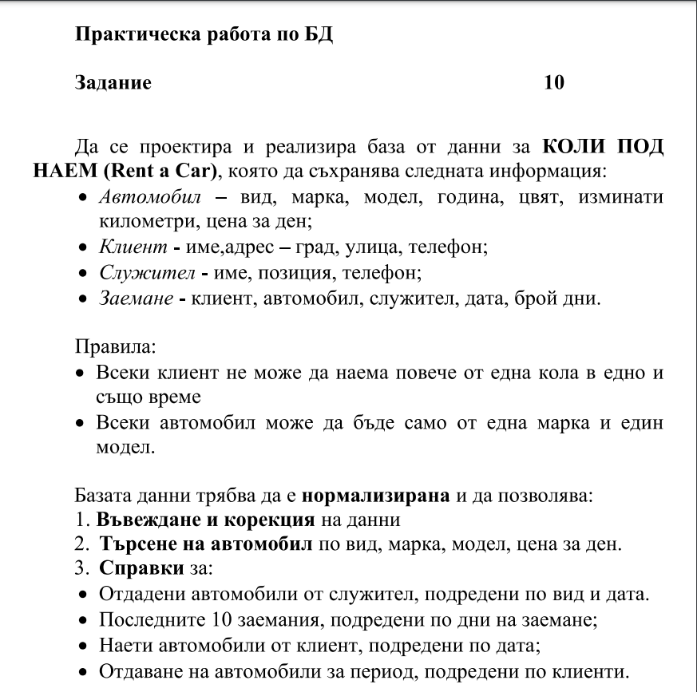**Задание:**
2. **Модели:**

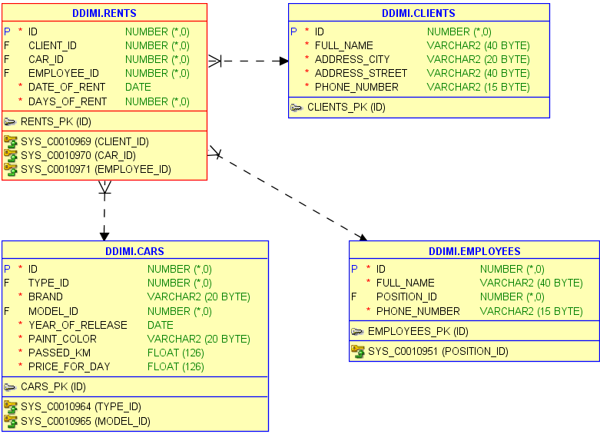

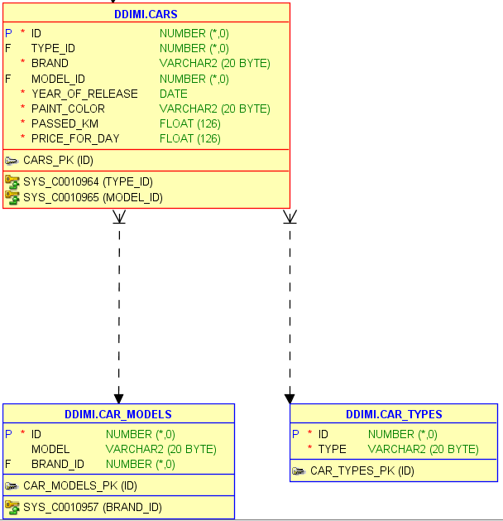

1. **Създаване на таблици:**

create table clients(

    id int,

    full_name varchar(40) not null,

    address_city varchar(20) not null,

    address_street varchar(40) not null,

    phone_number varchar(15) not null,

    primary key(id)

);

create table employee_positions(

    id int,

    position varchar(20) not null,

    primary key(id)

);

create table employees(

    id int,

    full_name varchar(40) not null,

    position_id references employee_positions(id),

    phone_number varchar(15) not null,

    primary key(id)

);

create table car_types(

    id int,

    type varchar(20) not null,

    primary key(id)

);

create table car_brands(

    id int,

    brand varchar(20) not null,

    primary key(id)

);

create table car_models(

    id int,

    model varchar(20),

    brand_id references car_brands(id),

    primary key(id)

);

create table cars(

    id int,

**type_id** references car_types(id),

    brand varchar(20) not null,

    model_id references car_models(id),

    year_of_release date not null,

    paint_color varchar(20) not null,

    passed_km float not null,

    price_for_day float not null,

    primary key(id)

);

create table rents(

    id int,

    client_id references clients(id),

    car_id references cars(id),

    employee_id references employees(id),

    date_of_rent date not null,

    days_of_rent int not null,

    primary key(id)

);

1. **Тригери:**

begin

    for i in (select sequence_name from USER_SEQUENCES)

    loop

        execute immediate ('drop sequence '|| i.sequence_name);

    end loop;

end;

/

create sequence clients_seq start with 1 increment by 1 nocache order;

create sequence employee_positions_seq start with 1 increment by 1 nocache order;

create sequence employees_seq start with 1 increment by 1 nocache order;

create sequence car_types_seq start with 1 increment by 1 nocache order;

create sequence car_brands_seq start with 1 increment by 1 nocache order;

create sequence car_models_seq  start with 1 increment by 1 nocache order;

create sequence cars_seq start with 1 increment by 1 nocache order;

create sequence rents_seq start with 1 increment by 1 nocache order;

*/\**

*Known error:*

*https://logbuffer.wordpress.com/2011/10/19/oracle-ora-0600-on-creating-trigger-on-11-2/*

*\*/*

ALTER SESSION SET PLSCOPE_SETTINGS = 'IDENTIFIERS:NONE';

create or **replace** trigger clients_trg

before insert on clients

for each row when(new.id is null)

begin

    :new.id := clients_seq.nextval;

end;

/

create or **replace** trigger employee_positions_trg

before insert on employee_positions

for each row when(new.id is null)

begin

    :new.id := employee_positions_seq.nextval;

end;

/

create or **replace** trigger employees_trg

before insert on employees

for each row when(new.id is null)

begin

    :new.id := employees_seq.nextval;

end;

/

create or **replace** trigger car_types_trg

before insert on car_types

for each row when(new.id is null)

begin

    :new.id := car_types_seq.nextval;

end;

/

create or **replace** trigger car_brands_trg

before insert on car_brands

for each row when(new.id is null)

begin

    :new.id := car_brands_seq.nextval;

end;

/

create or **replace** trigger car_models_trg

before insert on car_models

for each row when(new.id is null)

begin

    :new.id := car_models_seq.nextval;

end;

/

create or **replace** trigger cars_trg

before insert on cars

for each row when(new.id is null)

begin

    :new.id := cars_seq.nextval;

end;

/

create or **replace** trigger rents_trg

before insert on rents

for each row when(new.id is null)

begin

    :new.id := rents_seq.nextval;

end;

/ALTER SESSION SET PLSCOPE_SETTINGS = 'IDENTIFIERS:ALL';

1. **Процедури:**

CREATE OR **REPLACE** PROCEDURE clients_insert (

    full_name        clients.full_name%TYPE,

    address_city     clients.address_city%TYPE,

    address_street   clients.address_street%TYPE,

    phone_number     clients.phone_number%TYPE

) AS

BEGIN

    INSERT INTO clients VALUES (

        NULL,

        full_name,

        address_city,

        address_street,

        phone_number

    );

END;

/

CREATE OR **REPLACE** PROCEDURE employee_positions_insert (

    position employee_positions.position%TYPE

) AS

BEGIN

    INSERT INTO employee_positions VALUES (

        NULL,

        position

    );

END;

/

CREATE OR **REPLACE** PROCEDURE employees_insert (

    full_name      employees.full_name%TYPE,

    position_id    employees.position_id%TYPE,

    phone_number   employees.phone_number%TYPE

) AS

BEGIN

    INSERT INTO employees VALUES (

        NULL,

        full_name,

        position_id,

        phone_number

    );

END;

/

CREATE OR **REPLACE** PROCEDURE car_types_insert (

    type car_types.type%TYPE

) AS

BEGIN

    INSERT INTO car_types VALUES (

        NULL,

        type

    );

END;

/

CREATE OR **REPLACE** PROCEDURE car_brands_insert (

    brand car_brands.brand%TYPE

) AS

BEGIN

    INSERT INTO car_brands VALUES (

        NULL,

        brand

    );

END;

/

CREATE OR **REPLACE** PROCEDURE car_models_insert (

    model      car_models.model%TYPE,

    brand_id   car_models.brand_id%TYPE

) AS

BEGIN

    INSERT INTO car_models VALUES (

        NULL,

        model,

        brand_id

    );

END;

/

CREATE OR **REPLACE** PROCEDURE cars_insert (

**type_id**           cars.type_id%TYPE,

    brand             cars.brand%TYPE,

    model_id          cars.model_id%TYPE,

    year_of_release   cars.year_of_release%TYPE,

    paint_color       cars.paint_color%TYPE,

    passed_km         cars.passed_km%TYPE,

    price_for_day     cars.price_for_day%TYPE

) AS

BEGIN

    INSERT INTO cars VALUES (

        NULL,

**type_id**,

        brand,

        model_id,

        year_of_release,

        paint_color,

        passed_km,

        price_for_day

    );

END;

/

CREATE OR **REPLACE** PROCEDURE rents_insert (

    client_id      rents.client_id%TYPE,

    car_id         rents.car_id%TYPE,

    employee_id    rents.employee_id%TYPE,

    date_of_rent   rents.date_of_rent%TYPE,

    days_of_rent   rents.days_of_rent%TYPE

) AS

BEGIN

    INSERT INTO rents VALUES (

        NULL,

        client_id,

        car_id,

        employee_id,

        date_of_rent,

        days_of_rent

    );

END;

/

CREATE OR **REPLACE** PROCEDURE clients_delete(id_to_delete clients.id%type) AS

BEGIN

    DELETE FROM clients WHERE id = id_to_delete;

END;

/

CREATE OR **REPLACE** PROCEDURE employee_positions_delete(id_to_delete employee_positions.id%type) AS

BEGIN

    DELETE FROM employee_positions WHERE id = id_to_delete;

END;

/

CREATE OR **REPLACE** PROCEDURE employees_delete(id_to_delete employees.id%type) as

begin

    DELETE FROM employees WHERE id = id_to_delete;

END;

/

CREATE OR **REPLACE** PROCEDURE car_types_delete(id_to_delete car_types.id%type) AS

BEGIN

    DELETE FROM car_types WHERE id = id_to_delete;

END;

/

CREATE OR **REPLACE** PROCEDURE car_brands_delete(id_to_delete car_brands.id%type) AS

BEGIN

    DELETE FROM car_brands WHERE id = id_to_delete;

END;

/

CREATE OR **REPLACE** PROCEDURE car_models_delete(id_to_delete car_models.id%type) AS

BEGIN

    DELETE FROM car_models WHERE id = id_to_delete;

END;

/

CREATE OR **REPLACE** PROCEDURE cars_delete(id_to_delete cars.id%type) AS

BEGIN

    DELETE FROM cars WHERE id = id_to_delete;

END;

/

CREATE OR **REPLACE** PROCEDURE rents_delete(id_to_delete rents.id%type) AS

BEGIN

    DELETE FROM rents WHERE id = id_to_delete;

END;

/

CREATE OR **REPLACE** PROCEDURE clients_update (

    id_to_update         clients.id%TYPE,

    new_full_name        clients.full_name%TYPE,

    new_address_city     clients.address_city%TYPE,

    new_address_street   clients.address_street%TYPE,

    new_phone_number     clients.phone_number%TYPE

) AS

BEGIN

    UPDATE clients

    SET

        full_name = new_full_name,

        address_city = new_address_city,

        address_street = new_address_street,

        phone_number = new_phone_number

    WHERE

        id = id_to_update;

END;

/

CREATE OR **REPLACE** PROCEDURE employee_positions_update ( id_to_update employee_positions.id%type,

new_position employee_positions.positions%TYPE

) AS

BEGIN

    UPDATE employee_positions

    SET

        position = new_position

    WHERE

        id = id_to_update;

END;

/

CREATE OR **REPLACE** PROCEDURE employees_update (

    id_to_update       employees.id%TYPE,

    new_full_name      employees.full_name%TYPE,

    new_position_id    employees.position_id%TYPE,

    new_phone_number   employees.phone_number%TYPE

) AS

BEGIN

    UPDATE employees

    SET

        full_name = new_full_name,

        position_id = new_position_id,

        phone_number = new_phone_number

    WHERE

        id = id_to_update;

END;

/

CREATE OR **REPLACE** PROCEDURE car_types_update (

    id_to_update car_types.id%type,

    new_type car_types.type%type

) AS

BEGIN

    UPDATE car_types

    SET

        type = new_type

    WHERE

        id = id_to_update;

END;

/

CREATE OR **REPLACE** PROCEDURE car_brands_update (

    id_to_update car_brands.id%type,

    new_brand car_brands.brand%type

) AS

BEGIN

    UPDATE car_brands

    SET

        brand = new_brand

    WHERE

        id = id_to_update;

END;

/

CREATE OR **REPLACE** PROCEDURE car_models_update (

    id_to_update car_models.id%type,

    new_model car_models.model%type,

    new_brand_id car_models.brand_id%type

) AS

BEGIN

    UPDATE car_models

    SET

        model = new_model,

        brand_id = new_brand_id

    WHERE

        id = id_to_update;

END;

/

CREATE OR **REPLACE** PROCEDURE cars_update (

    id_to_update cars.id%type,

    new_type_id cars.type_id%type,

    new_brand cars.brand%type,

    new_model_id cars.model_id%type,

    new_year_of_release cars.year_of_release%type,

    new_paint_color cars.paint_color%type,

    new_passed_km cars.passed_km%type,

    new_price_for_day cars.price_for_day%type

) AS

BEGIN

    UPDATE cars

    SET

**type_id** = new_type_id,

        brand = new_brand,

        model_id = new_model_id,

        year_of_release = new_year_of_release,

        paint_color = new_paint_color,

        passed_km = new_passed_km,

        price_for_day = new_price_for_day

    WHERE

        id = id_to_update;

END;

/

CREATE OR **REPLACE** PROCEDURE rents_update (

    id_to_update rents.id%type,

    new_client_id rents.client_id%type,

    new_car_id rents.car_id%type,

    new_employee_id rents.employee_id%type,

    new_date_of_rent rents.date_of_rent%type,

    new_days_of_rent rents.days_of_rent%type

) AS

BEGIN

    UPDATE rents

    SET

    client_id = new_client_id,

    car_id = new_car_id,

    employee_id = new_employee_id,

    date_of_rent = new_date_of_rent,

    days_of_rent = new_days_of_rent

WHERE

    id = id_to_update;

END;

/

1. **Примерни данни:**

begin

    employee_positions_insert('director');

    employee_positions_insert('products manager');

    employee_positions_insert('executive');

    employee_positions_insert('seller');

    employees_insert('Georgi Dimitrov', 1, '0880099320');

    employees_insert('Stefan Georgiev', 2, '0881199321');

    employees_insert('Petur Ivanov', 3, '0882299322');

    employees_insert('Petur Petrov', 4, '0883399323');

    employees_insert('Martin Stamboliiski', 4, '0884499324');

    employees_insert('Angel Stefanov', 4, '0885599325');

    employees_insert('Yoan Qnev', 4, '0886699326');

    clients_insert('Daniel Dimitrov', 'Burgas', 'Izgrev', '0887575232');

    clients_insert('Ivailo Vasilev', 'Ruse', 'Bqla', '0892134455');

    clients_insert('Dimitur Zurlev', 'Turgovishte', 'Rusenska 4', '08770774666');

    clients_insert('Nikolai Zhelev', 'Shumen', 'Stefan Stambolov 12', '08770774563');

    clients_insert('Dimitur Stoqnov', 'Varna', 'Voivoda 59', '08770774669');

    clients_insert('Aleksandur Vasilev', 'Plovdiv', 'Centur 99', '08770774667');

    clients_insert('Georgi Evtimov', 'Sofiq', 'Manastirski Livadi', '08770774663');

    car_types_insert('Sedan');

    car_types_insert('Kombi');

    car_types_insert('Hatchback');

    car_types_insert('SUV');

    car_types_insert('MPV');

    car_types_insert('CUV');

    car_types_insert('VAN');

    car_types_insert('TRUCK/PICKUP');

    car_types_insert('Limousine');

    car_brands_insert('Toyota');

    car_brands_insert('Ford');

    car_brands_insert('Honda');

    car_brands_insert('Alfa Romeo');

    car_brands_insert('Volvo');

    car_brands_insert('VW/Volkswagen');

    car_brands_insert('Peugeot');

    car_brands_insert('Audi');

    car_brands_insert('BMW');

    car_brands_insert('Citroen');

    car_models_insert('Auris', 1);

    car_models_insert('Yaris', 1);

    car_models_insert('Corolla', 1);

    car_models_insert('Focus', 2);

    car_models_insert('Fiesta', 2);

    car_models_insert('Taurus', 2);

    car_models_insert('Accord', 3);

    car_models_insert('Civic', 3);

    car_models_insert('CR-V', 3);

    car_models_insert('Giulietta 5 gen', 4);

    car_models_insert('4C Spider 1 gen', 4);

    car_models_insert('AR-146', 4);

    car_models_insert('XC60', 5);

    car_models_insert('S60', 5);

    car_models_insert('V40', 5);

    car_models_insert('Golf 3', 6);

    car_models_insert('Golf 4', 6);

    car_models_insert('Golf 5', 6);

    car_models_insert('207', 7);

    car_models_insert('307', 7);

    car_models_insert('407', 7);

    car_models_insert('A3', 8);

    car_models_insert('A6', 8);

    car_models_insert('A8', 8);

    car_models_insert('E30 M3', 9);

    car_models_insert('i8', 9);

    car_models_insert('X1', 9);

    car_models_insert('C5', 10);

    car_models_insert('C4', 10);

    car_models_insert('C3', 10);

    cars_insert(3, 'Toyota', 1, to_date('06/05/2008', 'dd/mm/yyyy'), 'metalic', **round**(dbms_random.value(50000, 300000), 2), **round**(dbms_random.value(10, 99), 2));

    cars_insert(3, 'Toyota', 2, to_date('21/01/2009', 'dd/mm/yyyy'), 'black', **round**(dbms_random.value(50000, 300000), 2), **round**(dbms_random.value(10, 99), 2));

    cars_insert(3, 'Toyota', 3, to_date('26/04/2003', 'dd/mm/yyyy'), 'white', **round**(dbms_random.value(50000, 300000), 2), **round**(dbms_random.value(10, 99), 2));

    cars_insert(2, 'Ford', 4, to_date('01/06/2005', 'dd/mm/yyyy'), 'silver', **round**(dbms_random.value(50000, 300000), 2), **round**(dbms_random.value(10, 99), 2));

    cars_insert(3, 'Ford', 5, to_date('02/02/2001', 'dd/mm/yyyy'), 'white', **round**(dbms_random.value(50000, 300000), 2), **round**(dbms_random.value(10, 99), 2));

    cars_insert(4, 'Ford', 6, to_date('26/04/2003', 'dd/mm/yyyy'), 'royal blue', **round**(dbms_random.value(50000, 300000), 2), **round**(dbms_random.value(10, 99), 2));

    cars_insert(1, 'Honda', 7, to_date('15/09/2004', 'dd/mm/yyyy'), 'gray mate', **round**(dbms_random.value(50000, 300000), 2), **round**(dbms_random.value(10, 99), 2));

    cars_insert(3, 'Honda', 8, to_date('06/09/2011', 'dd/mm/yyyy'), 'dark mate', **round**(dbms_random.value(50000, 300000), 2), **round**(dbms_random.value(10, 99), 2));

    cars_insert(4, 'Honda', 9, to_date('17/07/2008', 'dd/mm/yyyy'), 'red', **round**(dbms_random.value(50000, 300000), 2), **round**(dbms_random.value(10, 99), 2));

    cars_insert(1, 'Alfa Romeo', 10, to_date('04/10/2011', 'dd/mm/yyyy'), 'light gray mate', **round**(dbms_random.value(50000, 300000), 2), **round**(dbms_random.value(10, 99), 2));

    cars_insert(3, 'Alfa Romeo', 11, to_date('29/11/2014', 'dd/mm/yyyy'), 'red mate', **round**(dbms_random.value(50000, 300000), 2), **round**(dbms_random.value(10, 99), 2));

    cars_insert(3, 'Alfa Romeo', 12, to_date('11/08/2008', 'dd/mm/yyyy'), 'black metalic', **round**(dbms_random.value(50000, 300000), 2), **round**(dbms_random.value(10, 99), 2));

    cars_insert(4, 'Volvo', 13, to_date('09/10/2020', 'dd/mm/yyyy'), 'royal blue mate', **round**(dbms_random.value(50000, 300000), 2), **round**(dbms_random.value(10, 99), 2));

    cars_insert(1, 'Volvo', 14, to_date('07/07/2016', 'dd/mm/yyyy'), 'white', **round**(dbms_random.value(50000, 300000), 2), **round**(dbms_random.value(10, 99), 2));

    cars_insert(3, 'Volvo', 15, to_date('09/09/2015', 'dd/mm/yyyy'), 'light blue metalic', **round**(dbms_random.value(50000, 300000), 2), **round**(dbms_random.value(10, 99), 2));

    cars_insert(3, 'VW', 16, to_date('23/10/1994', 'dd/mm/yyyy'), 'black', **round**(dbms_random.value(50000, 300000), 2), **round**(dbms_random.value(10, 99), 2));

    cars_insert(3, 'VW', 17, to_date('01/09/2005', 'dd/mm/yyyy'), 'gray', **round**(dbms_random.value(50000, 300000), 2), **round**(dbms_random.value(10, 99), 2));

    cars_insert(3, 'VW', 18, to_date('09/09/2004', 'dd/mm/yyyy'), 'dark blue mate', **round**(dbms_random.value(50000, 300000), 2), **round**(dbms_random.value(10, 99), 2));

    cars_insert(3, 'Peugeot', 19, to_date('23/05/2008', 'dd/mm/yyyy'), 'black', **round**(dbms_random.value(50000, 300000), 2), **round**(dbms_random.value(10, 99), 2));

    cars_insert(3, 'Peugeot', 20, to_date('30/09/2005', 'dd/mm/yyyy'), 'gray mate', **round**(dbms_random.value(50000, 300000), 2), **round**(dbms_random.value(10, 99), 2));

    cars_insert(3, 'Peugeot', 21, to_date('17/01/2006', 'dd/mm/yyyy'), 'blue', **round**(dbms_random.value(50000, 300000), 2), **round**(dbms_random.value(10, 99), 2));

    cars_insert(3, 'Audi', 22, to_date('23/02/2007', 'dd/mm/yyyy'), 'black', **round**(dbms_random.value(50000, 300000), 2), **round**(dbms_random.value(10, 99), 2));

    cars_insert(1, 'Audi', 23, to_date('30/05/2004', 'dd/mm/yyyy'), 'gray mate', **round**(dbms_random.value(50000, 300000), 2), **round**(dbms_random.value(10, 99), 2));

    cars_insert(1, 'Audi', 24, to_date('17/01/2010', 'dd/mm/yyyy'), 'dark blue', **round**(dbms_random.value(50000, 300000), 2), **round**(dbms_random.value(10, 99), 2));

    cars_insert(3, 'BMW', 25, to_date('23/02/2012', 'dd/mm/yyyy'), 'black', **round**(dbms_random.value(50000, 300000), 2), **round**(dbms_random.value(10, 99), 2));

    cars_insert(1, 'BMW', 26, to_date('30/05/2013', 'dd/mm/yyyy'), 'gray mate', **round**(dbms_random.value(50000, 300000), 2), **round**(dbms_random.value(10, 99), 2));

    cars_insert(1, 'BMW', 27, to_date('17/01/2017', 'dd/mm/yyyy'), 'dark blue', **round**(dbms_random.value(50000, 300000), 2), **round**(dbms_random.value(10, 99), 2));

    cars_insert(3, 'Citroen', 28, to_date('23/02/2016', 'dd/mm/yyyy'), 'black', **round**(dbms_random.value(50000, 300000), 2), **round**(dbms_random.value(10, 99), 2));

    cars_insert(4, 'Citroen', 29, to_date('30/05/2003', 'dd/mm/yyyy'), 'gray mate', **round**(dbms_random.value(50000, 300000), 2), **round**(dbms_random.value(10, 99), 2));

    cars_insert(1, 'Citroen', 30, to_date('17/01/2012', 'dd/mm/yyyy'), 'dark blue', **round**(dbms_random.value(50000, 300000), 2), **round**(dbms_random.value(10, 99), 2));

    rents_insert(1, 30, 4, to_date('23/02/2022', 'dd/mm/yyyy'), **floor**(dbms_random.value(7, 31)));

    rents_insert(2, 8, 2, to_date('30/01/2022', 'dd/mm/yyyy'), 31);

    rents_insert(3, 11, 3, to_date('15/02/2022', 'dd/mm/yyyy'), 15);

    rents_insert(4, 16, 5, to_date('05/03/2022', 'dd/mm/yyyy'), 21);

    rents_insert(5, 4, 5, to_date('01/04/2022', 'dd/mm/yyyy'), 6);

    rents_insert(6, 1, 6, to_date('28/02/2022', 'dd/mm/yyyy'), 7);

    rents_insert(7, 21, 1, to_date('27/02/2022', 'dd/mm/yyyy'), 3);

end;

1. **Справка „Търсене на автомобил по вид, марка, модел, цена за ден“**

* **Процедура**

create or **replace** PROCEDURE search_car (

    s_car_brand      cars.brand%TYPE,

    s_car_model       car_models.model%TYPE,

    s_car_type        car_types.type%TYPE,

    s_price_for_day   cars.price_for_day%TYPE

)

IS

BEGIN

    DECLARE

        CURSOR car_rows IS

        SELECT

            brand,

            car_models.model,

            car_types.type,

            year_of_release,

            paint_color,

            passed_km,

            price_for_day

        FROM

            cars

            INNER JOIN car_models ON **upper**(car_models.model) = **upper**(s_car_model)

            INNER JOIN car_types ON **upper**(car_types.type) = **upper**(s_car_type)

        WHERE

**upper**(brand) = **upper**(s_car_brand)

            AND price_for_day >= s_price_for_day - 15

            AND price_for_day <= s_price_for_day + 15

        ORDER BY price_for_day ASC;

    BEGIN

        dbms_output.put_line('Search Results for: ' || s_car_brand || ' ' || s_car_model);

        FOR car IN car_rows LOOP

            dbms_output.put_line('Brand: ' || car.brand);

            dbms_output.put_line('Model: ' || car.model);

            dbms_output.put_line('YearOfRelease: ' || car.year_of_release);

            dbms_output.put_line('Paint: ' || car.paint_color);

            dbms_output.put_line('PriceForDay: ' || car.price_for_day);

            dbms_output.put_line('PassedKm: ' || car.passed_km);

            dbms_output.put_line('-----------');

        END LOOP;

    END;

END;

* **Резултати**

set serveroutput on;

exec search_car('&CAR_BRAND', '&CAR_MODEL', '&CAR_TYPE', &PRICE_FOR_DAY);

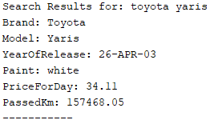

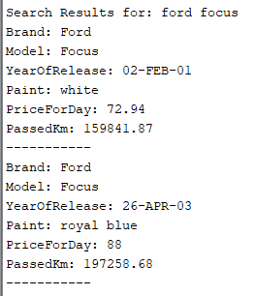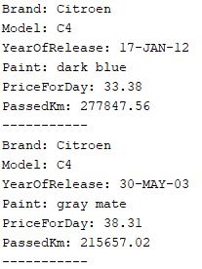

1. **Справка „Отдадени автомобили от служител, подредени по вид и дата“:**

* **Процедура**

create or **replace** PROCEDURE search_car_rentals_by_employee (

    s_employee_full_name employees.full_name%TYPE

) IS

BEGIN

    DECLARE

        CURSOR car_rental_rows IS

        SELECT

            clients.full_name     AS client_full_name,

            cars.brand as car_brand,

            car_models.model as car_model,

            car_types.type as car_type,

            date_of_rent,

            days_of_rent

        FROM

            rents

            INNER JOIN cars ON cars.id = car_id

            INNER JOIN car_models ON cars.model_id = car_models.id

            INNER JOIN car_types ON cars.type_id = car_types.id

            INNER JOIN clients ON clients.id = client_id

            INNER JOIN employees ON employees.id = employee_id

        WHERE

**upper**(employees.full_name) = **upper**(s_employee_full_name)

        ORDER BY date_of_rent DESC, car_types.type ASC;

    BEGIN

        dbms_output.put_line('Car rentals from Employee: ' || s_employee_full_name);

        FOR car_rental IN car_rental_rows LOOP

            dbms_output.put_line('Client: ' || car_rental.client_full_name);

            dbms_output.put_line('Car: ' || car_rental.car_brand || ' ' || car_rental.car_model || ' ' || car_rental.car_type);

            dbms_output.put_line('DateOfRent: ' || car_rental.date_of_rent);

            dbms_output.put_line('DaysOfRent: ' || car_rental.days_of_rent);

            dbms_output.put_line('-----------');

        END LOOP;

    END;

END;

* **Резултати**

set serveroutput on;

exec search_car_rentals_by_employee('&EMPLOYEE_FULL_NAME');

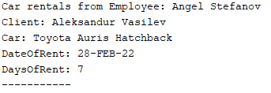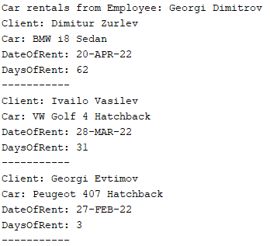

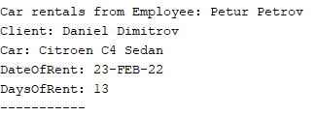

1. **Справка „Последните 10 заемания, подредени по дата“:**

* **Процедура**

create or **replace** PROCEDURE get_latest_rents

IS

BEGIN

    DECLARE

        CURSOR latest_rents_rows IS

        SELECT

            clients.full_name     AS client_full_name,

            cars.brand as car_brand,

            car_models.model as car_model,

            car_types.type as car_type,

            employees.full_name   AS employee_full_name,

            date_of_rent,

            days_of_rent

        FROM

            rents

            INNER JOIN cars ON cars.id = car_id

            INNER JOIN car_models ON cars.model_id = car_models.id

            INNER JOIN car_types ON cars.type_id = car_types.id

            INNER JOIN clients ON clients.id = client_id

            INNER JOIN employees ON employees.id = employee_id

        WHERE ROWNUM <= 10

        ORDER BY days_of_rent DESC;

    BEGIN

        dbms_output.put_line('Latest rents: ');

        FOR rent IN latest_rents_rows LOOP

            dbms_output.put_line('Client: ' || rent.client_full_name);

            dbms_output.put_line('Employee: ' || rent.employee_full_name);

            dbms_output.put_line('Car: ' || rent.car_brand || ' ' || rent.car_model || ' ' || rent.car_type);

            dbms_output.put_line('DateOfRent: ' || rent.date_of_rent);

            dbms_output.put_line('DaysOfRent: ' || rent.days_of_rent);

            dbms_output.put_line('-----------');

        END LOOP;

    END;

END;

* **Резултати**

set serveroutput on;

exec get_latest_rents;

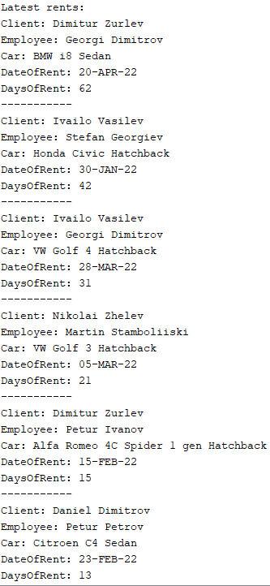

1. **Справка „Наети автомобили от клиент,подредени по дата“:**

* **Процедура**

create or **replace** PROCEDURE search_rented_cars_from_client (

    s_client_full_name clients.full_name%TYPE

)

IS

BEGIN

    DECLARE

        CURSOR cars_rented_rows IS

        SELECT

            cars.brand as car_brand,

            car_models.model as car_model,

            car_types.type as car_type,

            date_of_rent,

            days_of_rent

        FROM

            rents

            INNER JOIN cars ON cars.id = car_id

            INNER JOIN car_models ON cars.model_id = car_models.id

            INNER JOIN car_types ON cars.type_id = car_types.id

            INNER JOIN clients ON clients.id = client_id

            INNER JOIN employees ON employees.id = employee_id

        WHERE

**upper**(clients.full_name) = **upper**(s_client_full_name)

        ORDER BY date_of_rent ASC;

    BEGIN

        dbms_output.put_line('Cars rented by: ' || s_client_full_name);

        FOR car IN cars_rented_rows LOOP

            dbms_output.put_line('Car: ' || car.car_brand || ' ' || car.car_model || ' ' || car.car_type);

            dbms_output.put_line('DateOfRent: ' || car.date_of_rent);

            dbms_output.put_line('DaysOfRent: ' || car.days_of_rent);

            dbms_output.put_line('-----------');

        END LOOP;

    END;

END;

* **Резултати**

set serveroutput on;

exec search_rented_cars_from_client('&CLIENT_FULL_NAME');

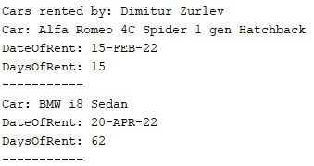

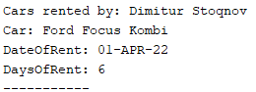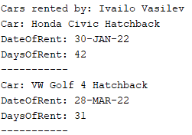

1. **Справка „Отдаване на автомобили за период, подредени по клиенти“:**

* **Процедура**

CREATE OR **REPLACE** PROCEDURE get_rented_cars_in_period (

    from_period_date date,

    to_period_date date

) IS

BEGIN

    DECLARE

        CURSOR latest_rents_rows IS

        SELECT

            clients.full_name     AS client_full_name,

            cars.brand            AS car_brand,

            car_models.model      AS car_model,

            car_types.type        AS car_type,

            employees.full_name   AS employee_full_name,

            date_of_rent,

            days_of_rent

        FROM

            rents

            INNER JOIN cars ON cars.id = car_id

            INNER JOIN car_models ON cars.model_id = car_models.id

            INNER JOIN car_types ON cars.type_id = car_types.id

            INNER JOIN clients ON clients.id = client_id

            INNER JOIN employees ON employees.id = employee_id

        WHERE

            date_of_rent BETWEEN from_period_date AND to_period_date

        ORDER BY

            clients.full_name DESC;

    BEGIN

        dbms_output.put_line('Rents between: ' || from_period_date || ' and ' || to_period_date);

        FOR rent IN latest_rents_rows LOOP

            dbms_output.put_line('Client: ' || rent.client_full_name);

            dbms_output.put_line('Employee: ' || rent.employee_full_name);

            dbms_output.put_line('Car: ' || rent.car_brand || ' ' || rent.car_model || ' ' || rent.car_type);

            dbms_output.put_line('DateOfRent: ' || rent.date_of_rent);

            dbms_output.put_line('DaysOfRent: ' || rent.days_of_rent);

            dbms_output.put_line('-----------');

        END LOOP;END;END;

* **Резултати**

set serveroutput on;

exec search_rented_cars_in_period(TO_DATE('&FROM_DATE', 'DD/MM/YYYY'), TO_DATE('&TO_DATE', 'DD/MM/YYYY'));

