# Issue Tracking System – AngularJS Practical Project

You are assigned to design and implement an **issue tracker system**. The system holds **projects**, which have **issues**. Each **project** has a **leader** (the person responsible for the project) , **name**, **description**, a **project key** (which should be generated by the client using the rule which is described below in the endpoints section), a set of **priorities** which the project’s issues can use and some **labels**.

Each **Issue** has a **title**, **description**, **issue key** (which is automatically generated by the system), an **assignee** (the person responsible to resolve the issue), a **status** which must follow a specific **status transition** (more on that below), a **due date**, a **priority** (which is some of the available priorities for the project), some **labels** and user-made **comments**.

A **status transition scheme** describes the workflow of an issue. See the image below for an example scheme:

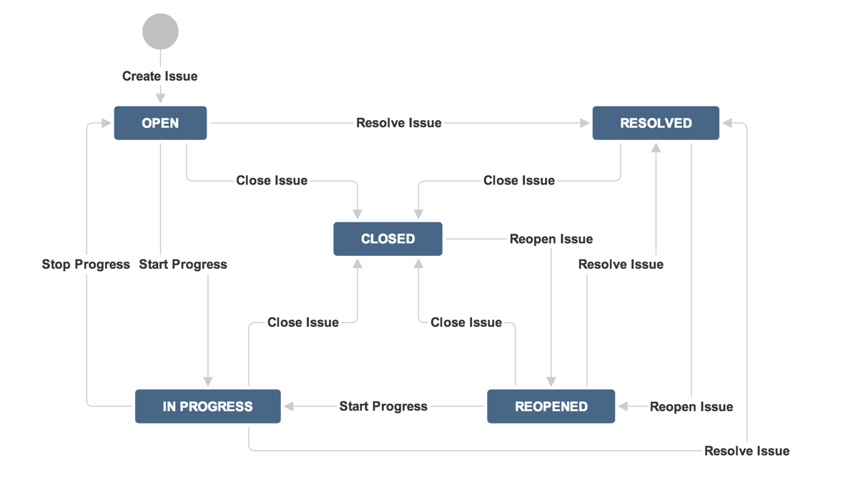

A logged in user can view the **dashboard**, which depending of his role, will consist of different elements. All users can view the assigned **issues** to them, ordered by **due date** in descending order. **Administrators** can also create or edit issues and projects.

The **project leader** can edit the project, add new issues to it and change the status of the current ones. The **issue assignee** has privileges to change the status of the issue.

Anonymous site visitors can only **login** and **register**. Logged in users can **logout**. You are given the server-side REST services to be called by your app with AJAX requests so you do not need to develop back-end.

## Important: Commit Every Day in GitHub

Please **use GitHub** for your project development!

* Commit several times a day.
  + You need to show many small commits that indicate your constant work on the project.
  + Avoid committing large blocks of code at once.
* You should prove that you have worked at least 3-4 days over your project!

Note that Git does not require Internet connection in order to commit changes. You can commit locally and push your changes to GitHub at once. Please commit many times to show your work progress step by step.

Up to 100 score

## Issue Tracker REST Services

You are given the following REST services for your Social Network SPA application.

* Services base URL (in the Windows Azure cloud): <http://softuni-issue-tracker.azurewebsites.net>
* Services help page (online documentation): <http://softuni-issue-tracker.azurewebsites.net/help>
* Services admin user (you can later make your own user admin using the “makeadmin” endpoint described below): Username: [admin@softuni.bg](mailto:admin@softuni.bg) ; Password: 123456

The documentation below provides additional details for the Social Network REST services.

## Issue Tracker Web Design

You аre given the **Web design** and **UI prototype** of the Issue Tracker SPA application as a folder with screenshots. You need to convert the design to HTML + CSS. Pixel-perfect layout is not required. **You do not need to match the design** at all, neither the sizes, alignment, fonts nor the colors of the elements. A responsive design is highly desirable. You can use responsive CSS frameworks like **Bootstrap**.

20 score

## Issue Tracker SPA Application

Design and implement a client-side SPA application based on **AngularJS**.

### AngularJS Project Structure

* Prepare an AngularJS project structure following the industry best practices.
* You should have separate folders for controllers, directives, filters, services, views, etc.

30 score

# Backend Endpoints

### Projects

##### [GET] Projects/?pageSize={pageSize}&pageNumber={pageNumber}&{filter}={value}

* **Purpose**: Gets projects by a given filter
* **Security**: Logged In
* **Url parameters**:
  + filter (String): the filters which you want the projects to be filtered by
    - Supports every projects property with equals, less (or equal) than, greater (or equal) than comparators (for example “Name == “SIT Project””)
    - Supports child properties (for example: “Lead.Id == “e980a9d8-53e5-4f6b-b8ae-1efec2e58938””)
    - Supports multiple criterias using “and” and “or” in between them (for example “Lead.Username == "admin@softuni.bg" or Description.Contains("test"))
  + pageSize (Int, Required): how many elements do you want the system to return
  + pageNumber (Int, Required): from which page to start (take the first pageSize * pageNumber elements)
* **Returns**: The projects with their leaders

##### [GET] Projects/{id}

* **Purpose**: Gets a project by id
* **Security**:Logged in

##### [POST] Projects/

* **Purpose**: Adds a new project with a default transition scheme which holds these statuses: Open, Closed, In Progress, Closed Progress
* **Security**: Admin
* **Body parameters**:
  + Name (Required)
  + Description (Required)
  + ProjectKey (Required): Should be generated by the first letters of the name. (Example: Project.Name = “Java Fundamentals” => Project.ProjectKey should be “JF”
  + List<Labels>: A list of labels which will be added to the project
  + List<Priorities>: A list of priorities which the project’s issues will be able to use
  + LeadId: The id of the person who will be leading the project
* **Returns**: The newly created project

##### [PUT] Projects/{id}

* **Purpose**: Edits a project by a given id
* **Security**:Admin, Lead of project
* **Body parameters**:
  + Same as **[POST] Projects/**, except for ProjectKey which cannot be edited
* **Returns**: The edited project

#### Issues

##### [GET] Projects/{id}/Issues

* **Purpose**: Gets the project’s issues by id
* **Security**:Logged in
* **Returns**: The project’s issues with their available statuses

##### [GET] Issues/?pageSize={pageSize}&pageNumber={pageNumber}&{filter}={value}

* **Purpose**: Gets issues by a given filter
* **Security**: Logged In
* **Url parameters**:
  + filter (String): the filters which you want the issues to be filtered by
    - Supports every issue’s property with equals, less (or equal) than, greater (or equal) than comparators (for example “ProjectId == 2”, “DueDate.Day >= 20”)
    - Supports child properties (as seen above: “DueDate.Day < 10”, “Project.Name” == “SIT”)
    - Supports multiple criterias using “and” and “or” in between them (for example “Priority.Name == "In Progress" or DueDate.Month == 3”)
  + pageSize (Int, Required): how many elements do you want the system to return
  + pageNumber (Int, Required): from which page to start (take the first pageSize * pageNumber elements)
* **Returns**: The issues with their available statuses

##### [GET] Issues/me?pageSize={pageSize}&pageNumber={pageNumber}&orderBy={by}

* **Purpose**: Gets the user’s currently assigned issues ordered by a given criteria
* **Security**: Logged in
* **Url parameters**:
  + orderBy (String): the property of the issue which you want the issues to be sorted by
    - Supports all issue’s properties (for example Project, IssueKey, DueDate)
    - Supports child properties (for example Project.Name will sort the issues by the name of their project)
    - Supports descending sorting, just add “desc” after the property (for example “IssueKey desc”)
    - Supports multiple criteria using comma separated syntax (for example “Project.Name desc, IssueKey, Priority.Name desc”)
  + pageSize (Int, Required): how many elements do you want the system to return
  + pageNumber (Int, Required): from which page to start (take the first pageSize * pageNumber elements)
* **Returns**: The user’s issues with their available statuses

##### [GET] Issues/{id}

* **Purpose**: Gets an issue by id
* **Security**: Logged in
* **Returns**: The requested issue with its available statuses

##### [POST] Issues/

* **Purpose**: Adds a new issue
* **Security**: Admin, Project lead
* **Body parameters**:
  + Title (String, Required)
  + Description (String, Required)
  + DueDate (DateTime, Required)
  + ProjectId (Int, Required): The issue’s project
  + AssigneeId (String, Required): The issue’s assignee
  + PriorityId (Int, Required): The priority’s id (should be one of the available priorities for the project)
  + List<Label> (Required): A list of labels for the issue
* **Returns**: The newly created issue

##### [PUT] Issues/{id}

* **Purpose**: Edits an issue by an id
* **Security**: Admin, Project lead
* **Body parameters**: Same as [POST] Issues/, except for ProjectId which cannot be edited
* **Returns**: The edited issue

##### [PUT] Issues/{id}/changestatus?statusid={statusId}

* **Purpose**: Edits an issue’s current status, only if it’s available in the status transition scheme (for example, you can’t change the status from ‘Open’ directly to ‘Stopped Progress’)
* **Security**: Admin, Issue assignee, Project lead
* **Url Parameters**:
  + statusid (Int, Required): the id of the new status
* **Returns**: The new available statuses

##### [GET] Issues/{id}/comments

* **Purpose**: Gets all the issue’s comments by a specified id
* **Security**: Logged in

##### [PUT] Issues/{id}/comments

* **Purpose**: Adds a new comment to an issue specified by id
* **Security**: Logged in user who is either a project leader or has a assigned issue in this project
* **Body parameters**:
  + Text (String, Required): The comment’s text
* **Returns**: list of all the issue’s comments

#### Labels

##### [GET] Labels/?filter={filter}

* **Purpose**: Gets all of the existing labels filtered
* **Security**:Logged in
* **Returns**: The labels with their id and name
* **Url Parameters**:
  + filter (String, Required): The starting substring for the searched labels (For example: “?filter=sof” can return “Softuni, software” and every existing label that starts with “sof”)

#### Users

##### [POST] api/Account/Register

* **Purpose**: Registers a new, non-admin, user to the system
* **Security**: None
* **Body parameters**:
  + Email (String, Required): The email for the newly registered user
  + Password (String, Required): Password
  + ConfirmPassword: The same password for confirmation
* **Returns**: Status code 200 on success

##### [POST] api/Token

* **Purpose**: Gets an authentication token from the system to later authenticate the user (client) with the requests he makes
* **Security**: None
* **Body parameters**:
  + Username (String, Required): Use the user’s email as it serves as the username in the system
  + Password (String, Required): Password
  + grant_type (String, Required): Should be always “password” in order to authenticate successfully
* **Returns**: Data with a field access_token which is the necessary token needed for authentication
* **Usage**: After getting the token you can authenticate every request made by the client by putting an “Authorization” key in the request headers with value: “Bearer {access_token}” where {access_token} is the one returned from the system.

##### [GET] Users/

* **Purpose**: Gets all of the registered users
* **Security**:Logged in
* **Returns**: The users with their id, username and whether they’re admin

##### [GET] Users/me

* **Purpose**: Gets the currently
* **Security**:Logged in
* **Returns**: The user with his id, username and whether they’re admin

##### [PUT] Users/makeadmin

* **Purpose**: Grants an user admin privileges
* **Security**: Admin
* **Returns**: Status code **200** on success
* **Body parameters**:
  + UserId (String, Required): The id of the user to be made admin

##### [POST] api/Account/ChangePassword

* **Purpose**: Changes the current user’s password
* **Security**: Logged in
* **Body parameters**:
  + OldPassword (String, Required): The user’s current password
  + NewPassword (String, Required): New Password
  + ConfirmPassword (String, Required): Again the new password for confirmation
* **Returns**: Status code 200 on success

# Project Requirements

### Public Screens

Public screens are accessible for site visitors without login.

* **Login Screen**
  + Route: **#/**
  + **Logins an existing user**. Shows notification for success or error message.
  + After login, the user is automatically redirected to the dashboard.

5 score

* **Register User Screen**
  + Route: **#/**
  + **Registers a new user**. Shows notification for success or error message.
  + After registration, the user is automatically logged in and is redirected to the dashboard.

10 score

### User Screens

User screens are accessible for authorized users only (after login).

* **User Dashboard**
  + Route: #/
  + Includes the user’s assigned issues, ordered by due date in descending order and a panel with all the projects that you are associated with (you have an assigned issue in them or you are a project leader)

10 score

* **Project Page**
  + Route: #/projects/:id
  + Includes all the project info and all of its issues. If the user is the project’s leader he can add new issues.

10 score

* **Edit Project Page**
  + Route: #/projects/:id/edit
  + If the user is the project leader, he can access this page and edit the project.

5 score

* **Add Issue** 
  + Route: #/projects/:id/add-issue
  + A modal dialog with a form for creating a new issue. The form consists of:
    - Assignee (Drop-down with all available users)
    - Project (Drop-down with all available projects)
    - Due (Calendar)
    - Priority (Drop-down with available priorities for this project)
    - Label (Text-box which suggests already created labels by typing a substring. If the label does not exist – creates it)
    - Title (Text-box)
    - Description (Textarea)
    - Create Issue (Button)

10 score

* **Issue page**
  + Route: #/issues/:id
  + Displays the information about the issue
  + If the user is the assignee, they can see a button for changing the status using an available status (e.g. Open -> Closed).
  + If the user is the issue’s project leader they can see the edit issue button.

15 score

* **Edit Issue page**
  + Route: #/issues/:id/edit
  + The page is not visible unless the user is the issue’s project leader or assignee.
  + If the user is the assignee, they can change the status using an available status (e.g. Open -> Closed).
  + If they are the project’s leader they can edit the whole issue (including its assignee).

10 score

* **Change User Password**
  + Route: #/profile/password
  + Users should be able to **change their password** from form (contains **old password**, **new password** and **confirm new password**). Show notification for success or error message.

10 score

* **Logout**
  + Route: #/logout
  + Successfully logged in users should be able to **logout** from the app.
  + Logout shows a notification message and redirects to the Home screen.

5 score

* **Guest Authorization Checks**
  + Anonymous site visitors (without login) should be able to access only Login and Register screens.
  + An attempt to access anonymously these screens should redirect the user to the Home screen.

10 score

Total 250 score

# Project Bonuses

### User Screens

* **Issue page**
  + Route: #/issues/:id
  + View the issue’s comments.
  + Additional field for adding comments if you are affiliated with this project (you have an issue assigned in the project or you’re the project’s leader).

20 score

* **Filtering issues in the Project Page**
  + Route: #/projects/:id
  + Make it so by default the user is showed only his assigned issues.
  + Create a filter to see all issues or specific ones based on different criterias (be creative).

20 score

### Administrator Screens

User screens are accessible for authorized users only (after login).

* **User Dashboard**
  + Route: #/
  + Same as the normal user’s dashboard. Includes two buttons for adding a new project and listing all projects.

10 score

* **Projects**
  + Route: #/projects
  + Lists all projects
  + Each project has the ability to be edited and an issue to be added to it.

10 score

* **Add Project** 
  + Route: #/projects/add
  + A modal dialog with a form for creating a new project. The form consists of:
    - Leader (Drop-down with all available users)
    - Project Key (Text-box)
    - Priorities (Text-box)
    - Label (Text-box, which suggests already created labels by typing a substring. If the label does not exist – creates it)
    - Name (Text-box)
    - Description (Textarea)
    - Create Project (Button)

15 score

* **Edit Project Page**
  + Route: #/projects/:id/edit
  + All of the functionality as the project’s leader including the ability to change the leader.

5 score

Total 80 score