CLI Demo

AWS command line for S3:

command:
aws s3 ls

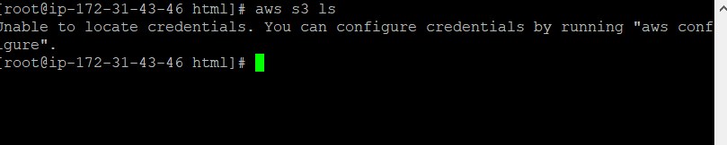
Since its no S3 is created or running. Use aws configure like below

Command: aws configure

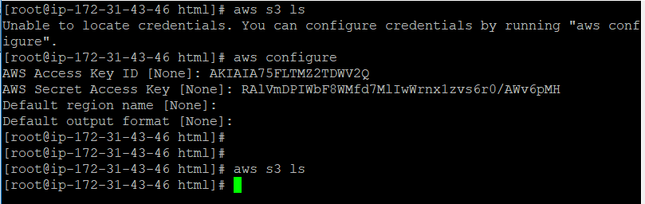

we need to create bucket first under the S3:

command: aws s3 mb s3://ddinesh-rk

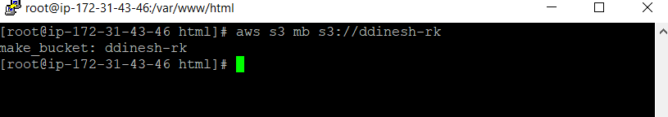
you can see the new bucket created successfully

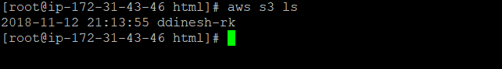

create document under the bucket ( this is available for the pubic usage service)

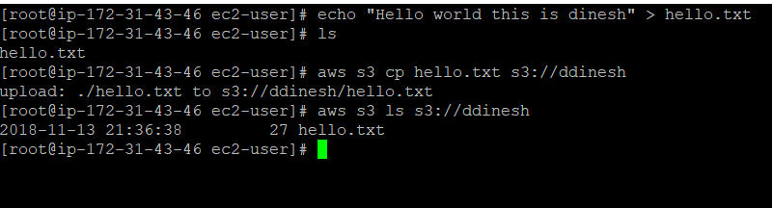

now the bucket is created in s3. If you want to see that file under the ddinesh bucket.
You need to go to aws console

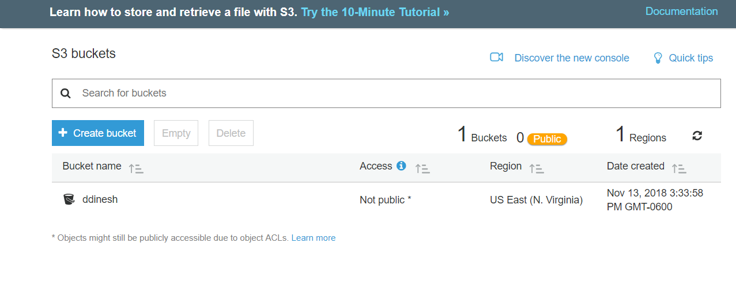

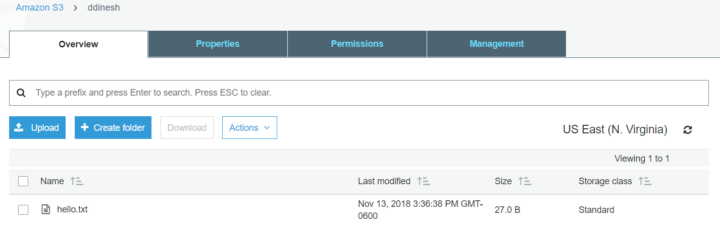

on click of the file, you can view the contents of that particular file.

