EC2 with S3 Role

There is another way to access the CLI without access key , secret access key.

By creating the Role in IAM, we can access the CLI.

- you need to create new role under the IAM

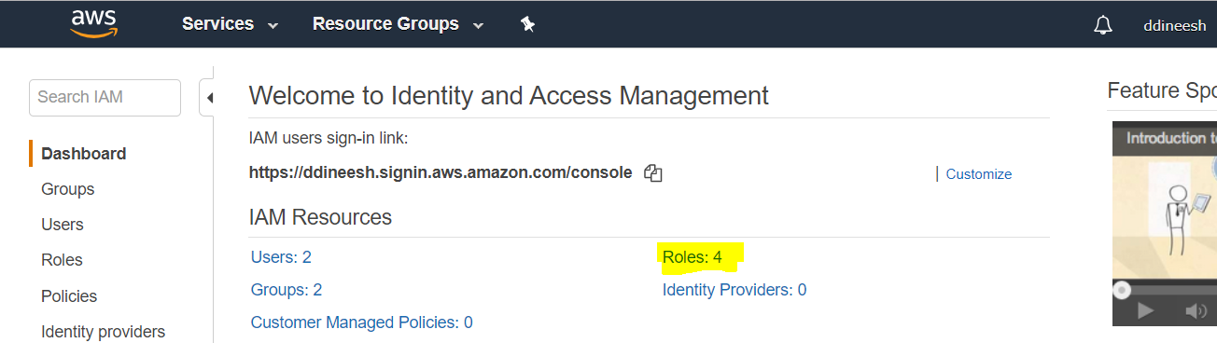

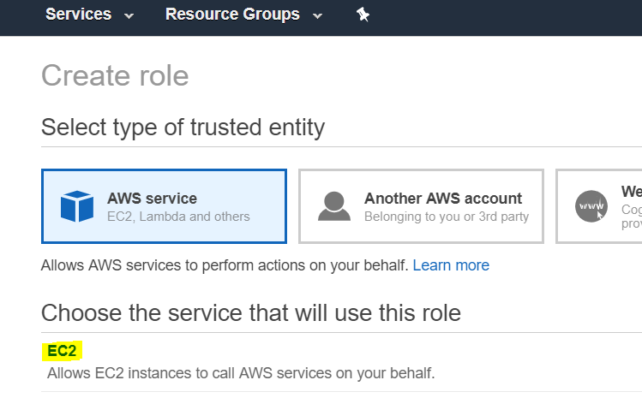

you need to select the full s3 access like below

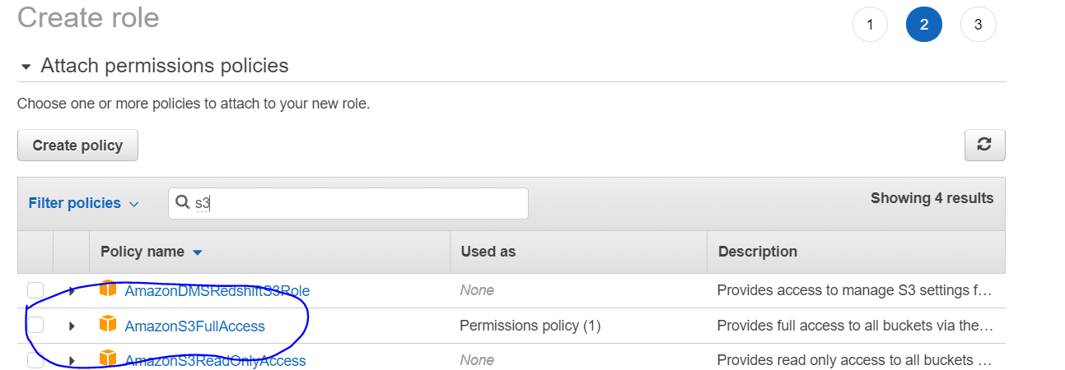

once you create role successfully then you need assign the role to you ec2 instance like below,

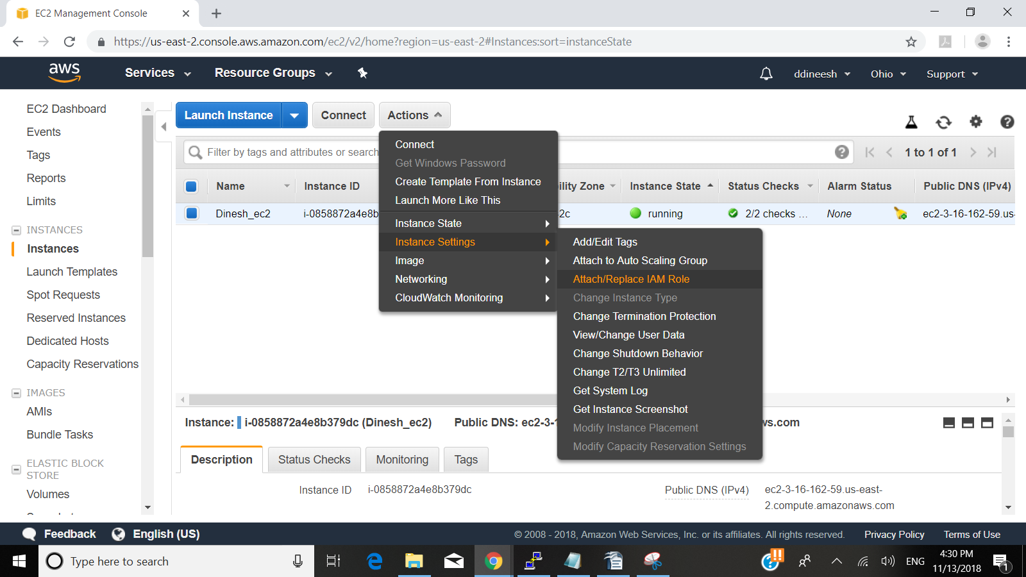

assign the recently created role to this ec2 instance,

once you assing this role, you should be able access directly with access key,

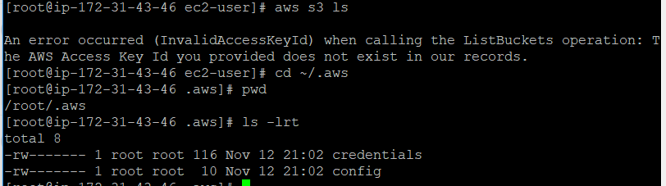

you need to delete these two folders in order to remove the configuration completely from your linux machine,

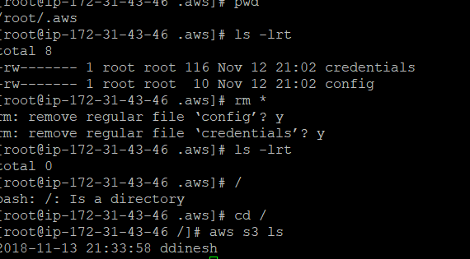

now you see its connected directly without access key because of the role we assigned our ec2 instance

