RDS A-Z and Read Replica

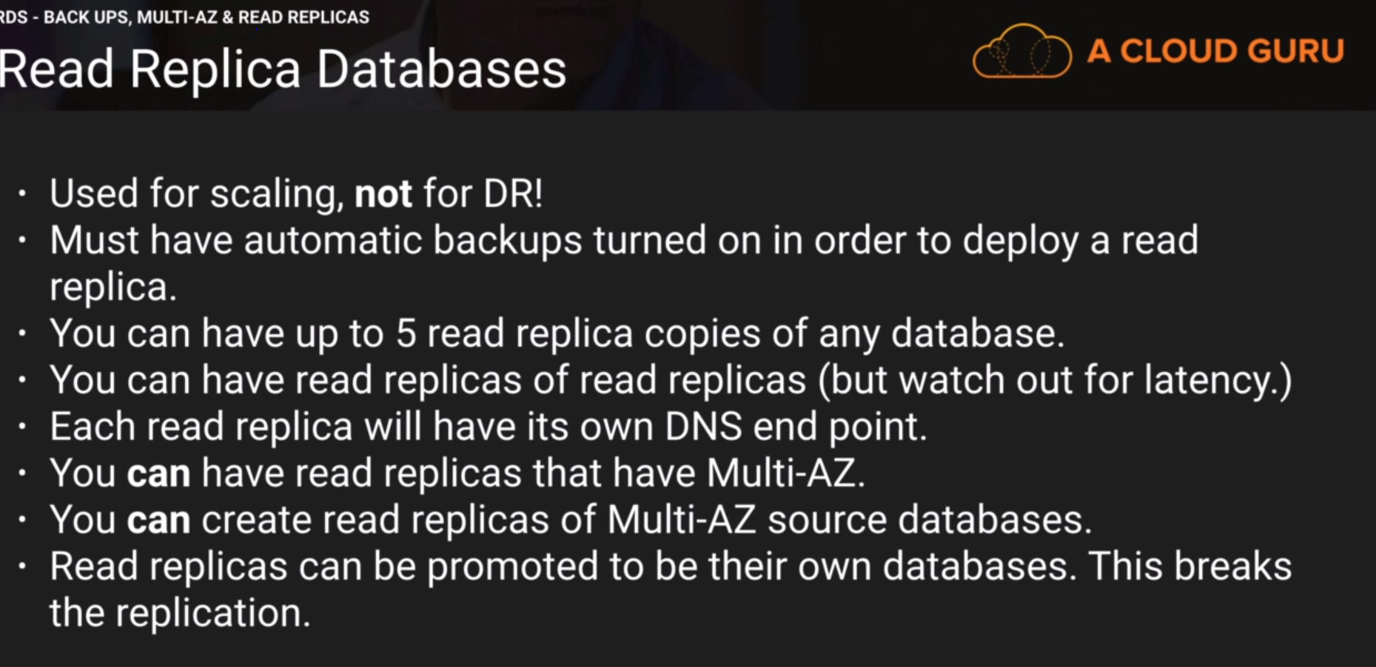

Backs automatic:

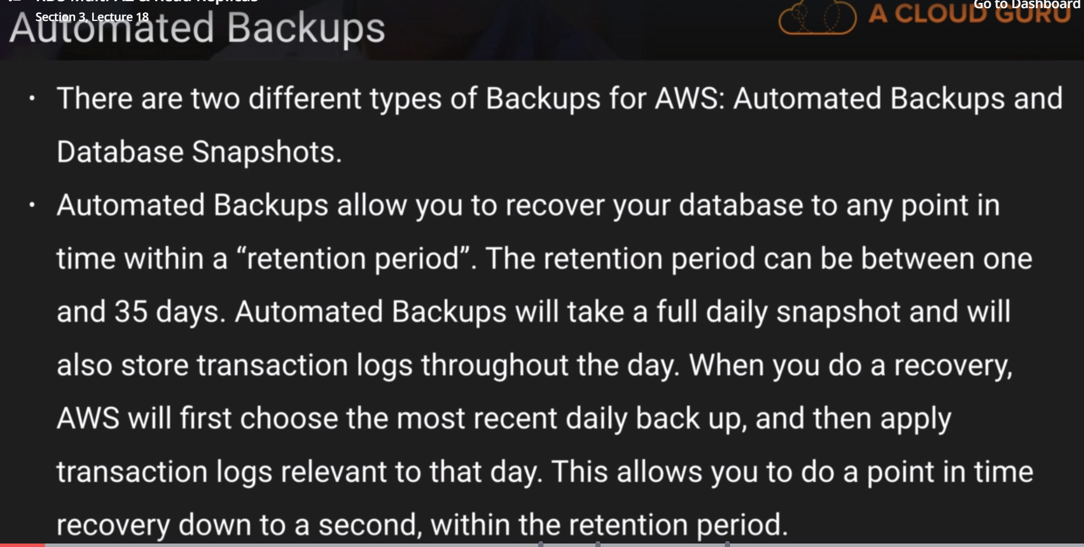

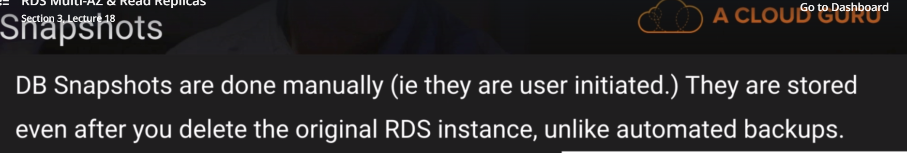

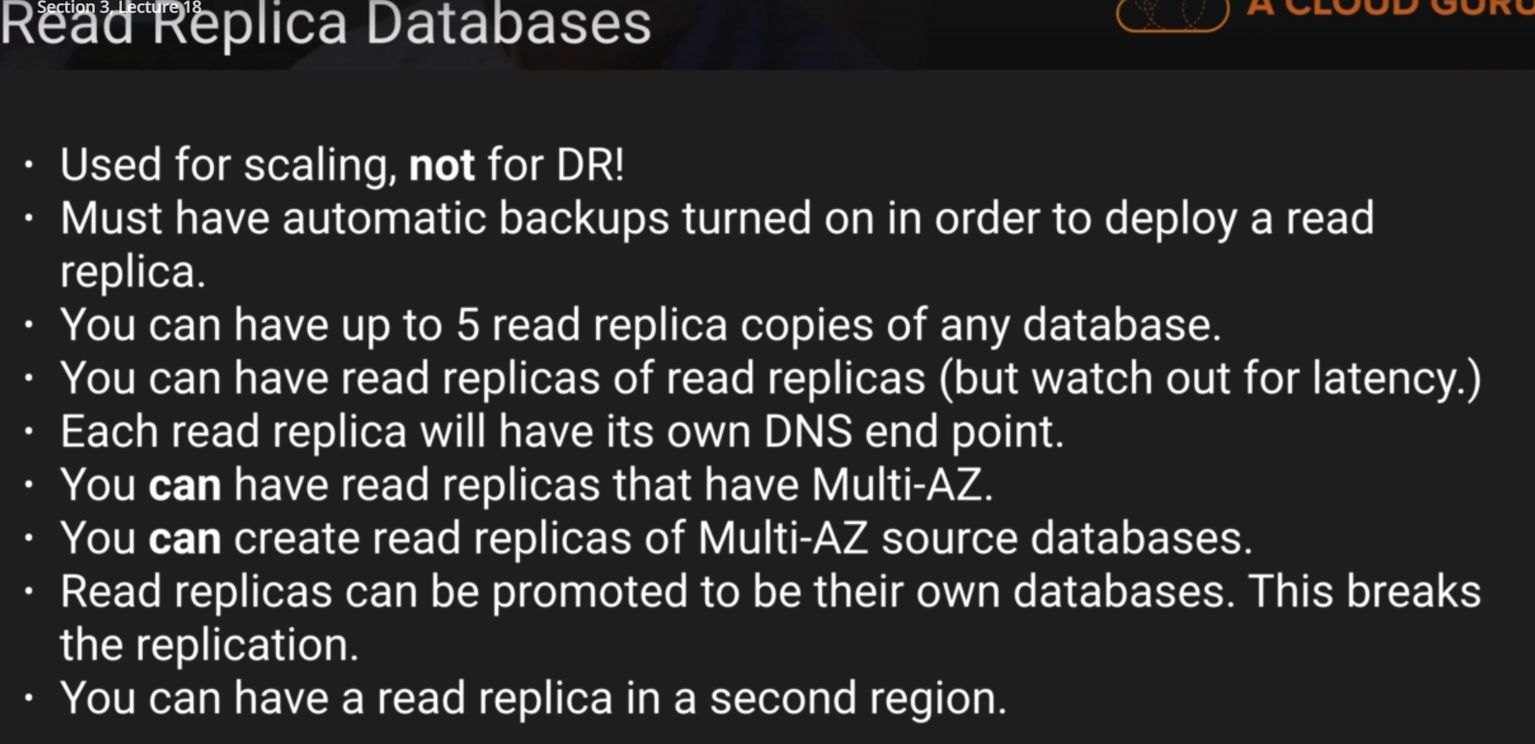

Create read replica:

Create A-Z:

Step 1: click the RDS and instance and select modify from the actions below (refer the screen shot above)

