**Week2**

**15, July 2019 ~ 21, July 2019**

**MyeongGeun(Matthew) Jo in UCSD**

Second week.

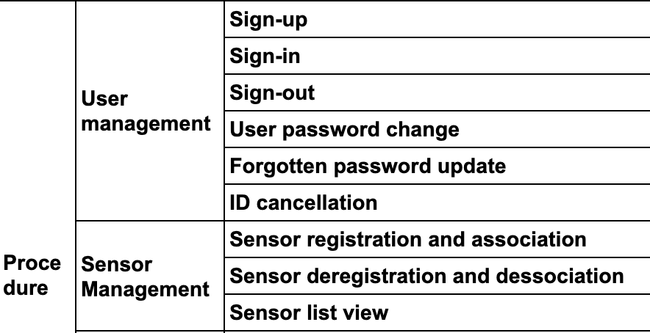

This is the procedure what make until this week. Too many works in here. I didn’t know that I’m going busy. However, We should do that whatever our works is big, or not. Maybe I use some expression what Mike(my server instructor) using. “It is not a big deal.” Haha.

Let’s talk about works what I had.

In the User management, Sign-in,out,up is not a big deal, because Sign-up Procedure was finished last week and sign-in/out is really easy to check.

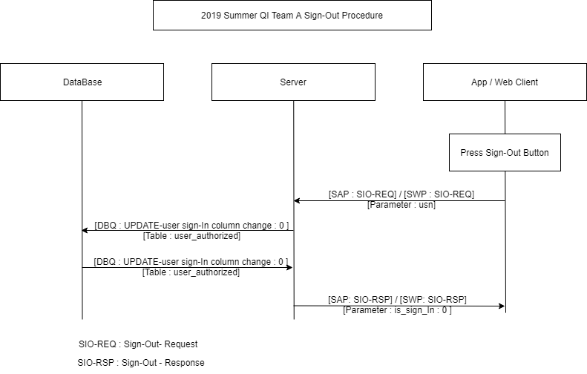

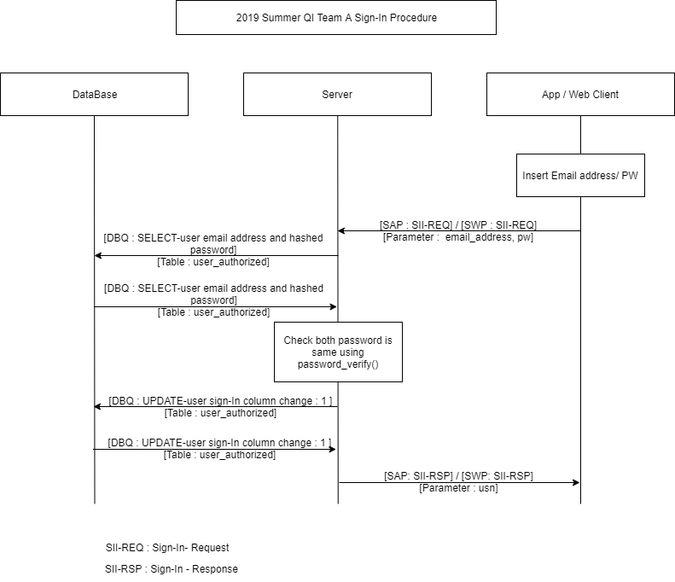

This is sign-in / out procedure. Not much complex. User password change and ID cancellation is too.. But Forgotten password update is much complex.

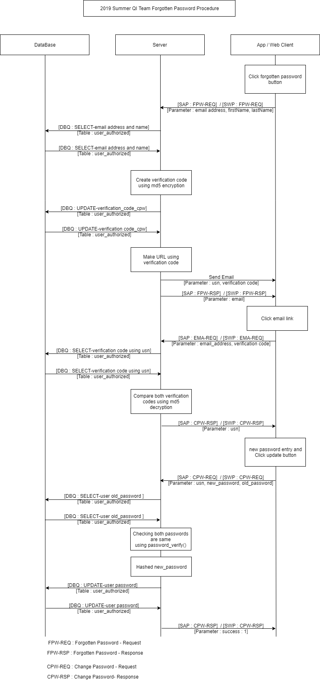

I think it is much complex than sign-up procedure. As doing I study procedure, I can improved my ability about architect some project. Also as doing server part, I learned what Is nonce and how to use in php. And md5 encryption too. It is my first php. So much hard to study, but not bad. It is fun. Last year, I studied ‘Spring Framework’, It used MVC pattern, Luckily, php ‘Slim Framework’ is using MVC pattern too! Thank you for me of the past!! Thanks to studied MVC pattern, It is much better to make web client. I completed to make sign-up page. And connected DB use PDO in php.

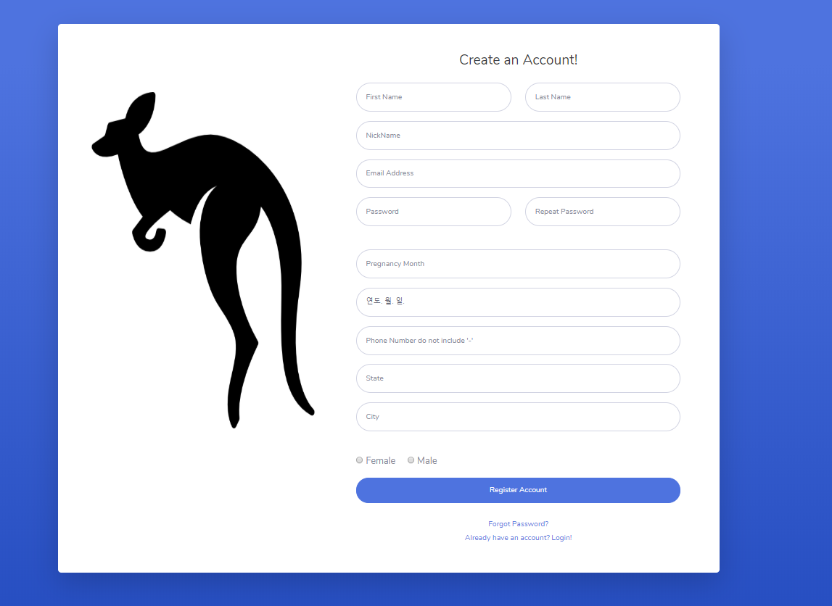

It is our sign-up page that used template. So in this week, I studied

* PHP
* Slim Framework
  + First. When access the server, php will find index.php file first using .conf file in site-enable. And access page what declare in routes.php file. and work something to access the function in Controller.php Contorller order to model and view, do something like take data from database or show something. That is processing how to slim framework work. When I using MVC pattern, It will be systematic than before. I think, that is the reason why using spring framework in Korea.
* MVC Pattern
* Java script (for check something in HTML)
  + 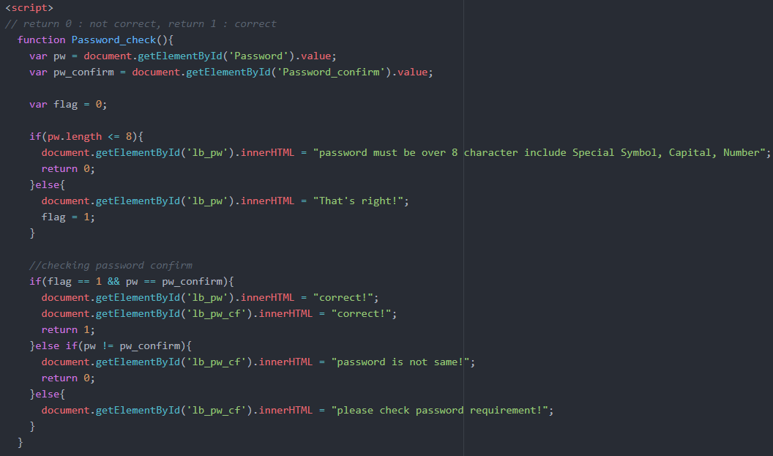
  + It is code for checking password condition. I will changed It use ‘Regular Expression’. It is way to check that String is included some special symbols, or capital or number.
* How to use template for web client
  + It is part of about how to using Slim Framework. It is just change .html file to .twig file. and rendering. whenever I want! Like this.
  + 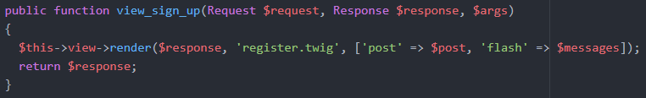
* Make procedure User management & Sensor management.
  + I will upload all of procedure in my github. I said before, It is best one of the best thing what I learned in here. I hope, Student learn it in Hallym university
* Upload code in github(study git too).
  + (<https://github.com/Matthew-IoT-2019-Summer/QI_2019_Summer_WebClient_Server>)
  + 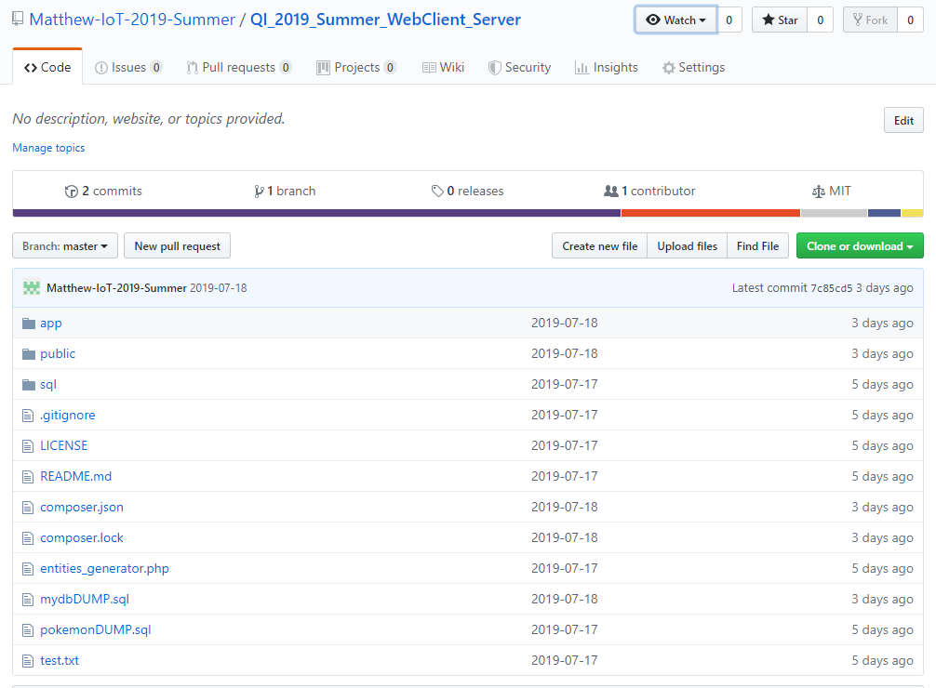

Last, I started blog posting, maybe I have time, I will post some board what I studied.

I will do my best.

**MyeongGeun(Matthew) Jo in UCSD, 2019 QI summer project.**