**Week3**

**22, July 2019 ~ 28, July 2019**

**MyeongGeun(Matthew) Jo in UCSD**

Third week.

At this week I’m really busy, So I don’t know how pass this week. I stared draw flowchart and fixed several pages and routes. Also I upload my code in public server. Let’s talk about how pass this week!!

First, Flowchart!

It is like procedure, but more detail. I should express that fail case, error code and query. Also It should drew by each part. For example, if I had drew 8 procedure, Flowchart should 24. Because we have 3 part, Server, Android, Sensor! It is hard, When I drew procedure, It much easier than now because works shared is possible but, Flowchart should draw each other parts, It can’t draw share.

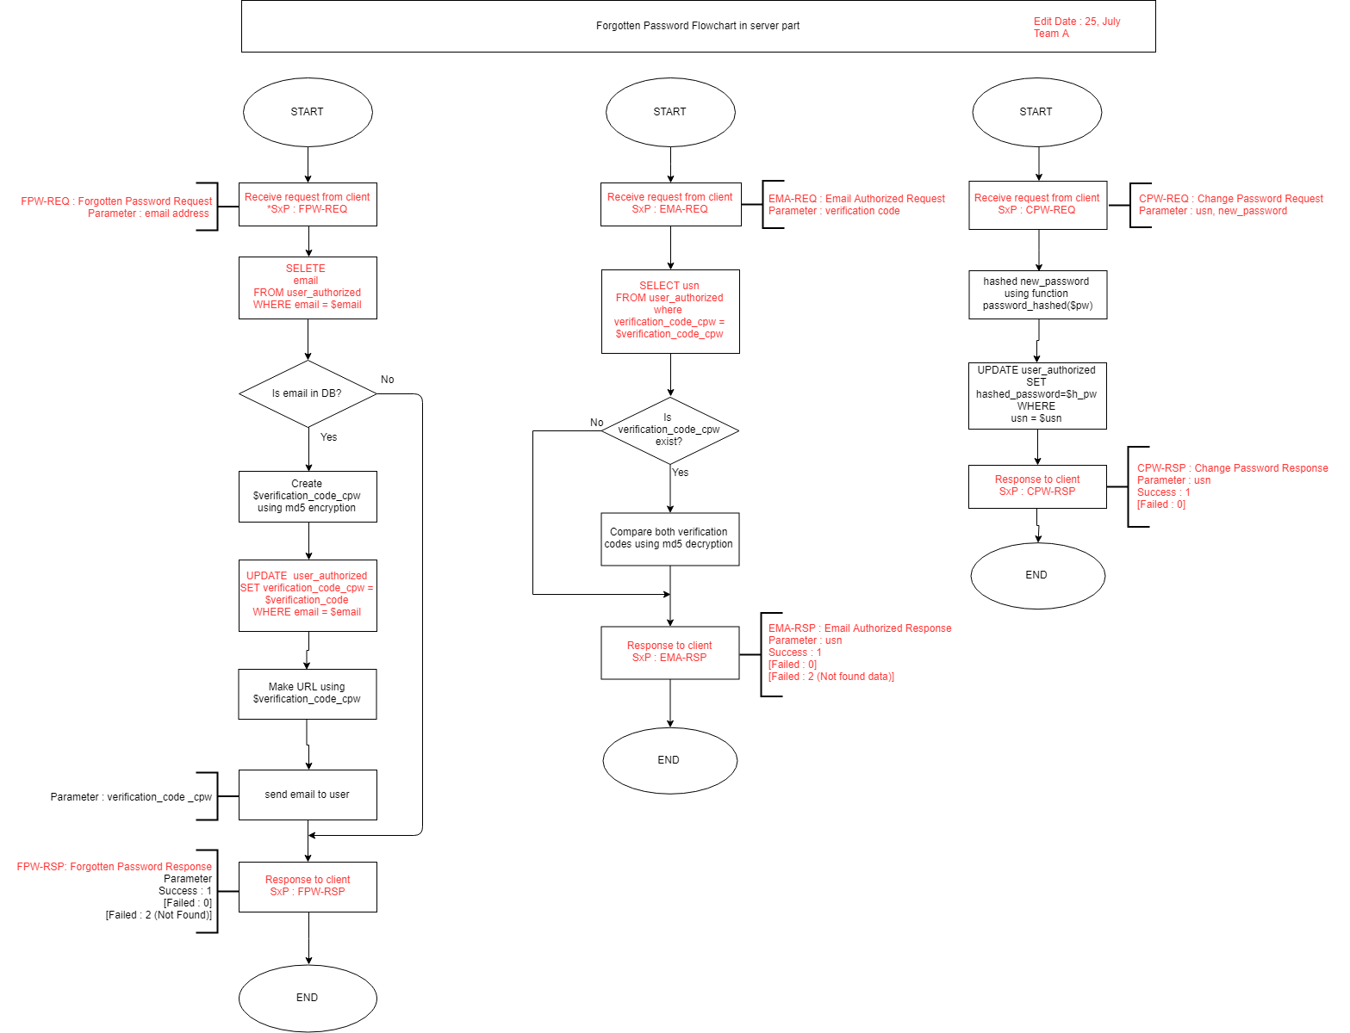

It is forgotten password flow chart. I had 8 flowchart in server part, It is too many, So I talk about only one. Each flow chart has parameter when process send or receive request, Process has parameter. So I should write down on ‘announce’. And write down what kind of process too. like FPW-REQ is Forgotten password request. error code, result code write down too.

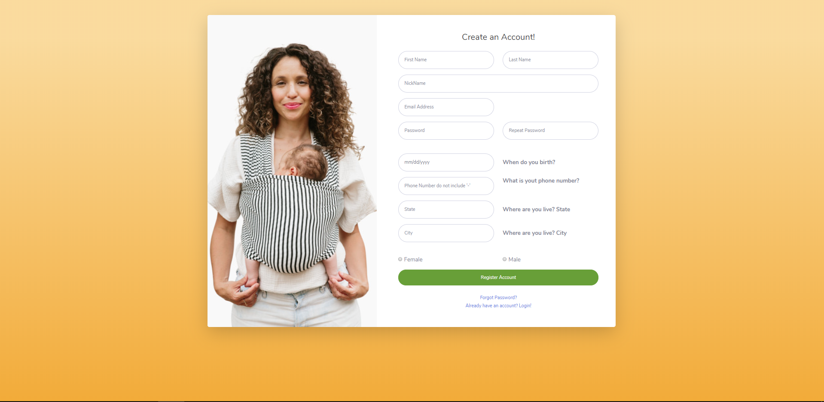It is our sign-up page. Really better than last week. We changed back-ground color and changed Image. Back-ground color should be same thing with android sign-up activity. said Jone, who teach android in QI. So What do in this week?.

* Sign-up Check duplicate email in DB
  + Request to server that, is email duplicate?, If not, sign-up process is had to, if duplicated, process is not had to.
* Sign-up Check each property is empty and use right format
  + If empty property is in form. Can’t process sign-up, and Every property checked there format is right, after write.
* Email authorized
  + When sign-up request is done in server, Server send mail to email address. And click the link in email, process email authorizing.
* Sign-in process
  + 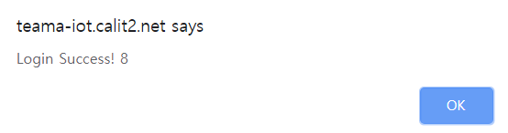
  + When I enter right information, Pop-up login success and print USN. I should display on homepage, but I tried, I don’t know how to display PHP variable in HTML, I will try using session, local storage.
* Make github branch with my partner
  + I made branch with my partner for cooperation. After I work, I commit and every week, We will merge works.

-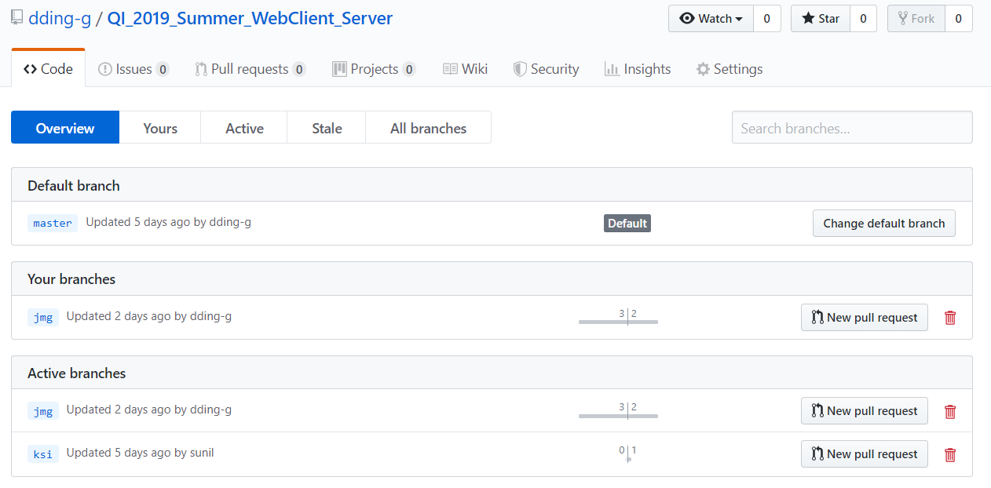

**MyeongGeun(Matthew) Jo in UCSD, 2019 QI summer project.**