**Week5**

**5, August2019 ~ 9, August2019**

**MyeongGeun(Matthew) Jo in UCSD**

WEEK 5..

In this week, I totally focused on development. No Activity, No play. I should finish minimum requirement. I slept on 3am every day, really hard to try for finished it. I was hard, but I’m done. Let’s look up what I did in this week.

* Data Monitoring
  + Heart Rate real-time view
  + Heart Rate Historical view
  + Air Quality real-time view
  + Air Quality Historical view

That is what I did in this week. That is MOST hard things what I did before few weeks. First. Heart rate real-time view. I want to draw chart in real time, So I use ‘apex chart’.

<https://apexcharts.com/javascript-chart-demos/line-charts/realtime/>

I use chart first time. So I don’t know how to work on JavaScript, but, It is not bad to understand. I’m just give right format data to chart, and fixed y axis a little. That’s it. Last few weeks, I use some template like that. It was totally fine. I’m just download, and use, after read some document. Most of template using like this. At least now. Anyway, Apex chart was great. That totally response what I want to.

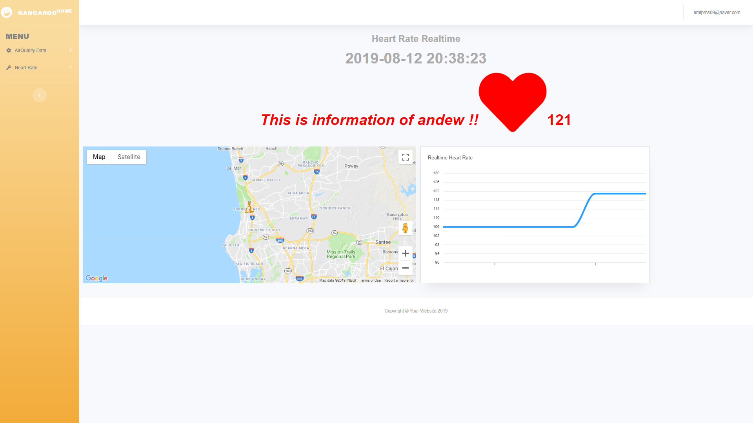

Like. This.

Next is Heart rate historical view. It used chart too. but in this case, I use ‘amchart’.

<https://www.amcharts.com/demos/date-based-data/>

This is based on date, So It sort by date. When I made chart using on js. I can know that, js and jquery is simple, and do many thing in front-end. We should know. 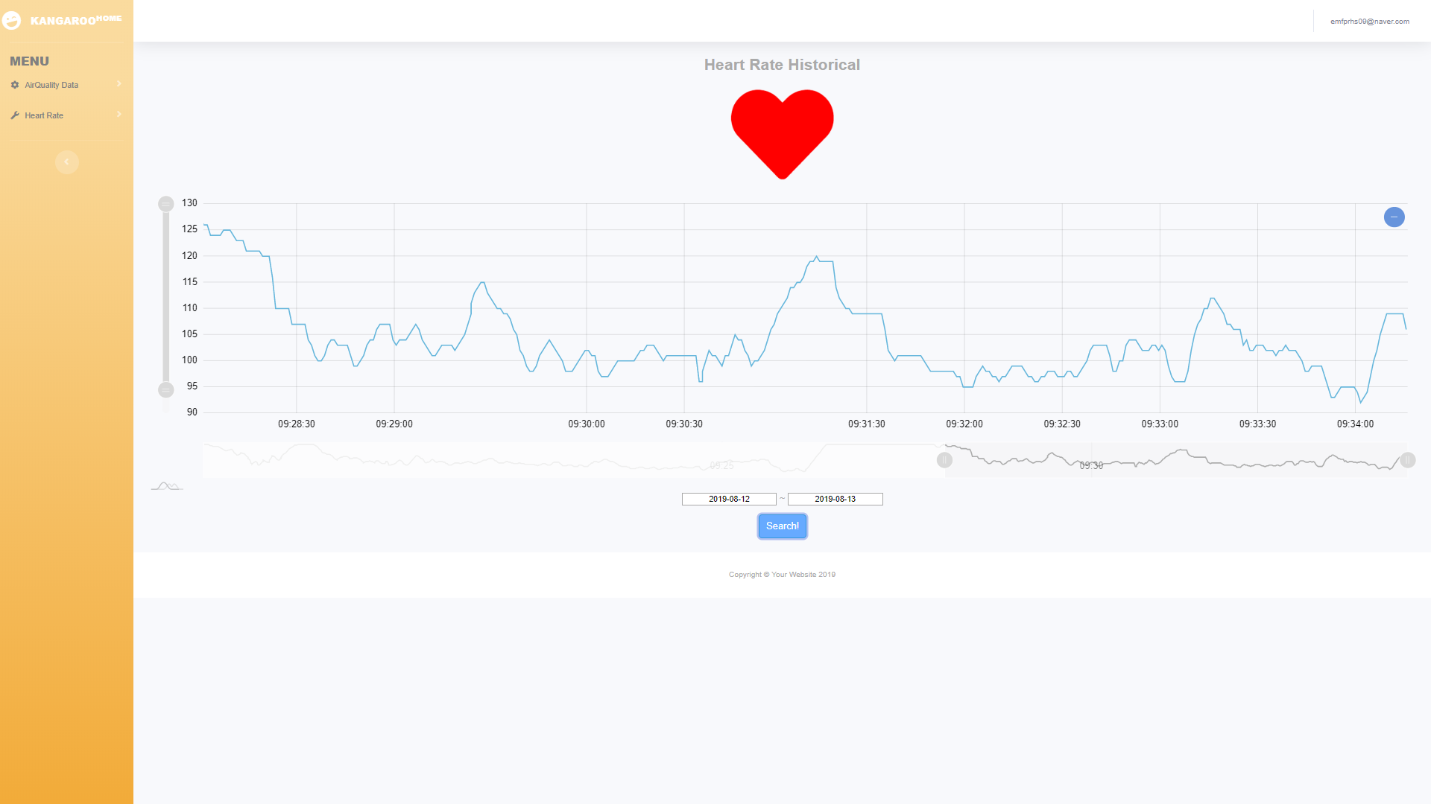

This is amchart what I use.

Next is AirQuality real-time data. In AQ real-time view, I didn’t use chart, because We don’t need to see any data in chart. Let’s look up.

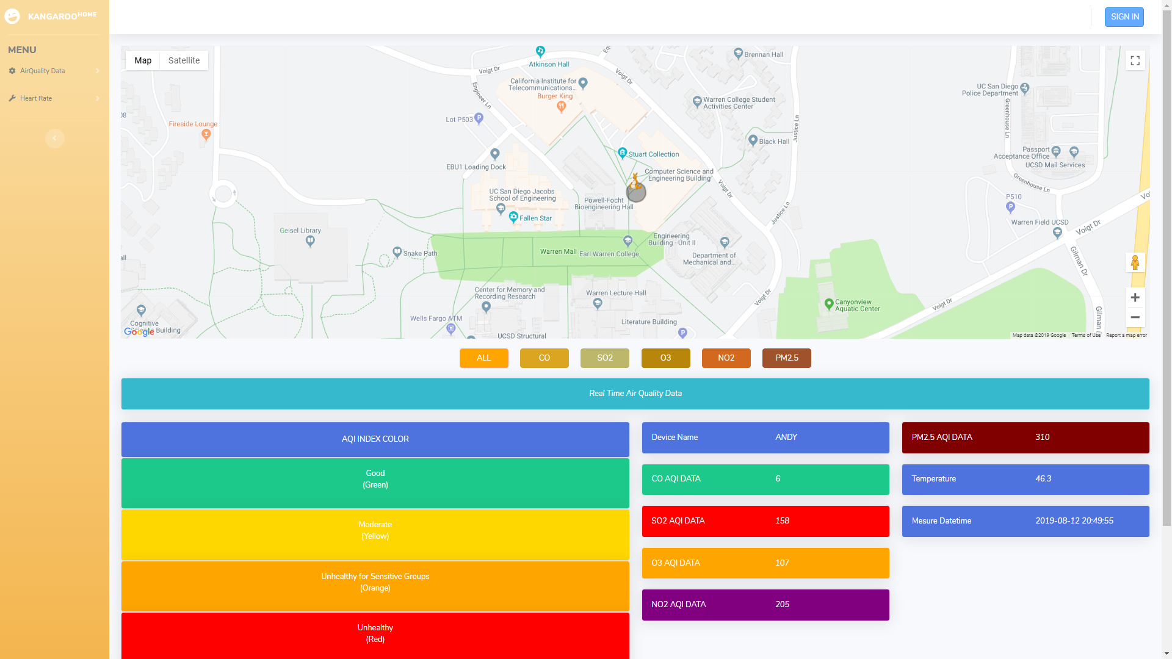

This is real-time AQ data view. On left side, You can see AQI index color, and right side, You can see real-time AQI data. They are change on real-time, and chage color too. based on AQI index range. For example, when SO2 ratio change good to moderate. Color changed green to yellow. It can ealiser to deteced which is worst.

Last is historical AQ data view. It show what device was mesured data in this period.

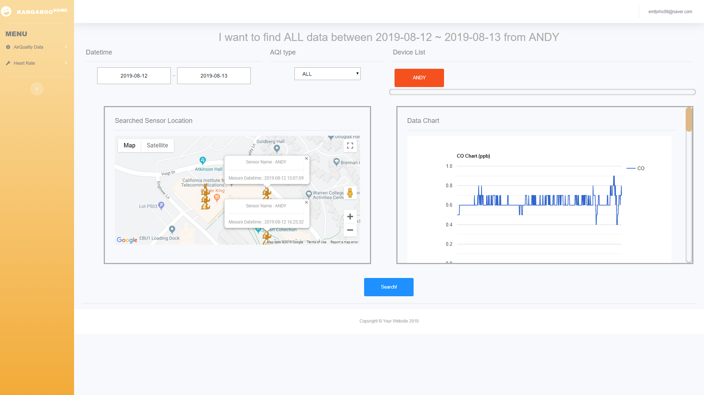

And It use google chart. Google chart is not good. Because it is not pretty for show than ‘am chart’ and ‘apex chart’. But google chart is minimum requirement. So I should use google chart. You can see in right side, that is a chart what I measure. Sensor measure and transfer to android phone after that, android phone transfer data to server. Finally server stored data in DB. Every chart extract the data from DB and display them. In left side, you can see sensor location during measure data. You can search using date, and chose air quality data what you want, and chose sensor what you want to see.

From this week, I upload code the other git what I contribute. Address is

<https://github.com/Yossarian92/Project_UCSD/tree/qi_jmg>

Thank you.

**MyeongGeun(Matthew) Jo in UCSD, 2019 QI summer project.**