

**** Confidential ****

IICRA RSR (R)
Testing Report

Model ID: RS-INS-GLB-R-001106-V001
Model Tier: 1

June 26, 2025

For Internal Use Only – Not for External Distribution

Model Information

Model Name | IICRA RSR (R)
Model ID | RS-INS-GLB-R-001106-V001
Model File Name | iicra-rsr-engine
Model Location | https://rscmre-blue.dev.spratingsvpc.com/content/33346a60-a177-45f1-b57f-692a3901ac3b/

Document Authorship and Change History

Doc. Version | Date | Author(s) | Model Version# | Model Revision# | Description
1.0 | June 26, 2021 | Anoop Garg | V001 | R1 | V001 testing

Contents
1 Testing Summary 4
2 Testing Methodology 4
3 Testing Scope 5
4 Test Cases 5
5 Issues found 6
6 Recommendation 6
7 Final Assesement 7
8 References 8

Introduction and Testing Summary
The purpose of this testing documentation is to summarize the work undertaken and the results of the tests performed on the model. This document presents and analyses the testing and the results for the Insurance Industry and Country Risk Assessment Summary Record (IICRA RSR ) model. The model testing is a requirement of the model governance policy and is undertaken in order to assess the correct implementation of the model.

The Insurance Industry and Country Risk Assessments (IICRA) RSR is used to derive and document insurance industry risk and country risk assessments, and the IICRA for approximately 100 IICRA sectors globally. The IICRA provides an assessment of the risks associated with a sector which an insurer has exposure to. This feeds into the derivation of the business risk profile (BRP) for an insurance company, which is one step in the process for rating such companies. The IICRA RSR is one of the main documents which are prepared and presented at IICRA review meetings.

To calculate IICRA, the model takes the country risk assessment, industry risk assessment and adjustment as an input. The raw IICRA is derived based on the steps outlined below.
- Use country risk assessment as anchor
- Modify score from 1) with our assessment of industry risk (see table 2: modifier below) with the numerical modifier mapped to the corresponding industry and country risk assessment combination.
For example, a country risk of '4' (Moderately High Risk) combined with an industry risk of ‘Low” would be mapped to a –1 modifier, resulting in an overall raw IICRA of '3' (Intermediate Risk),

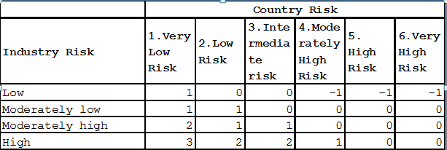
Table 1: modifier
The model allows for an analytical adjustment of plus/minus one notch in deriving the final IICRA. For example, if raw IICRA score is 3 (Intermediate Risk), and adjustment is 1, the final IICRA will be 4 (Moderately High Risk).
The model also derives the expected industry risk assessment for the scenarios outlined in Table 6 of [1] (see below screen shot). Each scenario represents a combination of sub-factors, and the corresponding expected industry risk assessment based on their values. However, since the model provides an expected assessment, analysts retain the discretion to adjust the final rating when deemed necessary.
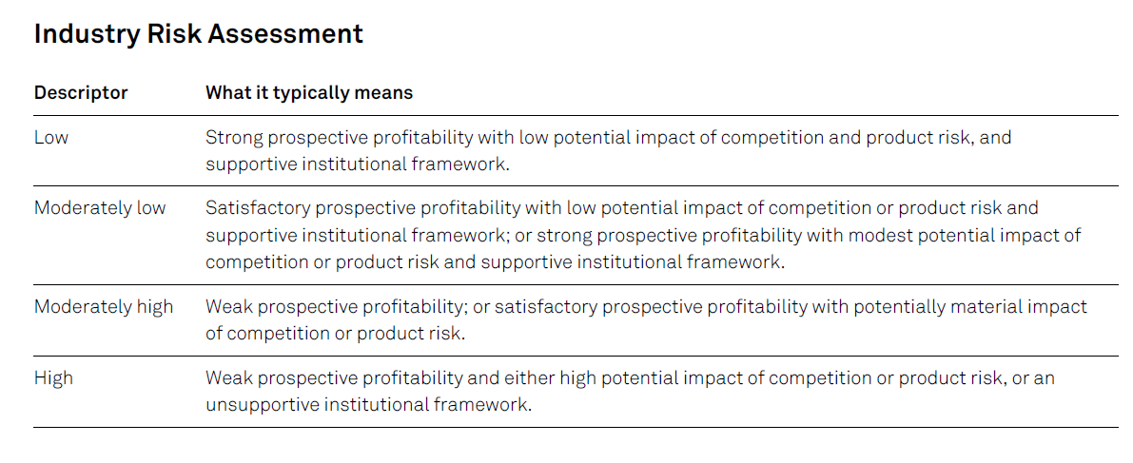

The scope of the testing covers the model implementation (model engine). Please refer to Section 3 for the detailed scope of testing performed. Testing forms a component of the developer testing requirements as set out in the model governance policy and is undertaken primarily to provide confidence in the implementation of the production model through comparison to an independent replica model.

Testing Methodology
Our testing process consisted of the following four steps:

- Reviewing all test cases and test coverage;
- Created extra test cases covering erroneous inputs.
- Running model engine through UI.

Testing Scope
The scope of the testing covers model engine. The implementation scope includes verification of the intermediate and final outputs listed below:

- IICRA Final score
- IICRA Final description
- Expected industry risk assessment score
- Expected industry risk assessment description

Test Cases

Model Engine

To test the model engine, which takes the country and industry risk scores and produces the IICRA score, we reviewed all test cases and ran the test packages to check accuracy and coverage.

Model UI (user interface) test was conducted separately and manually. We ran X test cases to examine if all the UI functionalities work properly. More specifically, in each test case, we entered the randomly generated input on the user interface to make sure there no abnormal behaviour observed. The IICRA scores and expected industry risk assessment calculated and displayed by the UI was compared with the replica results to verify correct calculation results displayed.

Recommendation

Final Assessment

References

[1] | “Criteria | Insurance | General:Insurers Rating Methodology, July 01, 2019”.
[2] | “IICRA_Specification_V008_20210123”.

