US T-Bill price decline analysis
June 22, 2026
Derek Ding

- Data Description

Source: St. Louis Federal bank website.
Index Name | Data Frequency | Data Type | Start Date | End Date
3-Month Treasury Bill Secondary Market Rate  (ticker: DTB3) | Daily | Yield | Jan, 1954 | Jun, 2026
U.S. Treasury Securities at 3-Month Constant Maturity  (ticker: DGS3MO) | Daily | Yield | Sep, 1981 | Jun, 2026
Both series are published by the Federal Reserve Bank of St. Louis (FRED) and track the 3-month Treasury bill, but they are quoted and constructed on different bases, which is relevant to the choice of input used below.
DTB3 (3-Month Treasury Bill Secondary Market Rate) is quoted on a bank-discount basis using a 360-day year and is taken directly from secondary-market trading quotes for bills currently being traded; it therefore reflects an actual, traded instrument.
DGS3MO (3-Month Constant Maturity Rate) is quoted on an investment (bond-equivalent) basis using a 365- or 366-day year and is interpolated from the Treasury’s daily yield curve. It represents the theoretical yield of a security with exactly three months remaining to maturity rather than any specific bill, and because of its longer day-count and price-based denominator it typically reads slightly higher than DTB3 for the same date.
A practical consequence is that DGS3MO holds time-to-maturity fixed at 90 days, so it does not capture the day-to-day pull-to-par accrual that a real bill experiences, whereas DTB3 does — a distinction that matters when measuring price changes.

- Price Decline Analysis
  - Method 1 – historical 5-day price decline analysis
In this method, we initially convert yield to price. Subsequently, we calculate the 5-day price decline on a rolling basis for aformentioned 2 T-bill 3-moth rates. The values representing price decline at selected critical quantiles are presented in the first table below.

 | 3M Tbill  (secondary market) | 3M Tbill  (constant maturity)
Data Range | Jan 1954 - Jun 2026 | Sep 1981 - Jun 2026
Max | 0.490% | 0.363%
99% | 0.135% | 0.094%
95% | 0.055% | 0.043%
90% | 0.035% | 0.026%
50% | 0.000% | 0.000%

  - Method 2 – closed-form calculation (auxiliiary proxy

Example 1: rate change – 1% to 4%
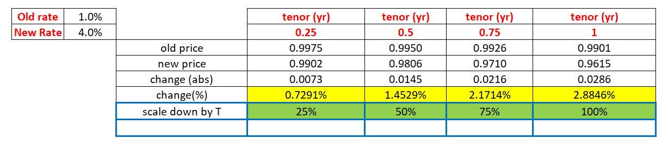
Example 2: rate change – 1% to 2%
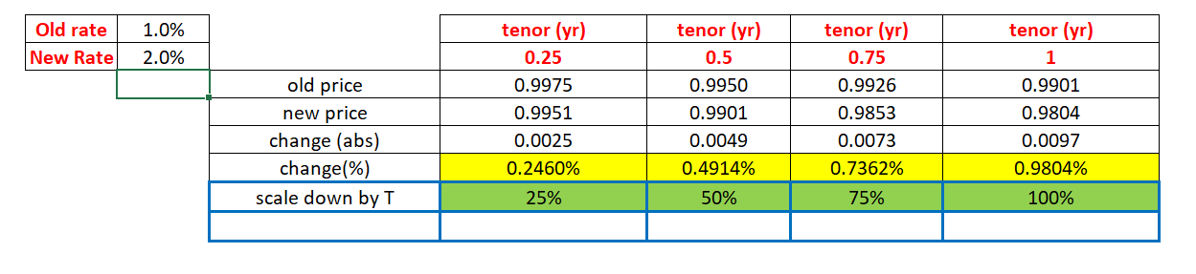
As indicated by the preceding results, the relative change (%) exhibits linearity with respect to time (t)

- Proposal

Based on the above results, we recommend adopting the DTB3 series – the 3-month Treasury bill secondary market rate – as the input for the transaction rating analysis. This recommendation is supported by the following considerations:
- Sourcing methodology. DTB3 is taken directly from observed secondary-market trading quotes for actual 3-month bills, on the standard 360-day bank-discount convention that market participants use to price these instruments. DGS3MO, by contrast, is a constant-maturity rate interpolated from the Treasury’s daily yield curve – a synthetic construct that does not correspond to any single traded security. Anchoring the analysis on prices that are actually realizable in the market is preferable for transaction rating purposes.
- Length of history. DTB3 begins in January 1954, whereas DGS3MO only begins in September 1981 – roughly 27 additional years of daily observations. The longer DTB3 window spans a wider range of interest-rate regimes, including the high-rate, high-volatility environment of the late 1970s and early 1980s, which produces more robust estimates of the tail quantiles that drive the stress assumption.
- More conservative outcome. Across every quantile examined, the empirical 5-day price declines derived from DTB3 exceed those from DGS3MO (for example, 0.490% vs. 0.363% at the maximum and 0.135% vs. 0.094% at the 99th percentile). Selecting DTB3 therefore yields the more conservative stress input, which is the prudent choice for rating analysis.
- Economically clean price change. Because DTB3 follows a real bill whose remaining days to maturity actually decline over the holding period, the resulting 5-day price change reflects both market-rate movements and the natural pull-to-par accrual. DGS3MO holds maturity fixed at exactly 90 days, which suppresses this aging effect and understates the true price change.
On balance, DTB3 provides the longer history, the more market-representative sourcing, and the more conservative stress estimates, and is therefore recommended as the basis for the transaction rating analysis.

