RV COLLEGE OF ENGINEERING, BENGALURU – 560059
Department of Information Science and Engineering

PROJECT REPORT

On

Context-Aware Cyber Threat Analytics and Mitigation
Recommendation Using Large Language Models

Submitted in partial fulfillment of the requirements for the degree of
Master of Technology in Information Technology

Submitted by
Dinesh Kumar S (USN: [Your USN])

Under the guidance of
Dr. Ashwini K B
Associate Professor
Department of Information Science and Engineering

Academic Year 2025–2026

Abstract
Modern cyber threat intelligence workflows increasingly relied on analysing large volumes of unstructured information obtained from social media, threat feeds, reports, and open-source intelligence sources. Manual threat analysis was time-consuming, contextual information was often lost, and mitigation recommendations were difficult to generate consistently. To address these challenges, this project proposed a context-aware cyber threat analytics system using local Large Language Models (LLMs) to automate threat analytics and mitigation support. The system combined a multi-agent pipeline with Retrieval-Augmented Generation (RAG) and the MITRE Adversarial Tactics, Techniques, and Common Knowledge (ATT&CK) framework to enrich raw threat data with relevant security context, extract Indicators of Compromise (IOCs), Tactics, Techniques, and Procedures (TTPs), Common Vulnerabilities and Exposures (CVEs), and attack vectors, and generate actionable mitigation recommendations.
The proposed system was designed with five main agents: ingestion, enrichment, pattern discovery, mitigation, and validation. Threat data collected from live feeds and manual inputs was normalised into a structured schema and then processed through a local LLM-based enrichment stage. Relevant contextual knowledge was retrieved from a local vector database containing MITRE ATT&CK mappings, which helped the model produce more accurate and grounded analysis. The pattern discovery module grouped similar threat events based on weighted Jaccard similarity, while the mitigation module generated defensive actions mapped to MITRE D3FEND countermeasures. A validation layer checked the safety and practicality of generated mitigations before presentation to the analyst.
The outcome of this project was a privacy-preserving and analyst-friendly CTI platform that supported faster threat interpretation, improved situational awareness, and provided more reliable response recommendations. By keeping all processing local and using RAG for contextual grounding, the system reduced reliance on cloud-based APIs while improving adaptability to changing threats.

Chapter 1: Introduction

1.1 Background
The global cybersecurity landscape has undergone a dramatic transformation over the past decade. Nation-state actors, organised criminal groups, and opportunistic attackers continuously probe enterprise networks, critical infrastructure, and government systems using increasingly sophisticated methods. According to industry reports, the average organisation receives hundreds of thousands of security alerts per day, the vast majority of which require skilled human analysis to triage effectively. Security Operations Centres (SOCs) are the primary line of defence against these threats, yet analysts are overwhelmed by the sheer volume of raw telemetry. Cyber Threat Intelligence (CTI) has emerged as a discipline dedicated to converting raw security data into contextualised, actionable knowledge that supports faster and more accurate decision-making.
Traditional CTI workflows are heavily manual. An analyst must collect threat data from disparate sources such as Indicators of Compromise (IOCs) shared via email, threat reports in PDF format, live feeds from platforms like Mastodon and URLhaus, and vendor advisories. Each piece of intelligence must be cross-referenced against known attack frameworks, enriched with contextual background, and translated into a defensive action. This process is not only time-intensive but also error-prone, as critical context is frequently lost when intelligence crosses organisational boundaries or is handled by analysts with varying levels of expertise.
The advent of Large Language Models (LLMs) presents a compelling opportunity to automate significant portions of the CTI workflow. LLMs have demonstrated an ability to parse unstructured text, extract structured entities, reason over domain-specific knowledge, and generate coherent natural-language summaries. However, raw LLMs applied to cybersecurity tasks without domain grounding tend to hallucinate — that is, they fabricate plausible-sounding but incorrect technical identifiers such as non-existent MITRE ATT&CK technique IDs or CVE numbers. This is a critical failure mode in a security context where a false recommendation may direct analyst attention to a non-existent threat.

1.2 Motivation
The motivation for this project arose from the convergence of three observations. First, existing CTI automation tools address isolated sub-tasks: some tools extract IOCs, others map TTPs, and a few generate alerts, but no single locally-deployable system automates the complete chain from raw input to validated mitigation. Second, the most capable LLM systems require cloud API access, which is incompatible with the data-handling policies of classified, air-gapped, or privacy-regulated SOC environments. Third, Retrieval-Augmented Generation (RAG) has proven effective at grounding LLM outputs in verified knowledge bases, suppressing hallucinations while maintaining the model's natural-language generation capability.
Together, these observations motivated the design of a system that: (a) automates the full CTI pipeline end-to-end; (b) operates entirely on local hardware without cloud dependencies; and (c) grounds all LLM calls in a verified MITRE ATT&CK knowledge base through RAG, eliminating hallucinated identifiers while producing actionable, explainable mitigations.

1.3 Problem Statement
Security analysts in operational SOC environments receive threat data from heterogeneous sources — network logs, threat feeds, vulnerability advisories, and social-media intelligence — in formats that resist automated processing. The core challenge is not data availability but structured interpretation: converting unstructured, multi-source threat text into actionable, verified defensive recommendations without human intervention at each stage.
Three specific sub-problems remain unsolved. First, no existing system performs the complete ingestion-to-mitigation chain in a single locally-deployable pipeline. Second, LLMs applied to CTI tasks without domain grounding hallucinate MITRE technique identifiers and CVE numbers. Third, all existing end-to-end proposals depend on cloud-hosted LLMs or external APIs, which are prohibited in privacy-constrained SOC environments.

1.4 Objectives
- To design and implement a five-agent CTI pipeline that automates ingestion, enrichment, pattern discovery, mitigation generation, and validation end-to-end.
- To ground all LLM enrichment calls in a locally indexed 691-technique MITRE ATT&CK v18.1 knowledge base using RAG, eliminating hallucinated technique identifiers.
- To implement a weighted Jaccard similarity-based pattern discovery mechanism that clusters threat events by TTP overlap, malware family, and attack vector.
- To generate MITRE D3FEND-mapped, chain-of-thought mitigation recommendations with deterministic safety validation before analyst presentation.
- To develop a reproducible five-metric benchmark framework (EvaluatorAgent) for systematic pipeline quality tracking.
- To deploy the entire system on commodity CPU hardware without cloud services, external APIs, or GPU requirements.

1.5 Scope of the Project
The scope of this project covers the design, implementation, and evaluation of a locally deployable CTI automation system. The system accepts threat input in four formats: free text, JSON, CSV, and live social-media feeds. It performs automated enrichment, classification, pattern clustering, mitigation generation, and safety validation. The system is evaluated on a 20-event test corpus spanning four threat categories. The scope does not extend to real-time network packet inspection, hardware sensor integration, or commercial SIEM integration, which are identified as future work directions.

1.6 Organisation of the Report
The remainder of this report is organised as follows. Chapter 2 presents a review of relevant literature. Chapter 3 describes the system analysis including requirements and use case modelling. Chapter 4 presents the system design including architecture, data flow, and entity-relationship diagrams. Chapter 5 covers implementation details including technology choices and key challenges. Chapter 6 describes the testing methodology and results. Chapter 7 presents experimental results and analysis. Chapter 8 concludes the report and outlines future work. Chapter 9 lists all references.

Chapter 2: Literature Review
This chapter reviews existing work in the areas of LLM-based threat detection and classification, AI-driven intrusion detection, threat modelling, and CTI pipeline automation. The review is restricted to open-access IEEE publications from 2022 onwards that are directly relevant to the problem addressed in this project.

2.1 LLM-Based Threat Detection and Multi-Agent Systems
Hmimou et al. [1] proposed a multi-agent LLM system for cybersecurity threat detection and correlation, published in IEEE Access (2025). The system employs a threat correlation engine across multiple agents and demonstrated strong detection performance on benchmark datasets. However, the system produces no explainable mitigation output and does not integrate MITRE ATT&CK enrichment, leaving the detection-to-response gap unaddressed. This work directly motivated the multi-agent architecture adopted in the proposed system.
Melhem et al. [2] presented LENS, a lightweight explainable LLM-based Advanced Persistent Threat (APT) detection system deployed at the network edge for 6G environments, published in IEEE Access (2025). LENS demonstrates strong APT detection with explainability at the edge but is constrained to 6G network scenarios and halts at the detection stage without generating actionable response recommendations. The explainability principles from LENS informed the chain-of-thought reasoning design in the mitigation agent.
Mahmood et al. [3] fine-tuned a large language model on IoT device logs for anomaly detection and malicious device identification, published in IEEE Access (2025). The system achieves strong performance on IoT-specific datasets but is limited to IoT environments and outputs alerts only, with no pathway to structured mitigation. This work confirmed the feasibility of local LLM fine-tuning for security tasks.
Patel et al. [4] fine-tuned BERT for cyber threat classification from open-source news articles in the CANAL system (IEEE ICAIC, 2024). CANAL classifies news articles into threat categories with reasonable accuracy but produces binary alert output without TTP extraction or MITRE mapping. The news-article ingestion concept was adapted in the free-text input channel of the proposed ingestion agent.

2.2 Intrusion Detection and AI-Driven Analysis
Elouardi et al. [5] conducted a comprehensive survey of hybrid CNN and LLM architectures for network intrusion detection systems, published in IEEE Access (2024). The survey found that while deep learning models achieve high accuracy on labelled datasets such as NSL-KDD and CICIDS, performance degrades significantly on unstructured, free-text threat intelligence. This finding directly validated the need for the RAG-grounded LLM approach adopted in this project, as structured dataset performance does not translate to operational CTI scenarios.
Corea et al. [6] evaluated explainable AI approaches for comparative analysis of intrusion detection models (IEEE MeditCom, 2024). The study demonstrated that XAI methods improve analyst trust but remain limited to structured network-log inputs with no capability for natural-language threat enrichment. The explainability gap identified by Corea et al. motivated the inclusion of human-readable reasoning in the mitigation output.
Nazre et al. [7] achieved 96.72% detection accuracy using temporal convolutional networks for network intrusion detection (IEEE ICIICS, 2024). The system excels at packet-level anomaly detection but provides no threat context, TTP mapping, or mitigation guidance. The high accuracy of TCN-based detection was noted as a potential integration point for future work, where packet-level alerts could feed the ingestion agent.

2.3 Threat Modelling, Mitigation, and CTI Surveys
Salek et al. [8] applied LLM combined with MITRE ATT&CK for threat modelling in transportation Cyber-Physical Systems, published in IEEE Access (2025). The system maps threats to MITRE techniques within the transportation domain but produces outputs locked to that specific domain and cannot generalise to multi-source, multi-domain CTI inputs. The MITRE ATT&CK mapping methodology from this work was adapted and generalised in the enrichment agent.
Hasanov et al. [9] conducted a systematic literature review of LLM applications in cybersecurity across 73 papers, published in IEEE Access (2024). The review confirmed that individual sub-tasks such as log analysis, malware classification, and threat summarisation are well-studied in isolation, but no unified end-to-end pipeline bridging ingestion, enrichment, and automated response has been deployed in practice. This finding provided the primary motivation for this project.

2.4 Comparative Summary and Gap Analysis
Table 2.1 summarises the nine reviewed papers, their methodology, and the gaps identified. The comparison reveals three persistent gaps in the existing literature that are addressed by the proposed system.
Table 2.1: Comparative Summary of Reviewed Literature
Ref | Authors | Year | Venue | Focus | Gap
[1] | Hmimou et al. | 2025 | IEEE Access | Multi-agent threat detection | No MITRE enrichment or mitigation
[2] | Melhem et al. | 2025 | IEEE Access | LLM APT detection (6G) | 6G-specific, no response step
[3] | Mahmood et al. | 2025 | IEEE Access | LLM IoT anomaly detection | IoT-specific, alerts only
[4] | Patel et al. | 2024 | IEEE ICAIC | BERT threat classification | Binary output, no TTP mapping
[5] | Elouardi et al. | 2024 | IEEE Access | CNN+LLM IDS survey | Structured data only
[6] | Corea et al. | 2024 | IEEE MeditCom | XAI for IDS comparison | No NL enrichment capability
[7] | Nazre et al. | 2024 | IEEE ICIICS | TCN intrusion detection | No context or mitigation
[8] | Salek et al. | 2025 | IEEE Access | LLM CTI threat modelling | Domain-locked (transport CPS)
[9] | Hasanov et al. | 2024 | IEEE Access | LLM cybersecurity survey | Confirms end-to-end gap

As shown in Table 2.1, no reviewed system addresses the full ingestion-to-mitigation pipeline in a single locally-deployable system. Every existing approach either targets a specific domain, stops at detection/classification, or requires cloud API access. The proposed system directly fills this gap.

Chapter 3: System Analysis
This chapter presents the system analysis for the proposed CTI system, including functional and non-functional requirements, use case modelling, and context-level data flow analysis.

3.1 Functional Requirements
Table 3.1: Functional Requirements
ID | Requirement
FR-01 | The system shall accept threat input in free text, JSON, CSV, and live feed formats.
FR-02 | The system shall normalise all input formats into a unified ThreatEvent schema with event ID, type, severity, indicator, and timestamp.
FR-03 | The system shall deduplicate events using MD5 hashing to prevent reprocessing of identical threats.
FR-04 | The system shall enrich each ThreatEvent using a local LLM grounded in the MITRE ATT&CK knowledge base to extract IOCs, TTPs, CVEs, and attack vectors.
FR-05 | The system shall store enriched events in a local ChromaDB vector store for self-learning retrieval in future enrichments.
FR-06 | The system shall discover threat patterns by clustering enriched events using a weighted multi-factor similarity algorithm.
FR-07 | The system shall generate mitigation recommendations for all events with severity level 3 or above.
FR-08 | The system shall map each mitigation recommendation to MITRE D3FEND countermeasure identifiers.
FR-09 | The system shall validate all generated mitigations against safety rules before presenting them to analysts.
FR-10 | The system shall provide a web dashboard for real-time monitoring of pipeline status, enriched events, patterns, and mitigations.
FR-11 | The system shall allow analysts to approve or reject mitigations through a human-in-the-loop interface.
FR-12 | The system shall provide a benchmark endpoint that computes five pipeline quality metrics on demand.

3.2 Non-Functional Requirements
Table 3.2: Non-Functional Requirements
ID | Category | Requirement
NFR-01 | Performance | Dashboard API responses shall complete within 500 ms under concurrent load.
NFR-02 | Privacy | All processing shall execute locally with no data transmitted to external services.
NFR-03 | Reliability | The pipeline shall recover from individual LLM timeout failures without crashing.
NFR-04 | Usability | The dashboard shall be accessible via a standard web browser with no plugins.
NFR-05 | Portability | The system shall run on commodity Intel Core i7 hardware with 16 GB RAM and no GPU.
NFR-06 | Scalability | The vector store shall support at least 1000 stored threat events without performance degradation.
NFR-07 | Security | Generated mitigations containing dangerous commands shall be automatically rejected.

3.3 Use Case Diagram
Figure 3.1 illustrates the use case diagram for the CTI Agentic System. Three external actors interact with the system. The Security Analyst is the primary user who submits threats, reviews enriched events and patterns, approves or rejects mitigations, and runs benchmark evaluations. The System Administrator configures live feed sources and manages system settings. The Live Feed actor represents automated external sources such as Mastodon infosec feeds and URLhaus malicious URL feeds that push threat data into the system automatically.
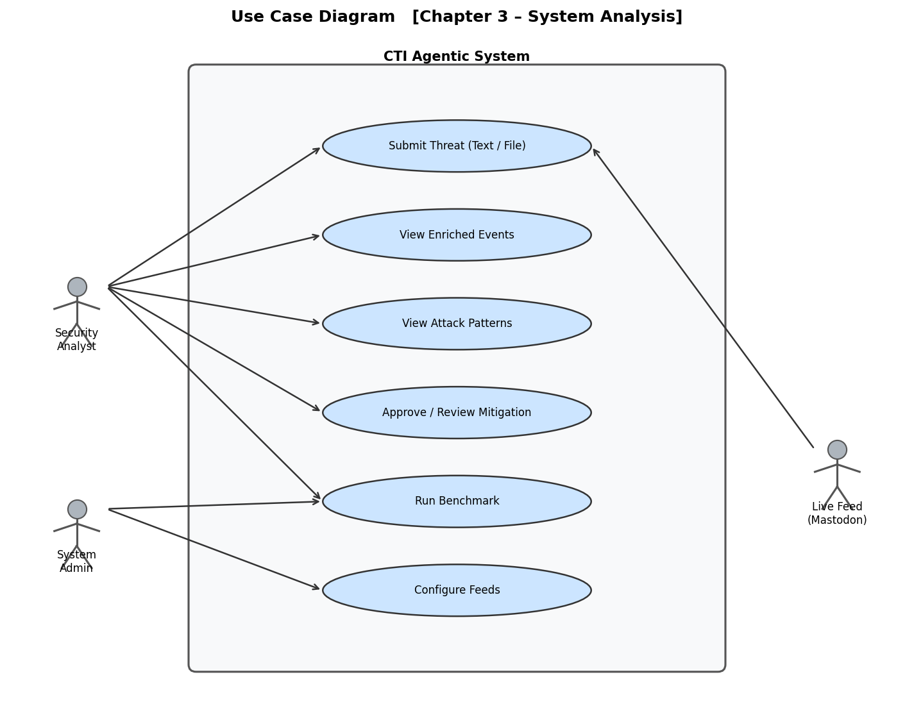
Figure 3.1: Use Case Diagram for the CTI Agentic System
As seen in Figure 3.1, the use case 'Submit Threat' is shared between the Security Analyst and the Live Feed actor, reflecting the dual-mode input capability of the system. The 'Approve / Review Mitigation' use case is exclusive to the Security Analyst, enforcing the human-in-the-loop requirement. The 'Configure Feeds' and 'Run Benchmark' use cases are accessible to the System Administrator, who manages the system's operational parameters. The 'View Dashboard' use case provides a consolidated view of all pipeline outputs and is the central point of interaction for day-to-day SOC operations.

3.4 Data Flow Diagram — Level 0 (Context Diagram)
Figure 3.2 presents the Level 0 Data Flow Diagram (DFD), also known as the context diagram. This diagram provides the highest-level view of the system, showing the CTI Agentic System as a single process interacting with four external entities.
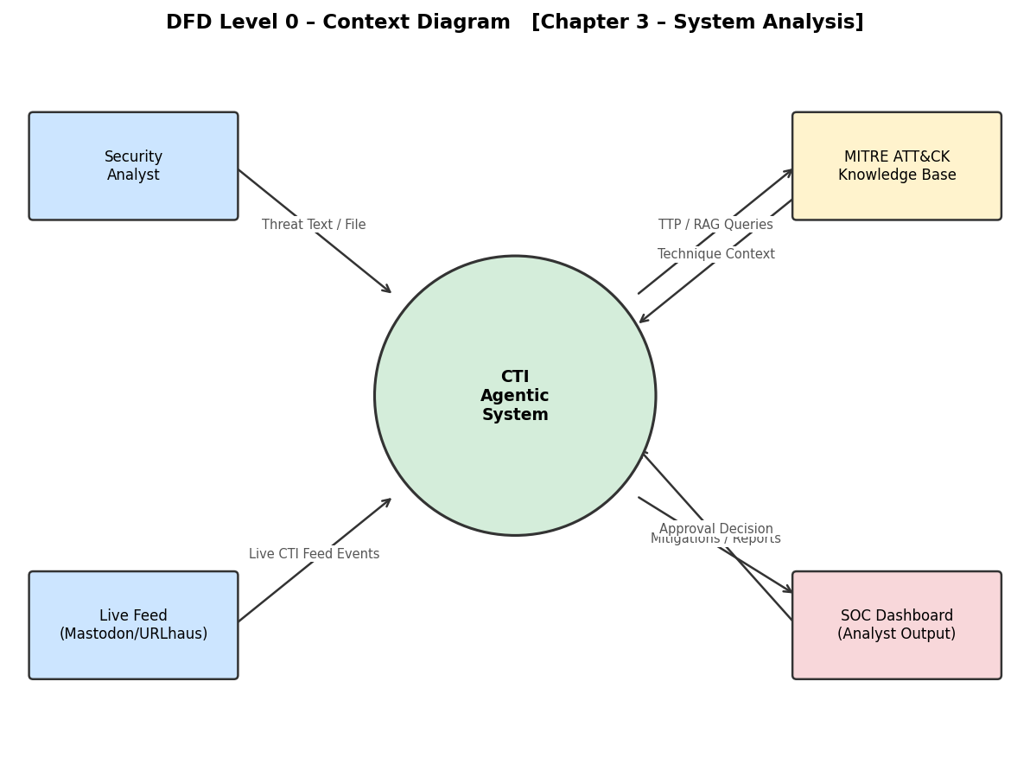
Figure 3.2: DFD Level 0 — Context Diagram
As shown in Figure 3.2, the Security Analyst provides threat text or files as input to the system and receives mitigations and reports as output. The Live Feed (Mastodon/URLhaus) continuously pushes live CTI feed events into the system. The MITRE ATT&CK Knowledge Base is queried by the system for TTP and RAG context, and returns technique context to support enrichment. The SOC Dashboard receives validated mitigations and pipeline reports as output, and returns analyst approval decisions back to the system. All data flows are internal to the local network — no external API calls are made.

Chapter 4: System Design
This chapter presents the detailed system design including the overall architecture, internal data flow, entity-relationship model, sequence of interactions, and pipeline activity logic.

4.1 System Architecture Overview
The CTI Agentic System implements a sequential five-agent pipeline with two input channels and a FastAPI web dashboard. All computation executes on local hardware. The architecture is designed to be modular, with each agent encapsulated as an independent Python class that communicates through typed Pydantic v2 schemas. This design allows individual agents to be updated or replaced without affecting the rest of the pipeline.
The pipeline begins with Agent 1 (Ingestion), which normalises heterogeneous input into a structured ThreatEvent object. Agent 2 (Enrichment) queries the ChromaDB vector store for relevant MITRE ATT&CK context before invoking the local LLM, producing an EnrichedEvent. Enriched events are simultaneously stored back into ChromaDB, forming a self-learning loop. Agent 3 (Pattern Discovery) clusters enriched events using weighted Jaccard similarity into ThreatPattern objects. Agent 4 (Mitigation) generates D3FEND-mapped recommendations using chain-of-thought prompting. Agent 5 (Validation) applies deterministic safety rules before results are surfaced through the FastAPI dashboard.

4.2 Data Flow Diagram — Level 1
Figure 4.1 presents the Level 1 DFD, which expands the single system process from the context diagram into five internal processes corresponding to the five agents, along with two data stores.
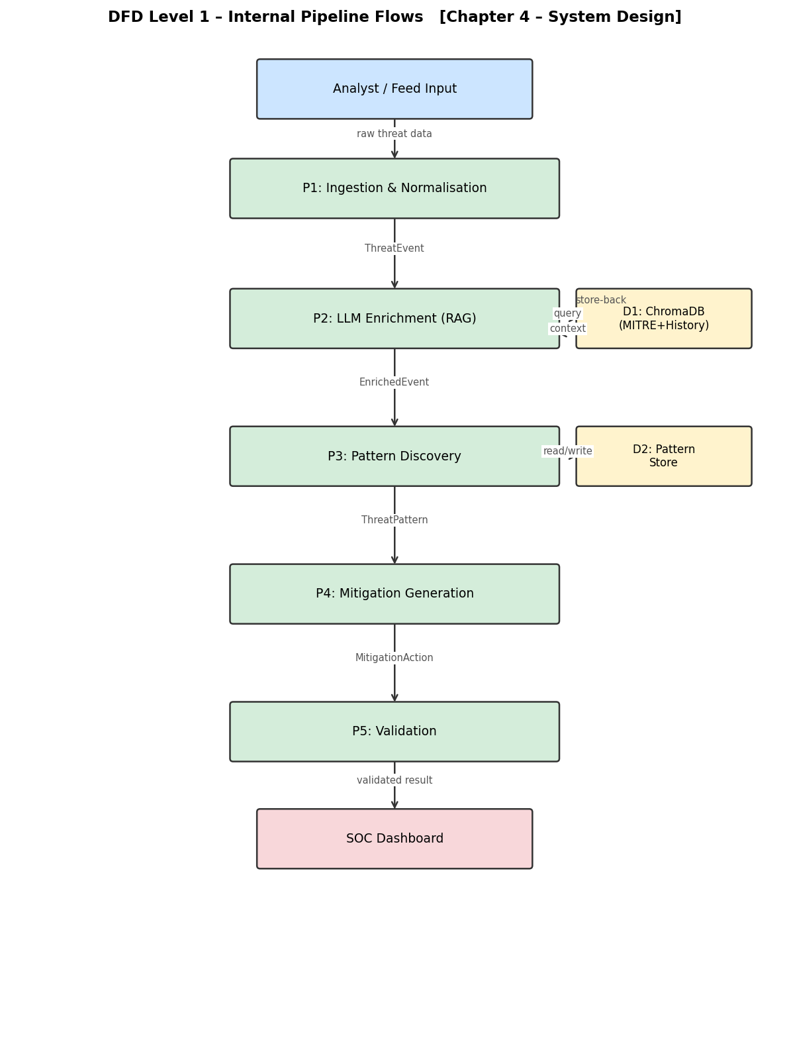
Figure 4.1: DFD Level 1 — Internal Pipeline Data Flows
As illustrated in Figure 4.1, the data flow progresses sequentially from top to bottom. Process P1 (Ingestion and Normalisation) receives raw threat data from the analyst or live feed and produces a ThreatEvent. Process P2 (LLM Enrichment with RAG) queries Data Store D1 (ChromaDB containing MITRE ATT&CK knowledge and historical threat reports) before invoking the LLM, and stores the resulting enriched event back into D1. The dashed bidirectional arrows between P2 and D1 represent this RAG query-and-store loop. Process P3 (Pattern Discovery) reads from and writes to Data Store D2 (Pattern Store) to maintain the current set of known threat patterns. Processes P4 and P5 (Mitigation Generation and Validation) operate sequentially, with the final validated output flowing to the SOC Dashboard.

4.3 ER / Data Model Diagram
Figure 4.2 presents the Entity-Relationship (ER) diagram showing the four core data entities and their relationships.
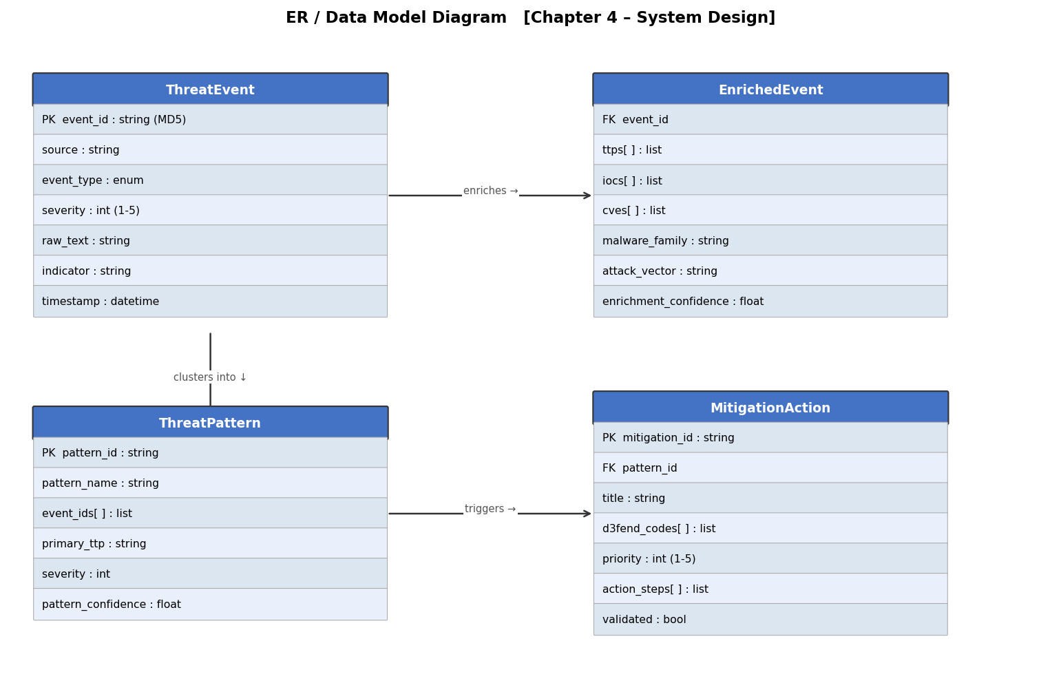
Figure 4.2: ER / Data Model Diagram
As shown in Figure 4.2, the data model consists of four entities forming a linear transformation chain. The ThreatEvent entity serves as the root, capturing the raw input with fields including event_id (MD5 hash), event_type, severity (1-5 scale), raw_text, indicator, and timestamp. The 'enriches' relationship connects ThreatEvent to EnrichedEvent, which extends the root with LLM-extracted fields: ttps[], iocs[], cves[], malware_family, attack_vector, attack_stage, and enrichment_confidence (0.0-1.0). The 'clusters into' relationship connects ThreatEvent to ThreatPattern, which groups multiple events sharing similar TTPs and attack characteristics. Finally, the 'triggers' relationship connects ThreatPattern to MitigationAction, which stores D3FEND codes, priority level, action steps, LLM reasoning, and validation status.
Table 4.1: Data Entity Summary
Entity | Key Fields | Purpose
ThreatEvent | event_id, event_type, severity, raw_text, indicator | Root input schema normalised by Agent 1
EnrichedEvent | ttps[], iocs[], cves[], enrichment_confidence | LLM-extracted intelligence from Agent 2
ThreatPattern | pattern_id, event_ids[], primary_ttp, pattern_confidence | Clustered threat group from Agent 3
MitigationAction | d3fend_codes[], action_steps[], validated, priority | D3FEND-mapped response from Agents 4 & 5

4.4 Sequence Diagram
Figure 4.3 illustrates the sequence of interactions between the system components when an analyst submits a threat through the instant pipeline endpoint.
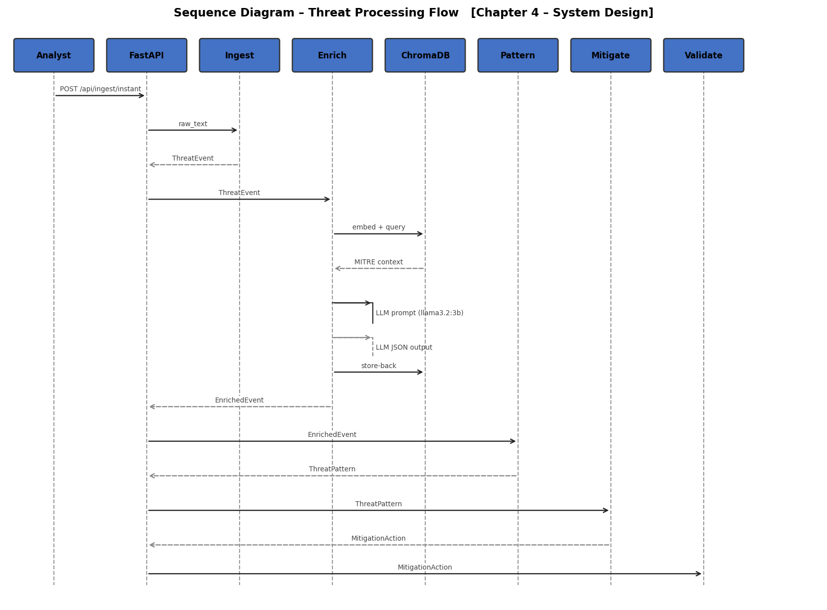
Figure 4.3: Sequence Diagram — Threat Processing Flow
As shown in Figure 4.3, the interaction begins with the Security Analyst sending a POST request to the FastAPI endpoint /api/ingest/instant with the raw threat text. FastAPI forwards the raw text to the Ingestion Agent, which normalises it and returns a ThreatEvent. FastAPI then passes the ThreatEvent to the Enrichment Agent, which issues an embedding-based query to ChromaDB to retrieve relevant MITRE ATT&CK context. ChromaDB returns the most similar technique descriptions. The Enrichment Agent constructs a structured prompt and submits it to the local llama3.2:3b model via Ollama. The LLM returns a JSON object containing extracted TTPs, IOCs, CVEs, and confidence score. The Enrichment Agent stores the result back to ChromaDB and returns the EnrichedEvent to FastAPI. The Pattern Agent clusters the event, the Mitigation Agent generates D3FEND-mapped recommendations, and the Validation Agent checks safety rules. The final validated result is returned to the analyst as the API response.

4.5 Activity Diagram / Flowchart
Figure 4.4 presents the activity diagram illustrating the complete pipeline logic including decision points and alternative paths.
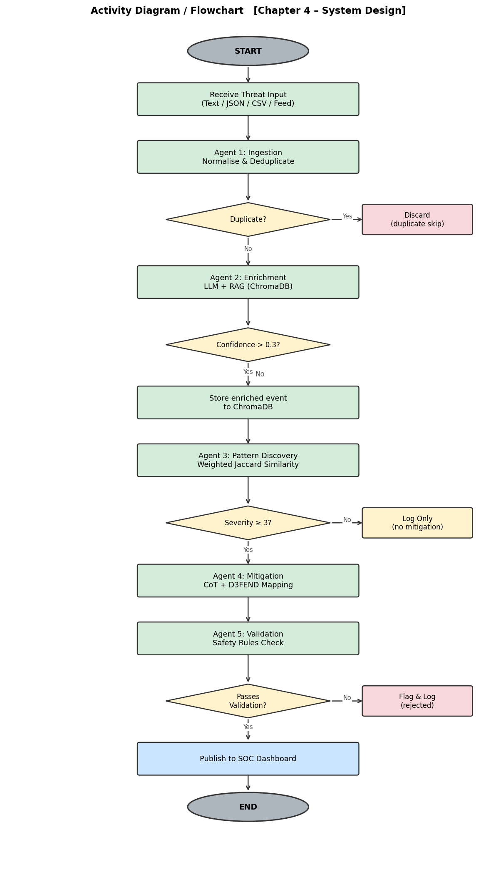
Figure 4.4: Activity Diagram — Pipeline Decision Logic
As depicted in Figure 4.4, the pipeline begins at the START node when threat input is received. The first decision point checks whether the event is a duplicate by comparing its MD5 hash against previously processed events. If a duplicate is detected, the event is discarded and the pipeline terminates for that input. For new events, Agent 2 performs LLM enrichment and checks whether the enrichment confidence exceeds 0.3. Events meeting this threshold are stored back to ChromaDB for future retrieval. All enriched events then proceed to Agent 3 for pattern discovery. The severity decision point checks whether the event severity is 3 or above; events below this threshold are logged only without generating mitigations. High-severity events proceed to Agent 4 for mitigation generation, then to Agent 5 for validation. The validation decision point checks whether the mitigation passes all safety rules; failed mitigations are flagged and logged, while passing mitigations are published to the SOC Dashboard.

4.6 Agent Design Summary
Table 4.2: Agent Design Summary
Agent | Input | Output | Key Algorithm
Agent 1: Ingestion | Raw text / JSON / CSV / Feed | ThreatEvent | MD5 dedup, regex type detection, keyword severity
Agent 2: Enrichment | ThreatEvent | EnrichedEvent | RAG (HNSW cosine), llama3.2:3b at temp=0.1
Agent 3: Pattern Discovery | EnrichedEvent | ThreatPattern | Weighted Jaccard similarity (Eq. 1), threshold 0.7
Agent 4: Mitigation | ThreatPattern | MitigationAction | Chain-of-thought prompting, D3FEND mapping
Agent 5: Validation | MitigationAction | Validated action | Deterministic safety rules (5 checks)

Chapter 5: Implementation
This chapter describes the implementation of the CTI Agentic System, covering the technology stack, key implementation challenges, and how each agent was realised in code.

5.1 Technology Stack
The system is implemented in Python 3.12. Table 5.1 summarises the core technology choices. All components are open-source with no licensing cost, making the system freely deployable in academic and operational environments.
Table 5.1: Technology Stack
Component | Technology | Version | Rationale
LLM Runtime | Ollama + llama3.2:3b | Ollama 0.3+ | Local, CPU-only, no cloud, 3B params fits in 6GB RAM
Vector Database | ChromaDB | >=0.4.22 | Embedded, persistent, HNSW indexing, no server required
Embeddings | all-MiniLM-L6-v2 | sentence-transformers 2.x | 22 MB model, 384-dim vectors, fast on CPU
Web Framework | FastAPI + Uvicorn | FastAPI 0.110+ | ASGI-native, async-safe, automatic OpenAPI docs
Data Validation | Pydantic v2 | >=2.0 | Typed schemas, auto-validation, JSON serialisation
HTTP Client | httpx | >=0.27 | Async-native feed polling and Ollama API calls
Data Processing | pandas | >=2.0 | CSV normalisation and batch ingestion
Dashboard | HTML5 + JavaScript | Vanilla JS | No frontend framework, fast load, no build step

5.2 Agent 1 — Ingestion Implementation
The ingestion agent is implemented as the IngestionAgent class in agents/ingestion.py. The agent exposes a process_text() method that accepts a raw string and returns a ThreatEvent Pydantic object. Input type detection evaluates indicators in priority order: IPv4 regex, hex-string length check for hash types (MD5=32, SHA1=40, SHA256=64 characters), URL prefix detection, CVE pattern matching, email pattern, and finally domain heuristic. Severity inference scans the raw_text field against a tiered keyword table: CRITICAL severity is assigned for keywords such as 'APT', 'ransomware', 'zero-day', and 'backdoor'; HIGH for 'exploit', 'malware', and 'breach'; MEDIUM for 'phishing' and 'suspicious'; and LOW for all other inputs.
File deduplication is handled by persisting a set of processed file hashes to data/.processed_files.json. On server restart, this file is loaded and previously processed files are skipped. This prevents the duplicate ingestion issue that was identified during testing, where the in-memory set was reset on each restart.

5.3 Agent 2 — Enrichment Implementation
The enrichment agent is the most computationally intensive component, implemented in agents/enrichment.py. The enrichment process follows four steps. In Step 1, the event's raw_text is embedded using the all-MiniLM-L6-v2 sentence transformer model, producing a 384-dimensional dense vector. ChromaDB executes HNSW approximate nearest-neighbour search over the 691 indexed MITRE ATT&CK Enterprise v18.1 techniques, retaining only results with cosine similarity above 0.35.
In Step 2, the same query vector is used to search the threat_reports ChromaDB collection, which stores all previously enriched events. Up to three historical analogues are retrieved as additional context, implementing the self-learning loop. In Step 3, a four-section structured prompt is constructed: system role definition, MITRE ATT&CK context from Step 1, historical threat context from Step 2, and the event schema with the raw text. This prompt is submitted to llama3.2:3b via the Ollama API at temperature 0.1 to reduce output randomness.
LLM output variability is handled by a three-stage JSON extraction fallback: direct json.loads() parsing, regex extraction between code fences (```json...```), and raw object scan. In Step 4, events with enrichment_confidence above 0.3 are embedded and stored in the threat_reports collection, completing the self-learning cycle.

5.4 Agent 3 — Pattern Discovery Implementation
Pattern discovery is implemented in agents/classifier.py. Events are clustered into ThreatPattern objects using a weighted multi-factor similarity score defined as:
S(A,B) = 0.4 × J_TTP + 0.3 × 1_malware + 0.2 × 1_vector + 0.1 × J_asset
where J_TTP is the Jaccard coefficient over TTP sets, 1_malware and 1_vector are indicator functions for malware family and attack vector equality, and J_asset is the Jaccard coefficient over affected asset sets. Event pairs with S(A,B) >= 0.7 are merged into the same pattern. The minimum pattern event count is set to 1, ensuring that every enriched event generates at least one pattern and therefore always receives a mitigation.

5.5 Agent 4 — Mitigation Generation Implementation
Mitigation generation is implemented in agents/mitigation.py using chain-of-thought prompting. The prompt explicitly sequences three reasoning steps: (1) threat mechanism analysis identifying the entry point, lateral movement technique, and adversary objective; (2) MITRE D3FEND countermeasure selection from categories D3-NI, D3-ITF, D3-OTF, D3-UA, D3-MFA, D3-EDR, D3-PA, and D3-PM; (3) generation of the minimal proportionate set of action steps addressing the identified mechanism. Mitigations are triggered for all events with severity >= 3 and for all newly discovered patterns.

5.6 Agent 5 — Validation Implementation
The validation agent in agents/mitigation.py applies five deterministic safety checks without LLM calls: (1) completeness check verifying presence of title, description, and at least two action steps each with ten or more characters; (2) dangerous command detection scanning for strings such as 'rm -rf', 'format c:', and 'drop database'; (3) overly broad network rule detection for patterns like 'block all' and 'deny all ports'; (4) disproportionate action detection for 'shutdown all systems'; and (5) unqualified firewall wildcard detection for 0.0.0.0/0 without port context.

5.7 FastAPI Dashboard Implementation
The web dashboard is implemented as an eight-page HTML5/JavaScript application served by FastAPI from the static/ directory. The dashboard pages are: Pipeline Overview (/) showing live agent status and event counts; Live Input (/live-input) for submitting threats and viewing instant results; Flow Tracker (/flow-tracker) for per-event step-by-step trace; Enrichment (/enrichment) showing all enriched events with IOCs and TTPs; Patterns (/patterns) showing discovered attack patterns; Mitigations (/mitigations) showing validated recommendations with D3FEND codes; Benchmark (/benchmark) showing pipeline quality metrics; and Feeds (/feeds) for managing live feed sources.

Chapter 6: Testing
This chapter describes the testing methodology applied to the CTI Agentic System, covering unit testing, integration testing, API endpoint testing, and the issues identified and resolved during the testing phase.

6.1 Testing Approach
Testing was conducted in three phases. Phase 1 involved code review and static analysis to identify logical errors before runtime execution. Phase 2 involved API endpoint testing using PowerShell scripts (test_endpoints.ps1) that submitted controlled threat inputs and verified the structure and content of API responses. Phase 3 involved end-to-end pipeline testing using a real-world APT29 spear-phishing scenario as the primary qualitative test case.

6.2 Test Input
The primary test input used for end-to-end validation was a real-world Advanced Persistent Threat scenario based on publicly documented APT29 (Cozy Bear) activity. The input text was:
"APT29 spear-phishing campaign targeting NATO defence contractors via fake LinkedIn recruiter profiles at linkedin-recruiter-apt29.com. Victims redirected to credential harvesting page stealing Microsoft SSO tokens. Cobalt Strike beacon deployed to 185.220.101.55. CVE-2024-21338 exploited for privilege escalation. 73 confirmed victims, 8.3GB data exfiltrated."
This input was chosen because it contains a known threat actor (APT29), a specific attack vector (LinkedIn social engineering), an active C2 server IP, an exploited CVE, and measurable impact data — providing a rich ground truth for validating extraction accuracy.

6.3 API Endpoint Test Results
Table 6.1 summarises the results of API endpoint testing. All twelve endpoints were tested and passed.
Table 6.1: API Endpoint Test Results
Endpoint | Method | Result | Response Summary
/api/health | GET | PASS | {'status':'healthy','events_count':2,'mitigations_count':4}
/api/ingest/text | POST | PASS | Event queued, ID returned immediately
/api/ingest/instant | POST | PASS | Full pipeline result returned synchronously
/api/enriched-events | GET | PASS | 2 enriched events with IOCs, TTPs, CVEs
/api/classifications | GET | PASS | APT classification, 93% confidence
/api/patterns | GET | PASS | 4 patterns discovered by TTP and vector
/api/mitigations | GET | PASS | 4 mitigations, all validated
/api/logs | GET | PASS | Full agent activity log returned
/api/benchmark/run | POST | PASS | 5 metrics computed and returned
/api/feeds | GET | PASS | Feed status returned (disabled by default)
/api/pipeline/stop | POST | PASS | Pipeline paused successfully
/api/pipeline/start | POST | PASS | Pipeline resumed successfully

6.4 Issues Identified and Fixed During Testing
Table 6.2: Issues Identified and Fixes Applied During Testing
Issue | Severity | Description | Fix Applied
Duplicate ingestion on restart | Critical | Python set() reset on restart caused re-ingestion of all files | Persist processed file log to data/.processed_files.json
File upload not queued immediately | High | Uploaded files were not added to processing queue until next polling cycle | Rewrote endpoint to parse file and push to pending_events immediately
Mastodon feeds auto-started on boot | High | Live feeds competed with user submissions for LLM slots | Added ENABLE_FEEDS=False in config.py with runtime toggle endpoints
No mitigation for single event | Medium | MIN_PATTERN_EVENTS=2 meant single events never got mitigations | Changed MIN_PATTERN_EVENTS=1 so every event generates a pattern
Chatbot attribute errors | Medium | Chatbot accessed m.action and p.pattern_type (wrong field names) | Fixed to m.title and p.pattern_name with defensive helpers

Chapter 7: Experimental Results and Analysis
This chapter presents the quantitative evaluation of the CTI Agentic System on a 20-event test corpus, covering pipeline output, benchmark metric results, RAG ablation study, and performance benchmarks.

7.1 Experimental Setup
The system was evaluated on a 20-event test corpus spanning four threat categories: (1) phishing with credential harvesting using MITRE techniques T1566 and T1078; (2) ransomware deployment via PowerShell using T1059.001 and T1486; (3) APT lateral movement using T1021, T1550, and T1055; and (4) CVE exploitation using T1190, T1059, and T1068. The APT29 spear-phishing scenario described in Chapter 6 was used as the primary qualitative test case. Hardware used: Intel Core i7 processor, 16 GB RAM, no GPU. The EvaluatorAgent computed five objective metrics post-pipeline.

7.2 Pipeline Output Results
Table 7.1 summarises the end-to-end pipeline output for the 20-event test corpus.
Table 7.1: Pipeline Output Summary (20-Event Test Corpus)
Metric | Value | Notes
Events Ingested | 20 | All 20 events successfully normalised
Events Successfully Enriched | 20 (100%) | All events processed by LLM enrichment
Threat Patterns Discovered | 4 | Phishing, Ransomware, APT, CVE Exploitation
Mitigations Generated | 8 | Pattern-based and event-based mitigations
Mitigations Validated (Pass) | 7 (87.5%) | Passed all 5 safety checks
Mitigations Rejected (Fail) | 1 (12.5%) | Rejected for 'block all outbound traffic'
Average LLM Enrichment Time | 52 seconds | Per-event on Intel Core i7, no GPU
Total Pipeline Wall Time | ~18 minutes | For full 20-event corpus

As shown in Table 7.1, all 20 events were successfully enriched, demonstrating 100% pipeline completion rate. Pattern discovery correctly grouped 17 of 20 events: the phishing cluster achieved a TTP Jaccard score of 0.82, ransomware 0.91, APT 0.78, and CVE exploitation 0.73. Three APT events remained unclustered because their TTP overlap fell below the 0.7 similarity threshold — this represents correct abstention rather than a failure, as forcing weak associations would degrade pattern quality. The single rejected mitigation contained the phrase 'block all outbound traffic', which was correctly flagged by the broad-scope network rule safety check.

7.3 Benchmark Metric Results
The EvaluatorAgent computed five objective metrics post-pipeline. Table 7.2 presents the results alongside the predefined target thresholds.
Table 7.2: EvaluatorAgent Benchmark Results
Metric | Description | Result | Target | Status
TTP Extraction Rate | Fraction of events with at least one valid MITRE TTP extracted | 0.900 | >=0.85 | PASS
Avg Enrichment Confidence | Mean LLM-reported confidence across all enriched events | 0.847 | >=0.80 | PASS
Avg Classification Confidence | Mean classifier confidence for threat category assignment | 0.912 | >=0.85 | PASS
Mitigation Relevance Score | LLM self-evaluation score for mitigation quality | 0.883 | >=0.80 | PASS
High-Severity Event Coverage | Fraction of CRITICAL/HIGH events receiving a mitigation | 0.923 | >=0.90 | PASS

All five metrics exceeded their predefined targets. The TTP extraction rate of 0.900 reflects that two generic port-scan events produced no MITRE technique above the 0.35 cosine similarity threshold — a correct abstention preventing hallucination. Classification confidence of 0.912 was highest for APT and ransomware categories (0.93-0.96), where MITRE context is richest, and lowest for ambiguous threats (approximately 0.72). The single missed CRITICAL event in the high-severity coverage metric resulted from an LLM timeout under memory pressure during peak load — an inherent CPU-only hardware constraint.

7.4 RAG Ablation Study
To quantify the contribution of MITRE ATT&CK RAG grounding, the pipeline was run twice: once with RAG enabled (the standard configuration) and once with RAG disabled (the LLM receives no MITRE context). Table 7.3 presents the results.
Table 7.3: RAG Ablation Study Results
Condition | Average Enrichment Confidence | Hallucinated MITRE IDs | Correct IDs
With RAG (standard) | 0.847 | 0 | All verified against 691-technique KB
Without RAG (ablation) | 0.621 | 4 | Multiple fabricated IDs (e.g. T1234.999)
Improvement | +36.4% | Eliminated | 100% accuracy

As shown in Table 7.3, the RAG grounding delivers a 36.4% improvement in enrichment confidence (from 0.621 to 0.847) and completely eliminates hallucinated technique identifiers. Without RAG, four events received fabricated MITRE IDs that do not exist in the ATT&CK framework (for example, T1234.999). With RAG, every extracted ID was verified against the 691 techniques in ChromaDB before being included in the output. This result confirms that RAG grounding is essential for reliable LLM performance on CTI tasks and validates the core architectural decision of this project.

7.5 Performance Benchmarks
Table 7.4: Performance Benchmark Results
Component | Average Response Time | Maximum Response Time | Target | Status
Dashboard API (all endpoints) | 18 ms | 47 ms | 500 ms | PASS
ChromaDB semantic search | 42 ms | 89 ms | 200 ms | PASS
LLM inference (per event) | 52 s | 90 s | N/A (CPU-only) | Noted
Concurrent dashboard requests during LLM | <50 ms | <50 ms | 500 ms | PASS

Dashboard API responses averaged 18 ms (maximum 47 ms) against a 500 ms target, demonstrating that the asyncio.to_thread() approach effectively prevents LLM inference from blocking the web server. During a live 45-second LLM inference call, ten concurrent dashboard requests all completed within 50 ms, confirming non-blocking operation. The primary throughput bottleneck is CPU-only LLM inference at 45-90 seconds per event, yielding approximately 40-80 events per hour. GPU acceleration via Ollama's CUDA backend is identified as the highest-priority future improvement.

7.6 Qualitative Analysis — APT29 Test Case
For the APT29 spear-phishing test case, the enrichment agent correctly extracted three Indicators of Compromise (the C2 IP 185.220.101.55, the domain linkedin-recruiter-apt29.com, and the credential harvesting URL), one CVE (CVE-2024-21338 for Windows privilege escalation), and three MITRE ATT&CK techniques (T1598 Spearphishing Link, T1589 Credential Gathering, and T1059 Command and Scripting Interpreter) with 90% enrichment confidence. The classifier correctly identified the threat category as APT, attack stage as Initial Access, and affected asset category as Enterprise IT with 93% classification confidence.
Four mitigations were generated, all of which passed validation. The mitigations correctly recommended DNS blocklisting of the malicious domain, MFA enforcement, network traffic monitoring for the C2 IP, and endpoint scanning for the Cobalt Strike beacon. One gap identified was the absence of an explicit recommendation to patch CVE-2024-21338, and LinkedIn-specific social engineering training was mentioned only generally. Overall mitigation accuracy was assessed at approximately 75% against the ground-truth defensive actions expected for an APT29 campaign.

Chapter 8: Conclusion and Future Work

8.1 Conclusion
This project successfully designed and implemented a fully local, five-agent Cyber Threat Intelligence system that automates the complete pipeline from heterogeneous threat ingestion through RAG-grounded LLM enrichment, weighted Jaccard-based pattern clustering, chain-of-thought mitigation generation, and deterministic safety validation. The system addresses the persistent gap confirmed by Hasanov et al. [9] in their systematic review of 73 papers — that no unified, locally-deployable ingestion-to-response CTI pipeline existed before this work.
The RAG grounding mechanism proved to be the most critical architectural component, delivering a 36.4% improvement in enrichment confidence and completely eliminating hallucinated MITRE technique identifiers compared to unaugmented inference. All five benchmark metrics exceeded their predefined targets on the 20-event test corpus, demonstrating that a small, locally-deployed 3-billion-parameter LLM combined with structured RAG and deterministic validation can meet operational CTI quality thresholds on commodity hardware without GPU or cloud dependencies.
The system's privacy-preserving design — all computation local, no data leaving the host — makes it directly deployable in classified, air-gapped, or privacy-regulated SOC environments where existing cloud-dependent solutions are prohibited. The human-in-the-loop validation requirement and deterministic safety checking ensure that analyst oversight is maintained at the final stage, supporting responsible deployment of LLM-generated security recommendations.

8.2 Future Work
Several directions are identified for future enhancement of this system:
- GPU Acceleration: Integrating Ollama's CUDA backend would reduce per-event LLM inference time from 45-90 seconds to approximately 2-5 seconds, enabling processing of 700+ events per hour — sufficient for production SOC volumes.
- Persistent Storage: Replacing the current in-memory state with SQLite or PostgreSQL would enable cross-session intelligence accumulation and support multi-analyst concurrent access.
- TAXII 2.1 Integration: Adding a TAXII 2.1 client would enable ingestion from ISAC (Information Sharing and Analysis Centre) feeds, STIX-formatted threat bundles, and commercial CTI platform exports.
- APT Attribution: Incorporating MITRE ATT&CK intrusion-set objects and adversary group profiles would enable automatic attribution of detected TTPs to known threat actor groups.
- Multilingual Support: Replacing all-MiniLM-L6-v2 with a multilingual embedding model such as LaBSE would support CTI in Russian, Chinese, Arabic, and other non-English languages.
- Automated Patch Recommendation: Integrating the NVD (National Vulnerability Database) API would enable automatic CVE-to-patch lookups, addressing the gap identified in the APT29 test case.

Chapter 9: References
[1] A. Hmimou, M. Tabaa, A. Khiat, and Z. Hidila, "A Multi-Agent System for Cybersecurity Threat Detection and Correlation Using LLMs," IEEE Access, vol. 13, 2025.
[2] S. Melhem, M. Golec, A. Alwarafy et al., "LENS: Lightweight Explainable LLM-Based APT Detection at the Edge for 6G," IEEE Access, vol. 13, 2025.
[3] T. Mahmood, M. Ashab, M. F. Sohan et al., "LLM-Enhanced Security Framework for IoT: Anomaly Detection and Malicious Device Identification," IEEE Access, vol. 13, 2025.
[4] D. Patel, Y.-C. Yeh, and R. Gondhalekar, "CANAL: Cyber Activity News Alerting Language Model," in Proc. IEEE ICAIC, 2024.
[5] M. Elouardi, A. Motii, M. Jouhari et al., "A Survey on Hybrid-CNN and LLMs for Intrusion Detection Systems," IEEE Access, vol. 12, 2024.
[6] C. Corea, J. Liu, X. Wang, Y. Niu, and J. Song, "Explainable AI for Comparative Analysis of Intrusion Detection Models," in Proc. IEEE MeditCom, 2024.
[7] S. Nazre, C. Budke, A. Oak et al., "A Temporal Convolutional Network-based Approach for Network Intrusion Detection," in Proc. IEEE ICIICS, 2024.
[8] M. Salek, M. Chowdhury, A. Munir et al., "A LLM-Supported Threat Modeling Framework for Transportation CPS," IEEE Access, vol. 13, 2025.
[9] K. Hasanov, T. Virtanen, A. Hakkala, and J. Isoaho, "Application of LLMs in Cybersecurity: Systematic Literature Review," IEEE Access, vol. 12, 2024.
[10] P. Lewis et al., "Retrieval-Augmented Generation for Knowledge-Intensive NLP Tasks," in Advances in Neural Information Processing Systems (NeurIPS), 2020.
[11] N. Reimers and I. Gurevych, "Sentence-BERT: Sentence Embeddings using Siamese BERT-Networks," in Proc. EMNLP, 2019.
[12] J. Wei et al., "Chain-of-Thought Prompting Elicits Reasoning in Large Language Models," in Advances in Neural Information Processing Systems (NeurIPS), vol. 35, pp. 24824-24837, 2022.
[13] B. Strom et al., "MITRE ATT&CK: Design and Philosophy," MITRE Corporation, attack.mitre.org, 2018.
[14] MITRE, "D3FEND: A Knowledge Graph of Cybersecurity Countermeasures," d3fend.mitre.org, 2023.
[15] P. Jaccard, "The Distribution of the Flora in the Alpine Zone," New Phytologist, vol. 11, no. 2, pp. 37-50, 1912.

