**Project Bloom: A Quest for Home**

Developed By:

Renegadeware

Version 1.0.0

# 

# Table of Contents

Table of Contents

1. Game Overview
   1. Target Learning Objective (LO)
   2. Demographics - Target Audience
   3. Genre / Theme / Setting
   4. Core Gameplay Summary
   5. Look and Feel
   6. Target Platform(s)
2. Game Flow
   1. Part 1 - [Name of this Portion of the Game]
      1. L.O. Concept(s) Covered
      2. Summary
      3. Mechanics
      4. Losing Gameplay / Incorrect Concept Understanding
      5. Mockups
   2. Part 2 - [Name of this Portion of the Game]
      1. L.O. Concept(s) Covered
      2. Summary
      3. Mechanics
      4. Losing Gameplay / Incorrect Concept Understanding
      5. Mockups
   3. Part 3 - [Name of this Portion of the Game]
   4. Etc.
3. LO Concept Coverage
   1. Academic Concepts
4. Legends of Learning Required Content Practices
   1. Checklist Overview
   2. Connection Between Gameplay and Learning
   3. Role of Text in Learning
   4. Characters - Diversity
5. Technical
   1. Development Hardware/Software
   2. Music and Sounds
   3. Asset Summary
6. Art Style
   1. Mockups
7. Schedule for Development + Delivery
8. [OPTIONAL] Story / Narrative
   1. Back Story
   2. Plot Elements

# 

# Game Overview

### Target Learning Objective (LO)

* [MS-ESS2.D-1](https://drive.google.com/file/d/1p5Yk3JNJUejWAimRI4LFcppuIQZPLdJZ/view)

### Demographics - Target Audience

* Ages 11-14 (Middle School)

### Genre / Theme / Setting

* Colony Sim – The player is tasked to maintain a healthy environment for a number of frogs within a region.
* Frogs – Due to their subtle role of maintaining the environment’s equilibrium. They also indicate the health of an ecosystem: where there are frogs, the natural balance is sustained. Frogs are also known to have a social structure, which fits into the game’s genre.
* Planet Earth – The game will take place across Earth. This will help students associate the various attributes of the climates in some real sense.

### Core Gameplay Summary

The game consists of two parts: Overworld and Colony Sim. The Overworld will consist of finding a suitable place for the frogs to inhabit. Once a suitable place is found, the colony ship will land, and the Colony Sim gameplay begins. The Colony Sim will last for a fixed duration. Afterwards, the game will continue with another colony ship to find a place to land, but with a different climate preference than before. Once all colony ships have landed, and the regions populated, the game ends.

#### Overworld

In the Overworld gameplay, the player is tasked to find a suitable region on Earth for a colony of frogs to inhabit. These frogs will be arriving via a colony ship.

Each colony of frogs will have a set of climate preferences for them to be able to inhabit. These preferences can be: temperature range, humidity range, wind strength, etc. Along with these preferences, their pigment color can also help summarize this at a glance (e.g., green frogs prefer temperate or tropic).

On the Earth’s map, there will be 4 hotspots the player can choose from. Information about the climate preference will also be shown to help as a general guide. Overlay toggles are available to show the Earth’s attributes: temperature, wind, humidity, ocean flow.

When the player clicks on one of the hotspots, a more elaborate detail will be displayed for the region. From here, the player can adjust two things: landing area and timeframe.

The landing area adjustment is essentially where the player chooses the altitude of area (can also factor in biomes). Adjusting this will update the general atmospheric attributes of the hotspot, demonstrating how certain areas (altitude) can change the atmospheric attributes.

The timeframe adjustment determines the Colony Sim gameplay’s starting and ending time. The player is presented with the weather forecast in that region during that entire period. This helps the players understand how the atmospheric attributes changes day-to-day.

As the player is adjusting the landing area and timeframe, 5 frogs are displayed depicting their mood based on the decision: happy, neutral, sad. This determines if the time and place is ideal. The player must at least have 3 happy frogs. A hint system will give advice as to what the ideal adjusts should be (and also if the player should pick another hotspot).

If all conditions are met (at least 3 happy frogs), the player can click on “Launch” and commence the Colony Sim gameplay.

#### Colony Sim

In the Colony Sim gameplay, the player is tasked to maintain the frogs’ ideal conditions: temperature, moisture, food. Maintaining these conditions will allow the population to increase, and vice-versa. After the gameplay ends, the player’s performance is dictated by the amount of population they were able to obtain.

In order to maintain these 3 attributes, the player can build structures to help compensate for any obstructions that decrease them. Each structure will however require certain resource, along with maintenance in order for them to function (e.g., agricultural structures require fresh water source, such as a well). Some of these resources can also be found naturally.

Along with structures, the player must assign roles to the special frogs to help build, maintain, and manipulate the environment (e.g., structures can only be built/maintained if there is at least one engineer). These frogs can be reassigned any roles as needed.

The first structure the player must place is a house, which will start populating to at least one. Each house has a capacity of 5. Afterwards, the player can build structures around to help increase the populations. The game will give hints throughout the cycle.

Certain weather events can cause damages to the structures (e.g., hurricane, high-tide, sandstorm). This can be mitigated by building certain structures, or simply allow engineers to repair them after the catastrophic event. Both cases have its pros/cons (e.g., structures waste spaces and resources).

Along with weather events, there are also wild inhabitants to deal with. These are for the most part can be handled by an assigned specialist frog.

### Look and Feel

* Simplified map of Earth – Emphasis on land outlines, ocean currents, and terrain heights.
* Earth Map Overlays – The game will simulate the overlay view of the Earth’s attributes. These will be simplified to make it clearer for the students on how they function (e.g., wind motions will mostly follow the prevailing winds).
* Backgrounds – Silhouette/shape of the topography/biome of the region, allow for change of color based on weather condition. Also show the sun/moon for each cycle.
* Weather – The game will show just enough details to indicate the current weather: rain, clouds, fog, etc.
* Structures – Each structure will have a symbol on them to indicate their functionality: energy, water, house. Along with the symbol, any form of state/vitality will also be shown (e.g., water amount, population count).
* Frogs – The frogs will have a palette based on their preferred climate (e.g., green = temperate, tan = desert). To distinguish their role, they will be wearing a hat specific to their work (e.g., engineer = hard hat). Though not very frog-like, they will stand upright to show their actions more clearly. However, they will still do their hopping as they move about.

### Target Platform(s)

* WebGL with iPad support – Since the game is completely mouse driven, there should be no issue with playing the game in any platform that supports mouse or touch input.

# Game Flow

## Overworld

### Summary

#### Hotspot Selection

* A display of criteria is shown to determine what the frog colony is looking for to inhabit. There is at most 3 criteria to satisfy:
  + Temperature range
  + Humidity range
  + Wind strength range
  + Altitude range
* To help the player evaluate these criteria, there are overlay toggles that show the Earth’s atmospheric attribute:
  + Temperature
  + Humidity
  + Wind Strength
* A wind particle animation is also displayed on the map to show how these atmospheric attributes are influenced.
* The player is presented with 4 hotspots to choose from. Selecting one will zoom the map to the location for further investigation.

##### Hotspot Selection Mockup

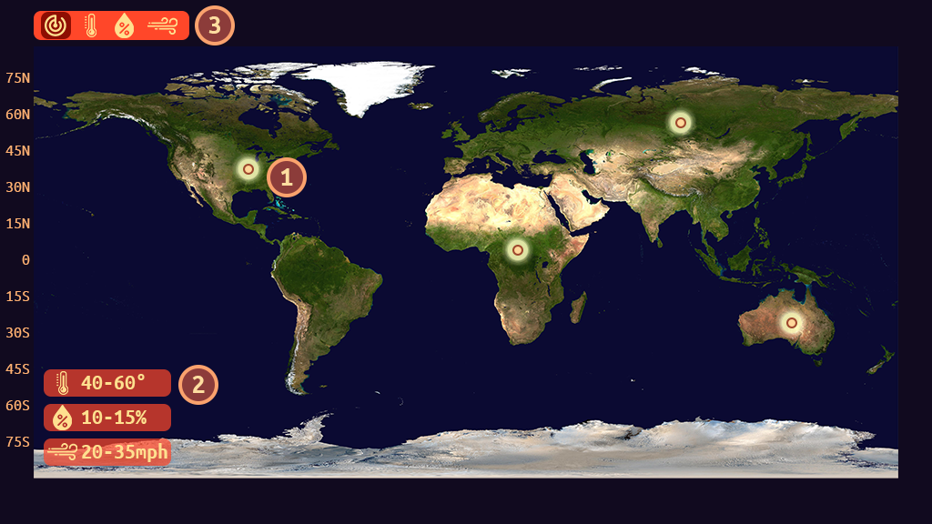

|  |  |
| --- | --- |
| 1 - Hotspot | 2 – Criteria |
| 3 – Overlay Control |  |

##### Temperature Overlay Mockup

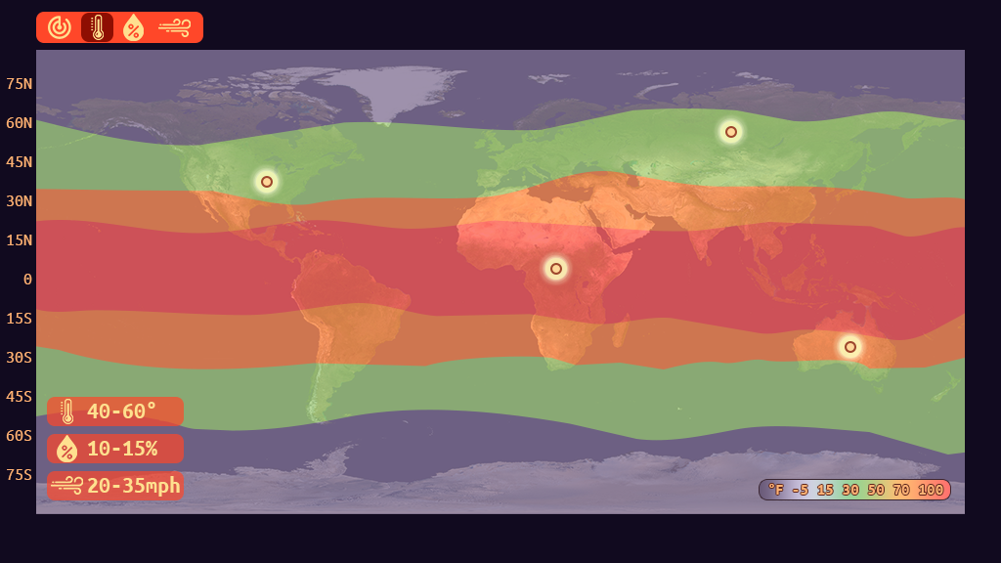

##### Humidity Overlay Mockup

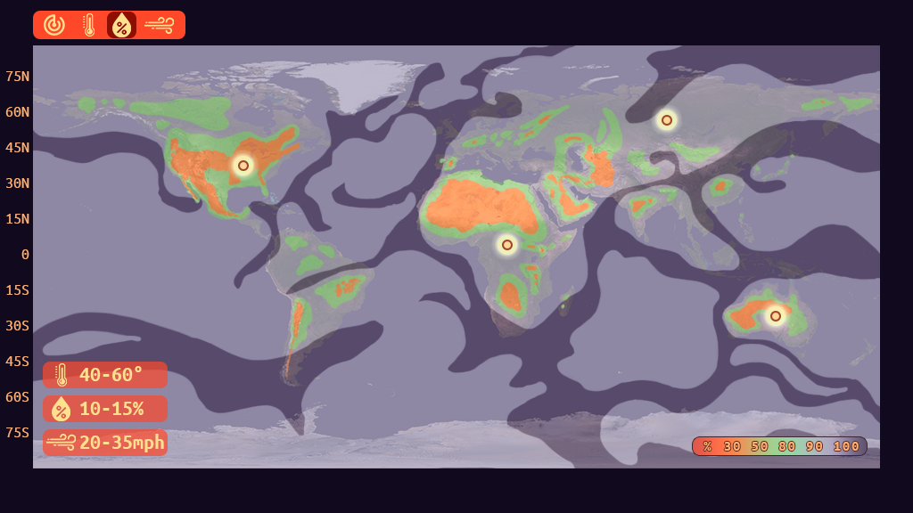

##### Wind Strength Overlay Mockup

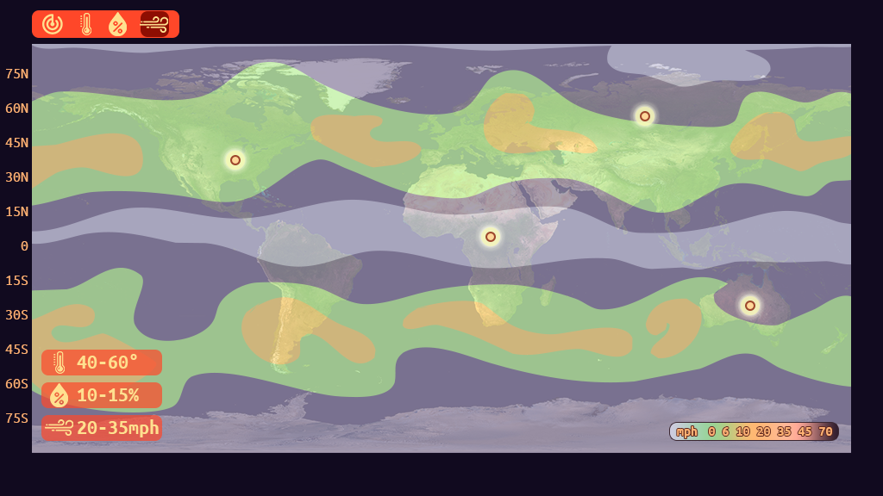

#### Hotspot Investigation

* Upon selecting a hotspot, zoom into the general area of the hotspot.
* From here, information regarding the region’s atmospheric attributes is displayed:
  + Temperature range.
  + Humidity range.
  + Wind strength.
  + Precipitation chance (possibly)
  + Hazard warning
* The player can adjust the location of the landing site via the region slider. This will affect the atmospheric attributes. Altitude is also displayed to show its relation to how the atmosphere is changed. Other than the altitude, the biosphere of the location can also affect the atmosphere.
* The time range can also be adjusted which is depicted by seasons. (Note: Will need to describe seasons based on the Earth’s position within the equinox and solstice. Also, the difference between meteorological vs. astronomical). This will also update the atmospheric attribute (also the landing site preview, if possible).
* As the player adjusts the landing site, and the time range, frogs will display their approval: happy, neutral, sad.
  + The player must have at least 3 happy and no sad to launch the expedition.
* Player can back out at any time if none of the adjustments are satisfactory.
* Once the player has most approvals, they can launch the expedition. Attempting to launch will simply activate the hint system.
* The hint system will suggest to the player what the sad frogs are looking for (e.g., low temperature, etc.).

##### Hotspot Investigation Mockup

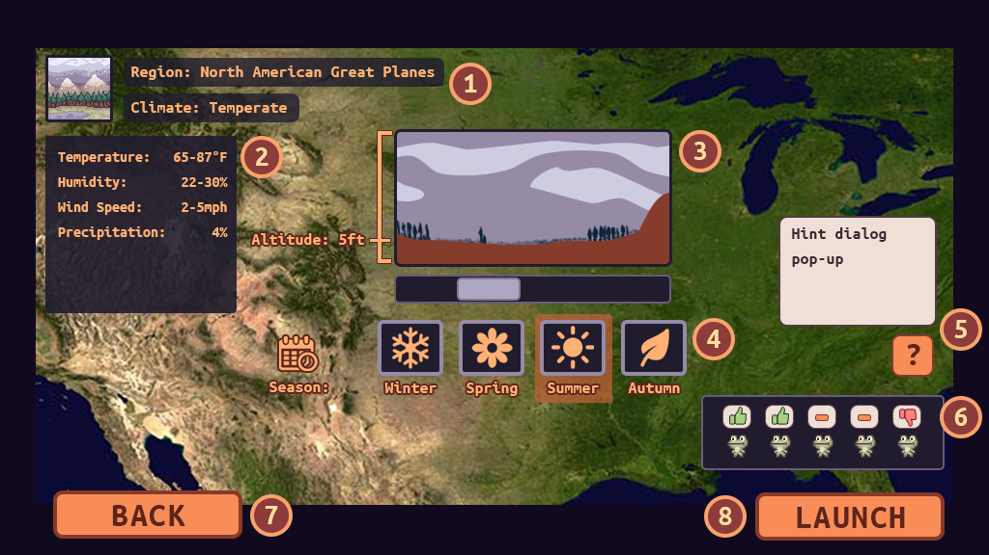

|  |  |
| --- | --- |
| 1 – Region Details | 2 – Atmospheric Attributes |
| 3 – Landing Site Slider | 4 – Timeline Selector |
| 5 – Hint System | 6 – Frog Approvals |
| 7 – Return to Hotspot selection | 8 – Start Colony Sim |

### Mechanics

* The game will be fully controlled via mouse or touch.
* All inputs are done by simply clicking on the widgets. A highlight for these widgets will appear on mouse hover, or if they are selected.
* Dragging is done when adjusting the Landing Site location via a slider.

### Losing Gameplay / Incorrect Concept Understanding

* There is no losing per-se during this part, only a restriction for launching the colony ship.
* The frog approvals will help the player understand what the requirements are. This allows investigation of how location/time affects the atmospheric attributes.
* Along with the frog approvals, the hint system can be accessed to give hints on what to look for by understanding the atmospheric attributes (e.g., “Look for an area with trees to increase humidity).

## Colony Sim

### Summary

* Colony ship lands, and the weather forecast is displayed. The player can examine each weather type closely from here. Once they are ready, they can click on “OK” to start the game.
* As time moves forward, weather will change as forecasted. The background will have a visual representation of the current weather.
* Each “day” is considered a cycle. The game will have ~7 days/cycles for the entire duration (~2 minutes). These can be adjusted when tweaking the game.
* The atmospheric measurements can be seen at all times at the corner of the screen. When an incoming hazard is about to happen (1-2 cycles away), an indicator will be displayed. Clicking on it will give further description of the hazard in question, along with a suggestion on what to do.
* The player is tasked to populate the region as much as possible. To do this, they first need to build a house. Each house will have a maximum capacity of 5 frogs (note: can be adjust when tweaking the game). There is a maximum amount of houses the player can place (adjust as needed).
* A house requires certain things to increase its population:
  + Temperature
  + Humidity
  + Food
  + Water
* When a requirement is not met, a popup with an icon that represents what is lacking will show on the top of the house.
* Population increases/decreases each cycle. If all requirements are met, the population of a house will increase. If 2 requirements are not met, it will decrease (note: can be adjusted as needed).
* To help with the requirements, the player can build structures to manipulate the environment. Some of these structures, however, will require energy. A balance must be made.
* Certain structures will be different based on the region (or based on the colony ship). Some structures will also only be available in some regions.
* The following are the structures available for construction (rough idea):
  + Power: wind turbine, solar panel, hydropower, coal power station. Each power has a capacity and charging rate. Any structures that require power will reduce the charge rate (can be negative). Some power structure will require certain environment condition: strong wind, sunny, etc.
  + Water: well, water tank, saltwater converter. Just like power, water has a charge rate, and this charge rate is consumed by each house. And just like power structures, some will require certain environment condition: rain, ocean tide level.
  + Heat Generator – place next to/near house.
  + A/C Unit – place next to/near house.
  + Bunker – for hazardous weather. Each bunker can hold 10 frogs (adjust as needed).
* To place a structure, the player clicks on the “structure” tab at the bottom, then click on the icon that represents the structure they want (e.g., thunder = power, a label will also be shown). Once a structure is selected, a ghost preview of the structure is shown on the landscape. The player can hover the mouse around to determine its placement. If it’s valid, the ghost tint will be green, otherwise it will be red. Clicking on a valid spot will give the player a confirmation by a pop-up. Once confirmed, the structure is placed it as “under construction”. Cancelling will stop the entire placement process (player needs to click on the structure again to place). At least one engineer must be available to build the structure. More engineers will build it faster.
* If the player wants to move the structure, or demolish it, they can click on the structure, and an action context will popup. Moving the structure will be similar to placing it, clicking on an invalid spot will cancel the move action. Just like placement, a confirmation is shown. Once confirmed, a construction queue will be placed for: deconstruct previous structure, construct same structure to a new location. Clicking on demolish will simply queue the building for demolish after a confirmation.
* Along with structures, the player can choose roles for a number of specialist frogs. The capacity for specialists starts with 1, increased by 1 per house.
* The following are the roles the frogs can be assigned to. And just like structures, some of them will only be available in certain regions (rough idea):
  + Engineer – the game starts with one frog assigned to this. They are responsible for: building, demolishing, repair of structures.
  + Farmer – they grow a “sunflower” near each house. There is a limit of one “sunflower” per household.
  + Forester – they grow trees behind the structures. These trees help with increasing humidity of the region. The more assigned to this, the more trees are planted. They will need a source of water to plant trees. They will have an icon of a water if they lack it.
  + Medic – tend to wounded frogs. Frogs are wounded if they are attacked by pests, harmed by weeds/mushrooms, or by hazardous weather.
  + Pest Control – attacks pests, weeds, mushrooms, etc.
* Specialist frogs reside in the colony ship, and as they are assigned/reassigned, they will emerge from it.
* To deploy specialist frogs, the player clicks on the “frogs” tab at the bottom, then click on an existing frog slot or empty slot. From there, a popup will display a list of specialists. The player can then click on one of the specialists to reassign/assign the role. The player can click outside the list to cancel this process.
* Harmful entities in the region will come in different forms:
  + Pests
    - Fly – flies around menacingly. Can get caught in a wind turbine, causing damage. They also eat “sunflowers”.
    - Hopper – hops around, injuring any frogs it touches.
    - Underground Critter – damages structures in its path as it moves across the landscape.
  + Flora
    - Weed – grows on “sunflowers”, and eats it away.
    - Mushroom – grows randomly around the landscape, destroying “sunflowers” and injuring frogs in contact.
    - Vine – gradually grows on structures, eventually damaging it.
* During hazard weather, the frogs will take shelter. Hazards will cause damages to some structures as it progresses. Some frogs that took shelter in houses will get injured.
* Injured frogs will disappear after a certain duration if they are not healed by a medic in time. In the case of specialists, they will be removed from their assignment.
* Frogs will come out of the house from time to time to wander around. This is simply an aesthetic to signify a thriving population (though they can be injured by harmful entities).
* Hint System – the hint system is accessed through an icon at the side of the screen, it’ll show up whenever there’s something the player ought to know or do (e.g., houses lacking food, water, power, etc.). This is also congruent with the pop-up icon that shows on structures that lack resources.
* Fast Forward – if needed/possible, we can add a fast forward feature. Will of course be disabled when there’s a hazard weather event, or certain actions need to take place.
* Once all the cycles have ended, it would be perfectly noon, where the sun is at its summit. All the frogs will gather around the colony ship to celebrate. Rays of sunshine, and special FX will play to emphasize this victory.

##### Colony Sims Mockups

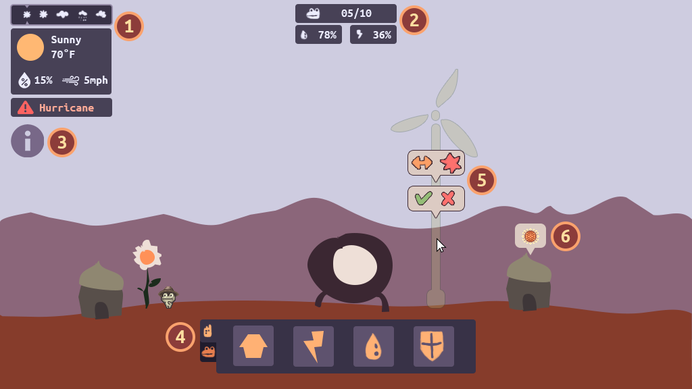

|  |  |
| --- | --- |
| 1 – Meteorologic Reading/Forecast/Hazzard Warning | 2 – Colony Info (population, water, power) |
| 3 – Hint System | 4 – Structures/Roles Palette |
| 5 – Structure Confirmations: build confirm, move/demolish | 6 – House needs icon pop-up. |

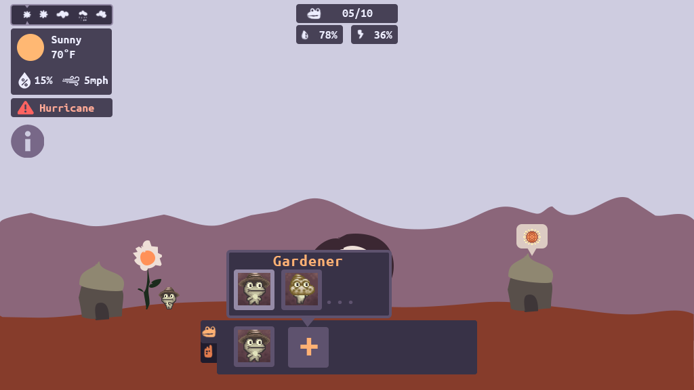

### Mechanics

* The game will be fully controlled via mouse or touch.
* All inputs are done by simply clicking on the widgets. A highlight for these widgets will appear on mouse hover, or if they are selected.

### Losing Gameplay / Incorrect Concept Understanding

* There is no losing condition during Colony Sims. The player’s performance is simply rated at the end based on how much the population grew.
* The hint system will guide the player throughout the duration on how to grow/sustain the population.
* The house requirements to grow the population is tied to understanding how one can manipulate the environment to change the atmospheric condition.

## Part 1 - [Name of this Portion of the Game]

### L.O. Concept(s) Covered

* List the concept(s) covered during this part of the game.

### Summary

Questions to consider:

* Indicate the gameplay goals. This is supposed to be fun, after all!
* What is the flow of the gameplay?
* What is the flow of the academic content?
* How will students/players be held accountable for understanding the academic content?
* Note: it is okay if the game becomes progressively more difficult from a gameplay/academic standpoint. It’s good to challenge the student, as long as it is at the appropriate level for the target age!

### Mechanics

* What are the controls for these physical movements?
* What are the physics of the movement through the game?
* What “skills” will the player need to play this game?
  + Examples: puzzle solving; manage resources; strategy; memory; drag and drop; tap on screen; rearranging pieces; platform jumping; etc.

### Losing Gameplay / Incorrect Concept Understanding

* What happens if a student loses a level or fails a mission / puzzle?
* How do they learn from their mistake(s)?
* If the student loses due to not understanding the academic content, how will the game help them learn from their mistakes?

### Mockups

* Show images of this part of gameplay here. Important items to show would be gameplay with the academic concepts integrated; the “losing gameplay” where students learn from their mistakes; and a good view of the mechanics

## Part 2 - [Name of this Portion of the Game]

### L.O. Concept(s) Covered

### Summary

### Mechanics

### Losing Gameplay / Incorrect Concept Understanding

### Mockups

## Part 3 - [Name of this Portion of the Game]

………

## Etc.

# LO Concept Coverage

### Academic Concepts

|  |  |
| --- | --- |
| **concept** | **weight** |
| Weather is defined as the conditions of the atmosphere at a particular place and time. | **Peripheral** |
| Climate is defined as the average weather over decades in a particular region. | **Peripheral** |
| The water cycle is dependent upon the flow of energy from the Sun. | **Peripheral** |
| The Coriolis effect deflects atmospheric and oceanic currents, which affects regional climates. | Core |
| Because of differential heating from the Sun, climate is warmer at equatorial regions and cooler at higher latitudes. | Core |
| Ocean water heats and cools more slowly than land, causing temperate climates in regions near the ocean. | Core |
| The angle at which the sun strikes different latitudes on Earth causes unequal heating across the globe. | Core |
| Air pressure and temperature drop with elevation, causing changes in climate. | Core |
| The cycling of matter and energy between living things and the atmosphere affects climate. | Core |
| The flow of air as wind on Earth is related to heating from the Sun. | **Peripheral** |
| When warm water evaporates from the ocean, it can condense to form storm clouds or intense tropical storm systems, such as hurricanes and tsunamis. | **Peripheral** |
| Weather characteristics include: temperature, air pressure, humidity, precipitation, wind speed and direction. | **Peripheral** |
| Atmospheric composition, including the amount of pollutants or greenhouse gases in the air, affects climate. | **Peripheral** |
| The interactions affecting weather and climate vary with latitude, altitude, proximity to the ocean, topography, and surface characteristics. | Core |
| Ocean currents transfer thermal energy between the equator and polar regions of the globe. | **Peripheral** |
| Gravity pulls denser air masses downwards, causing less dense air masses to rise. | Peripheral |
| Dense air masses are cool and dry, while less dense air masses are warm and humid. | Peripheral |
| Earth's hydrosphere includes all of the water existing in the atmosphere, bodies of water, and ground. | Peripheral |
| Albedo is the measure of how much light a surface reflects, which affects the climate in different regions. | Peripheral |

# Legends of Learning Required Content Practices

### Checklist Overview

[Google Doc Reference](https://docs.google.com/document/d/10yED8ZwFXOWjwvroqZxaHn1A6utMDncaFwmyc8dqc-g/edit?usp=sharing)

|  |  |
| --- | --- |
| **ITEM** | **COVERED** |
| Players should learn and be held accountable through gameplay-based problem solving and experience. Players should not be learning primarily through text-based instruction or assessment items. |  |
| Game does not include multiple choice assessment items. |  |
| All instruction is scientifically and mathematically correct. |  |
| Confirm that the game is linked to 2/3 or 5 main concepts of the total, whichever is greater. Confirm that the linked main concepts are correctly covered in the game. |  |
| All on-screen words spelled correctly and grammatically correct. |  |
| Vocabulary and reading level appropriate for the lowest grade level within the target audience and grade band. |  |
| Game does not include material that is inappropriate for school. This includes, but is not limited to: violence, firearms, bombs, knives, daggers, blood, gore, smoking, vaping, drug use, any mind-altering substances, alcohol, harm to human-looking characters, harm to animals, insinuating killing or death, ideally they’re always chased away rather than eliminated. If there is conflict with an enemy in game, they are chased away rather than eliminated or killed. (There can be death if it is in the context of the learning objective – ex. The food chain) If you have any questions about this policy and your game, please ask us. |  |
| Game avoids any stereotypic presentation of gender, race, region, or culture. |  |
| Characters are diverse in gender, race, culture, and ability. |  |
| Players cannot simply click through and complete the game without learning. Players should be prompted to re-learn and re-do portions of the game where they had poor results due to less understanding of the academic material. Avoid the word “FAIL” if the student incorrectly understands academic material. |  |
| Academic problems are not consistently repeated. Players are presented with different problems to solve. |  |
| Gameplay mechanic reinforces the academic material, rather than being completely separate from instruction. I.e, there is a focus on academic reasoning rather than concept / question repetition. |  |
| Gameplay is intuitive and a player in the target age range can navigate the game and beat it with enough effort. |  |
| Games should be fun and interesting, designed as non-educational games are designed, with design to encourage players to keep playing. |  |
| Game is between 5 and 25 minutes in duration. |  |
| All text must be large, clear and concise with font sizes that can be read on a small Chromebook screen. |  |

### Connection Between Gameplay and Learning

* During the Overworld gameplay, the student is presented with various atmospheric measurement of Earth. From here, they can intuitively see how the systems work via animation that simulates how they would work in the real world. Each Overworld level will of course gradually explain these systems in a more scientific way (along with more in-depth animated illustrations). Seeing these systems work in a simplified representation of Earth will also make the players feel familiar with how it ties with their existing geographical knowledge.
* Along with displaying the atmospheric measurement of Earth during Overworld gameplay, the student must also assess where and when to land the frogs’ colony ship. They will see how these systems further work based on altitude and season.
* In the Colony Simulation gameplay, the player will further learn how the environment can be manipulated to change the local climate to allow for a suitable habitation. These are more implicit, and the game will make some quick explanations of these through the tutorial.

### Role of Text in Learning

* The game will mostly use text to describe the visual simulation of the atmospheric measurement during Overworld gameplay. Most of these explanations will be accompanied with an in-depth animation of the systems.
* Text will also be used to teach the player the objective of the game, and will further support the LOs that these tie into.

### Characters - Diversity

* Frogs – The frogs will come with various colors to indicate their preferred climate. This is merely used as a way to ascertain where to bring these frogs on Earth.
* The ever-reassuring robot will be wearing a frog headdress to fit in with the rest of the cast.

# Technical

### Development Hardware/Software

* All development will be done in Windows 10.
* iPad 6 for tablet testing.
* Browsers: Firefox, Edge, Chrome, and Safari (via iPad 6)
* Game Engine: Unity 2020.4.40f1+

### Asset Summary

* Earth map – derive from a satellite image, simplify to reduce the noise and add clarity. Each overlay will use a specific sample from a real-world data (also simplified for clarity).
* Some of the assets will be generated within Unity (via model editor or sprite shape) to minimize the project’s file size.
* The game will be delivered via WebGL (targeting desktops and touchpads).

### Music and Sounds

* Branching out to other source of public domain music: [Dova-Syndrome](https://dova-s.jp/EN/)
* All sound effects will be acquired via our collection which is comprised of various licenses: purchased or public.

# Art Style

### Mockups

* Show a few examples

# Schedule for Development + Delivery [Optional, but Encouraged]

* You may link to another document / spreadsheet if you like
  + If you do, just make sure viewing permissions are available :)

# Story / Narrative

### Back Story

Space frogs exiled from a faraway galaxy, looking for a new home.

### Plot Elements

* Blah